Year 2 | Term 1 |  |  |  | Term 2 |  | Term 3 |  |  | Term 4 |  |  | Term 5 |  |  | Term 6
Genre |  | Narrative- Setting focus | Diary entry | Narrative- Character focus |  | Letter |  | Narrative: language focus | Information text / non chron |  | Narrative: simple, coherent narrative | Persuasion |  | Narrative: setting focus | Instructions |  | Narrative: story writing | Recount
Recommended Text/stimulus |  |   Little Red and the Very Hungry Lion | Bob the Man on the Moon   | The Dragon Machine  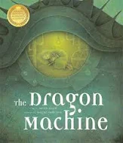 |  | The Day the Crayons Quit  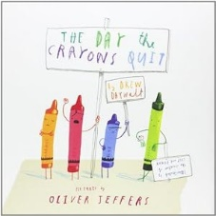 |  | 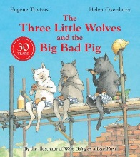  Three Little Wolves and the Big Bad Pig | 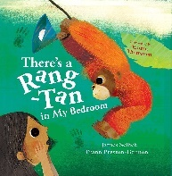  There’s a Rang-Tan in My Bedroom |  | The Lighthouse Keeper’s Lunch  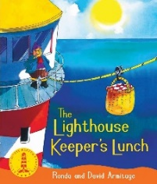 | The Lighthouse Keeper’s Cat  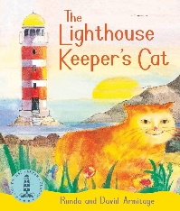 |  | The Pirate Cruncher   | Clean Up!  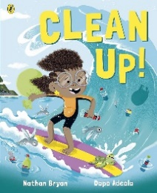 |  | The Bear and the Piano  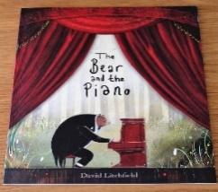 | The Wonder  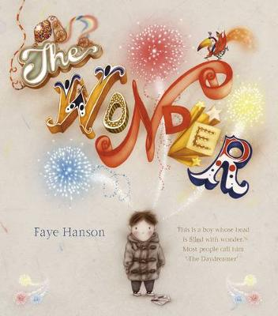
Outcomes/ form |  | Setting description (using the illustrations of Africa) | Diary entry (in role as Bob of his day on the moon) | Character description (of the Dragon Machine) |  | Letter writing (to Duncan in role as one of the crayons) |  | Innovated version of the story | Non-chronological report (about Orangutans) |  | Write a retell with some innovation | Persuasion- letter |  | Write a narrative (with a setting focus) | Writing a set of instructions (on how to build a sandcastle) |  | Write an alternative ending to the story | Recount (of the boy’s journey)
Writing Purpose |  | Writing to entertain | Writing to inform (recount) | Writing to entertain |  | Writing to Inform |  | Writing to entertain | Writing to inform (report) |  | Writing to entertain | Writing to discuss (persuade) |  | Writing to entertain | Writing to inform |  | Writing to entertain | Writing to inform (recount):
Text Features |  | 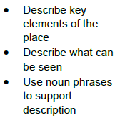 | 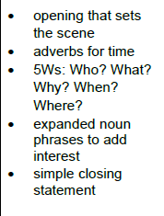 | 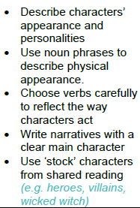 |  |  |  | 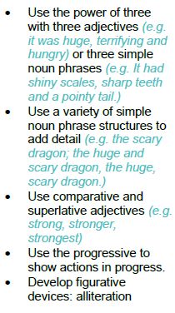 | 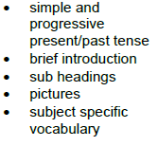 |  | 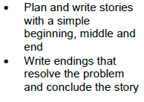 | 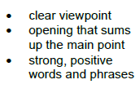 |  |  | 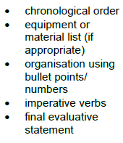
Grammatical structures |  | Recap Y1- Use and to join words and clauses. | Use subordination because to join clauses. | Use some subordination (e.g. when / because) to join clauses.  Use co-ordination (e.g. / and / so) to join clauses. |  | Use some subordination (e.g. when / if / because) to join clauses.  Use co-ordination (e.g. and / but/ so) to join clauses.  Write sentences different forms: statements, questions and commands. |  | Use adverbs to express manner e.g. quietly, quickly, sadly.  Write sentences different forms: statements, commands and exclamations. | Write sentences different forms: statements and exclamations. |  | Use some subordination (e.g. when / if / that / because) to join clauses. | Use co-ordination (e.g. / and /so/ or) to join clauses. |  | Use some subordination (e.g. when / if / that / because) to join clauses.  Use co-ordination (e.g. / and /so) to join clauses. | Write sentences different forms: statements, questions, commands and exclamations. |  |  | Use co-ordination (e.g. or / and / but/ so) to join clauses.  Use some subordination (e.g. when / if / that / because) to join clauses.
Descriptive language |  | Use noun phrases to describe and specify- Noun phrase – determiner, noun e.g. a car, three mice | Use expanded noun phrases to describe and specify when appropriate  Expand before the noun using adjectives  e.g. The fierce creature | Use expanded noun phrases to describe and specify when appropriate (adjective, adjective noun).  Expand before the noun using adjectives  e.g. The fierce, dangerous creature |  |  |  |  | Teach the use of technical vocabulary and correct use of adjectives in context. |  |  |  |  | Use expanded noun phrases to describe and specify when appropriate. |  |  |  | Use expanded noun phrases to describe and specify when appropriate.
Tense/ verb forms |  | Recap Y1- Use present and past tense with some accuracy- ed endings.  Use present and past tense mostly correctly and consistently- including irregular verbs. | Use present and past tense mostly correctly and consistently- consolidate use of irregular verbs. | Use the progressive form of verbs. |  |  |  |  | Use present and past tense mostly correctly and consistently- consolidate use of irregular verbs. |  |  |  |  |  | Use present and past tense mostly correctly and consistently- consolidate use of irregular verbs. |  | Use the progressive form of verbs.
Paragraphing/ cohesion |  | Recap Y1- Write linked sentences after discussion with teacher.  Consolidate use of personal pronouns e.g I, he, she, they, them. |  | Introduce editing and revising. |  |  |  | Adverbials for time to support story structure. |  |  | Use a variety of simple pronouns.  Adverbials for time to support story structure.
Punctuation |  | Recap Y1- Use many full stops used accurately at the end of sentences.  Recap Y1- Use many capital letters used accurately at the start of sentences. | Recap Y1- Begin to punctuate sentences using exclamation marks.  Demarcate most sentences in their writing with capital letters and full stops and use question marks correctly when required (on-going for the rest of the year). |  |  |  |  |  |  |  |  | To use an apostrophe in a contraction.
GDS objective |  |  |  |  |  |  |  | To use a possessive apostrophe. | To use commas in a list |  | To use a possessive apostrophe. | -Commas in a list  -Apostrophes for contractions and possession |  | Use a wider range of coordinating and subordinating conjunctions to vary sentence structure across a range of pieces (e.g. as, while, although, yet, for, nor). | Use punctuation taught at KS1 mostly correctly - apostrophes, commas in list, ! and ? |  | Introduce Year 2 suffixes- ment, ness, ful, less.  Use adverbs to express manner e.g. quietly, quickly, sadly. | To spell using suffixes – er, -est, -ment, -ful and -less
Handwriting | Use school approach
Spelling | Use school approach

Colour code
Black = new learning to this year group
Green = previous year group learning re-visited

