Year 3 | Term 1 |  |  | Term 2 |  | Term 3 |  |  | Term 4 |  |  | Term 5 |  |  | Term 6
Genre | Narrative Setting | Non-fiction  Recount  Diary – | Fiction  Narrative- (Character description) |  | Non-fiction  Persuasion -Letter |  | Fiction  Narrative: Retelling of story / part of story | Non chronological report |  | Fiction  Narrative: short story writing | Non-fiction  Persuasive letter |  | Fiction  Narrative: story setting / description | Non-fiction  Instructions  (Make their own potion / medicine) | Fiction  Narrative: Story writing  Poetry | Non-fiction Recount
Recommended texts/stimulus | The Iron Man   | The Iron Man   | Winter’s Child  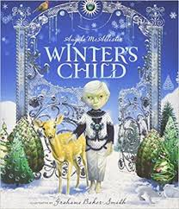 |  | Winter’s Child |  | Mrs Noah’s Pockets  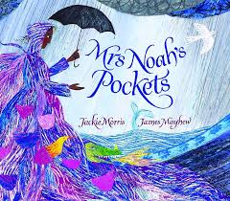 | Mrs Noah’s Pockets |  | Fly Eagle Fly  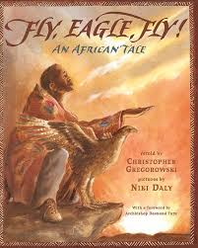 | Fly Eagle Fly |  | BFG  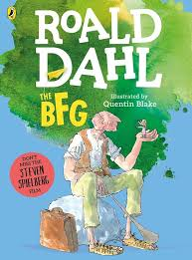 | BFG | Egyptian Cinderella  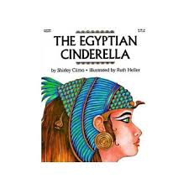 | Egyptian Cinderella
Outcome | Setting description contrasting cliff face – storm vs sun | A diary entry | Character description |  | Letter to persuade Winter’s Child to leave |  | Retelling the ending of the story of Mrs Noah’s Pockets | Create their own troublesome creature & write a report |  | Short story fiction | Persuasive letter to let eagle fly free |  | Narrative story / setting description based on BFG’s lair | Instructions – make their own potions / medicine | Write a section of Egyptian Cinderella as story | Recount
Writing purpose | To entertain | To inform (recount) | To entertain |  | To persuade |  | To entertain | To inform (report) |  | To entertain | To persuade |  | To entertain | To inform | To entertain | To inform (recount)
Text Features | 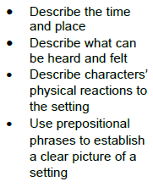 | 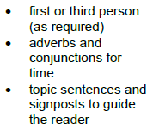 | 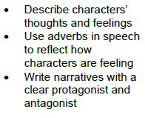 |  | 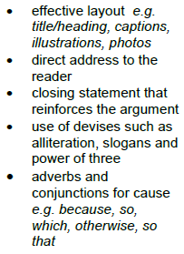 |  | 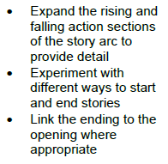 | 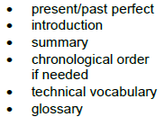 |  |  |  |  |  | 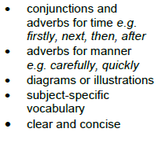
Grammatical structures | Use prepositions for place | Consolidate coordinating conjunctions (Year 2 objectives – and / but /so). | Consolidate coordinating conjunctions (Year 2 coordination and, but, or) |  | Subordinating conjunctions for cause e.g. because, since, as |  |  |  |  |  | Use conjunctions for cause e.g. because, since as, so  Recap simple subordinating conjunctions (if, when, that) |  | Use adverbs in speech to reflect how characters are feeling | Adverbs for time E.g. - Later, soon, |  | Adverbs for time E.g. - Later, soon, (Vary position of adverb).
Descriptive language | Use noun phrases expanded with adjectives |  | Use noun phrases expanded with adverbs  Describing characters’ appearance, feelings. |  |  |  |  |  |  |  | Write for a range of purposes and audiences including writing to argue (persuasive devices) |  | Describe characters’ appearance, thoughts and feelings | Use present tense correctly and consistently.
Tense/ verb forms | Use simple past tense correctly and consistently (regular verbs) | Use simple past tense correctly and consistently (irregular verbs) |  |  |  |  | Use present and past tense correctly and consistently (irregular verbs) including the progressive form of the verb
Paragraphing/ cohesion |  |  |  |  | Begin to use paragraphs to group related information (through modelling with reasons) |  |  | Use simple organisational devices (for example, headings and sub-headings) |  | Begin to use paragraphs to group related information |  |  |  |  | Begin to use paragraphs to group related information (beginning, middle, end)
Punctuation |  | Use apostrophes for contraction |  |  |  |  | Punctuate speech using inverted commas (speech marks) with some accuracy | Use apostrophes for singular possession.  Commas in a list. |  | Punctuate speech using inverted commas (speech marks) with some accuracy.  To punctuate sentences with exclamation marks for anger, surprise or frustration. |  |  |  |  | Punctuate speech using inverted commas (speech marks) with some accuracy.
GDS objectives |  |  |  |  |  |  | Show an awareness of and begin to use all speech punctuation | To consistently use paragraphs to structure my writing. |  | To use ambitious vocabulary inspired by their reading, appropriate to the purpose  To punctuate speech with accurate speech punctuation | Understand, identify and consistently use main and subordinate clauses beginning to mark clauses with a comma. |  | Accurately use inverted commas and other speech punctuation mostly correctly (e.g. comma before the reporting clause) | To use ambitious vocabulary inspired by their reading, appropriate to the purpose. | Accurately use inverted commas and other speech punctuation mostly correctly (e.g. comma before the reporting clause) | Understand, identify and consistently use main and subordinate clauses, beginning to mark clauses with a comma.
Handwriting | Use school approach
Spelling | Use school approach

Green text – previously taught skills – children should know this
Black text – new for this year group

Bold- new teaching
Green – Consolidation
Black – Y3 Skills

