Year 4 | Term 1 |  | Term 2 |  | Term 3 |  | Term 4 |  | Term 5 |  | Term 6
Genre | Narrative – Story Setting | Non-fiction  Recount | Narrative – Character Description | Non-fiction  Persuasion | Narrative – Retelling of a story/part of a story | Non-fiction -  Non chronological report | Fiction  Short Story Writing | Non-fiction -  Persuasive speech | Narrative – Story setting/description | Non-fiction  Instructions | Narrative – Story Writing | Non-fiction -Recount
Text | The Great Kapok Tree  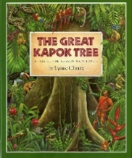 | Taking Flight (animation – literacy shed)   | Barnabus Project  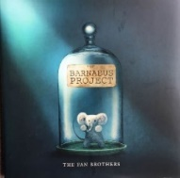 | The Gift (Youtube)  The gift   | Wolves in the Walls  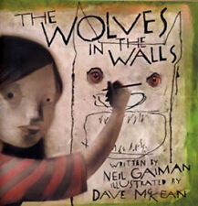 | What a Waste  One Plastic Bag  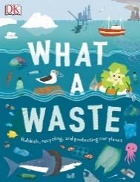 | Lost Happy Endings  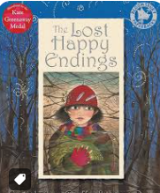 | After the Fall   | Wisp   | Wisp | 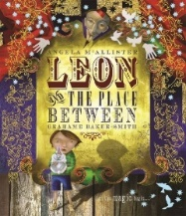  Leon and the Place Between | Leon and the Place Between
Outcome / form | Story setting about the rainforest where the Kapok tree is. | Diary from the little boy and the journey that he goes on with his Grandad. | Create their own character and write a character description about them. | Persuasive letter from the elf to not be put in the box by Santa. | Retell the story changing the animal that comes out of the walls. | Write a non-chronological about recycling and eco-friendly materials. | Retell the story. | Persuasive speech to HD to climb the wall. | Write a setting description for an additional memory that the boy visits. | Write a set of instructions about how to play a game | Retell the story (possible innovation of what is seen) | Diary written by Leon
Writing Purpose | Writing to Entertain | Writing to inform | Writing to Entertain | Writing to persuade | Writing to entertain | Writing to Inform | Writing to Entertain | Writing to Persuade | Writing to Entertain | Writing to Inform/ Explain | Writing to Entertain | Writing to Inform
Text Features | 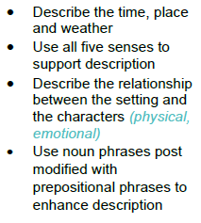 | 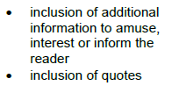 | 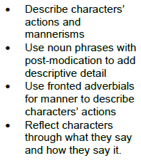 | 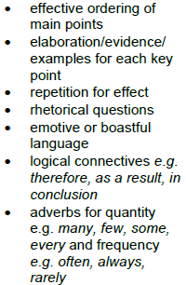 | 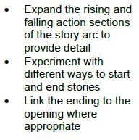 | 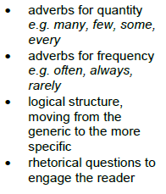 |  |  |  | 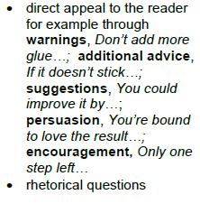
Grammatical structures | (NC: Using fronted adverbials/Using commas after fronted adverbials)  Fronted Adverbials for place– punctuated with a comma.  NC: Use a wider range of conjunctions | (NC: Use a range of subordinating conjunctions)  Use subordinating conjunctions ‘if’ and ‘when’ in the middle of the sentence. | (NC: Use a wider range of conjunctions)  Consolidate Co-ordinating conjunctions used to expand sentences. | (NC: Use a range of subordinating conjunctions)  Use subordinating conjunctions ‘before’, ‘after’, ‘until’, ‘as’ and ‘while’. Include ‘if’ and ‘when’ from term 1. | (NC: Using fronted adverbials/Using commas after fronted adverbials)  Use fronted adverbials for manner including a comma. | (NC: Use a range of subordinating conjunctions)  Focus on subordinating conjunctions for cause (because, as, since – link in ‘so’).  (NC: Using fronted adverbials/Using commas after fronted adverbials)  Use a comma to demarcate a fronted adverbial (time and place) from the main clause. |  | (NC: Use a wider range of conjunctions)  Positioning the subordinate clause at the start. | (NC: Using fronted adverbials/Using commas after fronted adverbials)  Fronted adverbials for time, place and weather. | Vary the position of the subordinate clause within a sentence. | (NC: Use a wider range of conjunctions)  Vary the position of subordinate clause within a piece of writing and vary conjunctions for time and cause.
Descriptive language | (NC: In narratives, develop settings and character)  Setting: place and weather.  (NC: Use Expanded Noun Phrases with adjectives, punctuated correctly.) | Use adverbs to modify expanded noun phrases. | (NC: In narratives, develop settings and character)  Character actions and mannerisms – begin to explore how your character will behave.  (NC: Use noun phrases expanded by the addition of modifying adjectives, nouns and preposition phrases) |  |  |  | (NC: In narratives, develop settings and character)  Develop settings and characters – time, place and weather. |  | (NC: In narratives, develop settings and character)  Describe the relation between setting and character (e.g. the sailor on the sea in the text)
Tense/ verb forms |  | (NC: Use present and past tense correctly and consistently throughout a piece of writing)  Use simple past tense – -ed suffix and irregular verbs spelled correctly. |  | (NC: Use present and past tense correctly and consistently throughout a piece of writing)  Use present progressive forms of the verb. |  | (NC: Use present and past tense correctly and consistently throughout a piece of writing)  Consistently use simple present tense and recap present progressive forms of the verb. | (NC: Use present and past tense correctly and consistently throughout a piece of writing)  Ensure evidence of past progressive tense (was/were chasing)  Accurately manage tense changes where needed e.g. a story written in the past tense with present tense for speech. |  |  |  |  | (NC: Use present and past tense correctly and consistently throughout a piece of writing)  Accurately manage tense changes where needed (including speech)  Use the present perfect form of verbs
Paragraphing/ cohesion |  | Use paragraphs to group ideas. | Maintain cohesion through the use of nouns and pronouns. | Organise content into relevant paragraphs across the text.  Ensure writing is semi-formal. |  | Organise content into relevant paragraphs across the text.  Use paragraphing and sub-headings appropriately in non-fiction writing. | Maintain cohesion through the use of nouns and pronouns.  Begin to use alternative nouns. E.g. the dragon, the monster. | Organise content into relevant paragraphs across the text.  Use a formal tone. |  | Use paragraphing and sub-headings appropriately in non-fiction writing. | Begin to edit and identify unnecessary repetition
Punctuation | Use commas for fronted adverbials. | Use apostrophes for contractions and singular possession. |  | Use question marks to show rhetorical questions. | To use speech punctuation accurately. | Use commas for fronted adverbials. |  |  |  |  | Ensure children end the speech punctuation accurately  (If reported clause is after the speech, they can only use ,?!)
GDS |  |  |  |  | Ensure that links within paragraphs are cohesive. | Vary the position of the subordinate clause within a sentence and consistently mark clauses with a comma. | To use ambitious and appropriate vocabulary inspired by their reading to maintain the required level of formality. | Accurately demarcate complex sentences with a comma. | To use ambitious and appropriate vocabulary inspired by their reading to maintain the required level of formality. | Vary the position of the subordinate clause within a sentence and consistently mark clauses with a comma. | Ensure that links within paragraphs are cohesive.  Consistently use the punctuation taught at LKS2 mostly correctly (apostrophes, commas, question marks, exclamation marks, inverted commas)  Vary the position of the subordinate clause within a sentence and consistently mark clauses with a comma. | Ensure that links within paragraphs are cohesive.
Handwriting | Follow school scheme
Spelling | Follow school scheme

Colour code
Black= current year group planning
Bold Black = new learning to this year group
Green = previous year group learning re-visited

