Year 5 | Term 1 |  | Term 2 |  | Term 3 |  |  | Term 4 |  |  | Term 5 |  |  | Term 6
Genre | Poetry  Story Setting | Recount - Diary Entry | Character description – contrasting | Persuasion – letter |  | Retell part of story | Non chronological report | Short story writing | Persuasion | Contrasting setting description |  | Instructions | Narrative Story Writing |  | Recount letter
Recommended Text/Stimulus | Lion Witch and The Wardrobe  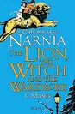 | Last   | The Promise – animation and book  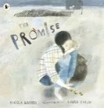 | The Promise – animation and book |  | 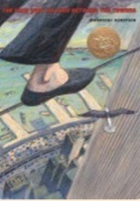  Boy 87 – Retell part of the story | The Land of Never Believe  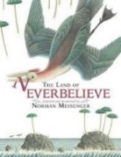 |   Wonder | Little Freak (animation)   | Letters from the Lighthouse  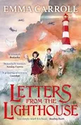 |  | Letters from the Lighthouse | 23 degrees 5 minutes   |  |   Everest
Outcome | Negative setting description based on Narnia | Diary entry from various perspectives in the book | Create a contrasting character description from the start and end of the book | Write a persuasive letter |  | Retell a significant part of the story e.g. getting ready to walk the wire, the wire, the arrest | Write a non-chronological report about a mythical beast of choice | Write a short story about Julian’s new school after leaving Beecher Prep | Letter from mum to Auggie persuading to go to school | Contrasting setting description of London vs. coastal village |  | Write instructions on what to do in an air raid | Who was the Professor and why did he disappear? |  | Write a recount letter home to his friend/family recounting the trip
Writing Purpose | Writing to entertain | Writing to inform | Writing to entertain | Writing to persuade |  | Writing to entertain | Writing to inform | Writing to entertain | Writing to persuade | Writing to entertain |  | Writing to explain | Writing to entertain |  | Writing to inform
Text Features | 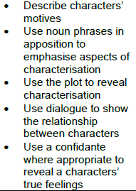 | 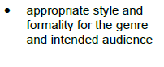 | 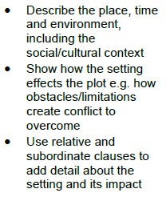 | 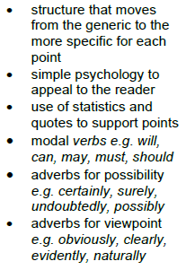 |  | 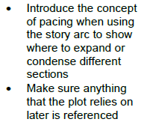 | 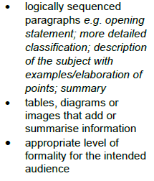 |  |  |  |  | 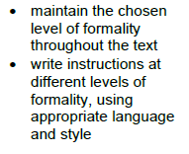
Grammatical structures | To use subordinate clauses at the beginning and end of sentences (use a variety of conjunctions) | To use prepositional phrases. |  | To use a range of grammatical structures including using a variety of conjunctions (coordinating) |  | To use a range of grammatical structures including using a  variety of conjunctions and relative pronouns, moving the  position of the clauses. |  | Use relative pronouns (who, whom, whose, who’s) to write relative clauses  Use commas to mark relative clauses e.g. Alex, who was incredibly brave, charged up to the fierce creature | Use of modal verbs and adverbs to indicate degree of possibility. | Use dialogue to move the action forward.  Use non-defining relative clauses using ‘which’ and ‘that’ |  | Use a comma to demarcate the subordinate clause when it is before the main clause.  Use a range of adverbs and adverbials within and across paragraphs in narrative (time, manner, place) and non fiction (In addition, Unfortunately…) | Use a range of relative pronouns in their writing and demarcate the relative clauses accurately.  Use a range of relative pronouns to expand the second noun
Descriptive language | Description of setting using senses,  emotive language,  thoughts and feelings,  descriptive language.  . | Character’s reactions to events through thoughts and feelings | Develop characters through physical appearance, interactions with others, reactions to events and figurative language e.g. show don’t tell  Describe characters’ motives |  |  | In narratives, begin to develop atmosphere e.g. through the  use of past progressive tense.  In narratives, develop character (through how others respond  to them) | identifying the audience for and purpose of the writing,  selecting the appropriate form and using other similar writing  as models for their own (technical vocabulary) | Develop characters in narrative e.g. through using show-not-tell, describing reactions to other characters, reactions to the setting etc. |  | Develop settings through use of noun phrases including concise adjectives, prepositional phrases and correct punctuation; weather, senses time, characters’ reactions and figurative language e.g. alliteration and similes
Tense/ verb forms |  |  |  |  |  |  | ensuring the consistent and correct use of tense throughout a  piece of writing (present) |  |  |  |  |  |  |  | Manage tense changes within a piece of writing.
Paragraphing/ Cohesion |  |  | Use a range of devices to build cohesion within and across paragraphs e.g. consistent tense and person; pronoun chains; range of conjunctions; adverbs and adverbial phrases; repetition for effect. | Use a range of devices to build cohesion within and across paragraphs.  Use paragraphs to organise ideas |  |  | using further organisational and presentational devices to  structure text and to guide the reader [for example, headings,  bullet points, underlining] |  |  |  |  | Use further organisational and presentational devices to structure text and to guide the reader e.g. bullet points |  |  | Use a range of devices to build cohesion within and across paragraphs e.g. consistent tense and person; pronoun chains; range of conjunctions; adverbs and adverbial phrases; repetition for effect.
Punctuation | To write sentences using dashes to show an afterthought. | To understand the purpose of a rhetorical question and to use them to convey thoughts and feelings.  To write sentences using dashes to show an afterthought. |  |  |  |  | using brackets to indicate parenthesis | Use dialogue in narrative to show the relationship between characters and move the action on | Use dashes for afterthoughts
GDS objectives |  |  |  |  |  |  |  | Use a range of cohesive devices to ensure there are links within and between paragraphs (Include an extended metaphor throughout the work based on one specific part of the main character’s description) | Use the full range of features and grammatical structures for a range of purposes and audiences, within formal and informal writing (e.g. rhetorical questions, one - two-word verbs, colloquialisms, passive voice, formal tone, modal verbs) | To select and use a range of ambitious vocabulary with precision.  To precisely advance the action by varying the position of the reporting clause.  Use a variety of complex sentences (e.g. including relative clauses and range of conjunctions) and manipulate clauses for effect. |  | Use the full range of features and grammatical structures for a range of purposes and audiences, within formal writing  Use a range of cohesive devices to ensure there are links within and between paragraphs (e.g. range of conjunctions, adverbs) | Use a variety of complex sentences (e.g. including relative clauses and range of conjunctions) and manipulate clauses for effect.  Use the range of punctuation taught at key stage 2 correctly (dashes for afterthought and commas for parenthesis) recapped through modelling throughout |  | Use a variety of complex sentences (e.g. including relative clauses and range of conjunctions) and manipulate clauses for effect.  Use a range of cohesive devices to ensure there are links within and between paragraphs (e.g. range of conjunctions, adverbs, tense, person, pronoun alternatives, ellipsis, topic based sentences followed by evidence)
Handwriting | Use school approach
Spelling | Use school approach

Colour code
Black = new learning to this year group
Green = previous year group learning re-visited

