Year 6 | Term 1 |  | Term 2 |  |  |  | Term 3 |  | Term 4 |  | Term 5 |  |  | Term 6
Genre | Poetry  Narrative: Story Setting | Non-fiction: Recount Writing: Diary Entry |  | Narrative: Alternative Ending with Character Description |  | Non-fiction: Persuasive Letter | Narrative: Myth | Non-fiction: Non-Chronological report | Narrative: Retelling a story | Non-fiction: Balanced Argument | Narrative: Alternative/ Invented Ending | Non-fiction: Eye Witness Account |  | Teachers to select appropriate writing opportunities to prepare for moderation
 |  |  |  |  |  |  |  |  |  |  |  |  |  | Narrative:  Focusing on dialogue and characterisation | Non-fiction: Instructions (or explanation) |  |  | Non-fiction: Persuasive Advert  Recount letter
Recommended Text/Stimulus | Skellig   | The Viewer   |  |     or |  |  | The Girl of Ink and Stars  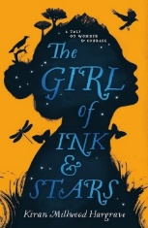 |  | 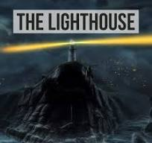  The Lighthouse (animation) – |   Can we Save the Tiger? | Alma (animation)   |  |  |  |  |  |  | 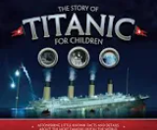
Outcome | Skellig – Setting of Skellig’s garage as Michael moves through the scene | Diary entry – To write a diary through Tristan’s eyes describing what he sees through the viewer. |  | Alternative Ending with character description  Persuasive Letter – Persuade to save the ice palace (from the perspective of the Snow Queen). | Additional scene  Persuasive letter either for OR against the use of animals for human gain |  | Myth: Imagine a place | Non-Chronological Report – mythical beast | Retelling the story | Balanced argument: Can We Save the Tiger? | Retelling a story with invented ending | Eye witness account of someone who notices Alma enter the alley way. | Short narrative focusing on dialogue |  |  | Instructions – linked to Science for explanation (GDS) something practical | To write a persuasive advert encouraging people to set sail onboard the Titanic
Writing Purpose | To entertain | To inform |  | To entertain | To persuade |  | To entertain | To inform | To entertain | To persuade and inform | To entertain | To inform: |  | To entertain |  | To inform | To persuade
Text Features | 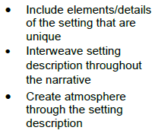 | 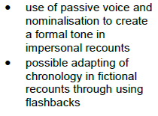 |  | 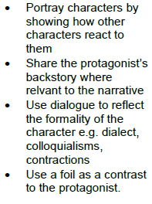 | 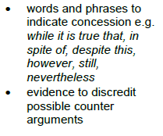 |  | 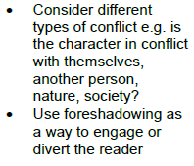 | 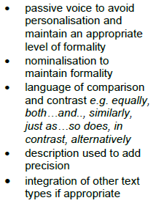 |  |  |  |  |  | 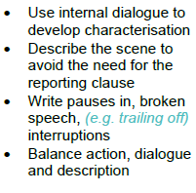 |  | 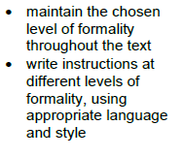
Grammatical structures | Extending the range of sentences with more than one clause by using a wider range of conjunctions, including when, if, because, although  Using fronted adverbials |  |  | Use relative clauses beginning with a range of relative pronouns. | Use passive voice to create empathy or suspense, empathy and formality.  Using modal verbs or adverbs to indicate degrees of possibility |  |  |  | Integrate dialogue in narratives to convey character and advance the action | Select vocabulary and grammatical structures that reflect what the writing requires, doing this mostly appropriately (modal verbs as question tags) | Integrate dialogue in narratives to convey character and advance the action | TAF OBJECTIVE:  Integrate dialogue in narratives to convey character and advance the action.  Select vocabulary and grammatical structures that reflect what the writing requires, doing this mostly appropriately (e.g. using contracted forms in dialogues in narrative; using passive verbs to affect how information is presented; using modal verbs to suggest degrees of possibility)  In narratives, describe settings, characters and atmosphere. |  | TAF OBJECTIVE:  Integrate dialogue in narratives to convey character and advance the action.  Select vocabulary and grammatical structures that reflect what the writing requires, doing this mostly appropriately (e.g. using contracted forms in dialogues in narrative; using passive verbs to affect how information is presented; using modal verbs to suggest degrees of possibility)  In narratives, describe settings, characters and atmosphere. |  | TAF OBJECTIVE:  Integrate dialogue in narratives to convey character and advance the action.  Select vocabulary and grammatical structures that reflect what the writing requires, doing this mostly appropriately (e.g. using contracted forms in dialogues in narrative; using passive verbs to affect how information is presented; using modal verbs to suggest degrees of possibility)  In narratives, describe settings, characters and atmosphere. | TAF OBJECTIVE:  Integrate dialogue in narratives to convey character and advance the action.  Select vocabulary and grammatical structures that reflect what the writing requires, doing this mostly appropriately (e.g. using contracted forms in dialogues in narrative; using passive verbs to affect how information is presented; using modal verbs to suggest degrees of possibility)  In narratives, describe settings, characters and atmosphere.
Descriptive language | Using expanded noun phrases to convey complicated information concisely  Selecting appropriate grammar and vocabulary, understanding how such choices can change and enhance meaning | Using expanded noun phrases for precision  To use figurative language  Selecting appropriate grammar and vocabulary, understanding how such choices can change and enhance meaning |  | Select vocabulary that reflect what the writing requires eg. Figurative language, adverbs, preposition phrases and expanded noun phrases effectively to add detail, qualification, and precision.  Develop character within writing. |  |  | To develop atmosphere (understand how to build up tension and suspense) |  | In narratives, describe settings, characters and atmosphere  Share the protagonist’s backstory where relevant to the narrative |  | In narratives, describe settings, characters and atmosphere
Tense/ verb forms |  |  |  |  |  |  | Use past progressive tense |  |  |  |  | TAF OBJECTIVE:  Use verb tenses consistently and correctly throughout their writing. |  | TAF OBJECTIVE:  Use verb tenses consistently and correctly throughout their writing. |  | TAF OBJECTIVE:  Use verb tenses consistently and correctly throughout their writing. | TAF OBJECTIVE:  Use verb tenses consistently and correctly throughout their writing.
Paragraphing/ cohesion |  |  |  |  | Use a range of devices to build cohesion within and across paragraphs. |  | To use a range of sentence openers (DADWAVERS) |  | Use a range of devices to build cohesion |  |  | TAF OBJECTIVE:  Use a range of devices to build cohesion (e.g. conjunctions, adverbials of time and place, pronouns, synonyms) within and across paragraphs. |  | TAF OBJECTIVE:  Use a range of devices to build cohesion (e.g. conjunctions, adverbials of time and place, pronouns, synonyms) within and across paragraphs. |  | TAF OBJECTIVE:  Use a range of devices to build cohesion (e.g. conjunctions, adverbials of time and place, pronouns, synonyms) within and across paragraphs. | TAF OBJECTIVE:  Use a range of devices to build cohesion (e.g. conjunctions, adverbials of time and place, pronouns, synonyms) within and across paragraphs.
Punctuation |  | To use a dash for an afterthought |  | Use inverted commas, commas for clarity, and punctuation for parenthesis mostly correctly, and making some correct use of semi-colons, dashes, colons and hyphens. |  |  |  | Use semi-colons, colons or dashes to mark boundaries between independent clauses  Use dashes, brackets and commas to mark parenthesis |  | To use dashes, brackets and commas for parenthesis |  | TAF OBJECTIVE:  Use the range of punctuation taught at KS2 mostly correctly (e.g. inverted commas and other punctuation to indicate direct speech, commas to mark clauses, punctuation for parenthesis). |  | TAF OBJECTIVE:  Use the range of punctuation taught at KS2 mostly correctly (e.g. inverted commas and other punctuation to indicate direct speech, commas to mark clauses, punctuation for parenthesis). |  | TAF OBJECTIVE:  Use the range of punctuation taught at KS2 mostly correctly (e.g. inverted commas and other punctuation to indicate direct speech, commas to mark clauses, punctuation for parenthesis). | TAF OBJECTIVE:  Use the range of punctuation taught at KS2 mostly correctly (e.g. inverted commas and other punctuation to indicate direct speech, commas to mark clauses, punctuation for parenthesis).
GDS |  |  |  |  |  |  |  |  | Distinguish between the language of speech and writing and choose the appropriate register | exercise an assured and conscious control over levels of formality, particularly through manipulating grammar and vocabulary to achieve this. | Distinguish between the language of speech and writing and choose the appropriate register  Use the range of punctuation taught at key stage 2 correctly and, when necessary, use such punctuation precisely to enhance meaning and avoid ambiguity  Exercise an assured and conscious control over levels of formality, particularly through manipulating grammar and vocabulary to achieve this. | TAF OBJECTIVES:  use the range of punctuation taught at key stage 2 correctly (e.g. semi-colons, dashes, colons, hyphens) and, when necessary, use such punctuation precisely to enhance meaning and avoid ambiguity.  write effectively for a range of purposes and audiences, selecting the appropriate form and drawing independently on what they have read as models for their own writing (e.g. literary language, characterisation, structure)  distinguish between the language of speech and writing and select the appropriate register  exercise an assured and conscious control over levels of formality, particularly through manipulating grammar and vocabulary to achieve this. |  | TAF OBJECTIVES:  use the range of punctuation taught at key stage 2 correctly (e.g. semi-colons, dashes, colons, hyphens) and, when necessary, use such punctuation precisely to enhance meaning and avoid ambiguity.  write effectively for a range of purposes and audiences, selecting the appropriate form and drawing independently on what they have read as models for their own writing (e.g. literary language, characterisation, structure)  distinguish between the language of speech and writing and select the appropriate register  exercise an assured and conscious control over levels of formality, particularly through manipulating grammar and vocabulary to achieve this. |  | TAF OBJECTIVES:  use the range of punctuation taught at key stage 2 correctly (e.g. semi-colons, dashes, colons, hyphens) and, when necessary, use such punctuation precisely to enhance meaning and avoid ambiguity.  write effectively for a range of purposes and audiences, selecting the appropriate form and drawing independently on what they have read as models for their own writing (e.g. literary language, characterisation, structure)  distinguish between the language of speech and writing and select the appropriate register  exercise an assured and conscious control over levels of formality, particularly through manipulating grammar and vocabulary to achieve this. | TAF OBJECTIVES:  use the range of punctuation taught at key stage 2 correctly (e.g. semi-colons, dashes, colons, hyphens) and, when necessary, use such punctuation precisely to enhance meaning and avoid ambiguity.  write effectively for a range of purposes and audiences, selecting the appropriate form and drawing independently on what they have read as models for their own writing (e.g. literary language, characterisation, structure)  distinguish between the language of speech and writing and select the appropriate register  exercise an assured and conscious control over levels of formality, particularly through manipulating grammar and vocabulary to achieve this.
Handwriting | Use school approach for Handwriting
Spelling | Use school approach for spelling

Colour code

Black = new learning to this year group

Green = previous year group learning re-visited

