RICH Reading Books
 | Term 1 | Term 2 | Term 3 | Term 4 | `Term 5 | Term 6
Narrative Focus | setting | character | retell | short story | description | innovated story
Non-fiction Focus | Recount (diary/ letter/ recount) | Persuasion | Non- chron report | Persuasion/ Recount | instructions | Recount (diary/ letter/ recount)
Year 2 | 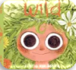  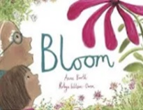  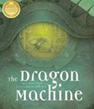  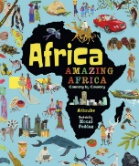  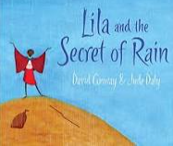 | 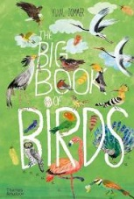  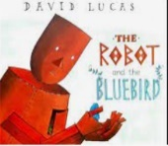  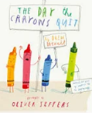 | 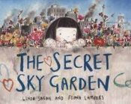  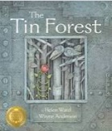  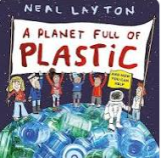 | 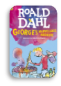 | 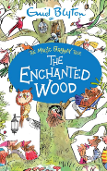  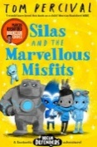 | 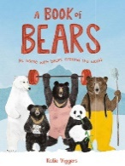  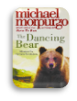
Reason of Choice |  | Story type: quest  Value/ theme: resilience, determination  Diversity: set in Africa/ gender equality | Story type: overcoming the monster/ self- discovery  Value/ theme: resilience, environmental awareness, friendship | Story type: comedy, fantasy  Value/ theme: curiosity, consequences | Story type: adventure  Value/ theme: happiness, individualism, | Story type:  Value/ theme:  Diversity:
Year 3 | 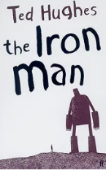 | 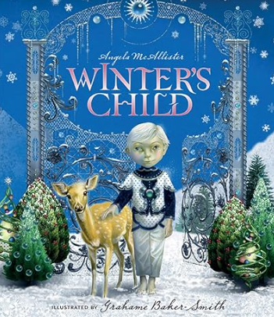 | 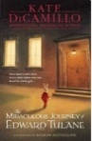  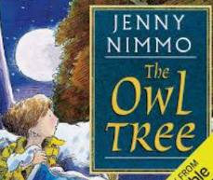 | 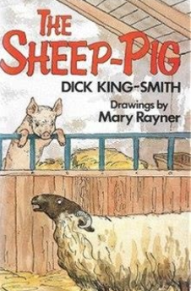 | 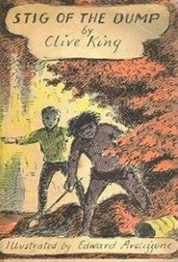 | 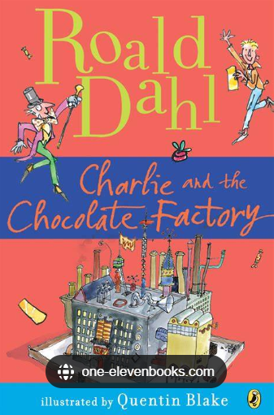
Reason of Choice | Story type: classic, fantasy  Recommended list: Pie Corbett, Power of Reading  Value/ theme: bravery, acceptance, fear, inclusion | Story type: fantasy, adventure  Value/ theme: the beauty of nature, kindness, compassion  Recommended list: Book Trust | Edward Tulane:  Story type: rebirth, voyage, adventure  Recommended list: Power of Reading,  Value: identity, loss, kindness, compassion-  The Owl Tree  Story type: coming-of-age  Recommended list: Book Trust  Diversity: different family structures, inclusion  Values: belonging, empathy, kindness, care for nature | Story type: classic, animal fantasy  Recommended list: Pie Corbett, Book Trust, Reading Reconsidered  Value: family, individuality, respect  Diversity: adoption | Story type: adventure, fantasy, coming-of-age, classic  Value/ theme: friendship, acceptance, imagination  Recommended list: English curriculum’s reading list, Book Trust | Story type: fantasy, morality, fable-like  Recommended list:  Value/ theme: greed, consequences, honesty, integrity, family  Diversity: poverty
Year 4 | 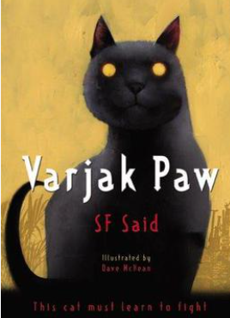 | 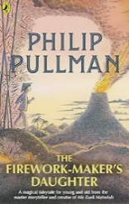 | 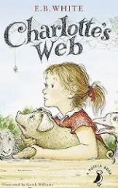 | 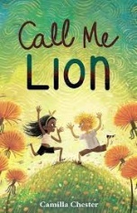 | 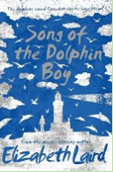 | 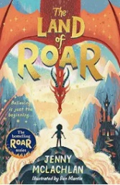
Reason of Choice | Story type: adventure, rebirth,  Recommended list: Pie Corbett, Power of Reading, Book Trust, Reading Reconsidered  Value/ theme: being different, courage, determination  Diversity: set in W Asia | Story type: adventure, voyage and return,  Recommended list: Pie Corbett, Power of Reading, Reading Reconsidered (non-linear plot)  Value/ themes: courage, determination  Diversity: set in Asia, female protagonist | Story type: classic, animal fantasy, rebirth  Recommended list: Pie Corbett, Book Trust, Reading Reconsidered (archaic)  Value/ themes: friendship, compassion | Story type: contemporary realistic fiction  Recommended list: Book Trust  Value/ themes:  Diversity: selective mutism | Story type:  Recommended list:  Value/ themes: | Story type: adventure, fantasy, overcoming the monster  Value/ theme: bravery, family
Year 5 | 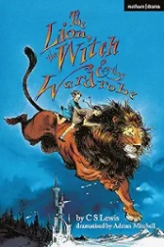 | 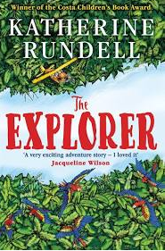 | 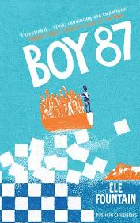 | 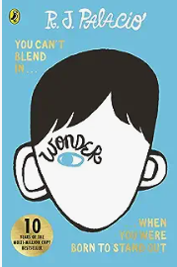 | 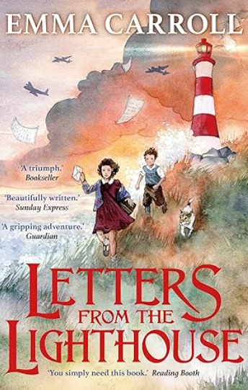 | 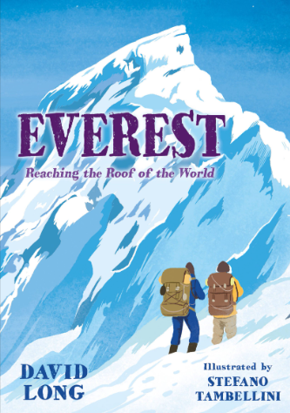
Reason of Choice | Story type: adventure, voyage and return  Recommended list: Book Trust,  Value / theme: coming of age, friendship, ecology, | Story type: adventure  Value/ themes: friendship, survival, hope, fear  Diversity: set in Brazil | Story type: contemporary, overcoming the monster  Recommended list:  Value/ themes: kindness, strength, hope  Diversity: refugee | *Story type: contemporary fiction, rebirth, overcoming the monster  Recommended list: Reading Reconsidered (complex narrator)  Value/ theme: resilience, acceptance, friendship, identity  Diversity: medical | *Story type: historical fiction, mystery, quest  Recommended list:  Value/ themes: hope, determination, prejudice | Story type: non fiction  Value/ themes: determination, ambition,
Year 6 | 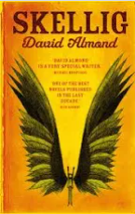 | 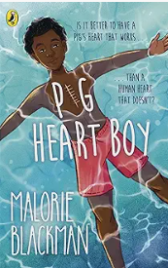 | 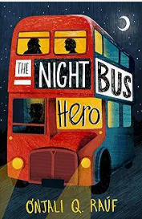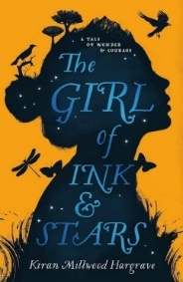 | 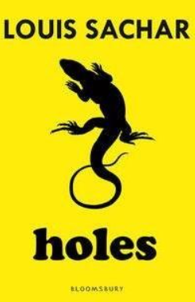 | Use of extracts: SATs prep | 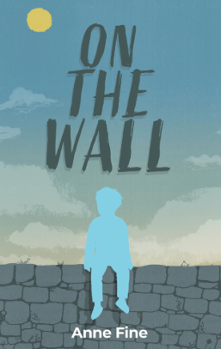
Reason of Choice | Story type: fantasy, rebirth  Recommended list: Book Trust, Pie Corbett, Power of Reading, Reading Reconsidered (complexity in plot/ symbol)  Value/ theme: friendship, discovery | Story type: emotive novel, overcoming the monster  Value/ theme: resilience, hope  Diversity: medical | Story type: mystery, rebirth  Value/ themes: bullying, family, friendship  Diversity: poverty/ homelessness  Recommended list: | Story type: adventure, overcoming the monster  Recommended list: Pie Corbett, Book Trust, Reading Reconsidered (non-linear)  Value/ theme: consequences, justice |  | Story type: coming-of-age, contemporary fiction  Recommended list: Book Trust  Value/ themes: kindness, empathy, respect, courage perseverance  Diversity: diversity of pupils

