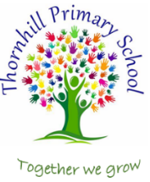

Thornhill Primary School
English Progression of Knowledge

Intent
At Thornhill Primary School, we place English at the centre of our curriculum. We believe that the ability to read, write and speak confidently is fundamental to success in all subjects and in life beyond school. Our intent is to develop articulate, thoughtful learners who:
- Read widely and with curiosity.
- Write with clarity, creativity and purpose.
- Speak with confidence in a range of contexts.
We aim to foster a love of literature and language, helping children build a rich vocabulary and a strong literary repertoire that supports their learning across the curriculum.
Implementation
We deliver English through both the Literacy Tree curriculum and a bespoke Hamwic curriculum which use a thematic and book-based approach that places high-quality children’s literature at the heart of learning. Our teaching is structured around the Teach Through a Text pedagogy, which ensures consistency and depth across all year groups.
Key features of our approach include:
- Immersion in quality texts: Children explore the language, themes and structure of engaging books before beginning their own writing.
- Purposeful writing opportunities: Each unit leads to meaningful outcomes, with a clear audience and purpose.
- Integrated grammar and vocabulary: Language skills are taught in context, enhancing understanding and application.
- Reading for pleasure: We promote a love of reading through daily reading sessions, library access, and author studies.
Phonics is taught using a systematic programme in EYFS and KS1, ensuring children develop strong decoding skills early on. Spelling, punctuation and grammar are embedded throughout the curriculum and revisited regularly.
Impact
The impact of our English curriculum is seen in the confidence and creativity of our learners. Children at Thornhill:
- Develop strong reading habits and can discuss texts with insight.
- Write with increasing sophistication, adapting their style for different audiences and purposes.
- Speak clearly and confidently, expressing ideas and opinions effectively.
Progress is monitored through formative and summative assessments, and outcomes are used to inform planning and support.

Curriculum Overview
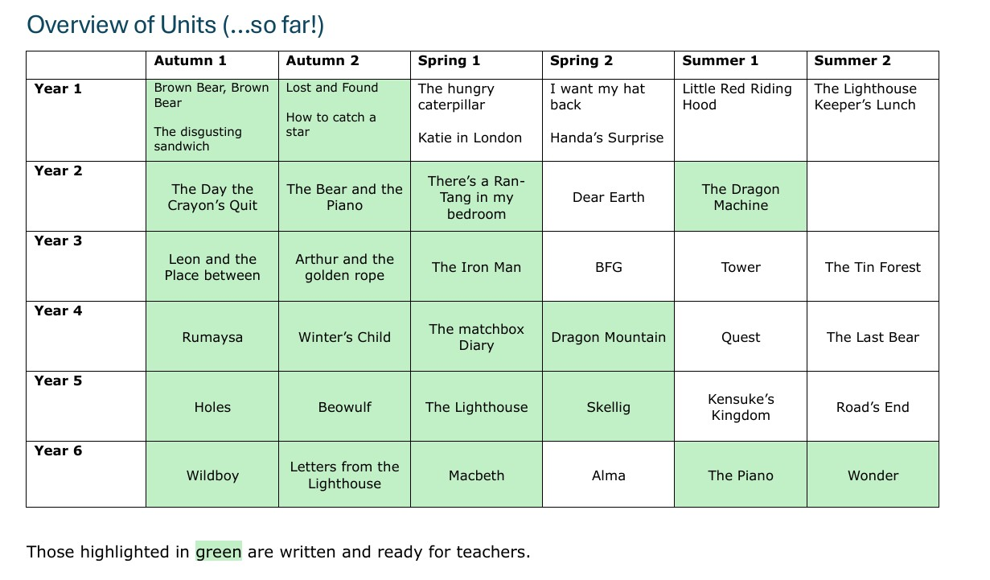

Writing Milestones
