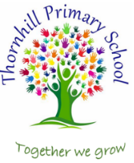
Thornhill Primary School

Mathematics Intent, Implementation and Progression of Knowledge.
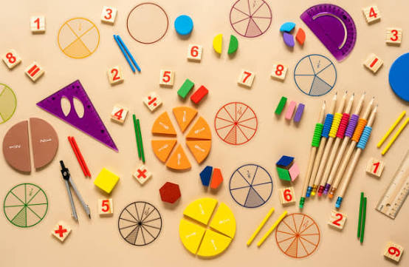

"Every child can learn mathematics to high levels when they are given the opportunity to think deeply, reason and make connections." Inspired by the work of Jo Boaler.

Intent
At Thornhill Primary School, we believe that every child can succeed in mathematics. We are committed to providing a high-quality mathematics education that develops confident, resilient and fluent mathematicians who enjoy challenge, think critically and can apply their learning to the world around them. We want every child to leave Thornhill with the mathematical knowledge, understanding and confidence they need to thrive in secondary education and beyond.

We have chosen the Ark Mathematics Mastery curriculum because it aligns with our vision of developing deep, connected mathematical understanding. Within our school community, where many children begin with gaps in mathematical fluency and confidence, we believe that a mastery approach gives every child the opportunity to succeed. Rather than racing through content, children are given the time to develop secure conceptual understanding, make meaningful connections and apply their learning through reasoning and problem solving.
Our mathematics curriculum is carefully sequenced to ensure that knowledge builds over time. We want children to understand the 'why' behind mathematics, not simply remember procedures or methods. Through rich mathematical discussion, precise mathematical vocabulary and opportunities to explain, justify and challenge thinking, children become articulate mathematicians who can communicate their ideas with confidence.
We recognise that fluency is essential to mathematical success. Alongside deep conceptual understanding, we are committed to developing children's automatic recall of key number facts and calculation strategies. Through daily opportunities to revisit prior learning, practise number facts and strengthen understanding, children build the secure foundations needed to access increasingly complex mathematics.
Ultimately, we aim to develop learners who approach mathematics with curiosity, resilience and self-belief. We want every child to know that mathematics is something they can achieve, enjoy and use throughout their lives.

Implementation
Our mathematics curriculum is delivered through the Ark Mathematics Mastery programme, which provides a carefully planned progression of knowledge and skills from Reception to Year 6. Learning is deliberately sequenced so that new concepts build upon prior understanding, enabling children to make connections and develop increasing depth of understanding over time.

Teaching follows the mastery approach, where concepts are explored in depth before moving on to new learning. Lessons are structured to develop the three Dimensions of Depth: conceptual understanding, language and communication, and mathematical thinking. Children are encouraged to explain their reasoning, justify their methods and discuss different approaches using accurate mathematical vocabulary.

Across the school, teachers use the Concrete, Pictorial and Abstract (CPA) approach to support learning. Children first explore mathematical concepts using practical resources before representing their ideas visually and then progressing to abstract mathematical symbols. This enables all learners to develop secure conceptual understanding while supporting pupils to access increasingly sophisticated mathematics.
Lessons follow a consistent structure, including opportunities for retrieval practice, explicit teaching, mathematical discussion, guided practice and independent application. Teachers use questioning, discussion, mini whiteboards and ongoing formative assessment to identify misconceptions and adapt teaching so that all children can achieve success. Pre- and post-unit assessments inform future teaching and targeted intervention where needed.

As we begin our second year (September 2026) of implementing Ark Mathematics Mastery, we continue to strengthen children's mathematical fluency through daily practice. From September 2026, children in Reception, Years 1, 2, 5 and 6 will participate in the NCETM Mastering Number programme, developing strong number sense and automatic recall of key facts. Children in Years 3 and 4 will take part in Ark Mathematics Mastery's Number Facts Fluency sessions to further embed essential number knowledge. Alongside this, daily Maths Meetings across the school revisit previously taught concepts, providing regular opportunities to consolidate learning, strengthen recall and develop long-term mathematical understanding.

Our classrooms promote mathematical thinking through carefully selected resources, consistent representations and rich mathematical talk. We foster an environment where mistakes are valued as part of learning, children feel confident to explain their thinking and perseverance is celebrated. Through high expectations, carefully planned teaching and a belief that every child can succeed, we are developing confident mathematicians who understand mathematics deeply and are prepared for the next stage of their education.
Progression of Knowledge.

