

Thornhill Primary School
PE Progression of Knowledge
‘Sport and physical activity have a powerful and positive effect on mental health.’


Intent
At Thornhill Primary School, our intent is to provide a rich, engaging and inspiring PE curriculum rooted in our school values and underpinned by our Learning Heroes. We aim to develop children's fundamental movement skills, physical confidence and knowledge through a wide range of physical activities, team sports and competitive opportunities. Our PE curriculum supports children's physical, social and emotional development, with wellbeing and mental health embedded throughout. Alongside our My Happy Mind programme and OPAL play, children develop resilience, teamwork, confidence and healthy, active lifestyles. By the end of their time at Thornhill, children will have the skills, knowledge and confidence to enjoy lifelong participation in physical activity and be well prepared for the next stage of their education.
Implementation
At Thornhill Primary School, PE is delivered through the Real PE curriculum and supported by our School Games programme. Teaching focuses on the six Real PE cogs: Personal, Social, Cognitive, Creative, Physical and Health & Fitness, enabling children to develop both physical skills and their overall wellbeing. Fundamental movement skills are taught progressively across all year groups, with each class revisiting the same key areas while building on age-appropriate knowledge and skills. PE is taught twice a week, providing regular opportunities for children to develop teamwork, resilience, emotional regulation and confidence through a wide range of physical activities. We further enrich our curriculum through opportunities including tag rugby, football, multi-skills, racket sports, swimming, Bikeability and dance, ensuring all children experience a broad and enjoyable PE curriculum.

Key Threads
Personal  Skills | Social  Skills | Cognitive (thinking matters)  Skill | Observe and copy  (Skills | Physical  (Skills) | Exercises and Good Health  (Skills)

Year Plan
 | Autumn 1 | Autumn 2 | Spring 1 | Spring 2 | Summer 1 | Summer 2
All years follow the same cycle | 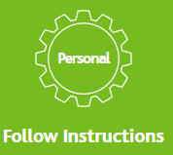 |    | 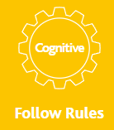 |  | 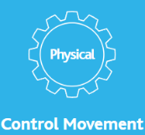 | 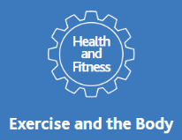
Y3 and 5 Swimming throughout the year


Curriculum Overview
 | Autumn 1 | Autumn 2 | Spring 1 | Spring 2 | Summer 1 | Summer 2
Early Years | Real PE  Unit 1  Follow Instructions  Coordination/Footwork (footwork/one legged balance)  Coaches | Real PE  Unit 2  Play with others  Dynamic Balance to Agility/ static balance (jumping and landing/ seated balance)  Coaches  Real Dance  Unit 1  Shapes Artistry  Partnering  Circles    Class Teacher | Real PE  Unit 3  Follow Rules  Dynamic Balance/ static balance (stance)  Coaches | Real PE  Unit 4  Observe and Copy  Coordination (Ball Skills) Counter Balance  Coaches | Real PE Unit 5  Move in Different Ways    Coordination (Sending and Receiving) Agility (Reaction/ response)  Coaches | Real PE Unit 6  Exercise and Good Health  Agility (Ball chasing)  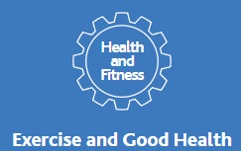  Static balance (Floor work)  Coaches
Year 1 | Real Gym  Unit 1  Stay on Task    Coaches | Real PE  Unit 2  Dynamic Balance to agility/ static balance.  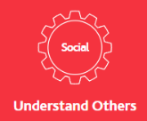  Understand Others  Coaches  Real Dance  Unit 1  Shapes Artistry  Partnering  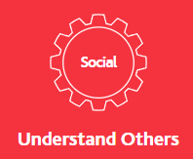  Circles  Class Teacher | Real PE Unit 3 Dynamic Balance Static Balance (stance)  Observe and Describe  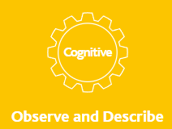  Coaches | Real PE Unit 4  Coordination (ball skills) Counter balance    Explore and describe.  Coaches | Real PE Unit 5  Coordination (sending/ receiving) Agility (reaction and response)  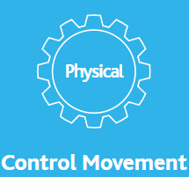  Control Movement  Coaches | Real PE Unit 6  Agility (ball chasing) Static balance (floor work)  Exercise and the Body  Coaches
Year 2 | Real PE  Coordination/Static Balance  Keep Trying  Coaches | Real PE  Unit 2  Dynamic Balance to agility (jumping/ landing static balance (seated balance)  Help and Encourage    Coaches  Real Dance  Unit 1  Shapes Artistry  Partnering  Circles  Class Teacher | Real PE Unit 3 Dynamic Balance Static Balance (stance)  Understand Performance  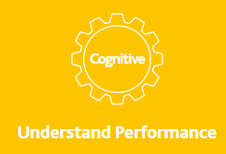  Coaches | Real PE Unit 4  Coordination (ball skills) counter balance  Link Movements    Coaches | Real PE Unit 5  Coordination (sending and receiving) Agility (reaction/response)  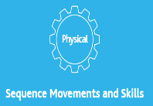  Sequence Movements and Skills  Coaches | Real PE Unit 6  Agility (ball chasing) Static balance (floor work)  Practise Safely  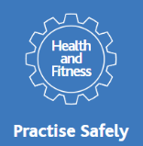  Coaches
Year 3 | Real PE  Coordination footwork/ static balance one leg.  Know when I am in my learning  Coaches | Real PE  Unit 2  Dynamic Balance to agility (jumper/landing) Static balance (seated balance)  Share Ideas    Coaches  Real Dance  Unit 1  Shapes Artistry  Partnering  Circles    Class Teacher | Real PE Unit 3 Dynamic Balance Coordination Ball Skills.  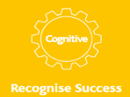  Recognise Success  Coaches | Real PE Unit 4  Coordination (sending and receiving) Counter balance    Respond differently  Coaches | Real PE Unit 5  Agility (reaction/response, static balance work  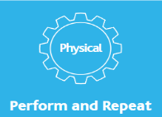  Perform and Repeat  Coaches | Real PE Unit 6  Agility (ball chasing) Static balance (stance)  Know how and why the body changes.    Coaches
 | Y3 Swimming throughout the year
Year 4 | Real PE  Coordination footwork/ static balance one leg.  Accept Challenge.  Coaches | Real PE  Unit 2  Dynamic Balance to agility (jumper/landing) Static balance (seated balance)  Support Others    Coaches  Real Dance  Unit 1  Shapes Artistry  Partnering  Circles  Class Teacher | Real PE Unit 3 Dynamic Balance Static Balance (stance)  Identify Areas to Improve  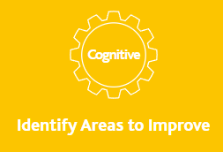  Coaches | Real PE Unit 4  Coordination (sending and receiving) counter balance.  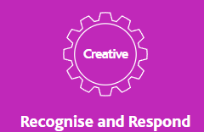  Recognise and Respond  Coaches | Real PE Unit 5  Agility (reaction/response) Static Balance (floor work)  Select and Apply    Coaches | Real PE Unit 6  Agility (ball chasing) Static Balance (stance)  Prepare for an Activity.  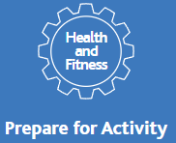  Coaches
Year 5 | Real PE  Coordination (Ball skills)  Agility (reaction/ response)  React positively to challenge  Coaches | Real PE  Unit 2  Dynamic Balance & counter balance  Provide Helpful Feedback    Coaches  Real Dance  Unit 1  Shapes Artistry  Partnering  Circles    Class Teacher | Real PE Unit 3 Static Balance (stance) Coordination (footwork)  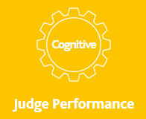  Judge Performance  Coaches | Real PE Unit 4  Static balance (seated balance) Static Balance (floor work)  Express Ideas    Coaches | Real PE Unit 5  Dynamic balance to agility (jumping/landing) Static balance (one leg balance)  Combining skills in specific contexts  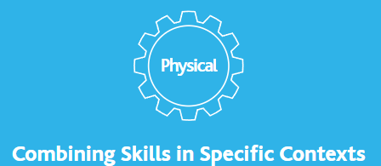  Coaches | Real PE Unit 6  Coordination (sending/ receiving) Agility (ball chasing)  Describe Basic Fitness Components  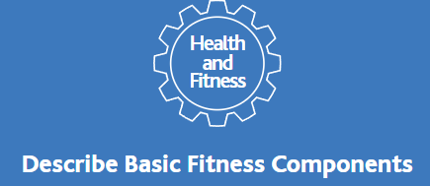  Coaches
 | Y5 Swimming throughout the year
Year 6 | Real PE  Coordination (Ball skills)  Agility (reaction/ response)  Consistently Try to improve  Coaches | Real PE  Unit 2  Dynamic Balance & counter balance  Organise and Guide Others.    Coaches  Real Dance  Unit 1  Shapes Artistry  Partnering  Circles  Class Teacher | Real PE Unit 3 Static Balance (stance) Coordination (footwork)    Make Good Decisions  Coaches | Real PE Unit 4  Static Balance (seated balance and footwork)    Adapt/Change Activities  Coaches | Real PE Unit 5  Dynamic Balance to agility (jumping and landing) Static balance ( one leg balance)  Links Actions to Flow  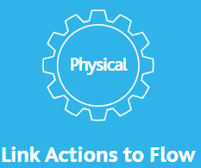  Coaches | Real PE Unit 6  Coordination( Sending and receiving) Agility (ball chasing)  Monitor Activity  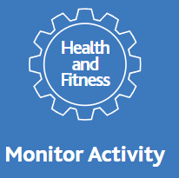  Coaches
-Learning Behavior = COG e.g. Personal (Follow Instructions)
- Fundamental Movement Skills e.g. Coordination

