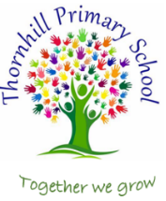

Thornhill Primary School
PSHE Progression of Knowledge
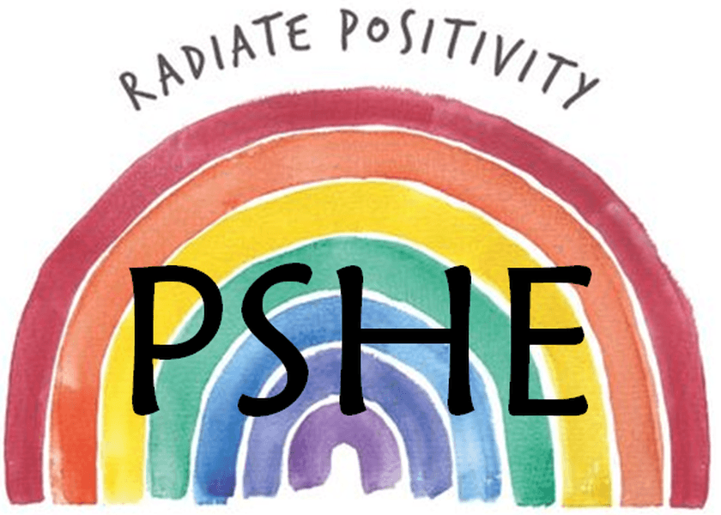
‘Education that prepares for life today, and tomorrow’ – PSHE Association
Intent
At Thornhill Primary School it is our intent to prepare our learners to be safe, happy and healthy members of the community. We aim to embed dispositions to support our children in becoming successful learners, responsible citizens and safe and happy individuals through developing the character skills of reciprocity, resilience, resourcefulness, reflectiveness and responsibility.
Our focus is to ensure that every pupil understands the importance of PSHE and that we create an open environment to discuss their own health and wellbeing with trusted adults and peers. Each half term, children will focus on a different key question linked to a core value which can be applied in the wider context.
Implementation
The teaching and implementation of PSHE at Thornhill Primary School is supported by the PSHE Association which sets out learning opportunities for each key stage. It is designed to accompany the 2026 edition of the Programme of Study for PSHE education, which covers all of Relationships, Sex and Health education (RSHE), including statutory content for Relationships and Health Education and recommended content for Sex Education, as well as essential learning on Economic Wellbeing and Careers Education. The Programme of Study sets out learning opportunities for each key stage. This scheme of learning is well planned across the primary phase which allows for progression and retention of key skills and knowledge and the introduction of some concepts at an age-appropriate point. PSHE education will be provided to all children within our school and will be taught on a weekly basis, with some content also being taught through other subject areas, and within other contexts, such as key stage assemblies, ‘circle time’ or ‘safe and happy assemblies’. In addition, we promote British Values through our spiritual, moral, social and cultural education which permeates through the curriculum offer and supports the development of the ‘whole child’.
Key Threads
Identity and belonging | Asking for help | Similarities and differences | Growth mindset | Teamwork | Self-esteem | Family, friends and relationships | Managing change
Curriculum Overview
 | Autumn 1 | Autumn 2 | Spring 1 | Spring 2 | Summer 1 | Summer 2
Early Years | Being safe in school | Friendship and Bullying | Foundations for wellbeing | Foundations for wellbeing | NSPCC: Talk PANTS | Dental Health
Year 1 | Making friends: playing and learning together | Mental health and wellbeing | Celebrating me, you and our families | Safety at home | Being healthy | Showing kindness to ourselves and others
Year 2 | Mental health and wellbeing | Keeping safe online | Me, my body and staying safe | Money and work | Safety outside the home | Looking back and moving on
Year 3 | Me, my friends and belonging | Mental health and wellbeing | Building healthy habits | Making choices online | Keeping safe out and about | Looking out for each other
Year 4 | Mental health and wellbeing | Exploring ways to manage risk | Forming respectful relationships | Money matters and news literacy | Me, my body and growing up | Families and growing together
Year 5 | Friendships, stereotypes and bullying | Mental health and wellbeing | Positively engaging with our world | Respecting boundaries | Safe connections online | Embedding healthy habits and learning first aid
Year 6 | Mental health and wellbeing | Managing money and online spending  Bank workshop (virtual) | Changes in puberty (and sex education) | Drug education: assessing risk and managing influences | Developing our AI literacy skills | Looking to the future
Progression of Knowledge and Skills
Please see supporting document PSHE Association Programme of Study for PSHE Education (Key stages 1–5), 2026.pdf.

