



Thornhill Primary School
Special Educational Needs and Disability Policy

Reviewed on |  | 2025/26, Term1 |  | Review frequency |  | Annual
Next review due |  | 2026/27, Term 1 |  | Template Yes / No |  | Yes
Owner |  | Dir of Ed, Primary |  | Approved by |  | Board of Trustees

History of Policy Changes

Date | Page | Change | Origin of Change
Sep 25 | All | References to Governing Body changed to Local Governing Committee (LGC) | Annual Review
Sep 25 | All | References to Headteacher changed to School Leader | Annual Review
Sep 25 |  | This review is ‘wholesale’ and the document should be reviewed in its entirety, before approval. | Annual Review

1. Introduction 3
2. Scope 3
3. Aims 3
4. Definitions 3
5. Roles and Responsibilities 4
6. Identification and Assessment of SEN 4
7. Reviewing 5
8. Link to other HET policies 6

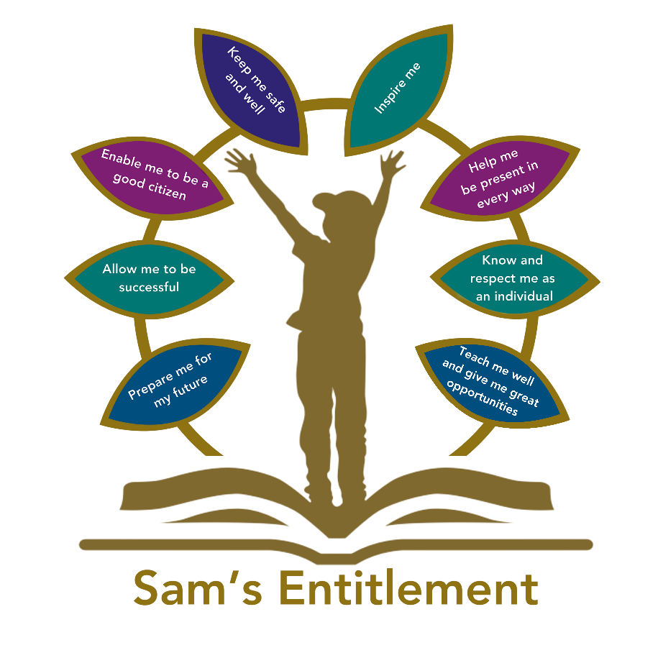

Introduction

Hamwic Education Trust (HET) believe that all pupils should receive a high quality, enriching, learning experience in a safe and inclusive environment, which promotes excellence through a broad curriculum that prepares them for their future and opens doors to a diverse array of opportunities as well as that all pupils and adults within HET flourish as individuals and together.

Scope

This policy is for all employees working within a HET school or establishment (which for ease of reference are referred to throughout this document as ‘schools’) or the HET Managed Service (MS) Team.

It does not apply to agency workers, consultants, self-employed contractors, volunteers or work experience students.

Aims

3.1 All academies within the Trust share common values and an ethos that that all our pupils receive a high-quality, enriching learning experience in a safe and inclusive environment. The SEND policy aims to strengthen and work with our communities to continue to ensure that all students receive their entitlement to a quality education, one that is appropriate to their individual needs, and promotes high standards and the fulfilment of potential. Our support for all children within our care extends to those children with additional needs that require assistance to help them fulfil their potential.

3.2 Each HET school shall ensure that:

- Pupils will not be labelled or disadvantaged by any policy or procedure operated within the Trust.
- It works in partnership with parents and appropriate external agencies to support students with special educational needs and will use its best endeavours to ensure that appropriate provision is secured for any pupil with special educational needs to achieve agreed outcomes.
- It has a Special Educational Needs Coordinator (SENCO). The SENCO will maintain and regularly review the SEN register held in respective of an individual pupil and coordinate support; however, it will be the responsibility of all staff to support individual pupils, to implement strategies suggested by the SENCO, and generally be responsible for ensuring that pupils receive provision appropriate to their needs and agreed outcomes.
- Children and young people with SEN engage in the activities of the school alongside pupils who do not have SEN

3.3 All support provided and decisions taken have regard to these general principles as well as the legal framework set out in the Children and Families Act 2014, the SEND Regulations 2014, and the SEND Code of Practice 2015.

As an inclusive setting, Thornhill Primary school is committed to:

- Providing all students, including those with special educational needs and disabilities (SEND), with equitable access to high-quality education regardless of their academic or physical ability, behaviour, gender, religious or ethnic background.
- Creating a safe, welcoming environment that fosters belonging, removes learning barriers, promotes diversity, and enables every student to achieve their full potential.
- Supporting all children by providing flexible and varied support appropriate to their individual needs, in a caring atmosphere where resilience, collaboration, adaptability and reflectiveness are fostered.
- Working in partnership with parents and external professionals to ensure that the needs of children with SEND are met.

At Thornhill Primary School, our school value of ‘together we will grow successful learners, responsible citizens and safe and happy individuals’ sits alongside our commitment to provide each child with opportunities and experiences which will enable them to achieve. We want every child to feel included in the life of our school and see the purpose of their attendance. Our inclusive educational experience is driven by the desire for children to have a love of learning and to foster the early stages of their engagement in lifelong learning.

Thornhill Primary School SEND provision is supported via a Graduated Approach. This means that provision for a child with a SEND is a continuum between whole class QFT at the one end and highly personalised 1:1 teaching at the other. All children have access to quality first teaching, but where a potential SEND has been identified, the approach to this child’s teaching and learning becomes increasingly personalised as understanding of the child and his/her need grows. Thus, support becomes more targeted as outlined below.

Stage 1 – Universal Provision.
- Well-differentiated, quality first teaching, including, where appropriate, the use of small group interventions
- A broad and balanced curriculum within an inclusive classroom
• Personalised learning targets
• Attention paid to different learning styles
• Carefully planned adaptive teaching, including practical, visual, concrete resources
• Modelling by adults within the classroom
• Curriculum assessment of progress to support target setting for pupils
• Assessment for learning and constructive feedback

Stage 2 – Early intervention support. These children will not be placed on the SEN register.
In addition to Stage 1:
• Support within class through small groups and individual support (e.g. cut away, workshops)
• Adaptation of the curriculum to meet individual learning needs
• Tools and resources to support access
• Use Inclusive teaching checklist as a quality assurance tool & evidence of high-quality teaching
• Wave 2 -Teacher/TA led Classroom based interventions from school menu

Stage 3 - Targeted Support: Additional SEN Support. These children will not be placed on the SEN register.
In addition to Stages 1 - 2:
• Investigation of strengths and needs
• Inclusion of parents and child as part of an Assess - Plan – Do – Review cycle of targeted assessment
• Targeted support within class through small groups and working individually with an adult
- Additional group or individual programmes to individual learning needs e.g. alternative methods of recording
- Tools and resources to support access
• Differentiation of the curriculum
• Evidence based interventions delivered individually or in small groups between 8-20 weeks, outside of the classroom from school menu
- Our children with an ND profile of presenting needs will have in class adjustments planned for and made by class teacher, with support from the school Autism Champion, in the first instance. This will involve following the school flowchart of support. These adjustments will be recorded through an ‘Individual Pupil Early Identification of Concerns’ sheet and will be co-produced with the child’s parents/carers. Support and provision will be reviewed every 6 weeks to ensure it is meeting the child’s needs.

Stage 4 - Targeted Intensive Additional Support: These children will be placed on the SEN register (K code).
In addition to Stages 1 – 3:
• Multi-professional planning and coordinated support may be in place e.g. E.P. Service, Outreach Services, Health colleagues, CAMHS.
• High levels of adult support and modelling to enable access to the curriculum
• Personalised resources e.g. workstation if appropriate
• Inclusion of parents/carers, child as part of a Plan-Do-Review cycle of targeted assessment and intervention
• Individual Education Plan reviewed at least termly
• Access to an adapted environment, if appropriate
• Individual modifications to the curriculum
• Use of individual provision checklist to evidence impact of provision Pupils will be offered targeted intensive SEN support when it is clear that their needs require intervention which is “additional to” or “different from” the well-differentiated curriculum offer for all pupils in the school i.e.: they have a special educational need as defined by the SEN Code of Practice 2014.
• In keeping with all vulnerable learners, intervention for pupils on the SEN list will be identified and tracked using the whole-school provision map and by the SENCo and subject leaders, as appropriate.

Stage 5 – SEN register, EHCP level or application in process.
It may be decided that a very small number of the pupils on the SEN list will require additional High Needs funding from the Local Authority Provision over and above that which would be expected at all other stages because pupil’s needs are exceptional, severe, complex and long term. Child will be on the school SEN register and will have an EHCP or application underway. Pupils with an Education Health and Care Plan will have access to all arrangements for pupils on the SEN list (above) and, in addition to this, will have an Interim or Annual Person-Centred Review of their plan.
• Where a pupil has a significant, severe and sustained need, it may be necessary to enter a multi-disciplinary assessment process with health and social care in order to consider the need for an Education Health and Care Plan.
• Where a pupil is in receipt of High Needs Funding and/or an Education Health and Care Plan, a short-term target IEP and timetable is created and will be reviewed through an Individual Education Plan (IEP) Review meeting (termly) and targets are set to key staff to work towards with the pupil.
• Personalised provision as identified in EHCP
• Multi-professional planning and coordinated support e.g., E.P. Service, Outreach Services, Health colleagues, CAMHS
• Outcomes broken down in to targets, long term targets broken down into short-term targets.
- Individual modifications to the curriculum
- Access to an adapted environment if appropriate
• Personalised curriculum if appropriate
• Our school will comply with all local arrangements and procedures when applying for:
- High Needs Block Funding
- An Education Health and Care Plan
- Transport and will ensure that all pre-requisites for application have been met through ambitious and proactive additional SEN Support using our devolved budget at an earlier stage.
• Our review procedures fully comply with those recommended in Section 6.15 of the Special Educational Needs Code of Practice and with local policy and guidance - particularly with regard to the timescales set out within the process.

Within each section of this continuum, a cycle of assessing, planning, doing, and reviewing is ongoing. This cycle can become more individualised as the child’s needs become more complex. The cycle is driven by the child’s needs. A few children with complex SEND will move through the graduated approach towards more specified individual support.

Definitions

4.1 Under the Children and Families Act 2014, a child/young person will have SEN if they have a learning difficulty or disability which calls for special educational provision to be made for them.

4.2 A child or young person will have a learning difficulty or disability if they have:

- A significantly greater difficulty in learning than the majority of others of the same age.
- A disability that prevents or hinders them from making use of facilities that are generally provided for others of the same age in mainstream schools in England.

4.3 Special educational provision is education or training that is additional to or different from that made generally for other children/young people of the same age by mainstream schools.

Roles and Responsibilities

5.1 The implementation of this policy will be monitored by the Board of Trustees and Local Governing Committees (LGC) and remain under constant review by Directors of Education for Primary and Secondary.

- Each School will appoint a Governor with responsibility for SEN. The SEN Governor will raise SEN issues at LGC meetings, monitor the quality and effectiveness of SEN provision within the School and work with designated senior leaders to develop the SEND policy and provision.
- The School Leader will work with the SENCO and SEN Governor to develop the SEN policy and provision within the school. The School Leader has overall responsibility for the provision and progress of learners with SEND.
- The SENCO will coordinate the School’s approach to SEND provision and will undertake those duties set out in chapter 6 of the SEND Code of Practice 2015.
- Class Teachers are responsible for the progress and development of every pupil in their class and will work with the SENCO and Teaching Assistants (TA) to ensure the “assess, plan, do, review” cycle is appropriately implemented to support any pupil with SEND.

5.2 The School will work in partnership with pupils, teachers, parents and, where appropriate, other external agencies to ensure that individual learning needs are addressed within the context of the school curriculum.

5.3 Parents of pupils with SEN will be able to discuss the needs of their child with their child’s teacher, the school SILSA (if the have a speech and language programme of support) or the SENCO.

Identification and Assessment of SEN

6.1 Information about previous special educational needs will usually accompany pupils upon entry to the School and this will be used by the SENCO to make sure appropriate provision is continued. Each school will adhere to HET’s Graduated response for SEND. This guidance ensures that the correct provision at each identification stage is made for pupils.
6.2 This information is collated from the transfer of school files from the previous school or Early Years setting and during transition meetings which are held with all the feeder schools or Early Years Settings in the summer term, before students start at the School. If necessary, a strategy sheet will be drawn up for each student with SEN.
6.4 The assessments taken by pupils on entry include baseline assessments on entry to Reception, ongoing termly assessments and weekly assessments as well as other assessment for learning (AFL) ongoing. This is all part of the APDR cycle.
6.5 Ongoing identification is also completed alongside the school reporting process as data is collected and analysed in all subject areas by [subject leads]. If a pupil has not made expected progress, teachers should consult the HET Graduated response for SEND and identify appropriate next steps. If a member of staff identifies a pupil whose special educational needs are not met by the normal adapted programme of study, then the class teacher will work with the pupil setting clear targets and providing greater adaptation. If the situation improves, then no further action is needed. If there is no improvement, the SENCO will be informed.
6.6 At this point, information will be gathered. The class teacher will inform the parents about the issue and there will be consultation and discussion around the proposed additional support for the pupil, parents and the pupil, where appropriate, will be involved in sharing information and agreeing outcomes. It will be decided whether it is appropriate to further monitor the pupil. An information and monitoring document will be drawn up by the SEN team, with copies shared with all staff concerned with the pupil’s progress.
6.7 If a parent/carer refers their child to the School as they believe their child has special educational needs, they should contact the SENCO, who will undertake investigations and appropriate assessments (with input from the relevant teachers) to see if they are achieving expected levels of progress. If the pupil is not achieving appropriate levels of progress, then internal support will be implemented in accordance with the paragraphs above.
6.8 In all cases, where internal support is not effective in supporting the pupil, in accordance with the HET Graduated response for SEND, school should make a referral to a relevant specialist (e.g. Educational Psychologist, speech therapy, occupational therapy) and will be completed with the parents’ knowledge, and information and strategies for support shared with all staff.
6.8 If there are no concerns regarding the pupil’s academic progress, then the School will ensure appropriate adaptation continues in the classroom and interventions are put in place if appropriate.
6.10 Contact details for professionals who are able to assess will be provided for parents/carers so they can consider a private assessment. Whenever special educational provision is being made, parents and pupils will be involved in developing and reviewing support plans/strategies.
6.11 All staff teaching pupils on the SEN register will be made aware of the individual needs. Directors of subject and the special needs team will help teachers, when required, to develop techniques to support differentiation and ensure that appropriate resources are available as part of the academy’s professional development programme.

Identification of children with special educational needs is carried in a number of ways. At Thornhill Primary School, we identify the needs of pupils by considering the needs of the whole child, which will include not just the Special Educational Needs of the child or young person. Through discussions with parents/ carers, we can quickly identify any special needs children already have and will tailor our educational package to suit their individual needs. The CoP states that class and subject teachers should seek to identify pupils making less than expected progress (CoP: 6.17) and that where this is the case the first response to a lack of progress should be high quality teaching targeted at their area of weakness.

Children are assessed regularly and parents are always informed of any concerns regarding their children. The school also responds to any concerns raised by parents as parents know their children best and it is important that all professionals listen and understand when parents’ express concerns about their child’s development (CoP: 6.20). The SENCo may carry out additional observations when SEN is identified, and outside agencies may also be involved to support the process of identification. Individual Education Plans (IEPs) are written and reviewed by the class teacher and SENCo as appropriate.

Children’s needs should be identified and met as early as possible through:
• The analysis of data including transition data, baseline scores, EYFS data and other whole-school pupil progress data
• Classroom-based assessment and monitoring arrangements (cycle of assessing, planning, action and review).
• Following up parental concerns
• Following up teachers concerns through the use of our initial SEN concerns sheet
• Tracking individual children’s progress over time
• Liaison with feeder nurseries/pre-schools on transfer
• Information from previous schools
• Information from other services
• Maintaining a provision map for all vulnerable learners but which clearly identifies pupils receiving additional SEN Support from the school’s devolved budget or in receipt of High Needs funding
• Undertaking, when necessary, a more in-depth individual assessment carefully chosen to deliver appropriate, useful information on a pupil’s needs. It may include a bilingual assessment where English is not the first language, where appropriate.
• Involving an external agency where it is suspected that a special educational need is significant to help us in our gathering information stage.

Reviewing

7.1 All pupils, regardless of needs, are set targets. Data collated during the School reporting process is analysed and strategies are put in place to support those that are not achieving as expected. All SEN interventions delivered outside the classroom have Specific, Measurable, Achievable, Relevant and Time-bound targets (SMART) set to ensure that progress is made. These are recorded using individual education plans (IEPs) and are monitored and reviewed against a timeframe agreed within the plan. If expected progress is not made, in accordance with the HET Graduated Response for SEND, the SENCO may refer to a specialist service such as an Educational Psychologist.

7.2 Where, despite the School having taken relevant and purposeful action as set out above to meet the pupil’s needs, they have not made expected progress, the School will consider requesting an Education, Health and Care needs assessment.
7.3 If a pupil has an Education, Health and Care Plan (EHCP), an annual review is held in accordance with legal requirements.
7.4 If, because of appropriate progress, a pupil is removed from the SEN register, the pupil will continue to be monitored through the school’s structured reporting programme by the SENCO team, and through the system of a monitor register.

Link to other HET policies

This policy should be read in conjunction with:

  - SEN information report (updated annually).
  - Equality, diversity and inclusion policy.
  - Accessibility plan.
  - Behaviour policy.
  - Supporting pupils with medical conditions policy.

Other policies and guidance.

  - HET Graduated Response for SEND
  - Intimate Care policy

