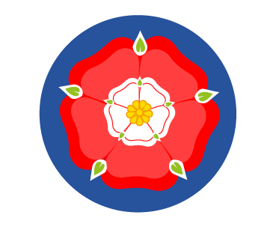
EYFS – Long Term Plan
Nursery/Reception
 | Autumn 1 | Aut 2 | Spr 1 | Spr 2 | Summer 1 | Summer 2
Theme | Colour | In a kingdom far, far, away | Amazing animals - Arctic | Come outside  Spring and Growth | Stories from other cultures | Fun at the seaside
English | The colour Monster  Little red Hen  Mixed | The Nutcracker  The kiss that missed  Paddington  Books re kings | Lost and found  How big is a million  Penguins in the fridge  Iris and Isaac | Jack and the beanstalk  Oliver’s vegetables | Handa Surprise  Madam Panya’s Pancakes  The Runaway Chapati  Gingerbread Man | Lighthouse keepers lunch  Snail and the whale  Alba the 100 year old fish
Maths  White Rose | Getting to know you  Just like me  Its me 1,2, 3!  Light and Dark |  | Alive in 5!  Growing 6, 7, 8!  Building 9 & 10! |  | To 20 and beyond.  First, then, now.  Find my pattern.  On the move.
Science | Signs of Autumn  Colours changing/seasonal Changes including weather  Baking bread (link to harvest)  Hibernation  Migration  Bird feeders | Materials to build a castle  Healthy eating and basic hygiene | Animals  Ice  Why do bears have fur?  Why are polar bears white? | Growing from seeds  Signs of spring, including weather  Butterflies  Lambing  Trip to the Farm | Food hygiene  Composting food  Ecology  Decay over time  Lottie Shaw visit - biscuits | Floating and sinking  Seasonal change – signs of summer including weather identifying trees in the school grounds from leaves
History | Our family - sequencing  How have I changed? | Royal Family  King Charles Birthday  Royal family and children family tree | Chinese New Year – link to years | Seasons – link to previous | Buildings around the world – how they have changed? Old/new buildings  Story links | Pirate theme – Grace O’Malley  Comparing seaside from the past to now
Geography | Mapping the school and knowing our way around  Know where we are  Location of the school field | Google Earth  Castles/ palaces/ etc | Comparison of arctic and non-arctic countries – comparison with the UK  Google earth  Overhead maps  Ecology – saving the world!! | Fieldwork - | Fruits from other countries  Map of locations | Coastal Maps – seasides from where we live.  Postcards from the seaside  Seaside visit – human/physical features link.
RE | Special stories and times  Diwali – link to light and science | Which people are special?  Who is special to me?  Jesus birth  Christmas Story  Nativity | Which places are special?  Chinese New Year  Link to special days for different cultures – link to Diwali | Lent, Easter  Pancakes  Which times are special and why?  Eggs | Where do we belong? | What is special about our world?
PSHE | Jigsaw PHSE  Being me in my world | Jigsaw PHSE  Celebrating Difference | Jigsaw PHSE  Dreams and Goals | Jigsaw PHSE  Relationships: | Jigsaw PHSE  Healthy me: | Jigsaw PHSE  Changing me:
Art & Design | Mixing colours | Printing | Textiles | Drawing & Texture | Printing  Fruit printing  Potato printing | Textiles
DT | Learn how to use a variety of tools | Design and make a palace | Create a boat – link to Lost and found | Design make and evaluate a musical instrument |  | Explore and understand food and where it comes from.  Teddy bears picnic
Music | Me! | My Stories  Nativity | Everyone! | Our World | Big Bear Funk – A transition unit | Reflect, rewind, replay!

