Thornton-in-Craven Community

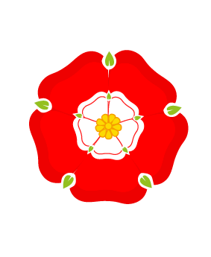

Primary and Nursery School

**History Long Term Plan (Geography in Green)**

|  |  |  |  |  |  |  |  |
| --- | --- | --- | --- | --- | --- | --- | --- |
|  | Y | **Autumn 1** | **Autumn 2** | **Spring 1** | **Spring 2** | **Summer 1** | **Summer 2** |
| **EYFS** | A | **Welcoming Others**  Invasion and immigration |  | **Toys**  Childhood |  | **Our village/school- Old and now buildings**  Settlements and civilizations |  |
|  | B | **Class/school rules**  **People who help us.**  Equality and Justice |  | **People who help us**  **Family tree/police**  Leadership |  | **Roots, shoots and muddy boots**  Agriculture |  |
| **Y1/2** | A | The United Kingdom | **The Fire of London**  Settlements and civilizations | Coasts | **Mary Anning**  Childhood | Children like you in Mugurameno Village, Zambia. | **Castles**  Invasion/immigration |
| B | Weather and seasons | **T-in-C School**  Leadership | Hot and cold places | **Walter Tull**  Justice and Equality | Urban or rural: Thornton School and its grounds | **T-in-C**  **How farming has changed.**  Agriculture |
| **Y3/4** | A | **The Anglo Saxons**  Childhood | Why do tourists and turtles love Florida? | **The Vikings**  **Invaders or settlers?**  Invasion and immigration | **Ancient Civilizations**  **The Shang**  Settlements and civilizations | Fair Trade | From Village to city-How had Bradford changed? |
| B | **Stone Age**  Agriculture | Why do some earthquakes cause more damage than others? | **Bronze Age and Iron Age** | Why are jungles so wet and deserts so dry? | **Roman Britain**  **Boudicca**  Leadership | How does tourism affect a village in the Yorkshire Dales? |
| **Y5/6** | A | **Victorian Childhood**  Childhood | How do volcanoes affect the lives of people? | **Early Islam**  Settlements and civilizations | Why are mountains so important? | **Black and British**  **Windrush**  Invasion and immigration | How does the River Aire change from source to mouth? |
| B | **Crime and Punishment**  **The Pendle Witches**  Justice and equality | Trade | **Ancient Greece- Athens and Sparta**  Leadership | How is climate change affecting the world? | **The Mayans**  **The end of a civilization**.  Agriculture | Why did the Leeds Liverpool Canal take 46 years to complete? |