PARENT WORKSHOPS

Delivered by the Childrens Learning Disability Team

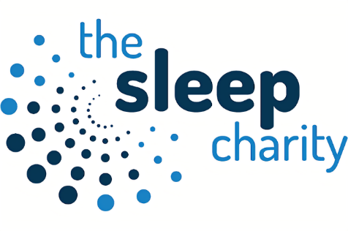
A national, award-winning charity empowering the nation to sleep better
Sleep workshop delivered by one of our practitioners who has received specialist training from the Sleep Charity. Workshops tailored to support parents with child/ren with a learning disability/SEN. 24th April 2023, 09:30 – 12:00
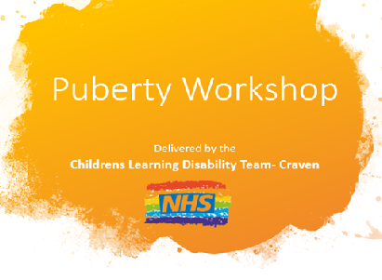
Puberty Parent Workshop
Workshop written and delivered by a specialist Learning Disability Nurse. Resources and strategies given to parents on how to support their child through Puberty. 15th May 2023, 09:30 – 12:00

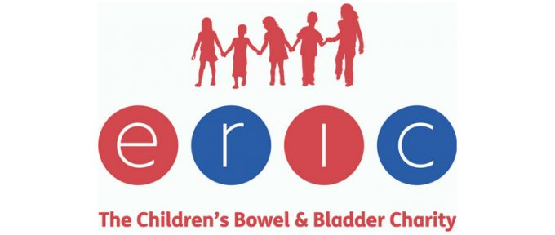
Toileting Workshop
Parent toileting workshop delivered by our specialist health care practitioners. Covering all things toileting/potty training. Workshops are tailored to children with a Learning Disability/SEN. 15th June 2023, 09:30 – 12:00
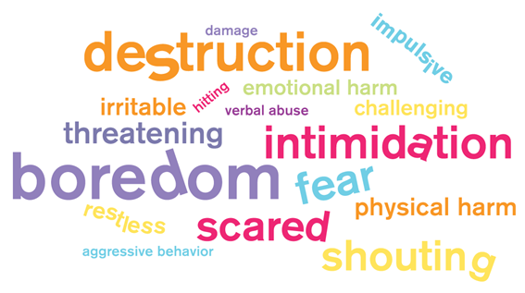
Introduction to Behaviour Workshop
Behaviour workshop delivered by our practitioners. Workshops tailored to support parents with child/ren with a learning disability/SEN. 10th July 2023, 09:30 – 12:00

All workshops are being held at SELFA Ings CP School, Broughton Road, Skipton, BD23 1TE.

