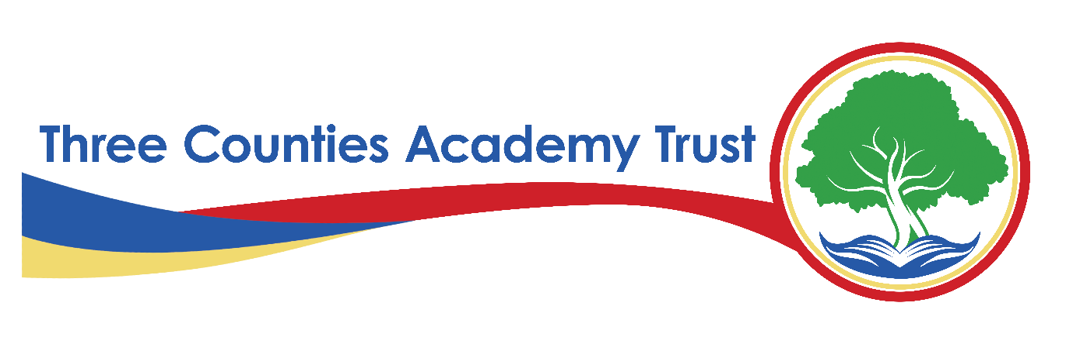
Privacy Statement – Pupil Data – FI12(A)
Three Counties Academy Trust (TCAT)
Effective Date: Academic year 2024-2025
Last Reviewed: February 6th, 2025
1. Introduction
Three Counties Academy Trust, commonly referred to as TCAT, is committed to protecting the privacy and security of personal data. This privacy statement explains how we collect, use, and share pupil data across all schools within TCAT in compliance with the UK General Data Protection Regulation (UK GDPR) and the Data Protection Act 2018.
TCAT is the Data Controller for the personal data held by our schools unless otherwise stated. Each school within TCAT follows this privacy statement to ensure consistency in data protection practices.
2. What Data We Collect
We collect, store, and process the following categories of pupil data:
- Personal Information – Name, date of birth, unique pupil number (UPN), gender, nationality
- Contact Information – Address, emergency contact details, parent/carer names, phone numbers, email addresses
- Educational Records – Attendance, assessment and exam results, progress reports, learning support records
- Special Educational Needs and Disabilities (SEND) Information – Details of additional learning needs and support provided
- Medical and Health Information – Allergies, medical conditions, medication, and care plans
- Safeguarding and Welfare Information – Child protection records, social services involvement, safeguarding referrals
- Behaviour and Exclusion Records – Behavioural incidents, detentions, exclusions
- Biometric Data (where applicable) – Fingerprint or facial recognition data for school meal payments or access systems
- Photographs and Videos – For identification, events, publicity, and school records (with consent where required)
- CCTV Footage – For security and safeguarding purposes
3. Why We Collect and Use Pupil Data
We process pupil data under the following lawful bases as defined under UK GDPR:
- Legal Obligation (Article 6(1)(c)) – To comply with education laws and safeguarding regulations
- Public Task (Article 6(1)(e)) – To carry out tasks in the public interest, such as delivering education and ensuring pupil welfare
- Legitimate Interests (Article 6(1)(f)) – Where processing is necessary for the Trust’s operations, balanced against pupil rights
- Consent (Article 6(1)(a)) – For specific activities such as marketing materials or event photography
- Vital Interests (Article 6(1)(d)) – Where necessary to protect someone’s life (e.g., in medical emergencies)
Additionally, we may process special category data (e.g., health, ethnicity, and SEND data) under Article 9(2)(b) and (g) UK GDPR, as processing is necessary for reasons of substantial public interest, safeguarding, or equality monitoring.
4. How We Use Pupil Data
We use pupil data for the following purposes:
- To support pupil learning and track academic progress
- To provide pastoral care and safeguard pupil welfare
- To manage school admissions and administration
- To comply with statutory obligations (e.g., reporting to the Department for Education)
- To monitor attendance and support behaviour management
- To administer school trips, extracurricular activities, and residential visits
- To assess the quality of our services and improve education provision
- To provide medical and special educational needs support
- To communicate with parents and carers regarding school matters
- To manage security through CCTV and biometric systems (where applicable)
5. How We Store and Protect Pupil Data
We take the security of pupil data seriously and implement the following measures:
- Physical Security – Secure storage of paper records in locked areas
- Technical Security – Encryption, password-protected systems, secure cloud storage
- Organisational Measures – Staff training, data protection policies, regular audits to ensure compliance
We only retain pupil data for as long as necessary in line with our Records Management Policy, which follows guidance from the Information and Records Management Society (IRMS) Schools Toolkit.
6. Who We Share Pupil Data With
We only share pupil data when it is lawful and necessary, including with:
- Department for Education (DfE) – To fulfil statutory reporting obligations
- Local Authorities – For admissions, safeguarding, and SEND support
- Exam Boards and Assessment Bodies – For registration and certification purposes
- Health and Social Care Services – For safeguarding and medical support
- Police and Law Enforcement Agencies – If required for crime prevention or safeguarding
- School Service Providers – Such as IT providers, catering services, and school trip organisers
- Educational Research Organisations – Where approved and compliant with data protection laws
All third parties we share data with must comply with strict data protection agreements.
7. International Data Transfers
We do not routinely transfer pupil data outside the UK. If we do, we ensure appropriate safeguards are in place, such as UK adequacy decisions or Standard Contractual Clauses (SCCs).
8. Pupil and Parent/Carer Rights
Under UK GDPR, pupils and their parents/carers have the following rights regarding personal data:
- Right to Be Informed – About how we use their data
- Right of Access – To request a copy of their personal data
- Right to Rectification – To correct inaccurate or incomplete data
- Right to Erasure ("Right to Be Forgotten") – In certain circumstances, to request data deletion
- Right to Restrict Processing – To limit how data is used
- Right to Data Portability – To request data in a transferable format (where applicable)
- Right to Object – To processing based on legitimate interests
- Rights Related to Automated Decision-Making – We do not use pupil data for automated decisions
To exercise any of these rights, please contact the Data Protection Officer (DPO) (details below).
9. Contact Details
For any questions about this privacy statement or to exercise your rights, please contact:
S Smith Information Governance Officer and Data Protection Officer
on behalf of Three Counties Academy Trust
Herefordshire Council, Plough Lane, Hereford, HR4 0LE
Email: samsmith@herefordshire.gov.uk
Tel: 01432 260282
If you have concerns about how your data is handled, you can also contact the Information Commissioner’s Office (ICO):
ICO Website: www.ico.org.uk
ICO Helpline: 0303 123 1113
10. Changes to This Privacy Statement
We may update this privacy statement from time to time. Any significant changes will be communicated via our website and school communications.

