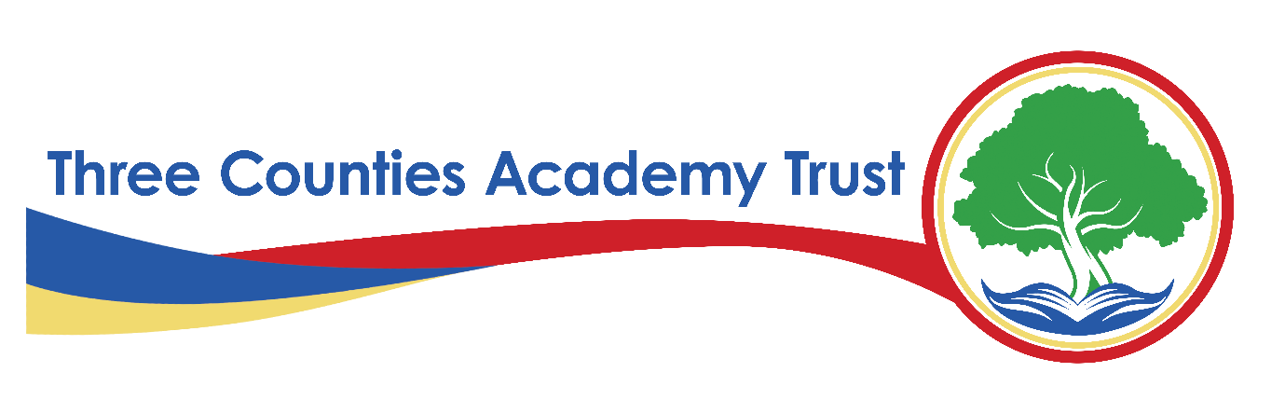
Privacy Statement – Parent/Carer Data – FI12(B)
Three Counties Academy Trust (TCAT)
Effective Date: Academic year 2024-2025
Last Reviewed: February 6th, 2025
1. Introduction
Three Counties Academy Trust, commonly referred to as TCAT, is committed to protecting the privacy and security of personal data. This privacy statement explains how we collect, use, and share parent/carer data across all schools within TCAT in compliance with the UK General Data Protection Regulation (UK GDPR) and the Data Protection Act 2018.
TCAT is the Data Controller for the personal data held by our schools unless otherwise stated. Each school within TCAT follows this privacy statement to ensure consistency in data protection practices.
2. What Data We Collect
We collect, store, and process the following categories of parent/carer data:
- Personal Information – Name, title, relationship to pupil, date of birth (if required), and gender
- Contact Information – Home address, email address, phone numbers
- Emergency Contact Details – Alternative emergency contacts provided by the parent/carer
- Parental Responsibility Information – Legal documentation regarding parental responsibility, custody arrangements, or court orders
- Financial Information – Bank details and payment records (e.g., for school meals, trips, and other services)
- Correspondence Records – Emails, letters, and records of communication with TCAT or our schools
- Safeguarding and Welfare Information – Where applicable, data related to child protection matters and involvement with social services
- Photographs and Video – For identification purposes, events, and safeguarding (with consent where required)
- CCTV Footage – If parents/carers visit TCAT schools where CCTV is in operation
3. Why We Collect and Use Parent/Carer Data
We process parent/carer data under the following lawful bases as defined under UK GDPR:
- Legal Obligation (Article 6(1)(c)) – To comply with legal and statutory duties, including safeguarding responsibilities
- Public Task (Article 6(1)(e)) – To carry out tasks in the public interest, such as managing pupil education and welfare
- Legitimate Interests (Article 6(1)(f)) – Where processing is necessary for the Trust’s operations, balanced against the individual’s rights
- Consent (Article 6(1)(a)) – For certain activities such as marketing communications or event photography
Additionally, if we process special category data (e.g., health-related safeguarding concerns), we rely on Article 9(2)(b) and (g) UK GDPR, as processing is necessary for reasons of substantial public interest or legal obligations.
4. How We Use Parent/Carer Data
We use parent/carer data for the following purposes:
- To communicate with parents/carers regarding pupil education, attendance, and behaviour
- To manage school admissions and pupil records
- To handle safeguarding and child protection matters
- To arrange and manage school trips, extracurricular activities, and events
- To process payments for school services, meals, and voluntary contributions
- To provide pastoral and welfare support for pupils
- To comply with legal and regulatory requirements
- To manage parental engagement and school improvement initiatives
- To ensure school security (e.g., visitor logs, CCTV monitoring)
5. How We Store and Protect Parent/Carer Data
We take the security of parent/carer data seriously and use the following measures to protect it:
- Physical Security – Secure storage of paper records in locked areas
- Technical Security – Encrypted databases, password-protected systems, and secure cloud storage
- Organisational Measures – Staff training, clear data policies, and regular audits to ensure compliance
We only retain parent/carer data for as long as necessary in line with our Records Management Policy, which follows guidance from the Information and Records Management Society (IRMS) Schools Toolkit.
6. Who We Share Parent/Carer Data With
We only share parent/carer data when necessary and lawful, including with:
- Department for Education (DfE) – To meet statutory reporting requirements
- Local Authorities – For school admissions, safeguarding, and SEND support
- Health and Social Care Services – Where required for safeguarding or welfare purposes
- Law Enforcement Agencies – If required for legal compliance or safeguarding concerns
- School Service Providers – Such as payment processors, IT providers, and communication platforms
- Educational Research Organisations – Where approved and compliant with data protection laws
All third parties we share data with must comply with strict data protection agreements.
7. International Data Transfers
We do not routinely transfer parent/carer data outside the UK. If we do, we ensure adequate safeguards are in place, such as UK adequacy decisions or Standard Contractual Clauses (SCCs).
8. Parent/Carer Rights
Under UK GDPR, parents and carers have the following rights regarding their personal data:
- Right to Be Informed – About how we use their data
- Right of Access – To request a copy of their personal data
- Right to Rectification – To correct inaccurate or incomplete data
- Right to Erasure ("Right to Be Forgotten") – In certain circumstances, to request data deletion
- Right to Restrict Processing – To limit how data is used
- Right to Data Portability – To request data in a transferable format (where applicable)
- Right to Object – To processing based on legitimate interests
- Rights Related to Automated Decision-Making – We do not use parent/carer data for automated decisions
To exercise any of these rights, please contact the Data Protection Officer (DPO) (details below).
9. Contact Details
For any questions about this privacy statement or to exercise your rights, please contact:
S Smith Information Governance Officer and Data Protection Officer
on behalf of Three Counties Academy Trust
Herefordshire Council, Plough Lane, Hereford, HR4 0LE
samsmith@herefordshire.gov.uk
Tel: 01432 260282
If you have concerns about how your data is handled, you can also contact the Information Commissioner’s Office (ICO):
ICO Website: www.ico.org.uk
ICO Helpline: 0303 123 1113
10. Changes to This Privacy Statement
We may update this privacy statement from time to time. Any significant changes will be communicated via our website and school communications.

