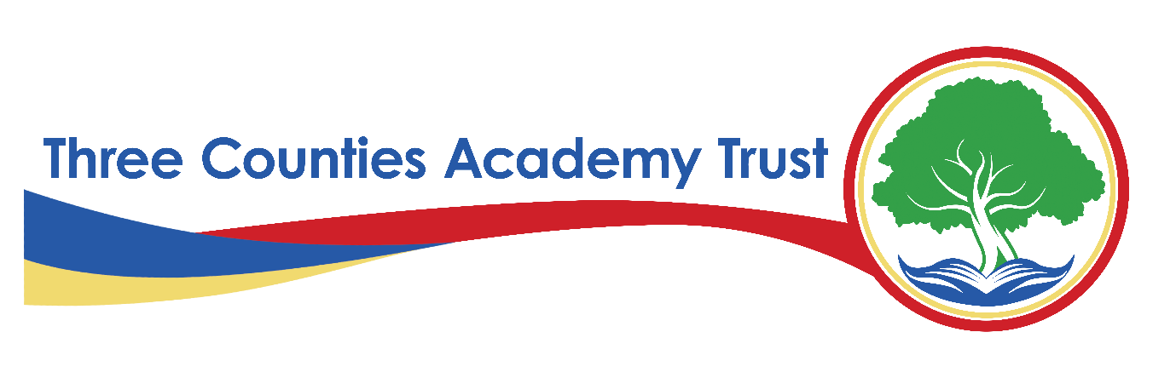
Privacy Statement – Volunteers and Visitors Data – FI12(D)
Three Counties Academy Trust (TCAT)
Effective Date: Academic year 2024-2025
Last Reviewed: February 6th, 2025
1. Introduction
Three Counties Academy Trust, commonly referred to as TCAT, is committed to protecting the privacy and security of personal data. This privacy statement explains how we collect, use, and share volunteers and visitors data across all schools within TCAT in compliance with the UK General Data Protection Regulation (UK GDPR) and the Data Protection Act 2018.
TCAT is the Data Controller for the personal data held by our schools unless otherwise stated. Each school within TCAT follows this privacy statement to ensure consistency in data protection practices.
2. What Data We Collect
We collect, store, and process the following categories of volunteers and visitors data:
- Personal Information – Name, title, date of birth (if required), and gender
- Contact Information – Home address, email address, phone numbers
- Identification Details – Employer details (if visiting on behalf of an organisation), professional credentials (if applicable)
- Visit Records – Purpose of visit, times of arrival and departure, location(s) visited within the school
- Emergency Contact Details – Next of kin and emergency contacts provided by the volunteer or visitor
- Safeguarding and Welfare Information – Disclosure and Barring Service (DBS) checks where required for roles involving pupils
- Medical and Health Information – Accessibility requirements, allergies, or medical conditions relevant to a visit or volunteering role
- Photographs and Videos – For identification, security, safeguarding, and event participation (with consent where required)
- CCTV Footage – If volunteers or visitors are present at TCAT schools where CCTV is in operation
3. Why We Collect and Use Volunteers and Visitors Data
We process volunteers and visitors data under the following lawful bases as defined under UK GDPR:
- Legal Obligation (Article 6(1)(c)) – To comply with health and safety, safeguarding, and legal requirements
- Public Task (Article 6(1)(e)) – To carry out tasks in the public interest, such as maintaining school security and safeguarding pupils
- Legitimate Interests (Article 6(1)(f)) – Where processing is necessary for the Trust’s operations, balanced against individual rights
- Consent (Article 6(1)(a)) – For specific activities such as marketing communications or event photography
- Vital Interests (Article 6(1)(d)) – Where necessary to protect someone’s life (e.g., in medical emergencies)
Additionally, we may process special category data (e.g., health, ethnicity, and SEND data) under Article 9(2)(b) and (g) UK GDPR, as processing is necessary for reasons of substantial public interest, safeguarding, or legal obligations.
4. How We Use Volunteers and Visitors Data
We use volunteers and visitors data for the following purposes:
- To comply with safeguarding and child protection responsibilities
- To process and verify DBS checks where applicable
- To ensure health and safety compliance
- To administer volunteer involvement in school activities, including training where required
- To respond to medical emergencies and ensure accessibility accommodations
- To maintain records for statutory reporting and compliance
- To manage security, including visitor logs, ID badges, and CCTV monitoring
- To communicate with volunteers regarding their roles and involvement in school activities
5. How We Store and Protect Volunteers and Visitors Data
We take the security of volunteers and visitors data seriously and implement the following measures:
- Physical Security – Secure storage of paper records in locked areas
- Technical Security – Encryption, password-protected systems, secure cloud storage
- Organisational Measures – Staff training, data protection policies, regular audits to ensure compliance
We only retain volunteers and visitors data for as long as necessary in line with our Records Management Policy, which follows guidance from the Information and Records Management Society (IRMS) Schools Toolkit.
6. Who We Share Volunteers and Visitors Data With
We only share volunteers and visitors data when it is lawful and necessary, including with:
- Department for Education (DfE) – To meet statutory reporting requirements
- Local Authorities – For safeguarding and regulatory purposes
- Health and Safety Executive (HSE) – If required for compliance with workplace and visitor safety regulations
- Disclosure and Barring Service (DBS) – Where required for safeguarding checks
- Law Enforcement Agencies – If required for legal compliance or safeguarding concerns
- School Service Providers – Such as security contractors and IT service providers
All third parties we share data with must comply with strict data protection agreements.
7. International Data Transfers
We do not routinely transfer volunteers and visitors data outside the UK. If we do, we ensure appropriate safeguards are in place, such as UK adequacy decisions or Standard Contractual Clauses (SCCs).
8. Volunteers and visitors Rights
Under UK GDPR, volunteers and visitors have the following rights regarding personal data:
- Right to Be Informed – About how we use their data
- Right of Access – To request a copy of their personal data
- Right to Rectification – To correct inaccurate or incomplete data
- Right to Erasure ("Right to Be Forgotten") – In certain circumstances, to request data deletion
- Right to Restrict Processing – To limit how data is used
- Right to Data Portability – To request data in a transferable format (where applicable)
- Right to Object – To processing based on legitimate interests
- Rights Related to Automated Decision-Making – We do not use volunteers and visitors data for automated decisions
To exercise any of these rights, please contact the Data Protection Officer (DPO) (details below).
9. Contact Details
For any questions about this privacy statement or to exercise your rights, please contact:
S Smith Information Governance Officer and Data Protection Officer
on behalf of Three Counties Academy Trust
Herefordshire Council, Plough Lane, Hereford, HR4 0LE
Email: samsmith@herefordshire.gov.uk
Tel: 01432 260282
If you have concerns about how your data is handled, you can also contact the Information Commissioner’s Office (ICO):
ICO Website: www.ico.org.uk
ICO Helpline: 0303 123 1113
10. Changes to This Privacy Statement
We may update this privacy statement from time to time. Any significant changes will be communicated via our website and school communications.

