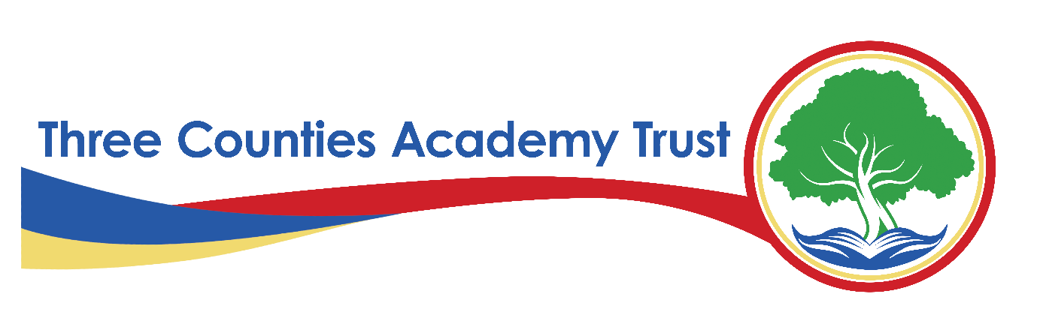
Privacy Statement – Members, Trustees and Local Governors Data – FI12(E)
Three Counties Academy Trust (TCAT)
Effective Date: Academic year 2024-2025
Last Reviewed: February 6th, 2025
1. Introduction
Three Counties Academy Trust, commonly referred to as TCAT, is committed to protecting the privacy and security of personal data. This privacy statement explains how we collect, use, and share Members, Trustees and Local Governors data across all schools within TCAT in compliance with the UK General Data Protection Regulation (UK GDPR) and the Data Protection Act 2018.
TCAT is the Data Controller for the personal data held by our schools unless otherwise stated. Each school within TCAT follows this privacy statement to ensure consistency in data protection practices.
2. What Data We Collect
We collect, store, and process the following categories of Members, Trustees and Local Governors data:
- Personal Information – Name, title, date of birth, and gender
- Contact Information – Home address, email address, phone numbers
- Identification and Governance Details – Role within TCAT, date of appointment, term of office, resignation date (if applicable)
- Employment and Professional Background – Occupation, qualifications, skills, and experience relevant to governance responsibilities
- Public Declarations – Register of interests, related party transactions, and conflicts of interest disclosures
- Financial Information – Bank details (if claiming expenses) and records of financial transactions
- Statutory Checks and References – Disclosure and Barring Service (DBS) checks, references, and right-to-work documents where applicable
- Correspondence and Meeting Records – Emails, letters, and minutes from governance meetings
- Safeguarding and Welfare Information – Where applicable, data related to safeguarding responsibilities
- Photographs and Video – For identification, governance records, school events, and promotional materials (with consent where required)
- CCTV Footage – If Members, Trustees, or Local Governors visit TCAT schools where CCTV is in operation
3. Why We Collect and Use Members, Trustees and Local Governors Data
We process Members, Trustees and Local Governors data under the following lawful bases as defined under UK GDPR:
- Legal Obligation (Article 6(1)(c)) – To comply with statutory governance, financial, and safeguarding duties
- Public Task (Article 6(1)(e)) – To carry out governance responsibilities in the public interest
- Legitimate Interests (Article 6(1)(f)) – Where processing is necessary for the Trust’s operations, balanced against individual rights
- Consent (Article 6(1)(a)) – For activities such as promotional materials and event photography
- Vital Interests (Article 6(1)(d)) – Where necessary to protect someone’s life (e.g., in medical emergencies)
Additionally, we may process special category data (e.g., health, ethnicity, and SEND data) under Article 9(2)(b) and (g) UK GDPR, as processing is necessary for reasons of substantial public interest, safeguarding, or legal obligations.
4. How We Use Members, Trustees and Local Governors Data
We use Members, Trustees and Local Governors data for the following purposes:
- To maintain statutory governance records and comply with legal requirements
- To manage trustee and governor appointments, terms of office, and resignation processes
- To process DBS checks and ensure compliance with safeguarding regulations
- To administer governance meetings, including invitations, minutes, and correspondence
- To maintain and publish the register of interests, related party transactions, and financial disclosures
- To comply with regulatory reporting requirements, including submissions to the Department for Education (DfE), Education and Skills Funding Agency (ESFA), and Companies House
- To provide training and development opportunities
- To facilitate effective communication between governance members, schools, and TCAT leadership
- To ensure health and safety compliance when visiting school sites
- To manage security, including visitor logs, ID badges, and CCTV monitoring
5. How We Store and Protect Members, Trustees and Local Governors Data
We take the security of Members, Trustees and Local Governors data seriously and implement the following measures:
- Physical Security – Secure storage of paper records in locked areas
- Technical Security – Encryption, password-protected systems, secure cloud storage
- Organisational Measures – Staff training, data protection policies, regular audits to ensure compliance
We only retain Members, Trustees and Local Governors data for as long as necessary in line with our Records Management Policy, which follows guidance from the Information and Records Management Society (IRMS) Schools Toolkit.
6. Who We Share Members, Trustees and Local Governors Data With
We only share Members, Trustees and Local Governors data when it is lawful and necessary, including with:
- Department for Education (DfE) – To meet statutory governance reporting requirements
- Education and Skills Funding Agency (ESFA) – For financial oversight and compliance with academy trust regulations
- Companies House – To register and update trustee and governance details where required
- Disclosure and Barring Service (DBS) – Where safeguarding checks are required
- Local Authorities – For governance support, safeguarding, and statutory duties
- Law Enforcement Agencies – If required for legal compliance or safeguarding concerns
- School Service Providers – Such as IT systems used for governance record-keeping and communication
- Public Registers and Websites – Where required by law, such as governance details published on the school and MAT websites
All third parties we share data with must comply with strict data protection agreements.
7. International Data Transfers
We do not routinely transfer Members, Trustees and Local Governors data outside the UK. If we do, we ensure appropriate safeguards are in place, such as UK adequacy decisions or Standard Contractual Clauses (SCCs).
8. Members, Trustees and Local Governors Rights
Under UK GDPR, Members, Trustees and Local Governors have the following rights regarding personal data:
- Right to Be Informed – About how we use their data
- Right of Access – To request a copy of their personal data
- Right to Rectification – To correct inaccurate or incomplete data
- Right to Erasure ("Right to Be Forgotten") – In certain circumstances, to request data deletion
- Right to Restrict Processing – To limit how data is used
- Right to Data Portability – To request data in a transferable format (where applicable)
- Right to Object – To processing based on legitimate interests
- Rights Related to Automated Decision-Making – We do not use Members, Trustees and Local Governors data for automated decisions
To exercise any of these rights, please contact the Data Protection Officer (DPO) (details below).
9. Contact Details
For any questions about this privacy statement or to exercise your rights, please contact:
S Smith Information Governance Officer and Data Protection Officer
on behalf of Three Counties Academy Trust
Herefordshire Council, Plough Lane, Hereford, HR4 0LE
Email: samsmith@herefordshire.gov.uk
Tel: 01432 260282
If you have concerns about how your data is handled, you can also contact the Information Commissioner’s Office (ICO):
ICO Website: www.ico.org.uk
ICO Helpline: 0303 123 1113
10. Changes to This Privacy Statement
We may update this privacy statement from time to time. Any significant changes will be communicated via our website and school communications.

