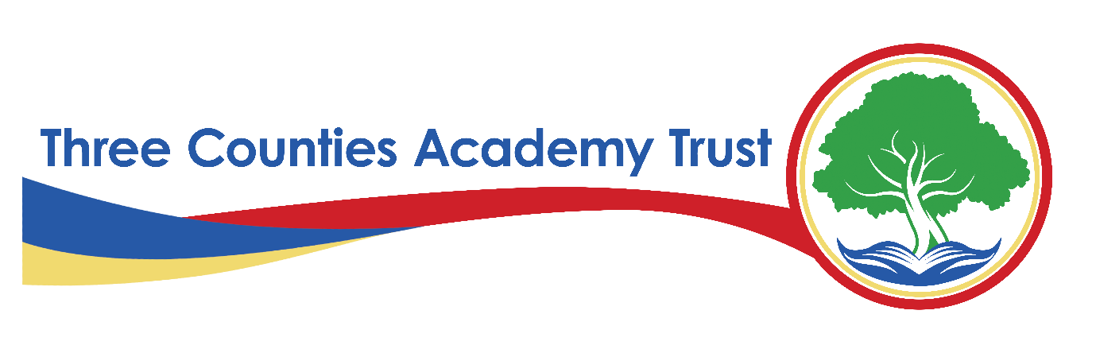
Privacy Statement – CCTV Data – FI12(H)
Three Counties Academy Trust (TCAT)
Effective Date: Academic year 2024-2025
Last Reviewed: February 6th, 2025
1. Introduction
Three Counties Academy Trust, commonly referred to as TCAT, is committed to protecting the privacy and security of personal data. This privacy statement explains how we collect, use, and share CCTV data across all schools within TCAT in compliance with the UK General Data Protection Regulation (UK GDPR) and the Data Protection Act 2018.
TCAT is the Data Controller for the personal data captured by CCTV systems unless otherwise stated. Each school within TCAT follows this privacy statement to ensure consistency in data protection practices.
2. What Data We Collect
We collect, store, and process the following categories of CCTV data:
- Video Footage – Recordings of individuals on school premises captured by CCTV cameras
- Still Images – Where extracted from CCTV footage for security or investigatory purposes
- Location Data – Information about where the footage was recorded within TCAT school sites
- Date and Time Stamps – To provide an accurate record of when the footage was captured
CCTV systems do not record audio unless explicitly stated in a designated area for security or safeguarding purposes.
We process CCTV data under the following lawful bases as defined under UK GDPR:
- Legal Obligation (Article 6(1)(c)) – To comply with safeguarding, security, and health and safety laws
- Public Task (Article 6(1)(e)) – To ensure the security of school premises and the safety of pupils, staff, and visitors
- Legitimate Interests (Article 6(1)(f)) – Where processing is necessary for crime prevention, investigation, and ensuring school security, balanced against individual rights
4. How We Use CCTV Data
We use CCTV data for the following purposes:
- To monitor and ensure the safety of pupils, staff, and visitors on school premises
- To prevent, investigate, and respond to security incidents, vandalism, and unauthorised access
- To assist in the detection, prevention, and investigation of crime
- To support the Trust’s safeguarding responsibilities
- To monitor compliance with health and safety regulations
- To provide evidence in disciplinary proceedings or legal matters where required
- To respond to requests from law enforcement agencies when necessary and lawful
5. How We Store and Protect CCTV Data
We take the security of CCTV data seriously and implement the following measures:
- Physical Security – Secure access to CCTV recording equipment and restricted access to viewing areas
- Technical Security – Encrypted storage, access controls, and secure networks
- Organisational Measures – Clear policies on access, retention, and authorised use of CCTV footage
CCTV recordings are retained for a maximum of 30 days, unless required for an ongoing investigation, legal matter, or safeguarding concern, in which case data may be retained for a longer period in accordance with legal and regulatory requirements.
6. Who We Share CCTV Data With
We only share CCTV data when it is lawful and necessary, including with:
- Law Enforcement Agencies – For the detection, investigation, and prevention of crime
- Local Authorities – Where required for safeguarding and security purposes
- Legal Representatives and Insurers – If needed for legal claims or investigations
- School Leadership and Safeguarding Teams – For the protection of pupils and staff in disciplinary or safeguarding matters
- Security and Facilities Management Providers – Where outsourced services are used for school security and site monitoring
All third parties we share data with must comply with strict data protection agreements.
7. International Data Transfers
We do not routinely transfer CCTV data outside the UK. If we do, we ensure appropriate safeguards are in place, such as UK adequacy decisions or Standard Contractual Clauses (SCCs).
8. CCTV Rights
Under UK GDPR, individuals whose images are captured on CCTV have the following rights regarding their personal data:
- Right to Be Informed – About how we use CCTV data
- Right of Access – To request a copy of footage containing their image (subject to exemptions for third-party privacy)
- Right to Rectification – To correct inaccurate data (not applicable to video recordings)
- Right to Erasure ("Right to Be Forgotten") – In certain circumstances, to request deletion of footage
- Right to Restrict Processing – To limit how CCTV footage is used
- Right to Object – To CCTV recording in certain circumstances (e.g., specific locations where privacy expectations are higher)
To exercise any of these rights, please contact the Data Protection Officer (DPO) (details below).
9. Contact Details
For any questions about this privacy statement or to exercise your rights, please contact:
S Smith Information Governance Officer and Data Protection Officer
on behalf of Three Counties Academy Trust
Herefordshire Council, Plough Lane, Hereford, HR4 0LE
Email: samsmith@herefordshire.gov.uk
Tel: 01432 260282
If you have concerns about how your data is handled, you can also contact the Information Commissioner’s Office (ICO):
ICO Website: www.ico.org.uk
ICO Helpline: 0303 123 1113
10. Changes to This Privacy Statement
We may update this privacy statement from time to time. Any significant changes will be communicated via our website and school communications.

