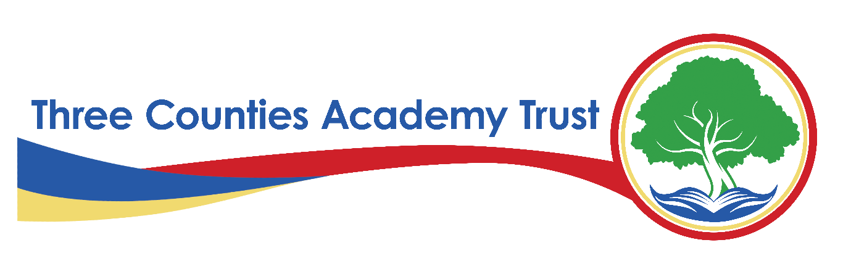
Privacy Statement – Website and Cookies Data – FI12(I)
Three Counties Academy Trust (TCAT)
Effective Date: Academic year 2024-2025
Last Reviewed: February 6th, 2025
1. Introduction
Three Counties Academy Trust, commonly referred to as TCAT, is committed to protecting the privacy and security of personal data. This privacy statement explains how we collect, use, and share website and cookies data across all TCAT-operated websites in compliance with the UK General Data Protection Regulation (UK GDPR), the Data Protection Act 2018, and the Privacy and Electronic Communications Regulations (PECR).
TCAT is the Data Controller for the personal data collected through its websites unless otherwise stated. Each school within TCAT follows this privacy statement to ensure consistency in data protection practices.
2. What Data We Collect
We collect, store, and process the following categories of website and cookies data:
- Personal Information (if provided) – Name, email address, phone number, and any details submitted via contact forms
- Technical Information – IP address, browser type and version, device type, operating system, and referral source
- Usage Data – Pages visited, time spent on the website, click interactions, and navigation paths
- Cookies and Tracking Technologies – Information stored in cookies to personalise content, improve website functionality
- Communication Preferences – Subscriptions to newsletters, alerts, or other communications
- Security and Fraud Prevention Data – Suspicious activity
3. Why We Collect and Use Website and Cookie Data
We process website and cookies data under the following lawful bases as defined under UK GDPR:
- Legitimate Interests (Article 6(1)(f)) – To improve website functionality, enhance security, and monitor user engagement, balanced against individual rights
- Consent (Article 6(1)(a)) – For cookies and analytics tracking that are not strictly necessary for website operation
- Legal Obligation (Article 6(1)(c)) – To comply with security and regulatory requirements
4. How We Use Website and Cookie Data
We use website and cookies data for the following purposes:
- To provide a secure and functional website experience
- To analyse website traffic and improve website content
- To track and manage cookie preferences in compliance with PECR
- To personalise user experiences based on previous visits and interactions
- To facilitate communication via online contact forms
- To prevent security threats and detect fraudulent activity
5. Cookies Policy
Cookies are small text files stored on a user’s device when they visit a website. TCAT uses the following types of cookies:
- Strictly Necessary Cookies – Essential for website operation (e.g., login authentication, security)
- Performance and Analytics Cookies – Used to track user interactions and improve website functionality
- Functional Cookies – Enhance user experience by remembering preferences
- Targeting and Advertising Cookies – Used for marketing and personalised content
Upon visiting TCAT websites, users are presented with a cookie consent banner allowing them to:
- View the cookie policy
6. How We Store and Protect Website and Cookie Data
We take the security of website and cookies data seriously and use the following measures to protect it:
- Encryption – Secure encryption for stored and transmitted data
- Access Controls – Restricted access to administrative and analytics tools
- Firewall and Security Monitoring – Continuous monitoring for potential threats
Cookies are retained for different periods depending on their type:
- Session Cookies – Deleted when the browser is closed
- Persistent Cookies – Stored for a period defined by the website (typically up to 12 months) unless manually deleted by the user
7. Who We Share Website and Cookie Data With
We only share website and cookies data when necessary and lawful, including with:
- Website Hosting and IT Providers – For maintaining and managing TCAT websites
- Analytics Providers – Such as Google Analytics, for website usage tracking
- Law Enforcement Agencies – If required for legal compliance or cybersecurity concerns
- Marketing and Communications Platforms – If users have opted in to receive updates
All third parties we share data with must comply with strict data protection agreements.
8. International Data Transfers
Some analytics and tracking tools may process data outside the UK. If this occurs, we ensure adequate safeguards, such as UK adequacy decisions or Standard Contractual Clauses (SCCs).
9. Website Users' Rights
Under UK GDPR, website users have the following rights regarding their personal data:
- Right to Be Informed – About how we use their data
- Right of Access – To request a copy of their personal data
- Right to Rectification – To correct inaccurate or incomplete data
- Right to Erasure ("Right to Be Forgotten") – In certain circumstances, to request data deletion
- Right to Restrict Processing – To limit how data is used
- Right to Data Portability – To request data in a transferable format (where applicable)
- Right to Object – To processing based on legitimate interests
- Right to Withdraw Consent – For cookie tracking and marketing communications
To exercise any of these rights, please contact the Data Protection Officer (DPO) (details below).
10. Contact Details
For any questions about this privacy statement or to exercise your rights, please contact:
S Smith Information Governance Officer and Data Protection Officer
on behalf of Three Counties Academy Trust
Herefordshire Council, Plough Lane, Hereford, HR4 0LE
Email: samsmith@herefordshire.gov.uk
Tel: 01432 260282
If you have concerns about how your data is handled, you can also contact the Information Commissioner’s Office (ICO):
ICO Website: www.ico.org.uk
ICO Helpline: 0303 123 1113
11. Changes to This Privacy Statement
We may update this privacy statement from time to time. Any significant changes will be communicated via our website and school communications.

