

Staff and Volunteer Confidentiality Policy
#HR32

Last updated: 25 July 2024
Review Date: 31 August 2027

Contents:
Statement of intent
- Legal framework
- Definitions
- Roles and responsibilities
- Confidentiality and child protection
- Sharing information
- Breaking confidentiality
- Responsible use of ICT and technology
- Management and security of records
- Maintaining confidentiality when staff leave
- Monitoring and review

Appendices
- Information Sharing Flowchart
- Staff Exit Procedure Checklist

Statement of intent
This document guides staff, volunteers and visitors on the policy and procedures surrounding confidentiality.
This policy will be adhered to at all times by staff, volunteers, visitors, pupils, and parents. In order to ensure the utmost level of safety for pupils, Three Counties Academy Trust (TCAT) staff members have a duty to act in accordance with this policy and not share information with external agencies, other schools, or individuals.
The Staff and Volunteer Confidentiality Policy has the following benefits:
- Ensures that important information regarding TCAT, or our schools is not shared
- Guarantees that financial information stays confidential and secure
- Helps to build trust amongst staff, volunteers, and external agencies
- Supports the TCAT’s safeguarding measures

Legal framework
This policy has due regard to all relevant legislation and guidance including, but not limited to, the following:
- Crime and Disorder Act 1998
- Equality Act 2010
- The UK General Data Protection Regulation (UK GDPR)
- Data Protection Act 2018
- Education Act 2002
- Human Rights Act 1998
- The Education (Pupil Information) (England) (Amendment) Regulations 2019
- DfE (2024) ‘Keeping children safe in education 2024’
- DfE (2018) ‘Information sharing’
- DfE (2023) ‘Working Together to Safeguard Children’

This policy is compliant under the following case law:
- The Common Law Duty of Confidentiality
This policy operates in conjunction with the following TCAT and school policies:
- Data Protection Policy
- Disciplinary Policy and Procedure
- Records Management Policy
- Child Protection and Safeguarding Policy and Procedures
- Anti-bullying Policy
- Freedom of Information Policy
- Whistleblowing Policy
- Online Safety Policy
- Allegations of Abuse Against Staff Policy

Definitions
For the purposes of this policy, “confidentiality” is an understanding that any information shared with someone in confidence will only be passed on to a third party with the prior and explicit agreement of the person disclosing it.
A “disclosure” is the sharing of any private information; this term does not solely relate to child protection issues.
The term “limited confidentiality” refers to the disclosure of information with professional colleagues; however, the confider would not be identified except in pre-determined circumstances.

Roles and responsibilities
The Executive Headteacher/CEO will:
- Ensure staff understand why they must agree to the regulations set out in this policy and the documents outlined in the legal framework
- Ensure that staff members sign confidentiality agreements
- Remain informed of any confidentiality, safeguarding or data protection concerns within each TCAT school by regular update from the Headteacher/Head of School
- Decide in collaboration with the Headteacher/Head of School on the appropriate disciplinary procedures that will be placed upon any staff member who is in breach of their confidentiality agreement or otherwise withholds, discloses, or shares confidential information without reason
- Ensure that this policy is kept up to date with all other documents, policies and statutory frameworks which operate in conjunction with this policy
The DPO will:
- Address all concerns relating to data protection
- Provide advice in the event of a data breach
- Understand all relevant legislation including the Data Protection Act 2018 and the UK GDPR
- Understand how to correctly withhold, store, move and share data
- Ensure that TCAT’s data is protected at all times and react quickly to any vulnerabilities
The DSL will:
- Understand the importance of information sharing with other schools/trusts, safeguarding partners, practitioners and any other relevant agencies or organisations
- Understand relevant data protection legislation and regulations with particular reference to the Data Protection Act 2018 and the UK GDPR
- Keep detailed, accurate, secure written records of concerns and referrals and understand the purpose of record-keeping
All staff members, volunteers and individuals working in cooperation with TCAT will:
- Uphold their responsibility and duty in relation to confidentiality
- Ensure that information and personal details are not shared or discussed with others, except for the appropriate necessary bodies
- Keep information regarding TCAT or an individual TCAT school, including its pupils and parents, confidential
- Understand and sign a confidentiality agreement and, where necessary, a responsible use of ICT agreement

Confidentiality and child protection
TCAT will always prioritise the welfare of its pupils and this will remain the primary concern when investigating an allegation which has been made against a member of staff and will always follow the procedures set out in the Allegations of Abuse Against Staff Policy.
A staff member who faces allegations relating to safeguarding concerns may find the investigation process extremely stressful. For this reason, TCAT will ensure that anyone who holds information relating to the investigation keeps said information confidential and that it will not ordinarily be shared with any other staff, pupils or parents who are not involved in the investigation.
The processes involved in maintaining confidentiality and carrying out an investigation will operate in line with The Education Act 2011, which made the publishing of any material illegal if it leads to the identification of a staff member in a school who has been subject to allegations by, or on behalf of, a pupil in the school.
TCAT will take steps to ensure that confidentiality is maintained against any unwanted publicity whilst an allegation is being investigated or considered; this will include ensuring that all staff who have access to files and data, or any other relevant form of information, sign a confidentiality agreement.
TCAT will ensure that the above restrictions on sharing information (including any speech, writing, or other communication which is exposed to any section of the public) are adhered to and will apply until:
- The accused person has been charged with a relevant offence
- The Secretary of State publishes information about an investigation or decision in a disciplinary case arising from the allegation
These restrictions will not be applied under the following circumstances:
- The individual who is being investigated waives their right to anonymity by going public on their own accord
- The individual being investigated provides written consent for another individual to publicly disclose the relevant confidential information
- A court lifts the reporting restrictions in response to a request to do so
Any individual, such as a parent or staff member, who discloses information to any section of the public, e.g., on a social networking site, will be in breach of the reporting restrictions if what they have disclosed could lead to the identification of the staff member by members of the public.
All external visitors will be made aware of this policy and act in accordance with it when dealing with information, particularly sensitive information, regarding TCAT or a TCAT school, its pupils, and parents.
The Headteacher/Head of School will be informed of all incidents regarding child protection concerns which are highlighted by a volunteer, parent, or another external party to the school and in turn alert the Executive Headteacher/CEO and Executive Leader for Safeguarding and Inclusion.
Staff members will immediately inform the DSL of any concerns regarding a pupil’s safety or welfare, and where necessary the LA designated officer. Any concerns raised over a child’s welfare and safety will be reported immediately to ensure that any intervention necessary to protect the child is accessed as early as possible.
Staff members will not be obliged to inform the police on most matters relating to illegal activity, such as illegal drugs or assaults. These will be assessed on a case-by-case basis with the support of the SLT and Executive Leaders.

Sharing information
TCAT will take the stance that all information about individual pupils is private and should only be shared with other professionals who have a legitimate need to know.
Under no circumstances will personal information about pupils, staff members, TCAT or an individual TCAT school be passed on indiscriminately.
Under no circumstances will information regarding the TCAT’s finances be shared with anyone, other than those with a legitimate need to know.
If members of staff, volunteers or cooperating external parties share unsuitable or misrepresented information, TCAT holds the right to take the appropriate civil, legal, or disciplinary action.
All staff and volunteers will report safeguarding concerns to the DSL as soon as possible and in an appropriate setting in line with policy.
All data will be processed and held in line with TCAT’s Data Protection Policy. In the event of information and data being shared with external or inappropriate parties, the situation will be dealt with in accordance with the Data Protection Policy.
The DSL will recognise and assure staff members with concerns about a safeguarding issue that the Data Protection Act 2018 and the UK GDPR do not prevent the sharing of information for the purposes of keeping children safe and promoting their welfare.
Staff members who manage or have access to TCAT’s data will always uphold our obligation to process personal information fairly and lawfully and keep the information they hold safe and secure.
TCAT will be open and honest with all individuals about how and why data is shared unless it is unsafe to do so.
Only information that is necessary for the purpose it is being shared for will be shared.
All decisions and reasons for sharing data will be recorded by the DPO.

Breaking confidentiality
When confidentiality must be broken because a child may be at risk of harm, in accordance with TCAT’s Child Protection and Safeguarding Policy and Procedures, we will ensure the following:
- Pupils will be told when information has been passed on
- Pupils will be kept informed about what will be done with their information
- To alleviate their fears concerning the information becoming common knowledge, pupils will be told exactly who their information has been passed on to
If confidential information is shared with the explicit consent of the individuals involved, and they are informed of the purpose of sharing the information in question, there will be no breach of confidentiality or of the Human Rights Act 1998.
In the event that explicit consent for sharing confidential information is not gained, an individual will satisfy themselves that there are reasonable grounds to override the duty of confidentiality in these circumstances before sharing the data.
TCAT will recognise that overriding public interest is a justifiable reason to disclose information; however, permission from the Executive Headteacher/CEO will be sought prior to disclosing any information regarding a TCAT school.
Staff will act in accordance with the TCAT’s Whistleblowing Policy at all times.
Staff in breach of this policy may face disciplinary action if it is deemed that confidential information was passed on to a third party without reasonable cause.

Responsible use of ICT and technology
Every member of staff will adhere to TCAT’s ICT Acceptable Use Policy at all times.
All staff, with particular reference to ICT technicians and staff members with access to wider files and data, will understand their obligation to use ICT systems in a responsible way and respect others’ privacy and confidentiality.
Staff will understand that their use of ICT systems, email and other digital communications will be monitored and the staff responsible for monitoring such activities will not share any confidential information unless this is for the purposes of keeping children safe or any other legal complication.
Staff will never disclose their password to anyone, nor will they attempt to use another individual’s account details.
All staff will immediately report illegal, inappropriate, or harmful material seen on another individual’s network to the Headteacher/Head of School.
Anyone found accessing, copying, removing, or altering any other user’s files without permission will face appropriate disciplinary measures.
Communication with pupils and parents will only take place through official TCAT school systems.
The Executive Headteacher/CEO and DPO will be informed immediately in the event of a data breach on any TCAT device.
The use of any programmes or software that attempts to bypass filtering or security systems in place throughout TCAT is strictly prohibited.
As outlined in TCAT’s Data Protection Policy, all staff members will understand that any staff or pupil data, which they have access to, will be kept private and confidential unless the sharing of information is deemed necessary as outlined above.

Management and security of records
In line with TCAT’s Records Management Policy, any staff member who is responsible for or has access to files, documents, or data within TCAT’s ICT infrastructure, database or other, is contractually obliged to maintain the security and management of such records which relate to:
- Pupils
- School management
- Finances
- Personal details of pupils or staff
- Information regarding progress and attainment which is not published on the TCAT or school websites

Maintaining confidentiality when staff leave
TCAT expects the departing staff member to respect and maintain any confidential information once they have left TCAT’s employment, as per the privacy and confidentiality terms within their contract of employment.
We will not share any information that we hold on the departing staff member, unless we have an obligation to do so or we have obtained consent – this will be detailed in a privacy notice, which will be available on the individual TCAT school’s website.
Where necessary, for example in the case of highly sensitive information, a settlement agreement will be established to ensure confidentiality – the departing staff member and Executive Headteacher/CEO will agree and sign this agreement.
All data that TCAT retains on the departing staff member will be stored in accordance with the Data Protection Policy and Records Management Policy.
Where consent was used to obtain information and the departing employee wishes to withdraw consent, they will express this to the DPO in writing.
Where the departing staff member had access to any password protected sensitive data, e.g., bank accounts, the passwords will be changed upon their departure by the Chief Finance Officer (CFO).

Monitoring and review
This policy will be reviewed in line with the published schedule at the front of this document and at any point material changes require it by the Executive Headteacher/CEO in conjunction with the Executive Team and Headteacher/|Heads of School and the Trust Board. Any changes made to the policy will be amended by the Executive Headteacher/CEO and will be communicated to all members of staff.
The next scheduled review date for this policy is 31st August 2027.

Signed by:
 | Executive Headteacher/CEO | Date:
 | Chair of the Trust Board | Date:

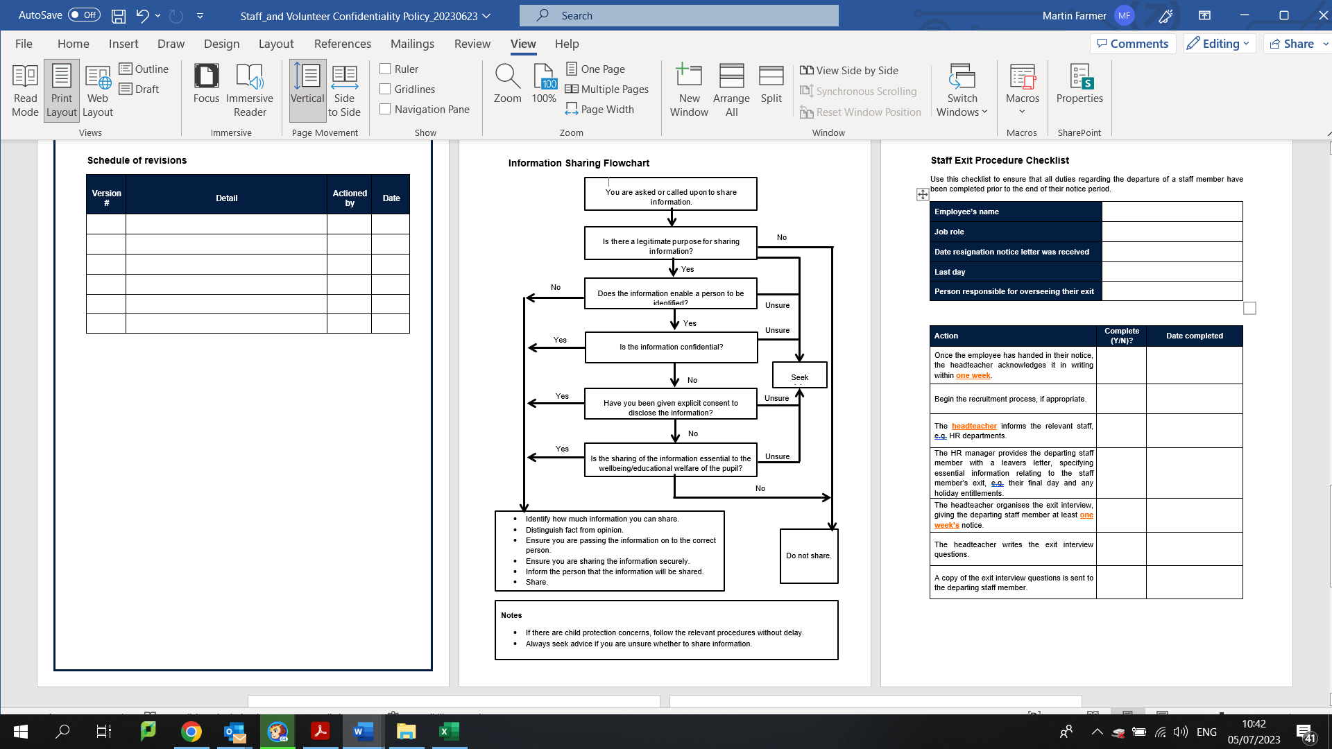

Staff Exit Procedure Checklist
Use this checklist to ensure that all duties regarding the departure of a staff member have been completed prior to the end of their notice period.
Employee’s name
TCAT school
Job role
Date resignation notice letter was received
Last day
Person responsible for overseeing their exit

Action | Complete (Y/N)? | Date completed
Once the employee has handed in their notice, the Headteacher/Head of School acknowledges it in writing within one week.
Begin the recruitment process, if appropriate.
The CFO informs the relevant staff, e.g., HR departments.
The CFO provides the departing staff member with a leavers letter, specifying essential information relating to the staff member’s exit, e.g., their final day and any holiday entitlements.
The Headteacher/Head of School for teaching staff or CFO for Associate Staff organises the exit interview, giving the departing staff member at least one week’s notice.
The Headteacher/Head of School for teaching staff or CFO for Associate Staff writes the exit interview questions.
A copy of the exit interview questions is sent to the departing staff member.

If the departing staff member declines the interview, they are asked to complete the questions as a questionnaire and send it back to the CFO.
A handover period is established, if necessary.
The CFO and DPO establish what information we need to keep pertaining to the departing staff member, and who is informed of this.
The CFO ensures the ICT Technician terminates the departing staff member’s accounts and obtains any TCAT-owned equipment.
The CFO manager ensures business continuity by:
- Removing the departing staff member from the website and any contact lists
- Delegating the departing staff member’s duties until a replacement is found
- Ensuring any repayments are made to either party, e.g., travel expenses
The CFO arranges for someone to fulfil any additional roles that the departing staff member has, e.g., fire safety officer or first aider.
The CFO establishes a system for incoming emails to the departing staff member’s account, e.g., forwarded to another staff member automatically.
HR systems are updated, e.g., payroll.
Colleagues and the school community are informed of the staff member’s departure, adhering to confidentiality issues.
The exit interview is held in the final week of the departing staff member’s final day.
The Headteacher/Head of School for teaching staff or CFO for Associate Staff makes arrangements to handle issues raised from the exit interview and informs the Executive Headteacher/CEO of any outcomes.
Where the departing staff member had access to password protected sensitive data, e.g., bank accounts, the CFO changes the passwords upon their departure.
Where necessary, an information settlement agreement is established.

