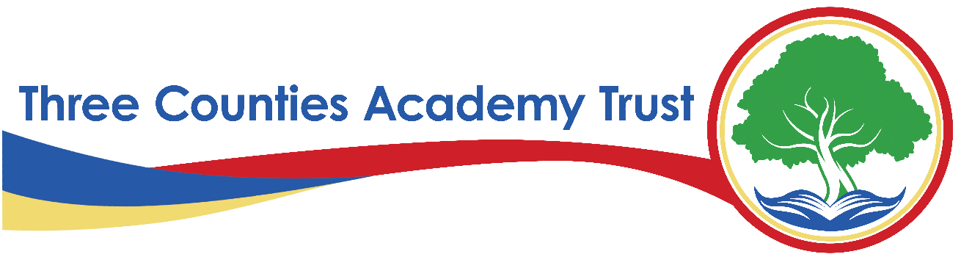
Social Media Policy
#SG24

Last amended 12th November 2025
To be reviewed no later than June 30th 2029

Statement of intent
Three Counties Academy Trust (TCAT) and our schools understand that social media is a growing part of life. We have a responsibility to safeguard our pupils against potential dangers when accessing the internet at school, and to educate our pupils about how to protect themselves online when outside of school.
We are committed to:
- Encouraging the responsible use of social media by all staff, parents, and pupils in support of TCAT and our mission, values, and objectives
- Protecting our pupils from the dangers of social media
- Preventing and avoiding damage to the reputation of TCAT and our schools through irresponsible use of social media
- Protecting our staff from cyberbullying and potentially career damaging behaviour
- Arranging online safety meetings for parents
To that effect, we subscribe to and use the Social Media Policy (HR015) as set out by our HR partners Hoople and used across the county of Herefordshire. The latest version of this policy will be the version used if and when need arises.
The latest (HR015) Social Media Policy can be obtained on request from the TCAT Central Team or from the Headteacher/Head of School and is the full and unabridged version as ratified by Hoople and adopted by the TCAT Trust Board.
Please note, where Hoople can at times have not ratified a new version of a policy before their planned review date, we will always use the latest version available, even where that may fall outside date scope until Hoople have approved a replacement.

