The 3 I’s | Modern Foreign Languages (MFL) - Spanish
INTENT  (What we want pupils to learn and why – curriculum design – how and why it is sequenced the way it is) | Aims: what big ideas do we want OUR pupils to come out with from this subject. | Our Spanish curriculum aims to instil a love of language learning and an awareness of other cultures. We want pupils to develop the confidence to communicate in Spanish for practical purposes, using both written and spoken Spanish.  We aim to give pupils a foundation for language learning that encourages and enables them to apply their skills to other language facilities further language study and opens future opportunities to study and work abroad.
 | Organisation of curriculum and sequencing: | - Content of the National curriculum (using Kapow).  - 2-year cycle (A&B). LTPS follow a mixed year group curriculum (KS2 only) and have been mapped out to build on previously taught skills.  - 1 unit every half term (taught weekly).  - Spiral curriculum, with key skills, grammar and vocabulary revisited with increasing complexity.  - Units are cumulative and enable teachers to reflect back to previous learning of skills:  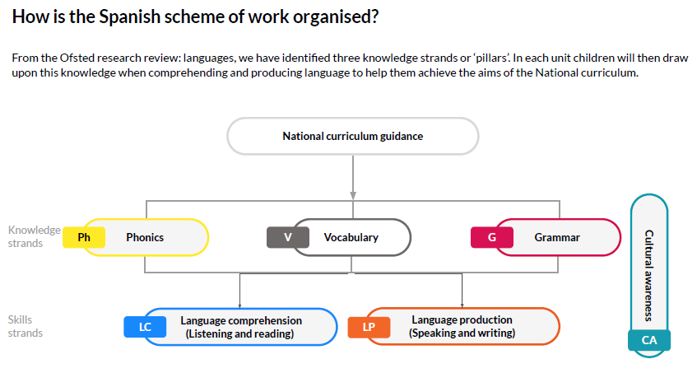  We use four building blocks of a language system:  - Phonics (explicit teaching of critical phonemes - both pronunciation and the sound-spelling link)  - Vocabulary (introduces the most commonly used words, especially simple and common verbs)  - Grammar (basic structures are taught before more complex across speaking, writing, reading and listening)  - Oracy (allows pupils to express and articulate themselves effectively across various contexts)  Pupils connect these building blocks to develop their skills in the following strands:  - Language comprehension: listening and reading  - Language production: speaking and writing  - Teachers are expected to sequence lessons to ensure pupils’ prior knowledge is built upon using Kapow as the primary source of support.  - Teachers are expected to use Kapow to access good quality units of work which show progression across the key stages.  - KAPOW scheme focuses on ‘language detective skills’ and understanding of Spanish grammar rather than memorising Spanish vocabulary.  - Teaching of Spanish Culture  - (1) Declarative (knowledge of what something is)  - Recognise learnt vocabulary when listening or reading.  - Spot cognates (words which have the same origin or are similar) and near-cognates.  - Discovering the geography of Spain and South America.  - Understanding key festivals and celebrations.  -Consider the legacy of ancient civilisations e.g. the Maya.  2) Procedural - knowledge of how to do something) is explicitly planned for in each unit of work  - Consider word order to anticipate the meaning of words.  - Use context and their own knowledge of the world to predict the meaning of unknown words.  - Appreciate traditional games, songs and dance.  - Comparing mealtimes and typical food.  - Examine the impact of global issues such as climate change.
IMPLEMENTATION  (How the curriculum - inc. cultural capital - is taught and assessed so our children develop knowledge, skills, understanding & SHINE) | Teaching & adapting to learners needs: | - Gaps are identified through end of unit assessments, enquiries, assessment for learning in lessons and outcomes of retrieval practice AND planned learning adapted to address misconceptions / gaps  - Intervention can simply be adapted questions, scaffolds, additional/less instructions  - Everyone in KS2 has access to the Spanish curriculum at the same pace.  - Support is provided for those learners who require it (also see “removing barriers” in Spanish policy).  - Considerations are given for learners who grasp concepts more rapidly- questions and tasks are used to deepen learning  - ‘Sound files’ and sound guides to support pronunciation.
 | What, How and When we assess learning | Teachers are expected to use key vocabulary, low stake quizzes and other retrieval practice techniques during lessons- in order to assess.
 | How and when we make links to other subjects: | Children will be able to make links and comparisons to other subjects taught in the English National Curriculum such as:  - Maths (numbers, dates, shapes)  - Geography (weather)  - History (Ancient Maya)  - RE (Spanish celebrations)
 | Cultural capital – visit / visitors / clubs | Food tasting.
IMPACT  (Key impact and how we will measure and monitor) | Monitoring and evaluating outcomes | - Year 3/4: By the end of Year 4, pupils should be confident in recognising and using basic Spanish vocabulary such as: greetings, numbers, shapes and colours (speaking and reading).  - Year 5/6: By the end of Year 6, pupils can use the “language detective skills” (as above) strategies to confidently grapple with unknown spoken and written language and search for meaning. Through these skills, pupils will gain a strong foundation for further language learning.  - Pupil and staff voice tells us what is working well- sent out via an annual online questionnaire.  - Floor-book looks  - Standards data - OTRACK

