CYCLE: A
SUBJECT:  ART | Autumn | Spring | Summer
KS1 | Drawing: Make Your Mark  Cross-hatch  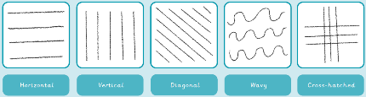  Drawing lines crossed over and close together.  Horizontal  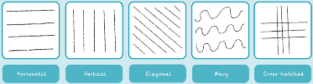  Flat or level with the ground and not at an angle to it.  Line  A mark on a surface can be different lengths, widths and create shapes.  Vertical  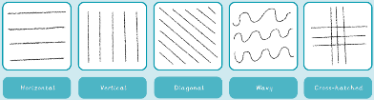  Pointing straight up at a 90 degree angle from a horizontal base.  Observe  To look at something carefully.  Texture  A surface quality that is not flat. | Sculpture and 3D: Paper Play  sculpture  Art in three dimensions; walk all around it to look at it.  three-dimensional  A solid shape; art that isn't flat on paper.  3D Display alongside this vocabulary  cylinder  A tube shape.  concertina  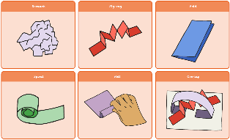  Folding something backwards and forwards so it becomes smaller but can be stretched out again.  overlap  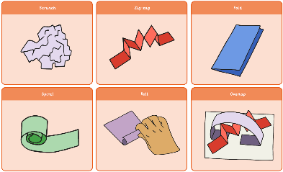  If two objects overlap, then one covers part of the other.  spiral  A shape made up of curves.  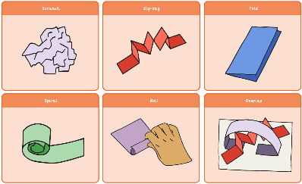 | Sculpture and 3D: Clay Houses  impress- pushing objects into a clay surface to make interesting marks.  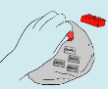  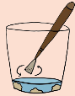  clay slip- A runny mixture of clay and water a bit like clay ‘glue’.  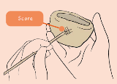  score- marking hatched lines into the clay surface.  sculpture  Art in three dimensions; walk all around it to look at it.  surface  The top layer of something.
LKS 2 | Sculpture and 3D: Abstract Shape and Space  sculpture  Art in three dimensions; walk all around it to look at it.  structure  Parts arrange in a particular way, like a cardboard model.  abstract  Art where the subject doesn't necessarily look like it does in real life.  negative space  The space around and between objects, e.g. the background.  positive space  The subject or areas of interest in an artwork, e.g. a figure in a portrait. | Drawing: Growing Artists  even tones  Smooth pressure when shading.  grip  Holding onto something tightly.  shading  Drawn marks to show areas of light and dark.  tone  How light and dark something is.  frottage  The technique of taking a rubbing from textured surfaces to form the basis of a work of art.  abstract  Art where the subject doesn't necessarily look like it does in real life. | Drawing: Power Prints  observational drawing  Looking carefully at something, drawing what is seen.  shading  A drawing technique that uses different levels of darkness to make objects look three-dimensional.  shadow  A shadow is a dark shape that appears when something blocks the light.  charcoal  A black material made from burned wood, used to create dark, smudgy lines or shades in drawings.  cross-hatching  Drawing lines crossed over and close together.  hatching  Drawing lines repeatedly and close together.
UKS2 | Drawing: I Need Space  collagraph  A printmaking process that uses textures to create interesting surfaces within a print.  culture  Everything that everyday people are interested in or are talking about.  evaluate  Deciding if something has been done in the best way and looking at what could be improved. | Painting and Mixed Media: Portraits  evaluate  Deciding if something has been done in the best way and looking at what could be improved.  justify  Giving a good reason for something that has been done.  atmosphere  The mood of an artwork, for example, mysterious or joyful.  photomontage  A collage of photographs that are arranged or modified.  mixed media  Art made from a combination of different materials. | Drawing: Make My Voice Heard  commissioned  When someone is asked to create a piece of art.  street art  Artwork that is created in a public space, typically without official permission.  experimental  Trying something in order to discover what will happen.  shading  A drawing technique that uses different levels of darkness to make objects look three-dimensional.  tone  How light or dark something is.

CYCLE: B
SUBJECT:  ART | Autumn | Spring | Summer
KS1 | Craft and Design: Map It Out  imaginary  Something that is not real but imagined in your mind.  shape  The form of something made by a line around the edge.  texture  The way that something feels when it is touched.  felt  A material made by layering fibres in different directions then squashing them together.  abstract  Art where the subject doesn't necessarily look like it does in real life.  curator  Someone who organises and looks after collections in museums and galleries. | Painting and Mixed Media: Colour Splash  mix  Combining two or more colours together.  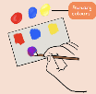  primary colours  Red, yellow and blue.  secondary colours  Orange, green and purple and made by mixing two primary colours together.  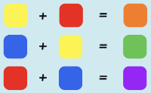  pattern  Pattern is a design in which shapes, colours or lines are repeated.  hue  Describing an exact colour: sky blue, dark green, rose pink.  shade  A colour referring to how dark or light it is. | Painting and Mixed Media: Life in Colour  primary colour  Red, yellow and blue; the colours from which all other colours are mixed.  secondary colour  Green, purple and orange; colours made by mixing primary colours.  texture  A surface quality that is not flat.  collage  Arranging different materials together and sticking them to a surface.
LKS 2 | Painting and Mixed Media: Light and Dark  shade  A dark tone of a colour made by adding black.  tint  A light tone of colour made by adding white.  still life  A type of painting or drawing or an arrangement of objects that does not move.  three-dimensional  Shapes with three dimensions, such as width, height and depth.  Tone  The light and dark something is  Shadow  A dark area created when light is blocked. | Craft and Design: Ancient Egyptian Scrolls  papyrus  A riverside plant used to make paper.  pattern  Pattern is a design in which shapes, colours or lines are repeated.  zine - pronounced ‘zeen’  A mini book made from folding a single sheet of paper. | Craft and Design: Fabric of Nature  batik  A technique to create patterns on fabric.  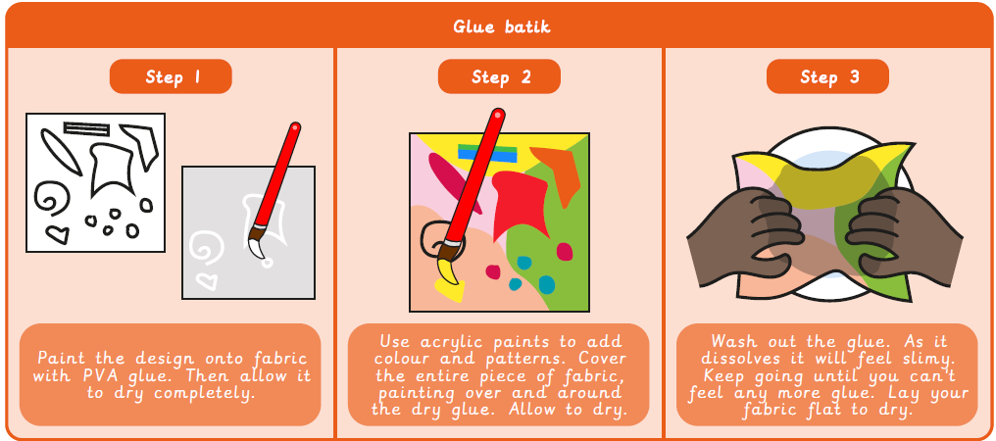  evaluate  Deciding if something has been done in the best way and looking at what could be improved.
UKS2 | Sculpture and 3D: Interactive Installations  installation art  Three dimensional art that aims to transform a particular place.  scale  The size of one object in relation to another.  installation art  Three dimensional art that aims to transform a particular place.  evaluation  Deciding if something has been done in the best way and looking at what could be improved. | Craft and Design: Photo Opportunity  photomontage  A collage of photographs that are arranged or modified.  macro  Very close-up photography, usually of very small subjects that are hard to see without using a magnifying tool.  photorealism  A painting or drawing style which closely resembles a photograph.  portrait  A painting, drawing or photograph that shows the head and shoulders of a person.  self-portrait  A picture or photograph that shows the artist who created it.  monochrome  The use of one colour. | Sculpture and 3D: Making Memories  Sculpture  Three dimensional art made by calving, modelling, casting or constructing.  assemblage  A three dimensional collage of collected or made items.  Composition  Putting different elements together in a pleasing way

