CYCLE: A
SUBJECT:  D.T. | Autumn | Spring | Summer
KS1 | Windmills (Structures)  Windmill- A structure with sails that is moved by the wind  Stable- object does not easily topple over  User/ client- the person who you are designing something for  Test- to find out whether something works as it should | Puppets (Textiles)  Fabric- a natural or manmade woven or knitted material that is made from plant fibres, animal fur of synthetic material.  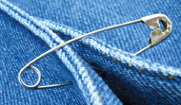  Safety pins- A U Shaped pin with a cap where the needle slots in securely after fastening.  Stapler and staples  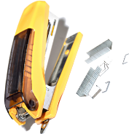  Template- a stencil which you can use to help you draw a shape more easily onto different materials.  Decorate- to add details to a design to improve its appearance. | Smoothies (Cooking and Nutrition)  Fruit- the part of a plant that has a seed in.  Vegetable- any part of a plant that you can eat.  Seed- new plants grow from it.  Root- part of a plant that takes water and other things from the soil.  Ingredients- the foods needed to make a recipe.
LKS 2 | Eating Seasonally Make a Tart (Cooking and Nutrition)  Appearance- the way something looks  Seasonal- food that grows at a certain time of year  Climate- the weather conditions that an area usually has  Import- food brought from another country  Export- food sold to another country | Wearable Technology (Digital World)  CAD- computer aided design  Annotate- labels on drawings which help to explain it  Wearable technology- technology you can wear to help with day-to-day activities  Initiate- to start a programme  Control- to command something to change, such as lighting up or flashing | Constructing a Castle (Structures)  Façade the front of a structure  Feature- a specific part of something  Net- a 2D flat shape that can become a 3D shape when assembled  Scoring- scratching a line with a sharp object into card to make the card easier to bend
UKS2 | Doodlers (Electrical Systems)  Product analysis- to look at an object and evaluate it based on certain criteria (e.g. function)  Investigate- research something by looking at it in greater detail  D.I.Y.- the acronym meaning Do It Yourself and represents various activities that someone chooses to do themselves at home, rather than through a service professional  Circuit component- one of several parts that make an electrical system | Pop up Book (Mechanical Systems)  Design brief- a description of what you are going to design and make and how it is going to work  Sliders- a part of a mechanism, which allows an object to move from side to side (e.g. left-to-right)  Prototype- a simple model that lets you test out your idea, showing how it will look and work | Developing a Recipe: Bolognaise (Cooking and Nutrition)  Balanced diet- measured amounts of different foods from the food groups  Cross contamination- when something harmful spreads from one food to another  Nutritional value- the nutrients a food or recipe provides  Nutrient- substances that help living things stay healthy and grow

CYCLE: B
SUBJECT:  D.T. | Autumn | Spring | Summer
KS1 | Baby Bear’s Chair (structures)  Structure- something that has been made and put together and can usually stand on its own (e.g. a building, a bridge, a chair).  Man-made- made by people  Natural- Found in nature e.g. spider’s web, sheep’s wool  Function- how something works | Fairground Wheel (Mechanisms)  Mechanism- the parts of an object that move together as part of a machine  Evaluation- when you look at the good and the bad points about something then think about how you could improve it.  Stable- object does not easily topple over  Strong- something that is not easily broken (e.g. wood, brick, building).  Weak- something that is easily broken (e.g. eggshell) | Moving Monsters (Mechanisms)  Pivot- the central pin, point, shaft on which a mechanism turns or swings.  Design criteria- a set of rules to help designers focus their ideas and test the success of them.  Output- is the motion that happens as a result of starting the input.  Linkage- length of material that are joined together by pivots, so that the links can move as part of a mechanism.
LKS 2 | Pavilions (Structures)  Aesthetics- how an object or product looks  Cladding- a material put on top of another material or on a structure as protection or to improve appearance  Pavilion- a decorative building or structure for leisure activities  Function- the purpose of an object (e.g. a chair needs to hold a person when sitting down); or how the product works (e.g. a torch needs to provide light in a dark space). | Sling Shot Car (Mechanical Systems)  Exploded diagram- it is used to illustrate how different parts of a product fit together to give a clear idea of exactly how to make it 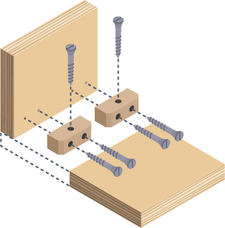  Graphics- images which are designed to explain or advertise something  Chassis- the body of a car 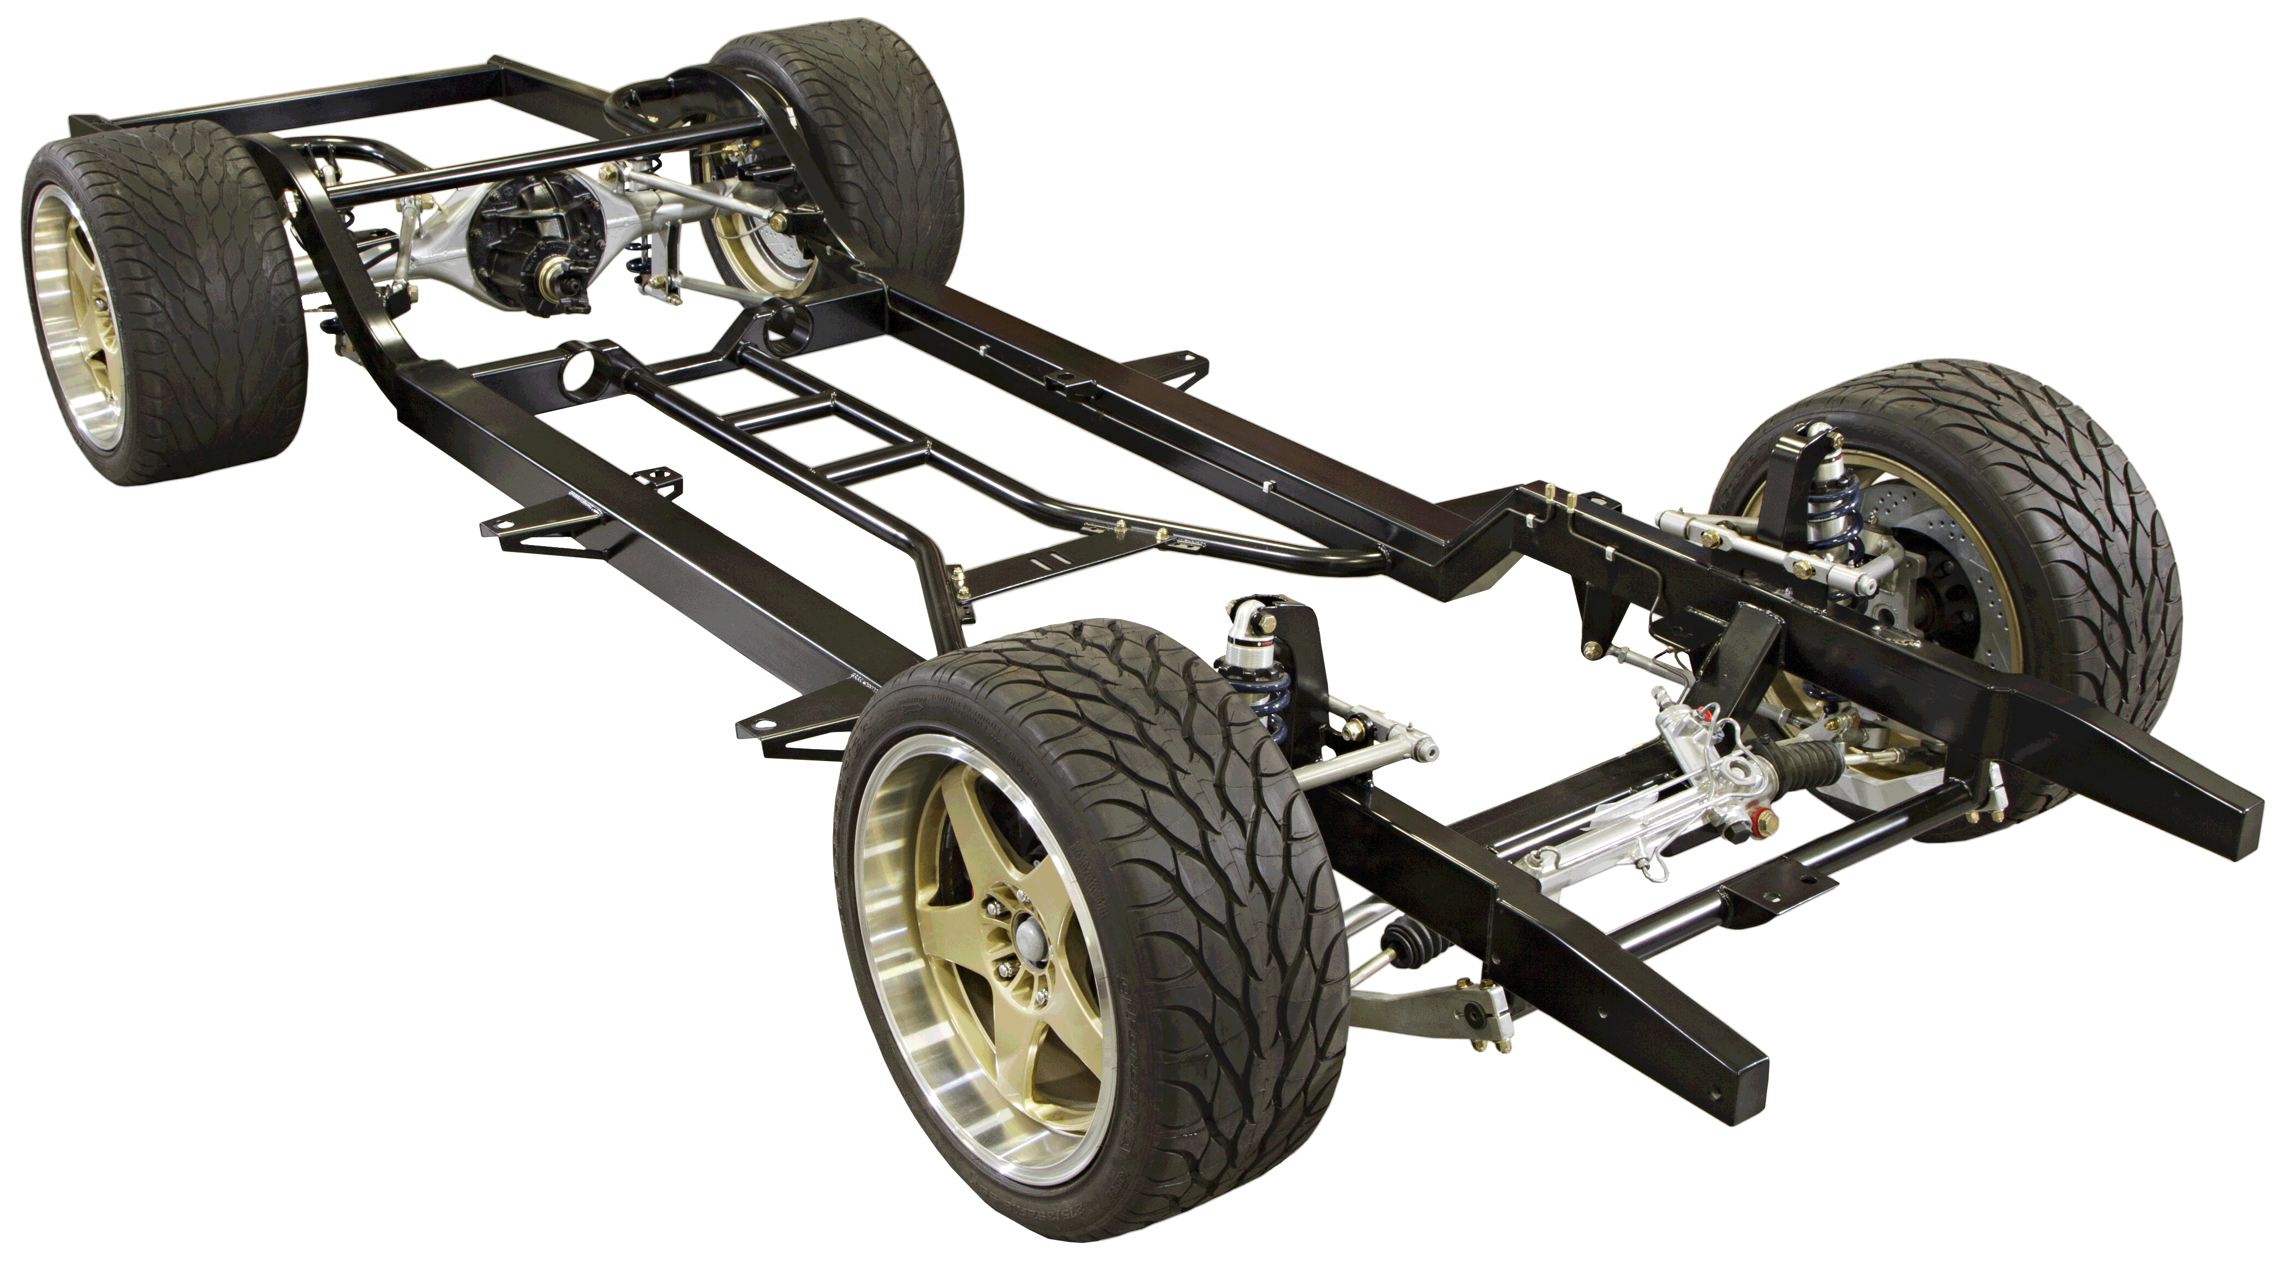  Air resistance- the level of drag on an object as it is forced through the air | Torches (Electrical Systems)  Electricity- a type of energy that is usually invisible that can be made or stored and used to make objects work (e.g. to move things or warm them up)  Conductor- a material that allows electricity to flow through it e.g. metal  Insulator- a material that does not allow electricity to flow through it e.g. plastic  Series circuit- a closed circuit where the current flows one path  Torch- a battery powered electric lamp
UKS2 | Waistcoats (Textiles)  Properties- the way in which we describe materials for their appearance, strengths and weakness (e.g. absorbent, flexible, transparent)  Seam- a line along the two edges of the cloth that are joined or sewn together  Running stitch- a simple style of sewing in a straight line with no overlapping  Waistcoat- a formal vest type jacket with no arms, usually worn over a shirt and under a jacket. They sometimes have buttons or pocket detailing. | Playgrounds (Structures)  Coping saw- a saw with a narrow D-shaped metal blade, used for cutting curves in wood. 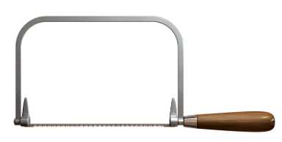  Tenon saw- a saw with a flat blade, used for cutting wood in straight lines or angles 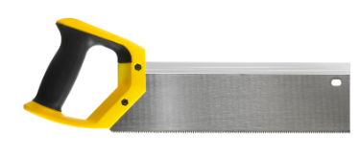  Vice- a piece of equipment used to hold an object still while you work on it 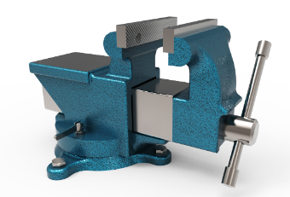  Bench hook- a tool which hooks onto the edge of the workbench. It’s used to hold word work still when sawing 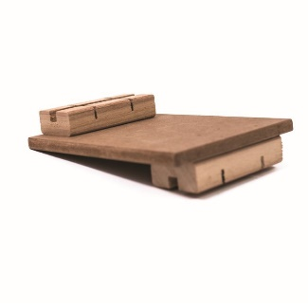  Modify- to change something to improve or fix it | Navigating The World (Digital World)  Multifunctional- something that has more than one function  Pedometer- counts the number of steps you have taken.  Compass- uses the Earth’s magnetic pull to guide you using cardinal directions (north, east, south and west).  Product lifespan- how long an object will last, before being recycled  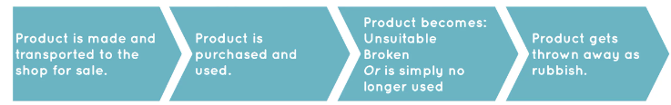  Sustainable- can be maintained

