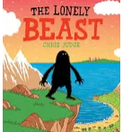
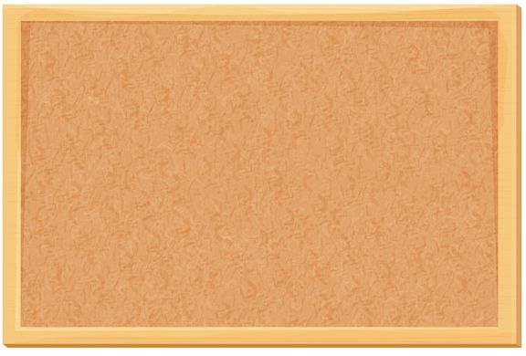





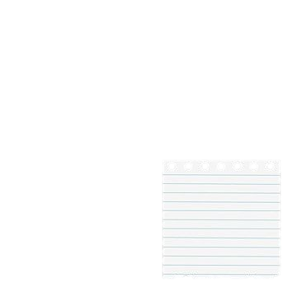
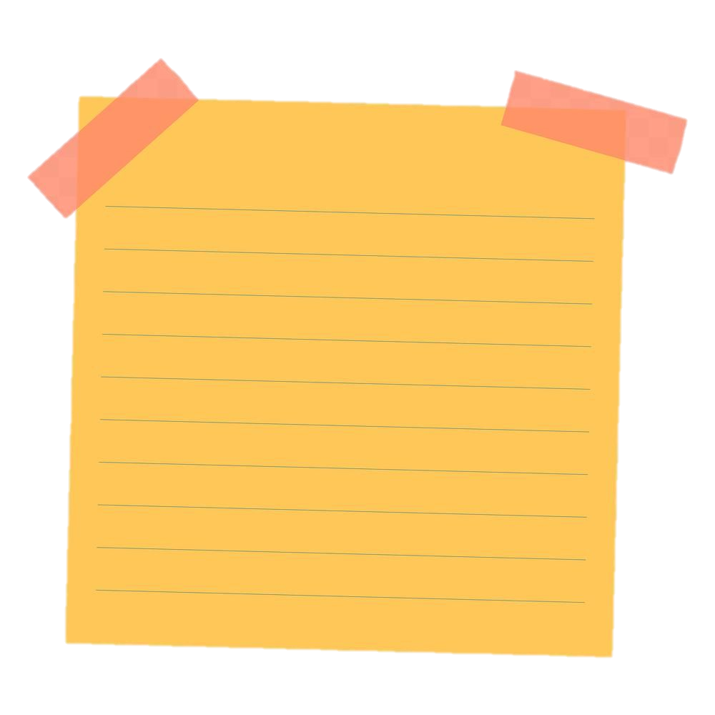
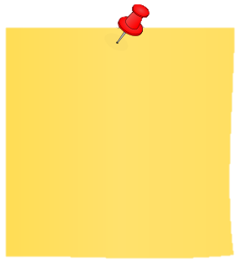
Geography
In geography, we will continue to learn all about Mexico, and compare this with our country, England. We will discover what continent both countries are located in and discuss their physical and human features. Key vocabulary: atlas, globe, equator, capital city, Union Jack.
History
Our history topic this term is explorers. We will learn all about why people explore and how explorations have changed over time.
Key Vocabulary: explorer, astronaut, oceanographer, mountaineer, monument

Mathematics
Y1: In maths, we will be learning all about place value of numbers to 50, and how to add and subtract numbers within 20. Later will move onto measurement, where we will learn how to measure length and height in centimetres. We will also learn about mass and volume.
Y2: We will learn all about money including how to find change and calculate using money. We will also learn how to multiply and divide, focusing on our 2, 5, 10 and 3 times tables. Later, we will learn about measuring length and height in metres/centimetres and measuring mass and capacity in grams/kilograms and millilitres/litres
English
This term we are going to be reading the text, The Lonely Beast and using this to inspire our writing. We will produce a range of different types of texts and learn how to improve our sentences when writing. We will think about including adjectives (describing words) to write noun phrases. We will also continue to revise the year 1 monster phonics sounds.
Jigsaw/PHSCE
Our jigsaw topics this term are: Dreams and Goals and Healthy Me.
Key vocabulary: achievement, collaboration, goal, resilience, determination, commitment.
Music
In Music we will explore Contrasting Dynamics and soundscapes through the Space unit.
Key vocabulary: dynamics, soundscape, symbols and mood.
RE
In RE we will learn all about Our Wonderful World, Key vocabulary: Hindu, Christian, creation, heaven, Brahma, world, lotus flower
PE
In PE we will explore linking movements in gymnastics and creating a water dance dance.

Science
In Science we will learn about everyday materials. We will identify and compare the suitability of a variety of everyday materials, including wood, metal, plastic, glass, brick, rock, paper and cardboard for particular uses.
Key vocabulary: material, flexible, ridged, bend, stretch, twist.
Art
In art, we will be developing our 3D sculpture skills through paper play. Key Vocabulary: three-dimensional, sculpture, cylinder, concertina, overlap and spiral.
DT
We will create puppets using textiles. We will design, make and evaluate these ensuring that it meets the design criteria. Key vocabulary; fabric, safety pins, stapler and staples, template and decorate.
Important Information
P.E will be on a Monday and Thursday
Reading books and records will be collected in on a Monday.

Computing.
In computing this term, we will learn ‘What is a computer? And we will input data into a spread sheet.
Key Vocabulary: cells, data, document, edit, save, share, camera, desktop and laptop.
Zeus Spring Term 2025-2026

