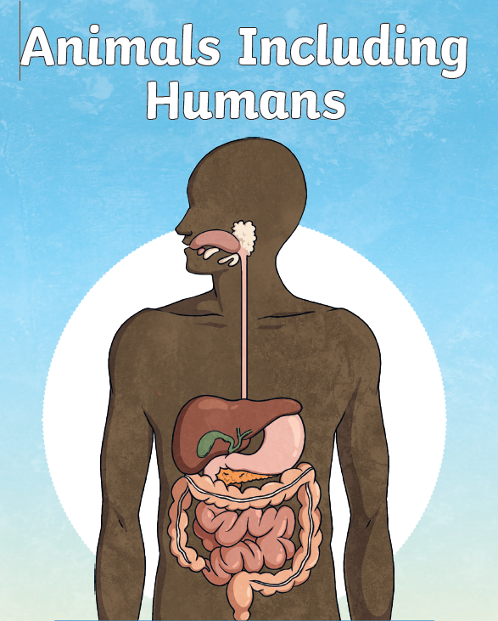
Please choose one of the following activities!

- Create your own digestive system showing the journey of food
- Create a food chain comic strip starting with a plant all the way to predators
- Build your own 3D teeth dentures creative molars, incisors and canines
- Write a fact file about the different types of teeth we have

With our Science focus being Animals including humans this term we have created some related tasks for you to complete.
Creative curriculum homework
Due w/c 03/03/26

