

Thrunscoe Primary and Nursery Academy
Statement of salaries and benefits 2025

Numbers of employees whose gross annual salary and benefits exceed £100k, in £10k bandings:
None

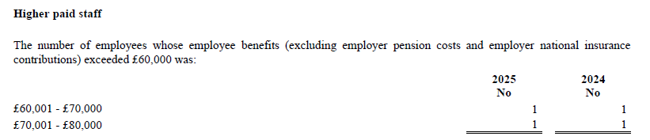
Extract from financial statements for year ended 31st August 2025:

