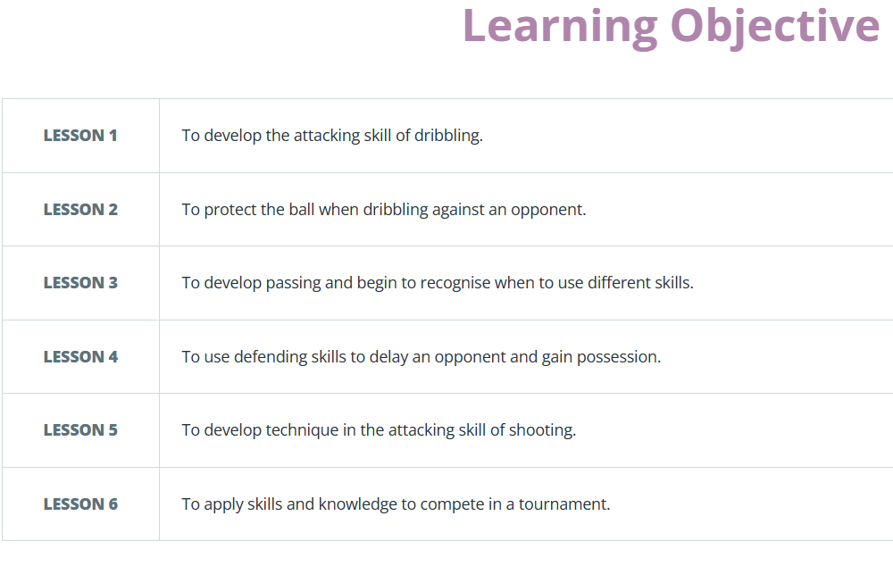
Lesson 7
Lesson 8
WTS EXC
Additional lessons used for unit copied and pasted from Awesome Stuff-> Resources by activity
Copied from Unit Overview on GetSet4PE
Column to note initials of pupils that are working towards or exceeding.

