Get Set 4 PE – Accessing the Planning Material and Resources
A Basic Overview
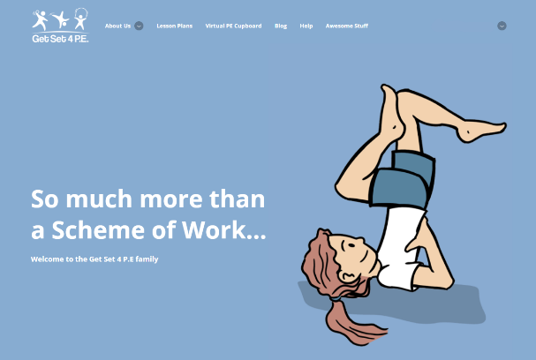
Using your unique password log-in on www.getset4pe.co.uk [ <insert> ]
Home Page
Note that your page will say –
Anthony Curton Primary here.

Getting Started
For planning – all the Lesson Plans for all years are located under the tab:
Lesson Plans

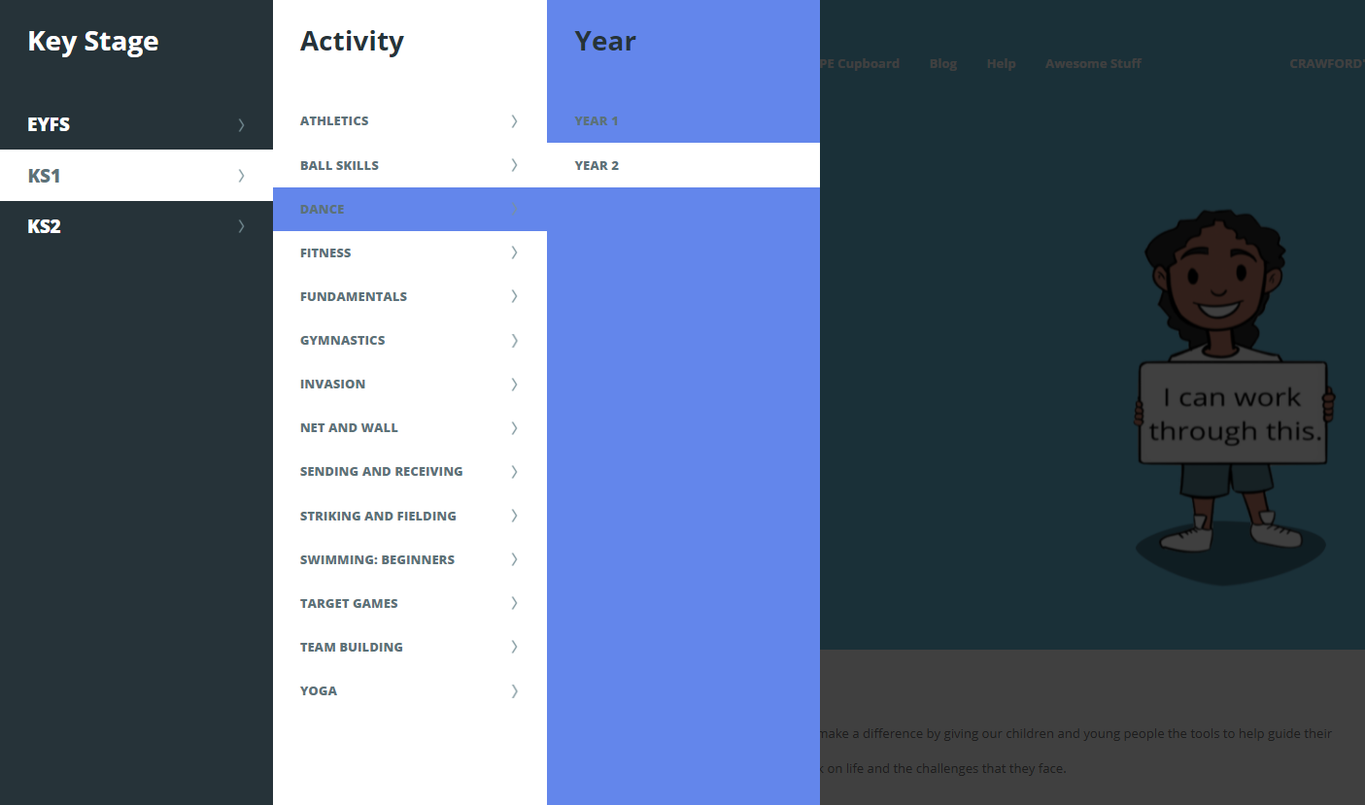
Click on ‘Lesson Plans’

Choice – EYFS, KS1 or KS2
Select what you want

Choice – Activity
Select what you want

Choice – Year
Select what you want
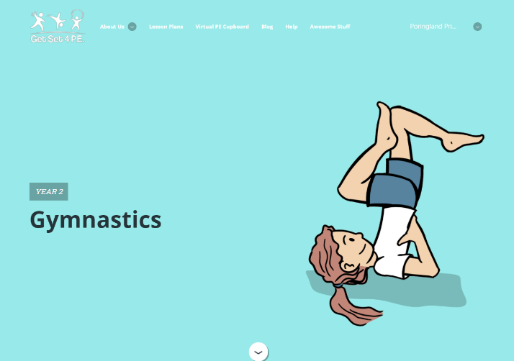
- Selected KS1
- Selected Gymnastics
- Selected Year 2

Year 2
Gymnastics
This screen will now allow you to see all the work for the unit ‘Year 2 Gymnastics’ by scrolling down the screen. You can also Print it from here too

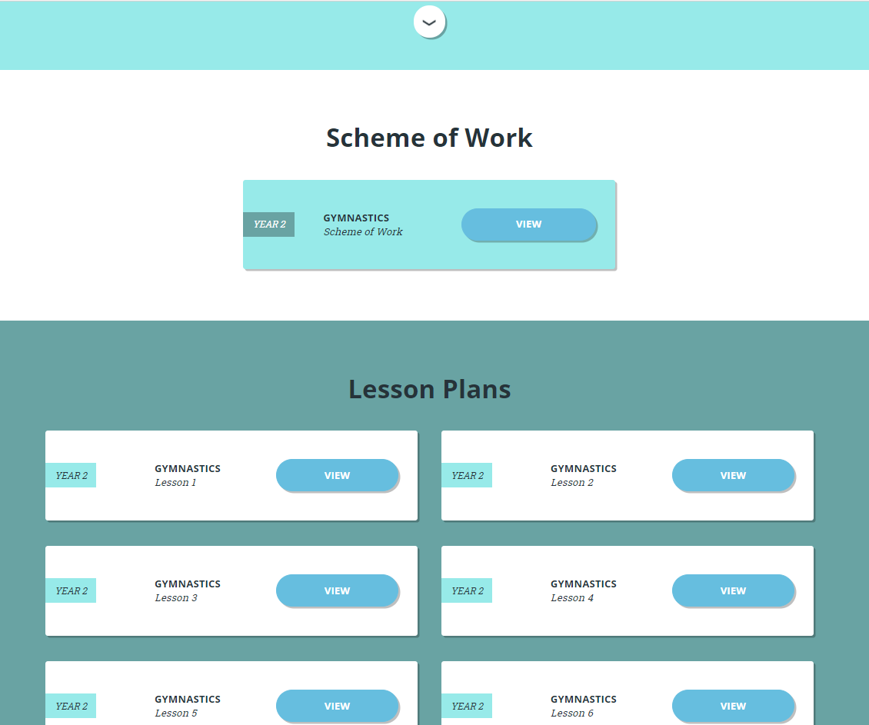
Scroll Down

You will see:
Scheme of Work

and under that

Lesson Plans (usually 6-8)
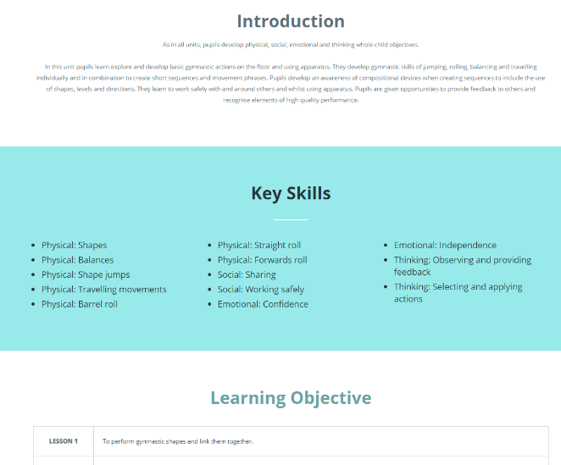
Click on
Scheme of Work

This will give you the vital overview or Introduction (brief) of what the unit is all about and how it links in, Key Skills, Learning Objectives and Assessment Criteria.

There is also a Link to Other National Curriculum Subjects & Health & Safety

The Learning Objectives can provide the most simple and straight forward assessment but also allow you to describe how each lesson fits in the sequence – important to Education Inspection Framework (EIF / Ofsted 2019 onwards).

This can keep it nice a simple and focus on how the pupils are meeting the INTENT – the planned learning objectives. The Lesson Plan will provide the IMPLEMENTATION framework
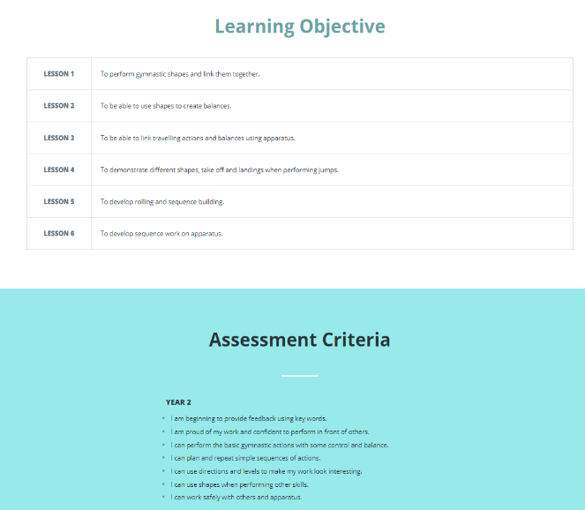

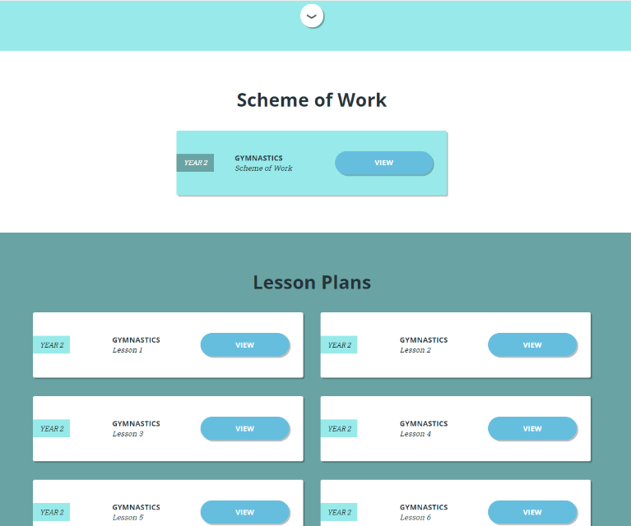
Click on
Lesson Plan – Lesson 1 (etc. as required)

There are usually 6 or 8 lesson plans which are sequenced, progressive and aligned to deliver the objectives and outcomes for the national curriculum expectations and more.

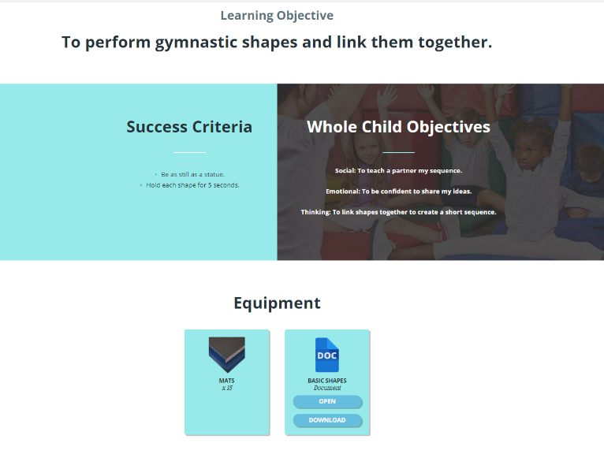
Each Lesson starts as in picture (left)

Scroll down for more.

Equipment needed is listed for ease

Supporting Documents / Videos are also often shown here.

Scroll Down to see:

Warm- Up and Introduction

Here you will get some ideas to start the lesson and get pupils warmed up.
You can of course use your own ideas or adapt theirs.

Think ‘how will ALL my class access this?’
Think ‘how will I get started on this?’

Scroll Down for more……….
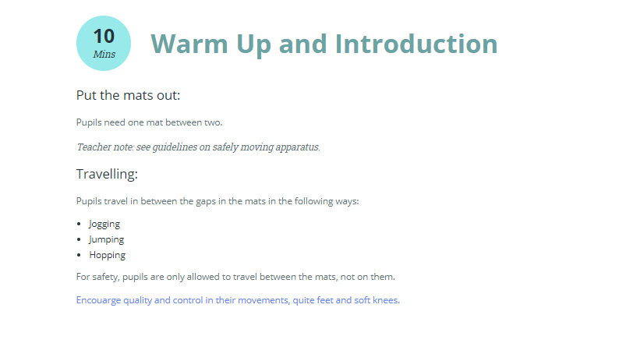

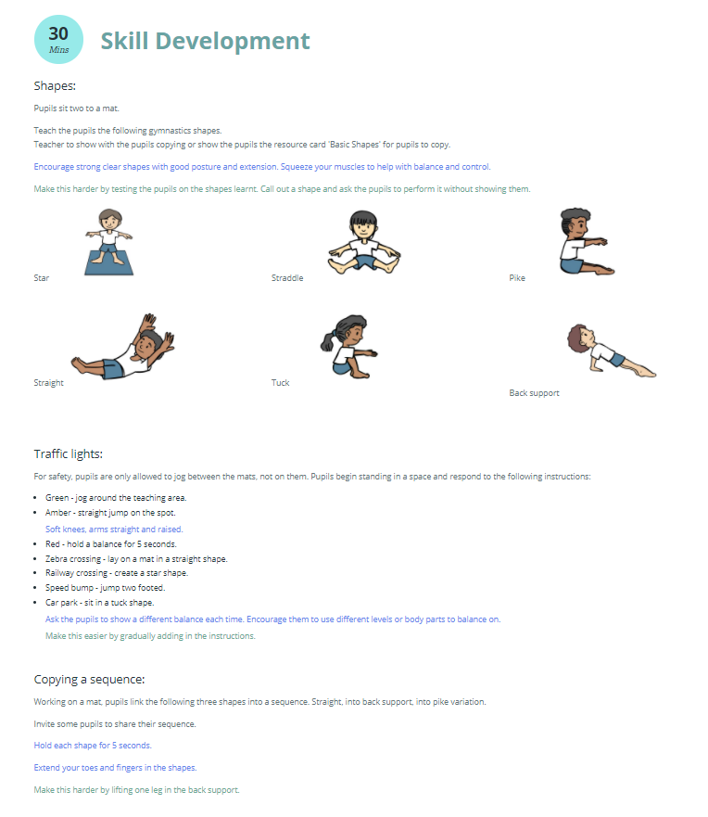
Each Lesson has the main learning activity identified as
Skill Development

You will see that there is text in Blue and Green.

Blue – Teaching Points – to stress and share with pupils

Green – ways to Challenge and Differentiate the tasks to support you and the pupils.

Scroll Down for more……….

Some lessons have lots of ideas etc. but all finish with a
Plenary
to help you bring the learning together.

REMEMBER – To PRINT off the lesson plan you have to go back to the TOP of the page.

Annotate any lessons to show how you will make them work for YOUR pupils
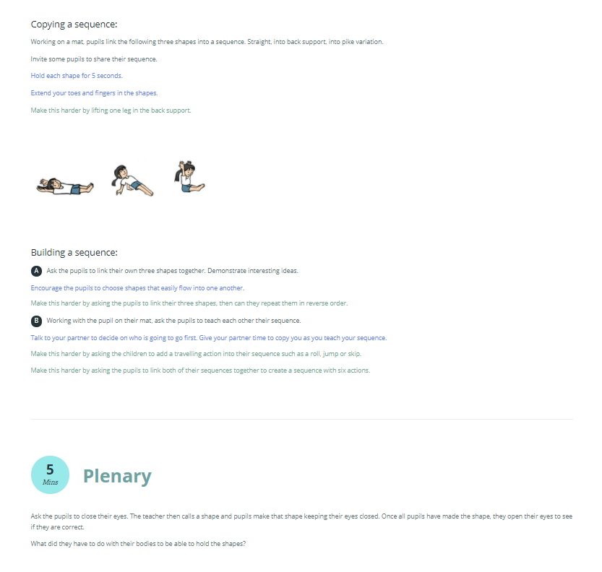

Other Features of the Site:
Virtual PE Cupboard: Located on Top Tab on Home Page
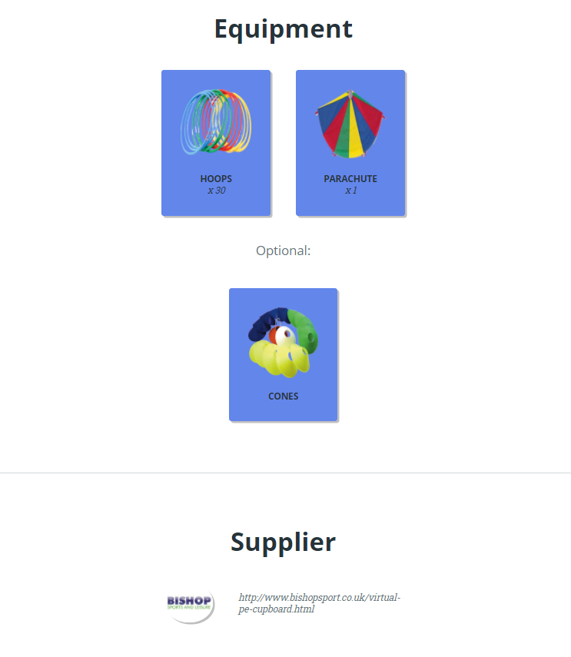
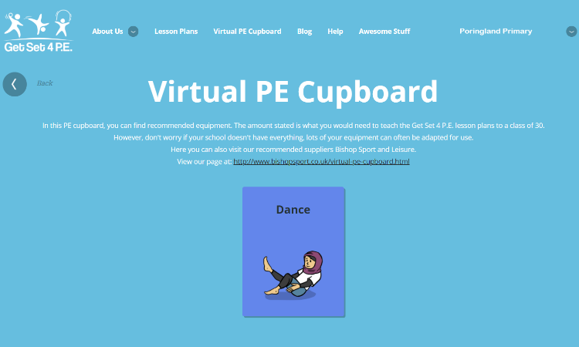

This Tab helps you to identify any Equipment that is needed in the lesson plans for the Unit.
They have a link with Bishop’s as a Supplier. It is helpful to just check to ensure that you have everything that they suggest for the lessons. You can always use and adapt with other equipment to both Challenge and Differentiate

Awesome Stuff – Located on the Top Tab on Home Page
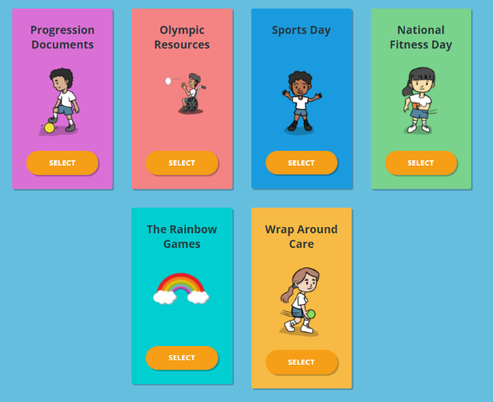
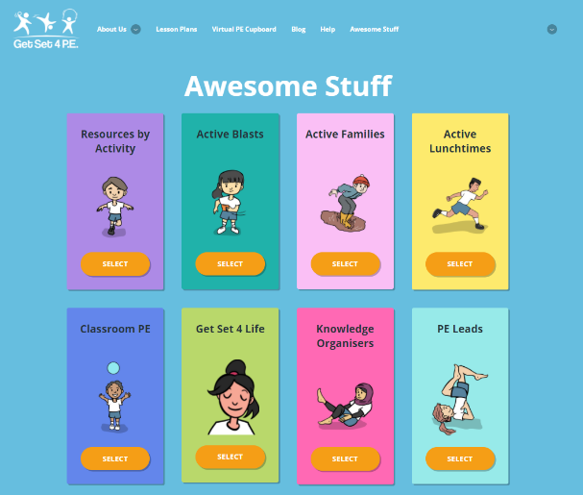

Here you will find resources for areas of activities, including Video Clips etc. There is also material for Home-learning, Health and National School Sports Week etc.
There is also a section for PE Leads – Lucie. Here you can plan out and map out the Curriculum Long Term Plan quickly and easily to guide colleagues and the learning in PE at the school.
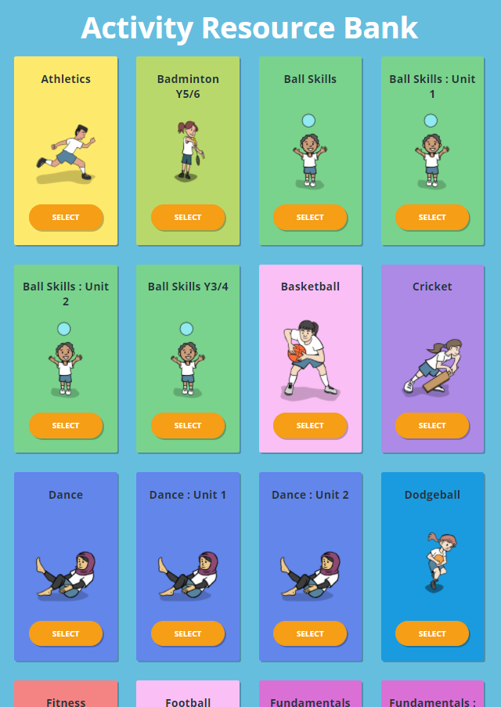
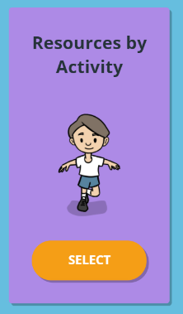
If you Select Basketball – you will; see a list of Word Document Resources. These include key vocabulary, rules, score sheets, assessment checklists etc.
Select this for materials, including Video, to support your teaching. There are lots of different resources including Music for Dance, Fitness Cards etc.
Select and you’ll see:
Scroll to find what you
want and Select

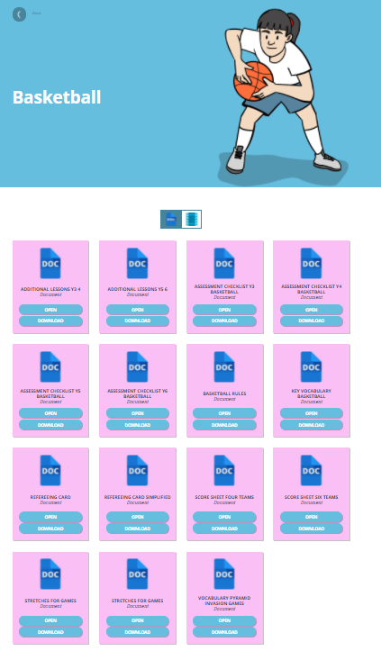

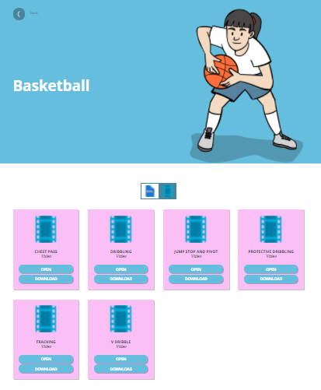

If you toggle between the Word Documents and Film / Video Icon you will see the different resources – including the video clips

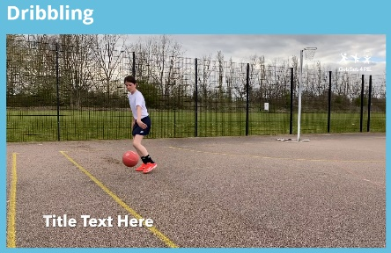

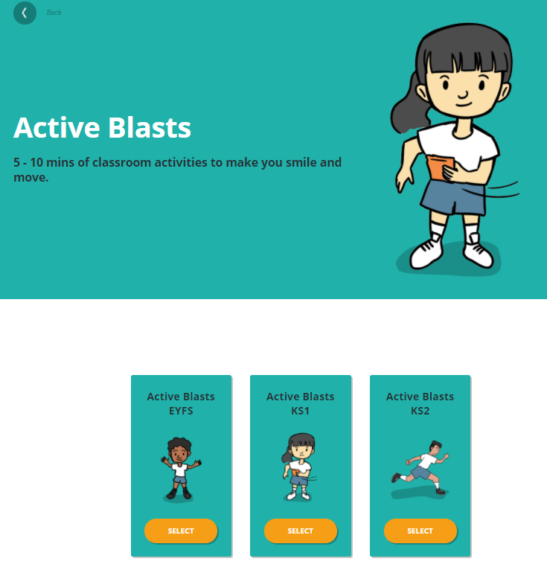
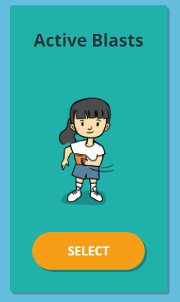
5-10 Minute activities in the classroom to get you moving, having fun and engaged!

