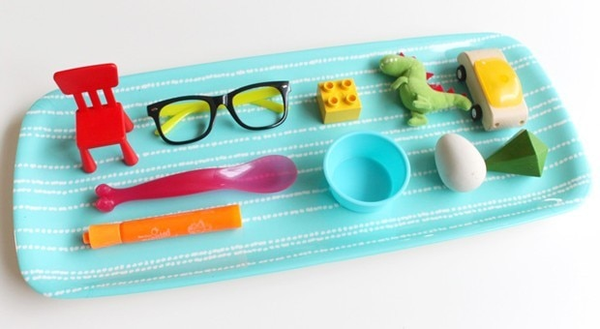

Tray Memory Game

You Will Need:
A tray, a tea towel and several small objects from around the house
- Instructions:
- Simply arrange the small objects you’ve collected on the tray so each can be seen clearly and you're done!
- Next, invite your child to investigate the items closely. Ask him or her to try and commit each of the items to memory before covering up the collection of objects up with the tea towel.
- Now the fun part—choose the way you want to play!
1. What’s Missing?
Carefully remove one object from the tray, using the tea towel to keep your selection a secret.
Wrap the object up inside the towel and reveal the remaining tray objects. See if your little one can tell you what is missing!
Afterwards, switch and invite your child to remove an object while you take a turn being the guesser.

2. Name The Objects
With the tray of items fully concealed under the towel, ask your child to name as many of the items as he or she can remember while you keep count.
Afterwards, switch positions and have them count up the number of items you can remember. Continue back and forth, taking a moment in between turns to look again at the tray in hopes of beating your previous personal record!
3. Add An Object
Ask your child to close or cover his or her eyes. While he or she is not looking, quickly remove a small, interesting item from around the room and slip it under the tea towel, adding it to the tray.
When you’re ready, remove the tea towel, have your child open his or her eyes and see if he or she can tell you what has been added.
Afterwards, switch roles and allow your little one to have a turn adding something to the tray while you close your eyes. Keep in mind that the difficulty level of these games can be adapted by adjusting the number of items on your tray.
If the game seems too easy, simply add a few more items. If it seems too challenging, consider removing a couple items.
Another fun idea is to create a mini take-along version of the game to keep in your purse or bag. Not only will it come in handy when you’re out and about with the kids (it's perfect for waiting at restaurants and appointments), but it’s also a great way to put random small objects—like extra game pieces, unpaired doll shoes and leftover craft supplies—to good use.
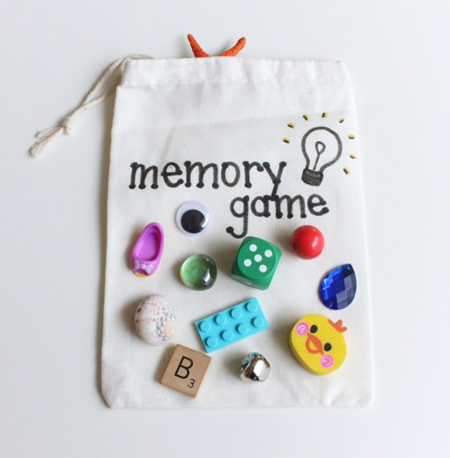
Once you’ve collected your items, find a small (preferably opaque) bag or container to store them in and you’re good to go. The bag or container will take the place of the tea towel in the tray version of the game, so no need to worry about that.
That's it. A super simple memory game that's easily adaptable to kids of all ages. Enjoy!
Interactive memory card games on the internet:
https://www.memozor.com/memory-games/for-toddlers-babies/teddy-bears
https://www.memozor.com/memory-games/for-kids/fruits
https://www.memozor.com/memory-games/big-or-giant/everyday-objects

What Is Mindfulness?
Mindfulness is about focusing on the present moment by tuning into our thoughts, feelings, bodily sensations and what's around us. It's all about being aware of what's happening here and now, slowing down and calming your mind.
Mindfulness activities can be practiced anywhere and anytime, and you can do these types of activities individually or as a group (of any size). Lots of teachers are even implementing mindfulness into their classrooms.
So if you've been wondering how to start teaching your kids (and yourself) about mindfulness, here are some simple ways you can get started.

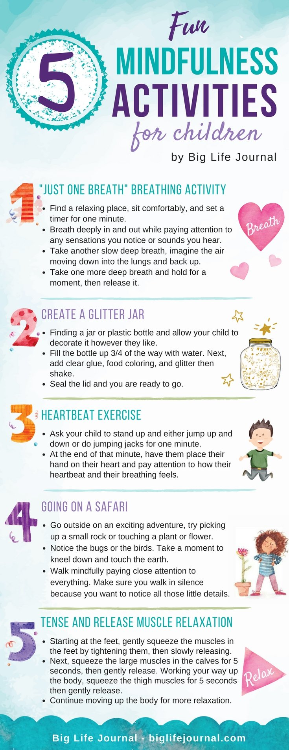

Mindful Breathing
It's as simple as taking a couple of deep breaths a few times each day. You can even schedule deep breathing breaks for you and your child.
I recently came across an idea to pick a trigger word and each time you hear that word, you pause and take a couple of deep breaths. The suggested word was "mum," and goodness, could you imagine how many times you would sneak in some mindful breathing every day if you used it as your trigger word?
You can even use a visual cue to remind you to pause and do some mindful breathing. For example, every time you stop at a red light while driving, encourage your kids to join you as you take a couple of deep breaths.
2 Deep Breathing Techniques To Try:
- Lie down on your back, place a small toy or stuffed animal on your belly, take slow deep breaths and watch the toy move up as you inhale and down as you exhale.
- Place one hand on your belly and the other on your chest, and breath deep so you can feel the rise and fall of your chest and belly as you breathe.

Noticing Games
You likely remember playing "I spy" games on road trips as a child. These types of games are a great way to get started with mindfulness as they encourage you to be aware of what's around you.
You can even switch it up to do "I hear." Instead of describing what you see, describe what you hear. This variation encourages you to focus on tuning into the sounds around you or even inside you.
3 Noticing Games To Try:
- Notice 5 Things: Look around you and name five things. Then encourage your child to do the same. Keep taking turns until you both feel calm and grounded.
- The ABC Grounding Technique: Look around and try to name an object you see or hear that starts with as many letters of the alphabet as possible, starting with A and then B, and so on.
- The 5-4-3-2-1 Grounding Technique: This activity makes use of the five senses. Have you and your child name five things you can see, four things you can feel, three things you can hear, two things you can smell and one thing you can taste.
Other types of noticing games can include going on a sound scavenger hunt or watching clouds as they move through the sky.

Relevant Reading: 7 Self-Regulating Apps For Kids That Teach Mindfulness Techniques

