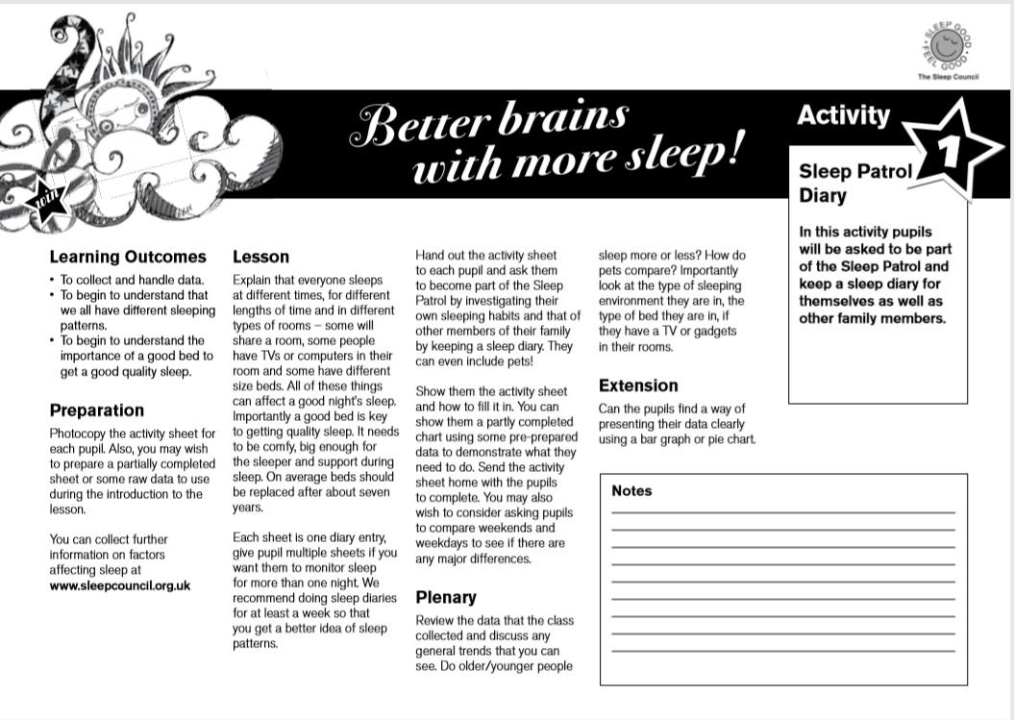
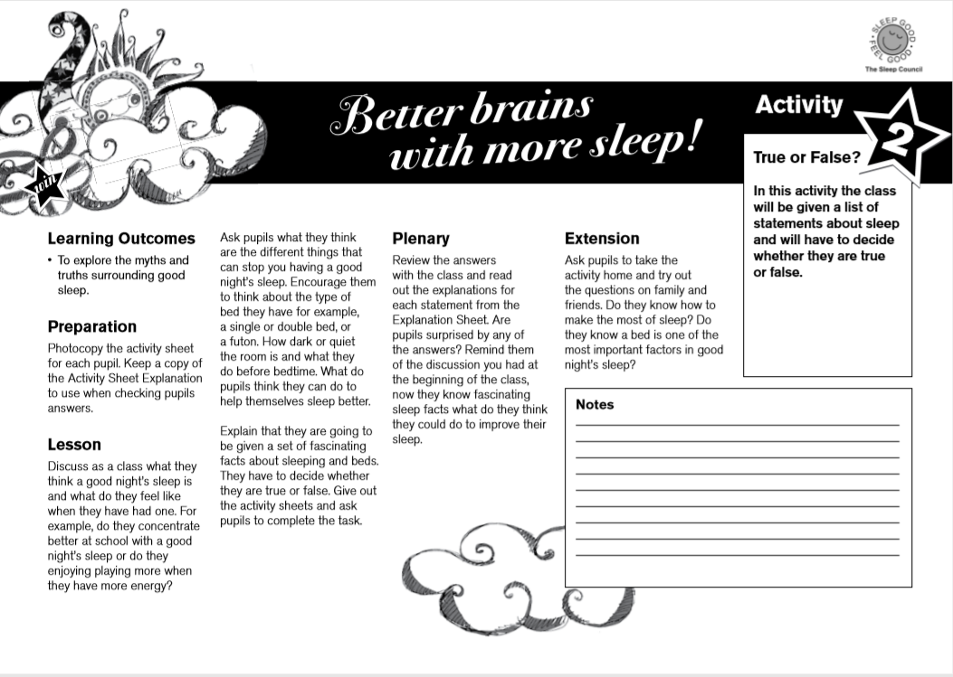
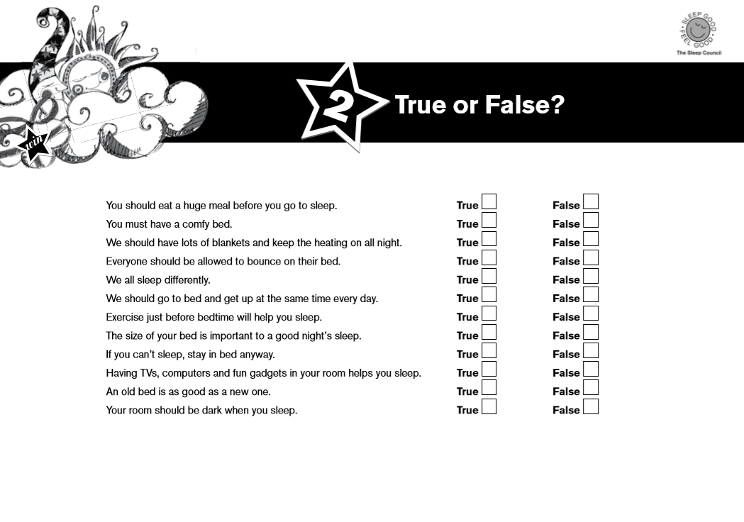
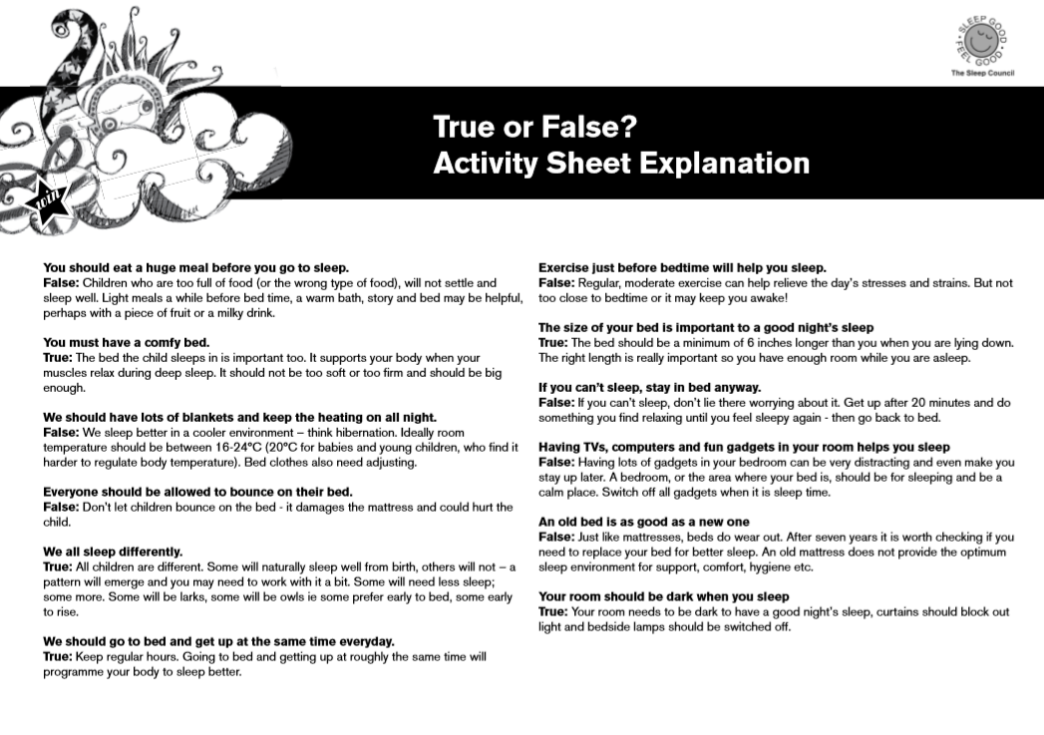
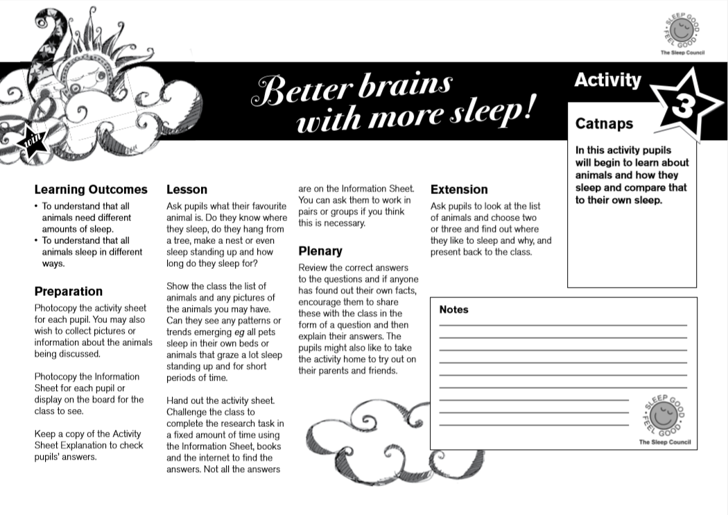
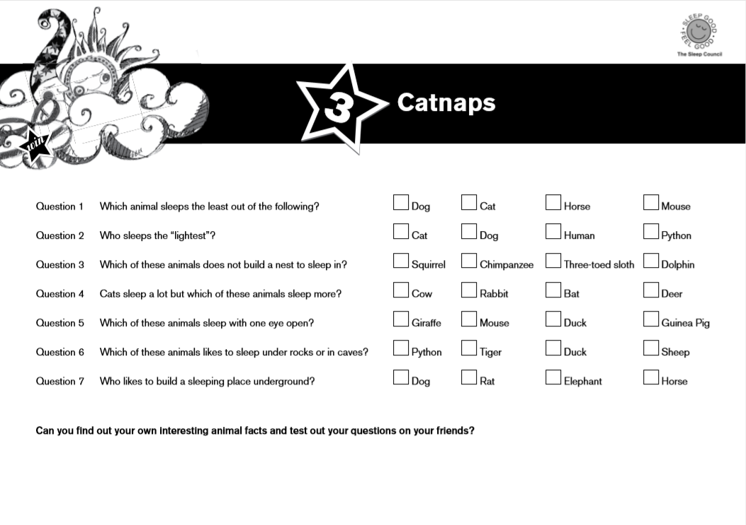
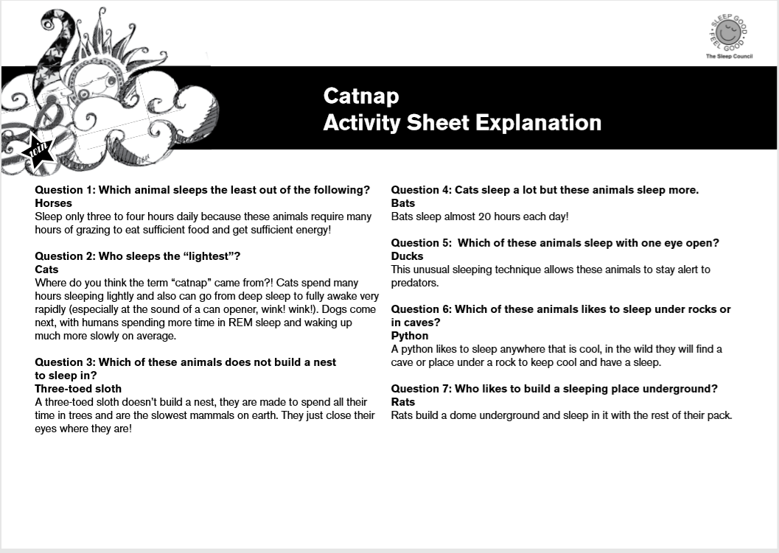
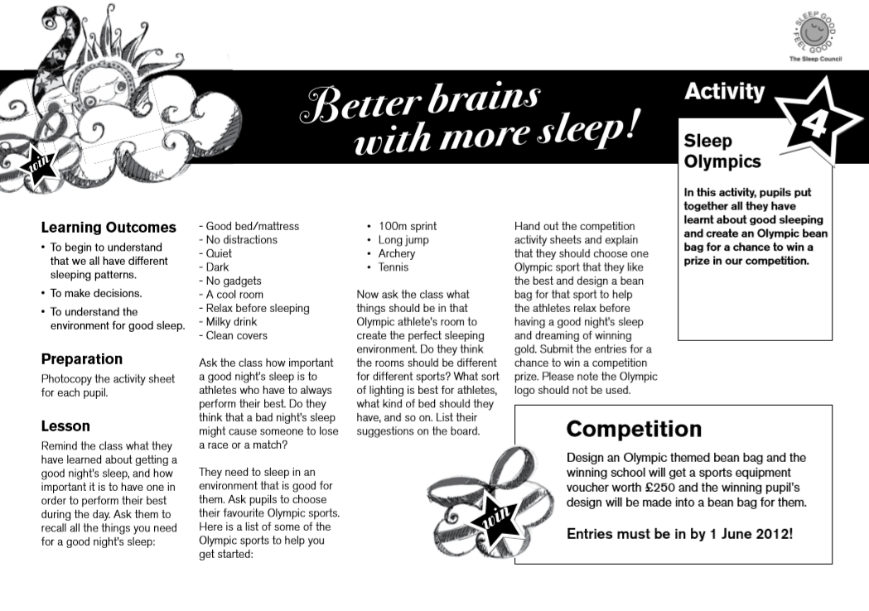

Think about the things you have learnt to help you get the best sleep you can. What do you think should be included and what to not have because you know it isn’t helpful. Have fun, anything goes?
Time to get creative and think about what would make a sleep hero bedroom?
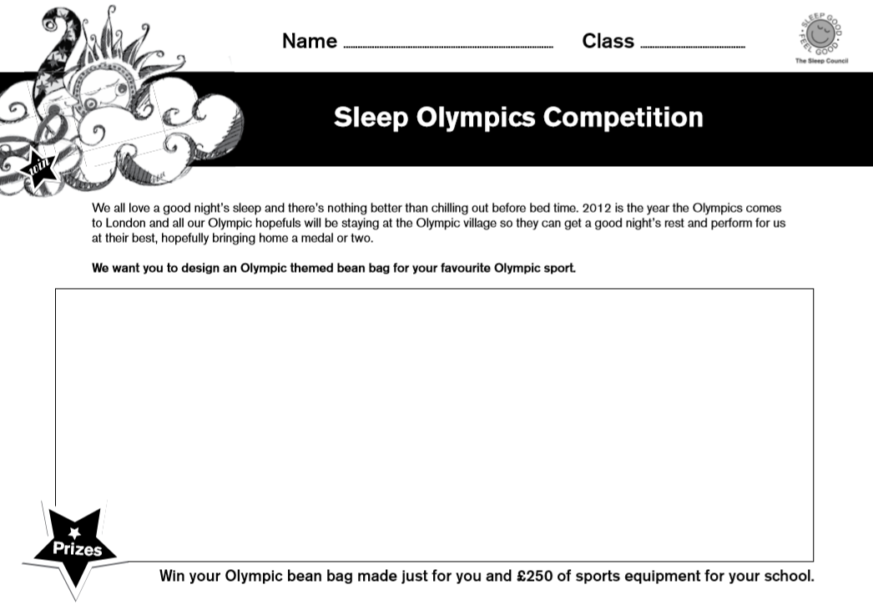
We should have been cheering on our favourite Olympians this Summer, unfortunately the Olympics has been postponed and our athletes are probably finding it hard to train and sleep. As you have learnt sleep is so important to help our bodies work well and athletes know that too. We all love to have a good night’s sleep and know it is important to chill out before bedtime. So can you design a room they can use to help them be calm and quiet before bed and to think about their day? For our younger pupils what would you like the bed to be like?
Challenge

