Long Term Mapping
Catering and Hospitality Further Education Department
2022-23
Autumn | 1 | Introductory skills/ Catering skills/  Hygiene and Safety around the kitchen
 | 2 | Hygiene and Safety around the kitchen and using basic tools
Spring | 1 | Follow routines / Catering and hospitality
 | 2 | Coffee morning /To follow a recipe
Summer | 1 | Storing food / working in the Hospitality business / café / serving/ waiting on
 | 2 | Serving/ waiting on/ To prepare food safely and  Hygienically/Preparing for the Summer Fair

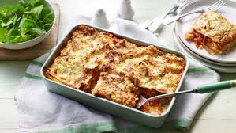
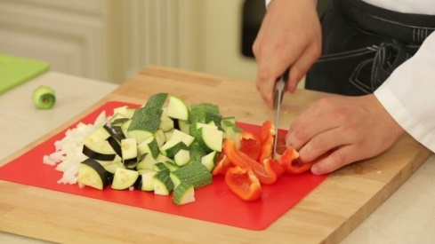
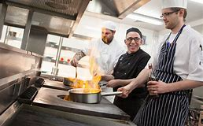
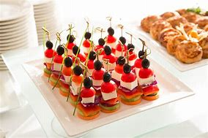
F.E CATERING AND HOSPITALITY MEDIUM TERM PLAN
Aspiration for Life |  | Differentiated, aspirational targets dependent on Studentsl needs. |  |  | Language for Life |  | Explicit teaching/ exposure to new and know vocabulary. |  |  |  | Learning for Life |  | Opportunities to develop cross curricular skills e.g.
CYCLE 1 | These sessions aims to build on confidence, offering students greater flexibility to be creative. It also provides the opportunity to assess students’ practical capability.  Unit / Theme: Introductory skills/ catering skills/ hygiene and Safety around the kitchen  Subject Skills: To identify areas of kitchen and understanding hygiene & safety.  To explore material in increasingly complex ways, for example, tearing, squashing, mixing or bending materials  Employability Skills Health and safety working in a Kitchen / hospitality environment.  Enterprise: Preparing dishes for the staff members / catering for events. Christmas fair  Skills- Pupils use a basic tool, with support, for example, spreading with a knife / using different equipment in the kitchen for example scales mixers, whisks, peelers, graters, etc  Cultural Capital:  Students will research and engage in activities relating to cultural celebrations, recipes and techniques throughout the year when possible. For example; Chinese New Year, Christmas and Diwali. Students will also discuss and create dishes that link with choices such as vegetarianism and veganism etc throughout the year to develop understanding of the morality and spiritualism linked to food.
 |  | Autumn 1 - 7 weeks |  | Autumn 2 - 7 weeks |  | Spring 1 - 6 weeks |  |  | Spring 2 - 6 weeks |  |  | Summer 1 - 5 weeks |  |  | Summer 2 - 7 week
 |  | Subject Skills:  To identify areas of kitchen hygiene & safety. Eating Well.  To explore material in increasingly complex ways, for example, tearing, squashing, mixing or bending material  Employability Skill::  Health and safety working in a Kitchen / hospitality environment.  Note that students will look at theory aspects relating to the given topic for the term. This will be covered every other week. |  | Enterprise:  Preparing dishes for the staff members / catering for events. Prepare food for cafe  work Skills-  Pupils use a basic tool, with  support, for example,  spreading with a knife  To analyse the work of past and present professionals and others to develop and broaden their  Understanding  Note that students will look at theory aspects relating to the given topic for the term. This will be covered every other week. |  | Subject Skills:  To learn and follow routines  around the Kitchen.  To acquire skills in slicing, chopping and grating, mixing, blending, whisking and folding in method.  Employability Skills:  To work in school kitchen to  develop skills  / work experience  Note that students will look at theory aspects relating to the given topic for the term. This will be covered every other week. |  |  | Enterprise:  Preparing dishes for the staff members / catering for events. Coffee morning  work Skills-  To follow a recipe step by step. Know what they have done well whilst cooking and say if they could change anything.  Note that students will look at theory aspects relating to the given topic for the term. This will be covered every other week. |  |  | Subject Skills:  To store food correctly and safely To be able to read sell by dates on food packaging. Identify and solve their own design problems and understand how to reformulate problems given to them.  Employability Skills:  working in the Hospitality  business / café / serving/  waiting on  Note that students will look at theory aspects relating to the given topic for the term. This will be covered every other week. |  |  | Enterprise:  Preparing dishes for the staff members / catering for events/ summer fair  work Skills-  To prepare food safely and hygienically.To follow a recipe step by step To cook a dish with or without support To develop specifications to inform the design of innovative, functional, appealing products that respond to needs in a variety of situation  Note that students will look at theory aspects relating to the given topic for the term. This will be covered every other week.
 |  | SUGGESTED PRACTICALS (Choose from or use suitable alternative)
 |  | Pies  Cakes for café  Fruit salad  Salad  Pasta salads  Jacket potatos  Buffets as and when |  | Pies  Cakes for café  Fruit salad  salad  soups  Mince pies  Buffets as and when |  | Cakes for the café, Jacket potatos Wraps  Pizzas  Buffets as and when  quiche |  |  | Cakes for café Lasagne  Breads Pasta  Stir fries  Buffets as and when |  |  | Cakes for café  Chutney  Jams  Stir fries  Buffets as and when |  |  | Cakes for café Chicken Fillets  Griddled vegetables  Buffet food  cakes for café  Buffets as and when
 |  | SKILLS
 |  | Peeling  Slicing  Cutting  Chopping weighing  measuring | Knife Safety  Oven Safety | Weighing  Measuring  Spreading  Bashing (with rolling pin)  Rubbing Together  Preparing Vegetables |  | Slicing  chopping  grating  blending  whisking  folding |  | Knife Safety  Oven Safety | Chopping  Mixing  Shaping Rise  Prove | Knife Safety  Oven Safety |  | Chopping  Slicing Pealing  Preparing |  | Knife  Safety  Oven  safety | Shaping  Chopping  Slicing  Skewering  Smoking
 |  | VOCABULARY (In addition to ‘skills’ terms listed above)
 |  | Healthy  Salad  vegetables fruits  Savoury  Balanced  Macronutrients |  | Fat  Eat-Well Guide  nutrition  celebration  carbohydrates |  | Pastry |  |  | Rise  Dough  Pasta machine  Italian |  |  | fruit  seeds  sugar  In season |  |  | Washing  Chopping Board  Germs  decontamination
 |  | IMPLEMENTATION
 |  | Week 1 Assessment  Week 2 Eat Well Guide  Week 3-4 Balanced diet 5 a day  Week 5-6 Role of ingredients within salads/ fruit  Week 7: Assessment |  | Week 1-2 Eat Well Guide  Week 3-4 weighing / measuring  Week 5-7 Different Cooking Methods |  | Week 1-2 Different cooking methods  Week 3-4 Knife safety  Week 5 Food Safety  Week 6: Assessment |  |  | Week 1-2 Prep for staff dishes  Week 3-4 Prep for Coffee morning  Week 5-6 Coffee morning |  |  | Week 1-2 Preparing food food hospitality/cafe  Week 3 Fruit within the Eat Well Guide  Week 4 cooking methods  Week 5: Assessment |  |  | Week 1-2 Setting up a BBQ  Week 3-4 Preparation techniques  Week 5-6 Food Hygiene | Cross Contamination  Week 7: BBQ Desserts
 | INTENT

