Long Term Mapping
DANCE KS4

 |  | Cycle 1 | Cycle 2
 |  | (2022-2023) | (2023-2024)
Autumn | 1 | DANCE AROUND THE WORLD | DANCE THROUGH THE AGES
 | 2
Spring | 1 | NUMBERS | NARRATIVE
 | 2 |  | MUSICAL THEATRE
Summer | 1 | VICTORIANS | SPORT
 | 2

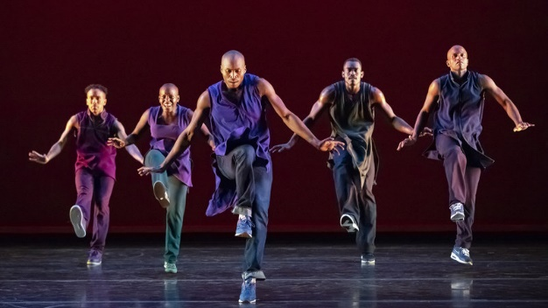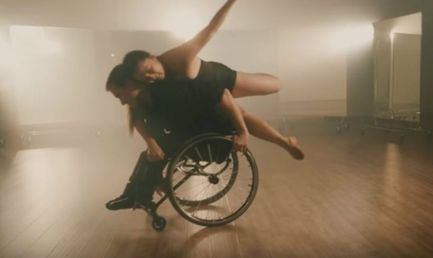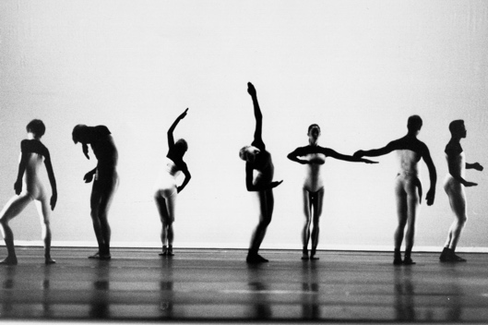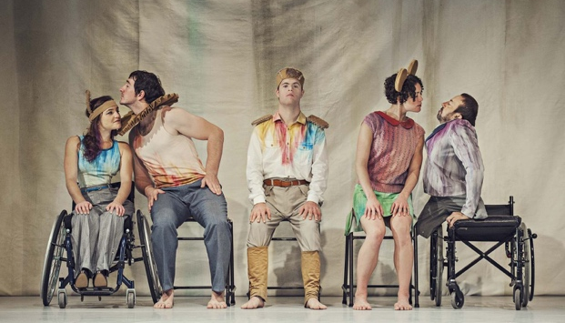

KS4 DANCE MEDIUM-TERM PLANNING
Aspiration for Life |  |  |  | Differentiated, aspirational targets dependent on pupil needs. |  |  |  | Language for Life |  | Explicit teaching/ exposure to new and know vocabulary. |  |  | Learning for Life |  |  | Opportunities to develop cross curricular skills e.g. drama
SMSC |  |  |  | Collaborative learning amongst whole key stage throughout topics / Peer assessment and acting upon feedback / Exposure to different time periods and cultures around the world / Encouragement for learners to work with independence.
Cycle 1 | To build on skills and knowledge of the basic elements of dance. To provide an encouraging environment to facilitate confidence, creativity & self-expression | Dancer | Theatre Performer | Teacher | Dance Therapist | YouTuber | Movement Photographer | Stunt Performer | Theatre Blogger | Dance Critic | DANCE AROUND THE WORLD |  |  |  |  |  | NUMBERS |  |  |  |  | THE VICTORIANS
 |  |  | Autumn 1  7 weeks |  |  |  | Autumn 2  7 weeks |  | Spring 1  6 weeks |  |  | Spring 2  6 weeks |  | Summer 1  5 weeks |  |  | Summer 2  7 weeks
 |  |  | Skill Focus: Actions |  |  |  |  |  | Skill Focus: Space |  |  | Skill Focus: Relationships |  | Skill Focus: Dynamics
 |  |  | Discover different ACTIONS through exploring, selecting and refining movements. Exhibit these through performance and evaluation opportunities. |  |  |  |  |  | Discover SPACE & RELATIONSHIPS through exploring, selecting and refining movements. Exhibit these through performance and evaluation opportunities. |  |  |  |  | Discover DYNAMICS through exploring, selecting and refining movements. Exhibit these through performance and evaluation opportunities.
 |  |  | SUGGESTED MUSIC
 |  |  | He Lives in You  (Lion King the Musical)  Wade in the Water  (Howard Roberts/Alvin Ailey)  Africa  (Shakira)  Rock My Soul  (Lee Humphrey Singers)  Despacito  (Luif Fonsi) |  |  |  | Baila Morena Flamenco  (Zumba)  Shakesenora  (Pitbull)  Preparing for the Dragon Dance  (Dragon Power)  Capoeira Music  (Halosamua)  Jai Ho  (A R Rahmen) |  | Mambo Number 5  (Lou Bega)  ABC  (The Jackson 5)  Alt. Easy Love  (Sigala)  Disco 2000  (Pulp) |  |  | 5 Colours in her Hair  McFly  22  (Taylor Swift)  One Vision  (Queen)  7 Nation Army  (The White Stripes) |  | Tubular Bells  (Mile Oldfield)  Jerusalem  Sherlock Holmes  (Hanz Zimmer) |  |  | Clockwork  (Jazz Fezz)  Glasgow Low Theme  (Slow waltz - ballroom)
 |  |  | VOCABULARY
 |  |  | The Five Basic Body Actions |  |  |  | Jump  Travel  Stillness (balance)  Gesture  Turn |  | Direction  Pathways  Levels  Focus |  |  | Solo  Duet  Group  Unison  Canon |  | Rhythm  Speed  Body tension  Tempo
 |  |  | Delivered through the teaching of a Motif
 |  |  | IMPLEMENTATION
 |  |  | Week |  | 1  2-3  4-5  6-7  8-10  10-12 | Introduction: Get to know each other  Africa: Gesture & Jump (tribal)  Spain: Gesture & Turn (flamenco)  China: Gesture & Travel (theatrical)  Brazil: Gesture & Stillness (capoeira)  India: All Actions (Bhangra/Bollywood) |  |  | 1-2  3-4  5-6  7-8  9-10 |  | Solo exploration (motif- direction)  Duet (pathways & focus)  Duet (pair choreography)  Lottery Dance (group choreography)  Whole class Dance |  |  | 1  2  3  4-5  6  7  8-9  10-11 | Motif & Development  Dynamics  Tempo (Teach led choreography)  Victorian Life (group choreography)  Waltz (Pair choreography)  Shine Festival Rehearsals  Shine Festival Rehearsals  Shine Festival Performance
 | INTENT | CAREERS

KS4 DANCE MEDIUM-TERM PLANNING
Aspiration for Life |  |  |  | Differentiated, aspirational targets dependent on pupil needs. |  |  |  | Language for Life |  | Explicit teaching/ exposure to new and know vocabulary. |  | Learning for Life |  |  | Opportunities to develop cross curricular skills e.g. drama
Cycle 2 | To build on skills and knowledge of the basic elements of dance. To provide an encouraging environment to facilitate confidence, creativity & self-expression | Dancer | Theatre Performer | Teacher | Dance Therapist | YouTuber | Movement Photographer | Stunt Performer | Theatre Blogger | Dance Critic | DANCE THROUGH TIME |  |  |  |  |  | NARRATIVE |  | MUSICAL THEATRE |  | SPORT
 |  |  | Autumn 1  7 weeks |  |  |  | Autumn 2  7 weeks |  | Spring 1  6 weeks |  | Spring 2  6 weeks |  | Summer 1  5 weeks |  |  | Summer 2  7 weeks
 |  |  | Skill Focus: Actions |  |  |  |  |  | Skill Focus: Space |  | Skill Focus: Relationships |  | Skill Focus: Dynamics
 |  |  | Discover different ACTIONS through exploring, selecting and refining movements. Exhibit these through performance and evaluation opportunities. |  |  |  |  |  | Discover SPACE & RELATIONSHIPS through exploring, selecting and refining movements. Exhibit these through performance and evaluation opportunities. |  |  |  | Discover DYNAMICS through exploring, selecting and refining movements. Exhibit these through performance and evaluation opportunities.
 |  |  | SUGGESTED MUSIC
 |  |  | BALLET  Dance of the Cygnets  (Swan Lake)  Comptine d’un aute été, l’aprés-midi  (Yann Tiersen)  CHARLESTON  Sing Sing Sing  (Benny Goodman)  Bang Bang  (Wil-i-am)  THE LINDY HOP  Pencil full of Lead  (Paolo Nutini)  Grove is in the Heart  The Puppini Sisters |  |  |  | CONTEMPORARY  Breathe Me  (Sia)  Skinny Love  (Birdy)  Lost Without You  Freya Riding  HIP HOP  It’s Tricky  (Run DMC)  Push it Real Good  Salt ‘n’ Pepa  It’s Like That  (Run DMC) |  | *Linked to English learning & following chosen narrative.  Suggested Texts  Holes  (Louis Sacher)  Into Thin Air  (Jon Krakauer)  Lord of the Flies  (William Golding) |  | All that Jazz  (Chicago)  Jellicle Ball  (Cats)  Step in Time  (Mary Poppins)  Prologue  (West Side Story)  Buenos Aires  (Evita)  Electricity  (Billy Elliot)  One  (A Chorus Line) |  | You’ll Never Walk Alone  (Rogers & Hammerstein)  Liverpool FC  Eye of the Tiger  (Survivor)  Rocky Theme  Abide with Me  (Emile Sande)  FA Cup & London Olympics  Chariots of Fire  (Vangelis)  Bizet  (Carmen Prelude)  Formula 1 |  |  | Zadok the Priest  (Handel)  The Champions League  Nessun Dorma  (Puccini)  The World Cup  Boléro  (Ravel)  Olympics: Torvill & Dean  Swing Low Sweet Chariot  (UB40)  Rugby World Cup  Waka Waka  (Shakira)  South African World Cup
 |  |  | VOCABULARY
 |  |  | The Five Basic Body Actions |  |  |  | Jump  Travel  Stillness (balance)  Gesture  Turn |  | Direction  Pathways  Levels  Focus |  | Solo  Duet  Group  Unison  Canon |  | Rhythm  Speed  Body tension  Tempo
 |  |  | Delivered through the teaching of a Motif
 |  |  | IMPLEMENTATION
 |  |  | Week |  | 1  2-3  4-5  6-7  8-10  10-12 | Introduction: Get to know each other  Ballet: Gesture & Stillness  Charleston: Jump & Travel  The Lindy Hop: Jump & Turn  Contemporary: Gesture & Travel  Hip Hop: Gesture & Travel |  |  | Oral retelling of chosen story.  Create a motif  Motif Development (Direction)  Motif Development (Level)  Motif Development (Focus)  Motif Development (Pathway) |  | Solo exploration (motif)  Duet (choreography)  Group Dance 1: Unison  Group Dance 2: Canon  Group Dance Rehearsal  Group Dance Performance |  | 1  2  3  4-5  6  7  8-9  10-11 | Tempo – slow  Tempo – fast  Speed – Different speeds of movement to tempo  Accent the beat (Hard, sharp & quick)  Shine Festival Chorography (dynamics focussed)  Shine Festival Rehearsals  Shine Festival Rehearsals  Shine Festival Performance
 | INTENT | CAREERS

