Long Term Mapping
Design & Technology – KS3

 |  | Cycle 1 | Cycle 2 | Cycle 3
 |  | (2022-2023) | (2023-2024) | (2024 – 2025)
Autumn | 1 | Wooden Lettering & using stencils & templates  FPT’s – Focused Practical Tasks | Design and Make a box with a blackboard  FPT’s – Focused Practical Tasks | Design and Make Signs  FPT’s – Focused Practical Tasks
 | 2 | Design and Make Acrylic Tree Twirlers | Gaming/DVD Racks | Key Ring Shelves
Nets | 1 | Axles and Card Vehicles  FPT’s – Focused Practical Tasks | Design and Make a Roundabout  FPT’s – Focused Practical Tasks | Nets and Packaging  FPT’s – Focused Practical Tasks
 | 2 | Design and Make a Wooden Vehicle | Movement and Mechanisms | Design and Make a Healthy Snack Pack
Summer | 1 | Mobile phone/iPad Holders/Photo frames  FPT’s – Focused Practical Tasks | Design and Make a set of coat hooks  FPT’s – Focused Practical Tasks | Mobiles and Wind Catchers  FPT’s – Focused Practical Tasks
 | 2 | SHINE preparation and manufacture | Notice Boards  SHINE preparation and manufacture | Design and Make Musical Instruments  SHINE preparation and manufacture

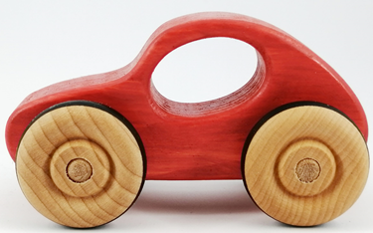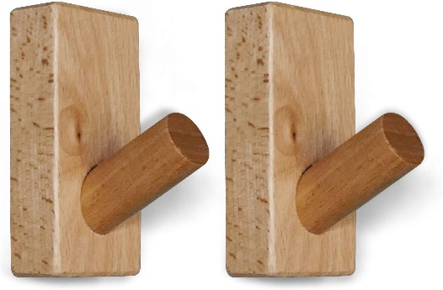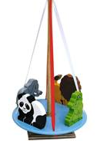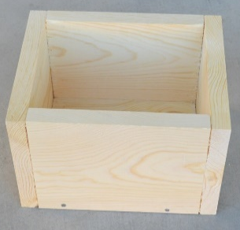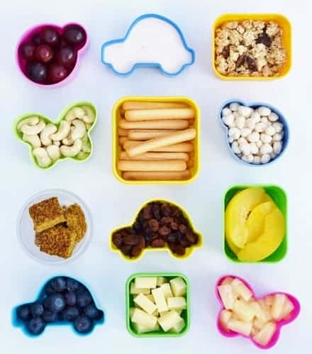

MEDIUM-TERM PLANNING 2022- 2023
Aspiration for Life |  | Differentiated, aspirational targets dependent on pupil needs.  Aspiring to make outstanding products that could be sold |  | Language for Life |  | Explicit teaching/ exposure to new & known vocabulary. |  | Learning for Life |  | Opportunities to develop cross curricular skills e.g. drama, Art History and using DIY skills, including links to hobbies
CYCLE 1 – 2022 - 2023 | Design and Technology Skills (Resistant Materials): Pupils will create significant levels of originality & the willingness to take creative risks to produce innovative ideas & prototypes. They will have an excellent attitude to learning & independent working. Pupils will master practical skills including cutting materials safely using tools provided, measure & demonstrate a range of cutting and shaping techniques. They will use a range of joining techniques & use materials to practise drilling, screwing, gluing & nailing materials to make & strengthen products. Design with purpose by identifying opportunities to design & make products by working efficiently. They will gain the ability to carry out thorough research, show initiative & ask questions to develop an exceptionally detailed knowledge of users’ needs. They will gain the ability to act as responsible designers & makers, working ethically, using finite materials carefully & working safely. Pupils will create simple products & have a thorough knowledge of which tools, equipment & materials to use to make their products. They will refine work & techniques as work progresses, continually evaluating the product design. | LETTERING, PLAQUES & SCENERY/PROPS  MATERIALS = MIXED/TEMPORARY |  |  | NETS & CONTAINERS –3D SHAPES  EASTER EGG DESIGN & VACUUM FORMING  MATERIALS = PLASTIC/TEMPORARY |  |  |  | MOBILES, JIGSAWS & MUSICAL INSTRUMENTS  MATERIALS = WOOD/TEMPORARY/MIXED/NATURAL
 |  | Autumn 1  7 weeks | Autumn 2  7 weeks |  | Spring 1  6 weeks |  | Spring 2  7 weeks |  | Summer 1  5 weeks |  | Summer 2  7 weeks
 |  | Where’s my Keys? Where’s my phone plaque | Key Ring Shelves  Scenery & Props |  | Nets and Packaging – Influences = Escher Mathematician/NETS |  | Design & Make a Healthy Snack Pack |  | Mobiles & Wind catchers |  | Musical Instruments  SHINE Preparation
 |  | Week 1- Health & Safety – Rules & Routines. Design Stage.  Weeks 2 + 3 Practicing drawing around templates & within stencils  Weeks 4 – 7 Design, Plan, Make & Evaluate, Improve? | Week 1 - Health & Safety – Rules & Routines. Design Stage.  Weeks 2 + 3 Drawing around templates/stencils  Weeks 4 – 7 Design, Plan, Make & Evaluate, Improve |  | Week 1- Health & Safety – Rules & Routines. Investigate Nets  Weeks 2 -5 Investigating nets – 2D /3D shapes, tabs, making packaging. Design a new Easter Egg Box  Week 6 Design, Plan, Make &-Evaluate, Improve |  | Week 1-4 Evaluate existing snacks – what are they made from? Investigate plastics. Design a Healthy Snack Pack/Use ICT to design using Publisher  Weeks 5 - Health & Safety – Rules & Routines. Watch the Vacuum Forming Machine working/watch videos, continue designs. Week 6 Design, Plan, Make & Evaluate, Improve Invite your Food Technology friends to try our Packs! |  | Week 1- Health & Safety – Rules & Routines. Play with Wind-catchers outside  Weeks 2 -4 Design wind catchers based on Spiral shapes & twisted acrylic sheet. Look at how acrylic is manufactured.  Week 5 - Design, Plan, Make & Evaluate, Change? Can they move in the wind? |  | Week 1- Health & Safety – Rules & Routines. Evaluate musical instruments  Weeks 2 + 3 Design & Make musical instruments using recycled and natural materials  Weeks 4 – 7 Design, Plan, Make & Evaluate, Improve  Do they make a noise?
 |  | SKILLS LINKED TO THE DESIGN PROCESS – DESIGN, PLAN, MAKE, EVALUATE, IMPROVE
 |  | Drawing around templates  Using Stencils/Templates  Design a new alphabet – looking at Typography  FPT’s -using Fine Felt tips  Colouring shapes  Cutting using scissors  Practice fine motor skills | Sanding & painting pre-prepared set installations. Using jigsaw to cut out large installations. Adding paint with rollers, fine line work along edges. Using art skills. Wallpapering  Using a decorators roller |  | Looking at existing Easter Eggs  Design a new Easter Egg and make an advert for it  Drawing & Annotating  2D/3D shapes  Drawing nets - 3D shapes  Cutting using scissors  Cutting using craft and Stanley knives - cutting mat  Scoring and Folding |  | Designing a Healthy Snack Pack/design their own packaging using ICT  FPT’s - folding, packaging, assembly  Nets, containers, investigating shapes  Healthy Food Posters – Food triangle & what we can have in our snack pack  Vacuum forming & mould making  Junk Food alternative Packaging |  | Choosing images for mobiles & wind catchers  Heating & twisting acrylic strips on the Strip Bar heater  Attaching – using glue/masking tape/tape/wood glue/PVA  Arts Week preparation & manufacture –banners |  | Looking at Existing musical instruments /jigsaws /mobiles/who is our product for?  Making musical instruments using junk/mixed materials /beads /stones/wooden blocks. Links to Andy Goldsworthy. Using saws to cut thick cardboard tubes  3D models /flowers /bugs /funky art installations
 |  | VOCABULARY (in addition to the skills list above)
 |  | Draw around  Hold down/press down  Name plaque  Typography/Alphabet  Keep all drawing tools upright – vertical when drawing around templates and stencils | Drawing  Sanding  Drilling small holes  Push and twist  Roll/spread/attach  Boiler suit/Health & Safety |  | Nets and tabs  2D/3D shapes  Scoring and folding  Cutting on the line  Be careful/press down on the card and keep your fingers away |  | Packaging/Advertising  Healthy foods from the Food Triangle  Vacuum Forming Machine – how products are manufactured.  Heat/cooling down/plastics  Thermoplastics/thermosetting plastics |  | Momentum  Wind Power  Twirling and twisting  Acrylic Strip Bar Heater |  | Attach/Model/Paper Mache  Collage/
 |  | IMPLEMENTATION
 |  | Week 1: Template work  Week 2: Where’s My Keys? /Where’s my Phone Plaque  Week 3 Typography  Week 4:Using a Power Sander  Week 5Using a drill driver  Week 6: Design and make  Week 7: Assessment | Week 1: Demo and Health and Safety  Week 2: Drawing – KEY plaque – stencil work  Week 3 Sanding  Week 4: Drilling small holes & threading ribbon  Week 5-6: Set & props  Week 7: Assessment and Evaluation |  | Week 1:Demo & Health & Safety  Week 2: Nets and tabs  Week 3 2D/3D shapes  Week 4: Scoring and folding  Week 5: Cutting on the line and making Easter Egg Nets  Week 6: Assessment |  | Week 1: Investigating Snack Packs  Week 2: Design packaging using ICT  Week 3: Healthy Snack Pack designs including what is inside  Week 4: Card folding, packaging, Nets, assembly  Week 5 – Vacuum Forming Machine  Week 6: Healthy Food Posters gaining our attention – advertising & wants/needs  Week 7: Assessment and Evaluation |  | Week 1: Demo & Health & Safety  Week 2: mobiles & wind catchers  Week 3 Heating & twisting acrylic strips on the Strip Bar heater  Week 4: Wooden wind catchers based on a rugby ball shape  Week 5: Assessment |  | Week 1: Demo and Health and Safety  Week 2: Making musical instruments  Week 3 Shakers Wooden block scrappers  Week 4-6 : Shine prep  Week 7: Assessment and Evaluation
 | INTENT

FUTURE CAREER AND ENTERPRISE OPPORTUNITIES
- Working as a designer/Blogger/vLogger/tradesperson working in a practical environment
- Working as a YouTuber – sharing design work on social media
- Becoming an influencer on social media – videos of DIY/painting/upcycling/hobbies/projects with design materials
- Working in the Design/Commercial Sector
- Working in the Trade industry – painting, decorating, renovating, upholstery, antiques
- Working in the DIY industry – renovating, designing, upcycling, fixing and using woodworking, craft and design tools
- Working in the retail world – selling design tools and materials – builders’ merchants, tool sales
- Promoting events in the future.
- Working towards exhibitions and designing spaces
- Auction of woodworking products to raise money for school funds
- Selling products at Shine Festival and school fair
- Enhancing appearance of school with 3D design
- Working in any Design and Make industry that uses sustainable materials for the future of our planet

LINKS TO CULTURAL CAPITAL = GREEN
LINKS TO PROGRESSION DOCUMENT = BLUE

