Long Term Mapping

DANCE & DRAMA KS3

 |  | Cycle 1 | Cycle 2 | Cycle 3
 |  | (2022-2023) | (2023-2024) | (2024-2025)
Autumn | 1 | BASIC DRAMA SKILLS | BASIC DRAMA SKILLS | BASIC DRAMA SKILLS
 | 2 | SECONDARY SHOW & REHEARSALS | SECONDARY SHOW & REHEARSALS | SECONDARY SHOW & REHEARSALS
Spring | 1 | DARKWOOD MANOR | PANTOMIME | MACBETH (WITCHES)
 | 2 | THE NUTCRACKER | SWAN SONG | ROCK & ROLL
Summer | 1 | USING SCRIPTS | OUR DAY OUT | ROALD DAHL’S REVOLTING RHYMES
 | 2 | PIRATES OF THE CARIBBEAN | THE LION KING | CAPOEIRA

DANCE & DRAMA
Subject skills & techniques are broken down into the following areas. Throughout the mapping, focus is placed on these areas where relevant to the topic.
DRAMA SKILLS | DANCE TECHNICAL SKILLS
Facial Expression | Body Language | Gestures | Focus | Voice (Tone, Accent, Pitch & Projection) | Action | Space | Dynamics | Relationship | Timing | Rhythm
DRAMA TECHNIQUES | DANCE PHYSICAL SKILLS
Freeze Frame | Sequencing | Thought Track | Flash Back | Flash Forward | Slow Motion Physical Theatre | Plot (Beginning/Middle/End) | Cliff hanger | Improvisation | Balance | Co-ordination | Extension |Flexibly | Posture | Mobility | Stamina
 | DANCE EXPRESSIVE SKILLS
DRAMA STYLES | Energy | Focus | Exaggeration | Musicality | Facial Expression
Comedy | Tragedy | Melodrama | Natalism | Physical
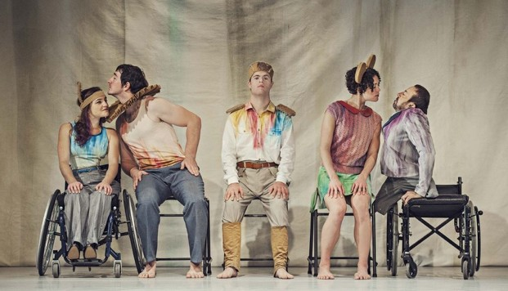
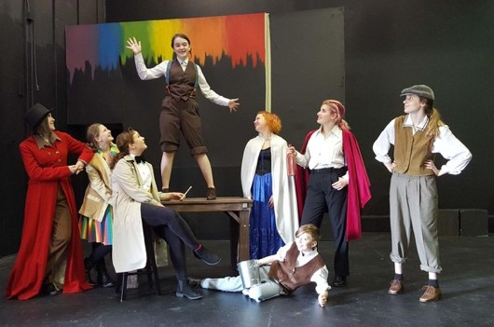
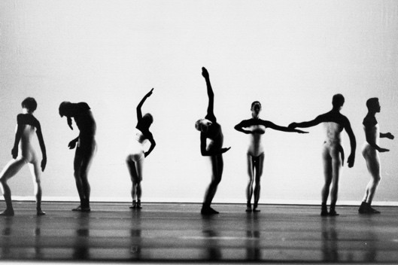
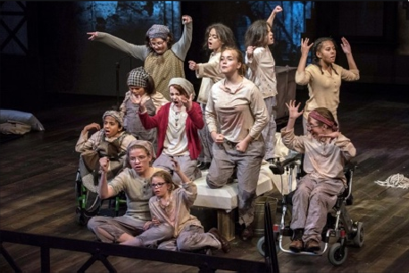

KS3 DANCE & DRAMA MEDIUM-TERM PLANNING
Aspiration for Life | Differentiated, aspirational targets dependent on pupil needs. | Language for Life | Explicit teaching/ exposure to new and know vocabulary. | Learning for Life | Opportunities to develop cross curricular skills e.g. drama
SMSC | Collaborative learning amongst whole key stage throughout topics / Peer assessment and acting upon feedback / Exposure to different time periods and cultures around the world / Encouragement for learners to work with independence.
Cycle 1 | To build on skills and knowledge of the basic elements of dance. To provide an encouraging environment to facilitate confidence, creativity & self-expression | Dancer | Theatre Performer | Teacher | Dance Therapist | YouTuber | Movement Photographer | Stunt Performer | Theatre Blogger | Dance Critic | DRAMA | DRAMA | DANCE | DRAMA | DANCE | DRAMA | DANCE
 |  |  | Autumn 1  7 weeks | Autumn 2  7 weeks |  | Spring 1  6 weeks | Spring 2  6 weeks | Summer 1  5 weeks | Summer 2  7 weeks
 |  |  | Basic Drama Skills | Secondary Show |  | Darkwood Manor | The Nutcracker | Using Scripts | Pirates of the Caribbean
 |  |  | Stimuli: Images, Film & Sounds  Style: Naturalism & Physical Theatre | Stimuli: Text, Script or Film  Style: Dependent on chosen stimuli |  | Stimuli: Image & Story  Style: Melodrama & Physical Theatre | Stimuli: Nutcracker, Stereotypes (contrasting motifs male/Female?) & motif development.  Style: Ballet & Contemporary | Stimuli: Script (Litter Gang, Rat’s Delight & The Lion, the Witch & the Wardrobe.  Style: Comedy, Melodrama & Physical Theatre | Stimuli: Pirates  Style: Combat
 |  |  | DRAMA TECHNIQUE | DRAMA TECHNIQUE |  | DRAMA TECHNIQUE | DANCE TECHNICAL SKILLS | DRAMA TECHNIQUE | DANCE TECHNICAL SKILLS
 |  |  | Freeze Frame | Following direction Script |  | Physical Theatre  Plot (Beginning, Middle & End) Cliffhanger | Gestures  Travel | Physical Theatre Improvisation  Following direction & script | Action: gestures Space: different levels  Dynamics – changing speed of movement.
 |  |  |  | DRAMA SKILLS
Freeze Frame Sequences

Thought Tracking
 |  |  |  | Facial Expression  Voice (Tone, Pitch & Projection) Following Stage Directions |  |  | Timing
 |  |  |  |  |  |  | DANCE PHYSICAL SKILLS |  | DANCE PHYSICAL SKILLS
 |  |  |  |  |  |  | Balance  Posture Co-ordination |  | Co-ordination, mobility and strength
 |  |  | DRAMA SKILLS | DANCE TECHNICAL SKILLS |  | DRAMA SKILLS |  | DRAMA SKILLS
 |  |  | Facial Expression | Movement Memory Timing |  | Facial Expression Body Language Focus
 |  |  | Body Language | DANCE PHYSICAL SKILLS |  |  | DANCE EXPRESSIVE SKILLS | Voice (Tone & Projection) | DANCE EXPRESSIVE SKILLS
 |  |  |  | Co-ordination Stamina |  |  | Exaggeration & Musicality |  | Exaggeration and musicality
 |  |  | Gestures |  |  |  |  | Body Language
 |  |  | Focus Mime | DANCE EXPRESSIVE SKILLS |  |  | MUSIC SUGESTIONS | Gestures | MUSIC SUGESTIONS
 |  |  |  | Energy Focus |  |  | Tchaikovsky – The Nutcracker Trepak- Russian Dance: Gobstopper Tea – Chinese Dance: Marshmallow |  | Pirates of the Caribbean Theme Song (YouTube)
 |  |  | VOCABULARY
 |  |  | Emotions and their synonyms  e.g. Sad, angry or frustrated  *plus, vocabulary which describes the technique/skill being used. | Stage Left (SL) Stage Right (SR) Entrance  Exit  Centre Stage (CS) or (C) Props  Costumes |  | *plus, vocabulary which describes the technique/skill being used. | motif  Gobstopper – Male/Masculine Marshmallow – Female/Feminine  Ballet Terminology  Plié Relevé | *plus, vocabulary which describes the technique/skill being used. | pirate sword levels focus rhythm speed  *plus, vocabulary which describes the technique/skill being used.
 |  |  | IMPLEMENTATION
 |  |  | Introduction  Still Image: Physical Theatre Still Image: Freeze Frame (solo) Still Image: Freeze Frame sequences (Group)  Still Image: Mime  Sound: Freeze Frame Sequence  Stimuli: Devise still image. Stimuli: Devise a scene using Freeze Frame sequence and then connect together with a scene. | Introduction  Auditions: All of Secondary Rehearsals: students used when needed (Principals)  Rehearsals: students used when needed (Ensemble)  Rehearsals  Rehearsals: Technical & Dress Performances: To an audience Celebration: Watch the performance |  | Introduction  Horror: Facial Expression  Statue: Body Language  Story: Retell the story of Darkwood Manor  Multi-Role: Interviewing the locals around the manor.  Devise: Approaching the manor Devise: Entering the manor Devise: Horrific event  Perform: Connecting Scenes | Introduction  Ballet: Basic Ballet Technique Marshmallow: Teacher led motif Marshmallow: Student contribution Marshmallow: Combined choreography  Gobstopper: Teacher led motif Gobstopper: Student contribution Gobstopper: Combined choreography Perform: Marshmallow & gobstopper comparison. | Introduction  Script: Features of a script  Script: Stage directions  Litter Gang: Character information Litter Gang: Follow a script (voice) Rat’s Delight: Character information  Rat’s Delight: Create a character LW&W: Voice & Body Language LW&W: Rehearse a scene LW&W: Perform a scene | Introduction  Become a Pirate: Body language & gestures  Action: Gestures & strength Space: Levels of movement using imaginary sword.  Dynamics: Slow & fast exaggerated movements with a sword.  Student Choreography: 1 phrase Student Choreography: +1 phrase Perform: Movement & musicality
 | INTENT | CAREERS

KS3 DANCE & DRAMA MEDIUM-TERM PLANNING
Aspiration for Life |  |  |  | Differentiated, aspirational targets dependent on pupil needs. |  |  | Language for Life |  | Explicit teaching/ exposure to new and know vocabulary. |  | Learning for Life |  | Opportunities to develop cross curricular skills e.g. drama
SMSC |  |  |  | Collaborative learning amongst whole key stage throughout topics / Peer assessment and acting upon feedback / Exposure to different time periods and cultures around the world / Encouragement for learners to work with independence.
Cycle 2 | To build on skills and knowledge of the basic elements of dance. To provide an encouraging environment to facilitate confidence, creativity & self-expression | Dancer | Theatre Performer | Teacher | Dance Therapist | YouTuber | Movement Photographer | Stunt Performer | Theatre Blogger | Dance Critic | DRAMA |  | DRAMA | DANCE |  | DRAMA |  | DANCE |  | DRAMA |  | DANCE
 |  |  | Autumn 1  7 weeks |  | Autumn 2  7 weeks |  |  | Spring 1  6 weeks |  | Spring 2  6 weeks |  | Summer 1  5 weeks |  | Summer 2  7 weeks
 |  |  | Basic Drama Skills |  | Secondary Show |  |  | Pantomime |  | Swan Song |  | Our Day Out |  | The Lion King
 |  |  | Stimuli: Images, Film & Sounds |  | Stimuli: Text, Script or Film |  |  | Stimuli: Tradition Fairy tale/ Script |  | Stimuli: Swansong/conflict |  | Stimuli: Script |  | Stimuli: The Lion King
 |  |  | Style: Naturalism & Physical  Theatre |  | Style: Dependent on chosen  stimuli |  |  | Style: Melodrama |  | Style: Contemporary dance trio |  | Style: Naturalism & Comedy |  | Style: African
 |  |  | DRAMA TECHNIQUE |  | DRAMA TECHNIQUE |  |  | DRAMA TECHNIQUE |  | DANCE TECHNICAL SKILLS |  | DRAMA TECHNIQUE |  | DANCE TECHNICAL SKILLS
 |  |  | Freeze Frame Freeze Frame Sequences  Thought Tracking |  | Following direction Script |  |  | Slap Stick Comedy  Audience Participation |  | Action and relationships (trio, unison, canon, Q&A) |  | Following direction & script Improvisation  Multi-Role |  | Action, Dynamics & Space
 |  |  |  |  | DRAMA SKILLS
 |  |  |  |  | Facial Expression  Voice (Tone, Pitch & Projection) Following Stage Directions |  |  | Physical Theatre  Beginning/Middle/End
 |  |  |  |  |  |  |  |  |  | DANCE PHYSICAL SKILLS |  |  |  | DANCE PHYSICAL SKILLS
 |  |  | DRAMA SKILLS |  | DANCE TECHNICAL SKILLS |  |  | DRAMA SKILLS |  | Balance, co-ordination and flexibility |  | DRAMA SKILLS |  | Co-ordination & Stamina
 |  |  | Facial Expression |  | Movement Memory Timing |  |  |  |  |  |  | Voice (Accent & Projection)
 |  |  |  |  | DANCE PHYSICAL SKILLS |  |  |  |  | DANCE EXPRESSIVE SKILLS |  |  |  | DANCE EXPRESSIVE SKILLS
 |  |  |  |  |  |  |  | Facial Expression
 |  |  | Body Language  Gestures |  |  |  |  | Body Language |  |  |  | Body Language  Gestures
 |  |  |  |  | Co-ordination Stamina |  |  |  |  | Facial Expression, Focus & Exaggeration |  |  |  | Energy, Exaggeration & Facial Expression
 |  |  |  |  | DANCE EXPRESSIVE SKILLS |  |  |  |  | MUSIC SUGESTIONS |  |  |  | MUSIC SUGESTIONS
 |  |  | Focus |  |  |  |  | Gestures |  |  |  | Focus
 |  |  |  |  | Energy Focus |  |  |  |  | Swansong choreographed by Christopher Bruce - music by Philip Chambon (YouTube) |  |  |  | The Lion King: Original Broadway Cast Recording  He Lives in You or The Lioness Hunt
 |  |  | VOCABULARY
 |  |  | Emotions and their synonyms  e.g. Sad, angry or frustrated  *plus, vocabulary which describes the technique/skill being used. |  | Stage Left (SL) Stage Right (SR) Entrance  Exit  Centre Stage (CS) or (C) Props  Costumes |  |  | Pantomime Dame  Principal Boy/Hero Villain Damsel  Magical Creature Comedy Sidekick.  *plus, vocabulary which describes the technique/skill being used. |  | conflict anger afraid intimidation victim unison canon direction pathways |  | Liverpool stereotype poor slang  characterisation  *plus, vocabulary which describes the technique/skill being used. |  | Tribal Body Percussion  Stomp Vocal/ Vocalisation  *plus, vocabulary which describes the technique/skill being used.
 |  |  | IMPLEMENTATION
 |  |  | Introduction  Still Image: Physical Theatre Still Image: Freeze Frame (solo) Still Image: Freeze Frame sequences (Group)  Still Image: Thought Tracking Sound: Freeze Frame Sequence Stimuli: Devise still image.  Stimuli: Devise a scene using Freeze Frame sequence and then connect together with a scene. |  | Introduction  Auditions: All of Secondary Rehearsals: students used when needed (Principals)  Rehearsals: students used when needed (Ensemble)  Rehearsals  Rehearsals: Technical & Dress Performances: To an audience Celebration: Watch the performance |  |  | Introduction – Fairy tales  Story: Retelling of a traditional Fairy tale  Roles: Traditional/stock roles within a pantomime.  Multi-Role: Switching characters. Devise: Character Introductions. Devise: Comedy Sketch (slapstick) Devise: Audience Participation (villain)/ Pantomime gaps.  Devise: Create mini pantomime |  | Introduction  Gestures: Intimidation & exaggeration  Body Language: Frightened victim  Contact: Duo & Trio work  Teacher led: Phrase of movement. Student Choreography: circular walking in space to intimidate victim Student Choreography: addition of gesture.  Student Choreography: addition of a phrase of contact |  | Script | developing characterisation  Script: Features of a script  Scene: Carol & Les (others crossing the road as different characters) Scene: Mrs Kay & Children on the yard (playground antics)  Scene: Headmaster & Mr Briggs (argument)  Scene: Bus Driver  Scene: Bus |  | Introduction Choreography: Teacher Led  Choreograph: Body percussion duet/trio.  Choreography: Teacher Led adding phrases.  Choreograph: vocal Choreography: Teacher Led Choreograph: African Rain Dance ceremony.  Rehearse: Full Dance  Preform: Peer Evaluation
 | INTENT | CAREERS

KS3 DANCE & DRAMA MEDIUM-TERM PLANNING
Aspiration for Life |  |  |  | Differentiated, aspirational targets dependent on pupil needs. |  |  | Language for Life |  | Explicit teaching/ exposure to new and know vocabulary. |  | Learning for Life |  | Opportunities to develop cross curricular skills e.g. drama
SMSC |  |  |  | Collaborative learning amongst whole key stage throughout topics / Peer assessment and acting upon feedback / Exposure to different time periods and cultures around the world / Encouragement for learners to work with independence.
Cycle 2 | To build on skills and knowledge of the basic elements of dance. To provide an encouraging environment to facilitate confidence, creativity & self-expression | Dancer | Theatre Performer | Teacher | Dance Therapist | YouTuber | Movement Photographer | Stunt Performer | Theatre Blogger | Dance Critic | DRAMA |  | DRAMA | DANCE |  | DRAMA |  | DANCE |  | DRAMA |  | DANCE
 |  |  | Autumn 1  7 weeks |  | Autumn 2  7 weeks |  |  | Spring 1  6 weeks |  | Spring 2  6 weeks |  | Summer 1  5 weeks |  | Summer 2  7 weeks
 |  |  | Basic Drama Skills |  | Secondary Show |  |  | Macbeth |  | Rock & Roll |  | Revolting Rhymes |  | Capoeira
 |  |  | Stimuli: Images, Film & Sounds |  | Stimuli: Text, Script or Film |  |  | Stimuli: Text |  | Stimuli: 1950s Dance |  | Stimuli: Script |  | Stimuli: Brazilian Martial Arts
 |  |  | Style: Naturalism & Physical Theatre |  | Style: Dependent on chosen stimuli |  |  | Style: Tragedy |  | Style: Rock & Roll |  | Style: Comedy |  | Style: Capoeira
 |  |  | DRAMA TECHNIQUE |  | DRAMA TECHNIQUE |  |  | DRAMA TECHNIQUE |  | DANCE TECHNICAL SKILLS |  | DRAMA TECHNIQUE |  | DANCE TECHNICAL SKILLS
 |  |  | Freeze Frame |  | Following direction Script |  |  | Sequencing |  | Action  Relationship |  | Sequencing |  | Relationship  Space
 |  |  |  |  | DRAMA SKILLS
 |  |  | Freeze Frame Sequences Thought Tracking |  |  |  |  | Thought Tracking Following a Script |  | Timing |  | Improvisation Free Frame |  | Actions
Facial Expression
Voice (Tone, Pitch & Projection) Following Stage Directions
 |  |  |  |  |  |  |  |  |  | DANCE PHYSICAL SKILLS |  |  |  | DANCE PHYSICAL SKILLS
 |  |  |  |  |  |  |  |  |  | Co-ordination Extension |  |  |  | Co-ordination, Extension & Flexibility
 |  |  | DRAMA SKILLS |  | DANCE TECHNICAL SKILLS |  |  | DRAMA SKILLS |  |  |  | DRAMA SKILLS
 |  |  | Facial Expression |  | Movement Memory Timing |  |  |  |  |  |  | Facial Expression Gestures  Voice (Tone & Accent)
 |  |  |  |  | DANCE PHYSICAL SKILLS |  |  |  |  | DANCE EXPRESSIVE SKILLS |  |  |  | DANCE EXPRESSIVE SKILLS
 |  |  | Body Language Gestures |  |  |  |  | Facial Expression Body Language
 |  |  |  |  | Co-ordination Stamina |  |  |  |  | Energy |  |  |  | Focus & Exaggeration
 |  |  |  |  | DANCE EXPRESSIVE SKILLS |  |  |  |  | MUSIC SUGESTIONS |  |  |  | MUSIC SUGESTIONS
Capoeira Music (YouTube)
Carsten Lovenkrands
 |  |  | Focus |  | Energy Focus |  |  | Voice (Projection & Pitch) |  | Jail House Rock  Elvis Presley/Blues Brothers
 |  |  | VOCABULARY
 |  |  | Emotions and their synonyms  e.g. Sad, angry or frustrated  *plus, vocabulary which describes the technique/skill being used. |  | Stage Left (SL) Stage Right (SR) Entrance  Exit  Centre Stage (CS) or (C) Props  Costumes |  |  | Macbeth Witches cauldron  *plus, vocabulary which describes the technique/skill being used. |  | Rock & Roll Hand Jive Twist  Kick Ball Change Leap Frog  *plus, vocabulary which describes the technique/skill being used. |  | Vocabulary taken from the poem chosen. When introduced, allow pupils to choose which poems to bring to life.  *plus, vocabulary which describes the technique/skill being used. |  | Capoeira esquiva (dodge)  ginga (right to left movements)  *plus other Portuguese terms to describe body parts and movements.
 |  |  | IMPLEMENTATION
 |  |  | Introduction  Still Image: Physical Theatre Still Image: Freeze Frame (solo) Still Image: Freeze Frame sequences (Group)  Still Image: Thought Tracking Sound: Freeze Frame Sequence Stimuli: Devise still image.  Stimuli: Devise a scene using Freeze Frame sequence and then connect together with a scene. |  | Introduction  Auditions: All of Secondary Rehearsals: students used when needed (Principals)  Rehearsals: students used when needed (Ensemble)  Rehearsals  Rehearsals: Technical & Dress Performances: To an audience Celebration: Watch the performance |  |  | Introduction  Becoming a character: Witch Script: Read in groups the witches spell in the character of a witch.  Props: Use props to recreate the scene, pupils to put objects into a cauldron and add gesturers.  Spell: Pupils to plan & create their own spell.  Script: Write their spell as a script.  Spell: Act out and create scene. |  | Introduction  Teacher routine: Learn choreography week 1 Teacher routine: Learn choreography week 2  Rock & Roll movement: Twist & kicks  Roca & Roll movement: Hand Jive & Turn.  Student Choreography (pairs):  Adding phrases and variation of Rock & Roll movements. |  | Introduction  Poem 1: Break up the poem up into Freeze Frames.  Freeze Frame Sequence:  Action Narration: Narrator step out of the freeze frame to read poem. Poem 2: Break up the poem up into Freeze Frames.  Freeze Frame Sequence:  Action Narration: Narrator step out of the freeze frame to read poem. |  | Introduction  Basic movement: combat gestures, smooth kicks & arm gestures.  Basic movement: ginga/ esquiva Teacher led routine: Phrase 1 Teacher led routine: Phrase 2 Pair: Pupils Mirror each other whilst performing routine and add phrase. Rehearse  Perform: Perform including self & peer assessment.
 | INTENT | CAREERS

