Long Term Mapping
KS3 Humanities

 |  | Cycle 1 | Cycle 2 | Cycle 3
 |  | (2020-2021) | (2021-2022) | (2022 – 2023)
Autumn | 1 | Globes, Maps & Atlases | Ordnance Survey Maps | Population and Urbanisation
 | 2 | Darwin’s ‘On the Origin of Species’ | The Norman Conquest | The Black Death
Spring | 1 | Geological timescales and plate tectonics | Climate Change | The Sahara & the Himalayas
 | 2 | Theatre, art, music and literature between 1509-1745 | Britain’s transatlantic slave trade | Local History
Summer | 1 | India & South Africa | Russia | Local Fieldwork
 | 2 | World War I | The Holocaust and World War II | Woman’s Suffrage

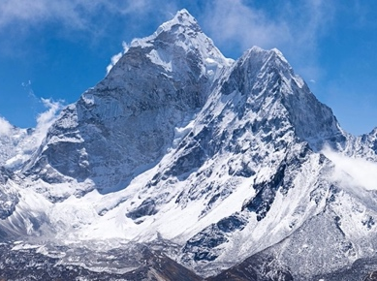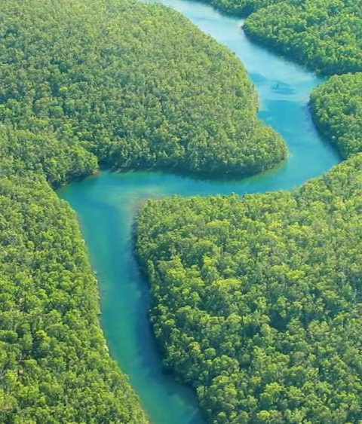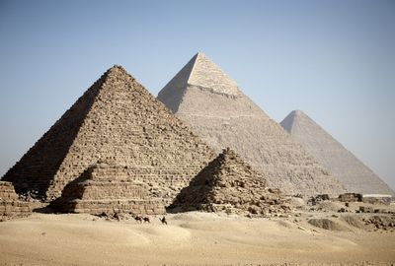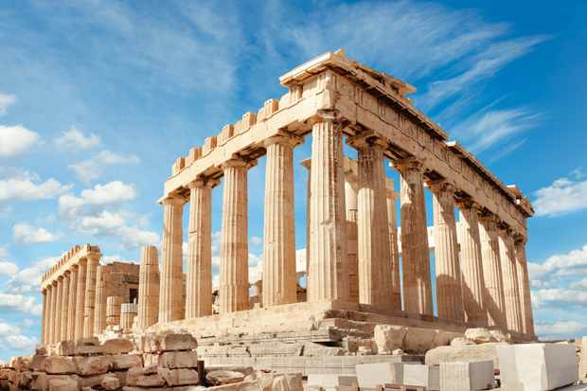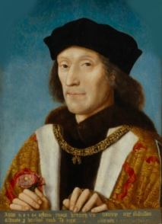

MEDIUM-TERM PLANNING (2020-21)
Aspiration for Life |  |  |  |  | Differentiated, aspirational targets dependent on pupil needs. |  |  | Language for Life |  |  | Explicit teaching/ exposure to new and know vocabulary. |  |  | Learning for Life |  |  | Opportunities to develop cross curricular skills
CYCLE 1 | For pupils to gain a deep and wide understanding of the world they live and the history of the world. All pupils should gain an understanding and appreciation of where they are in the world and key moments in history which shaped their community and the world. | Careers in geography and history are endless as the pupils will gain analytical skills which can applied to almost all workplaces. But common careers are: historian; librarian; Geographer; surveyor and any role around historical landmarks. | Globes, Maps & Atlases |  |  |  | Darwin’s ‘On The Origin of Species’ |  |  | Geological Timescales and Plate Tectonics |  | Theatre, art, music and literature between 1509 - 1745 |  |  | India & South Africa |  |  |  | World War I
 |  |  | Autumn 1  GEOGRAPHY  7 weeks |  |  |  | Autumn 2  HISTORY  7 weeks |  |  | Spring 1  GEOGRAPHY  6 weeks |  | Spring 2  HISTORY  6 weeks |  |  | Summer 1  GEOGRAPHY  5 weeks |  |  |  | Summer 2  HISTORY  7 weeks
 |  |  | HISTORICAL/GEOGRAPHICAL SKILLS (these should be developed through the various learning activates)
 |  |  | Geographical Skill and Fieldwork – Build on knowledge of Globes, Maps & Atlases |  |  |  | Using evidence | Continuity and change | Historical Perspective |  |  | Physical Geography - Understand the key processes in plate tectonics |  | Continuity and change |Using evidence |  |  | Place Knowledge - Understand geographical similarities, differences and links between places |  |  |  | Continuity and change |Using evidence | Historical Perspective | Cause and consequence
 |  |  | VOCABULARY
 |  |  | Map | Atlas | Globe | Key | Continent | Country | City | United Kingdom | Equator | Tropics | Compass | Direction | Landmark | Road |  |  |  | Adaptation | Darwin | Scientific theory | Species | Galapagos | Evidence | Evaluation |  |  | Continents | Tectonic Plates | Crust | Mantle | Ocean | Volcano | Earthquake | Continental Drift | Pangaea | Fossils |  | Shakespeare | Rembrandt | Renaissance | Literature | Various musical instrument names of the period | |  |  | Similarity | Difference | Connection | Asia | Africa | Continent | India | South Africa | Delhi | Cape Town | Thar Desert | Table Mountain | Robben Island | Taj Mahal | Religion | Food | Sport |  |  |  | Trench | Warfare | World History | United Nations | Assassination
 |  |  | LINKS TO WIDER CURRICULUM (these links need to be made clear to the learners)
 |  |  | English: Adventure  Maths: Direction |  |  |  | Science: Animals including Humans  RE: Creationism  Creative Curriculum: Animals and their habitats | Our World |  |  | Geography: Volcanoes & Earthquakes  Science: Animals |  | English: Hamlet  Creative Curriculum: 16th and 17th Century London |  |  | RE: Hinduism  PSHCE: British Values  Computing: Collecting Data, Presenting Information |  |  |  | Music: War Time Britain  Geography: Map Reading
 |  |  | SUGGESTED ACTIVITIES
 |  |  | Create & follow maps of the school | Treasure hunt | Create a globe | Read local maps | Find specific places on a map | Country map bingo | Map the local area |  |  |  | Reading extracts of ‘On the Species of Origins’ | Mapping Darwin’s Journey | Making your own Beagle | Create your own animal | Creationism v Evolution debates |  |  | Timeline of Continental Drift | Piece together continents puzzle | Volcano models | Create clay fossils | Dig for fossils | Profile a continent |  | Remaking famous pieces of art | Acting out a Shakespearian play | Comparing and contrasting theatre/art between time periods |  |  | Comparing population/religion/food/sport/wildlife/exports etc. | Profile India | Profile South Africa | Timeline Countries History | Research Countries | Profile Famous Natives/Places |  |  |  | Making Poppies | Digging a Trench (out of clay) | Eating rations | Listening and making War Time Music/clothes etc
 |  |  | Stimulus visit suggestions
 |  |  | Tour and map Haslingden/Rossendale | Tolkien Trail (Clitheroe) |  |  |  | National History Museum | Bird watching |  |  | Natural History Museum |  | Rembrandt’s house | Art museums | York Tudor houses | Shakespeare Theatre |  |  | Knowsley Safari Park |  |  |  | WW1 Monuments  | Trip to Flanders field
 |  |  | IMPLEMENTATION
 | INTENT | CAREERS |  | Week 1: Recap Maps and Our World  Week 2: Globes – Continents and Oceans  Week 3 Globes - Countries  Week 4: Atlases – Countries  Week 5: Atlases - Cities  Week 6: Maps of the UK  Week 7: Local maps |  | Week 1: Recap: Adaptation, animals, habitats.  Week 2: Who is Charles Darwin?  Week 3: What did Darwin find when he went to Galapagos?  Week 4: What evidence did he have to support his claims?  Week 5: Evolution  Week 6: Creationism  Week 7: Evolution vs. Creationism |  |  | Week 1: Recap Volcanoes and Earthquakes, Continents.  Week 2: Pangaea  Week 3: Crust, mantle and Tectonic Plates  Week 4: Continental Drift & modern-day continents  Week 5 & 6: Fossils & how they connect tectonic plates to Pangaea |  |  |  | Week 1: Recap: 16th and 17th Century London; any knowledge of the Tudors  Week 2: Art  Week 3: Theatre  Week 4: Literature  Week 5: Music  Week 6: Comparing these with Modern art etc. |  |  | Week 1: Recap Victorians & Our World  Week 2: Overview of India and South Africa  Week 3: Similarities  Week 4: Differences  Week 5: Connections e.g. British Empire |  | Week 1: Recap: war time music and any knowledge of WWI  Week 2: The Assassination of Archduke Ferdinand  Week 3: The effects of the Assassination  Week 4: Trenches  Week 5: Dog Fights and the birth of Ariel Combat  Week 6: The Treaty of Versailles  Week 7: What woman did during the war

MEDIUM-TERM PLANNING (2021-22)
Aspiration for Life |  |  |  | Differentiated, aspirational targets dependent on pupil needs. |  | Language for Life |  | Explicit teaching/ exposure to new and know vocabulary. |  | Learning for Life |  | Opportunities to develop cross curricular skills
CYCLE 2 | For pupils to gain a deep and wide understanding of the world they live and the history of the world. All pupils should gain an understanding and appreciation of where they are in the world and key moments in history which shaped their community and the world. | Careers in geography and history are endless as the pupils will gain analytical skills which can applied to almost all workplaces. But common careers are: historian; librarian; Geographer; surveier and any role around historical landmarks. | Ordnance Survey Maps |  | The Norman Conquest |  | Climate Change |  | Britain’s Transatlantic Slave Trade |  | Russia |  | The Holocaust and World War II
 |  |  | Autumn 1  GEOGRPAHY  7 weeks |  | Autumn 2  HISTORY  7 weeks |  | Spring 1  GEOGRPAHY  6 weeks |  | Spring 2  HISTORY  6 weeks |  | Summer 1  GEOGRPAHY  5 weeks |  | Summer 2  HISTORY  7 weeks
 |  |  | HISTORICAL/GEOGRAPHICAL SKILLS (these should be developed through the various learning activates)
 |  |  | Geographical Skills and Fieldwork – interpret Ordnance Survey maps |  | Using evidence | Cause and Consequence| Historical Perspective |  | Human and Physical Geography – understand how human and physical process influence the climate |  | Using evidence | Continuity and change | Historical Perspective |  | Locational Knowledge – deepen spatial awareness of the world’s countries (Russia) |  | Continuity and change |Using evidence | Historical Perspective | Cause and consequence
 |  |  | VOCABULARY
 |  |  | Map | Symbol | Key | Legend | Grid | Grid Reference | Direction | Compass | Distance | Scale | Road | Landmark | Satellite | Contour Lines | Terrain |  | Norman | Hastings | Battle | Marching | Castles | Invasion | Anglo-Saxon |  | Global Warming | Pollution | Greenhouse Gases / Effect | Deforestation | Energy | Population | Atmosphere | Fossil Fuel | Renewable Energy | Reduce, Reuse, Recycle | Ice caps | Sea level |  | Slave | Slave Triangle | Transatlantic | Ships | Trade | America | Plantations |  | Russia | Moscow | St. Petersburg | Asia | Europe | Ruble | USSR | Human | Physical | Arctic Circle | Tundra | Polar Dessert | Siberia | Grasslands | Plains | Permafrost | Population | St. Basil’s Cathedral | Ural Mountains |  | Holocaust | Jewish | Anti-Semitic | Nazi | War | Genocide | Axis Powers | Allies
 |  |  | LINKS TO WIDER CURRICULUM (these links need to be made clear to the learners)
 |  |  | Maths: Direction, Distance |  | Creative Curriculum: Anglo Saxons/ Vikings  RE: What is expected of a person following a religion or belief?  Music: Anglo-Saxon Settlers |  | Science: Materials, Gases and Climate Change  History: Industrial Revolution  RE: Looking after the community |  | Music: African Drumming  English: Seminal World Literature |  | History: WW1 & WW2  Science: Animals  RE: Christianity |  | Food and Nutrition: Wartime foods  Music: Wartime Britain
 |  |  | SUGGESTED ACTIVITIES
 |  |  | I Spy / Bingo on Ordnance Survey Maps / satellite image | Map the school | Treasure Ordnance Survey Map | Map Haslingden | Create a town | Google maps – satellite images and maps |  | Looking at/ recreating the Bayeux tapestry | Laws under the Normans | Building Motte and Bailey castles | Creating a Norman timeline | Enactment of the Battle of Hastings |  | Create your own forest/globe | Create posters/placards to promote 3 Rs | Sort items for recycling | Upcycling activity | Melting model ice caps and rising sea levels |  | Living the day of a slave | Mapping the Route of the Slave Triangle | Comparing and Contrasting Black working Rights | Analysing the paintings of JMW Turner |  | Create Russian Dolls | Compare two physical environments | Compare living in Ural Mountains/Siberia to living in Moscow | Research wildlife of tundra/grasslands | Model St. Basil’s | Timeline USSR to modern Russia | Study Sochi Olympics |  | Re-enacting famous Battles | Mapping the movements of the war | Decoding Morse Code | A day in the life of a Jew | Timeline of events
 |  |  | Stimulus visit suggestions
 |  |  | Haslingden | Musbury Tor |  | Clitheroe Castle | Hastings | Bolton Museum |  | Local recycling site |  | Liverpool Museum |  | Russian Orthodox Church |  | The National Holocaust Centre and Museum | WW2 Monuments
 |  |  | IMPLEMENTATION
 | INTENT | CAREERS | Week 1: Recap Maps  Week 2: Reading Ordance Survey Maps  Week 3: Understanding symbols and keys/legends  Week 4: Using Grid references  Week 5: Understanding contour lines  Week 6: Directions using ordance survey maps  Week 7: Satellite images |  | Week 1: Recap: Anglo-Saxons and Vikings  Week 2: Where do Normans come from?  Week 3: The events leading up to the battle of Hastings  Week 4: The Battle of Hastings  Week 5: The Bayeaux Tapestry  Week 6: The changes in law post 1066  Week 7: Norman Religion |  | Week 1: Recap Going Green  Week 2: Fossil fuels & deforestation  Week 3: Greenhouse gases and global warming  Week 4: Rising sea levels  Week 5: Renewable energy  Week 6: What we can do - The 3 Rs |  | Week 1: Recap: Where is Africa, USA and the UK? What is a slave?  Week 2: European ideas of Africa: looking at art and literature to explore how Europeans viewed Africa  Week 3: Slave Triangle and it’ purpose  Week 4: Slave ships  Week 5: The abolishment of slavery  Week 6: The effects of Slavery on modern America |  | Week 1: Recap Our World and Journeys UK & Europe  Week 2: Russian Overview – on a map, flag, currency, population, Moscow, history (USSR etc.)  Week 3: Urban Russia  Week 4: Rural Russia  Week 5: What is it like living in Russia? Compare to UK |  | Week 1: Recap: WWI, The Treaty of Versailles and Jewish people and culture  Week 2: Hitlers rise to power  Week 3: Kristallnacht (The Night of Broken Glass)  Week 4: The Blitz  Week 5: D-Day and how the Allies won the war  Week 6: Concentration camps and the liberation of Auschwitz  Week 7: Woman’s roles during the war

MEDIUM-TERM PLANNING (2022-23)
Aspiration for Life |  |  |  | Differentiated, aspirational targets dependent on pupil needs. |  | Language for Life |  | Explicit teaching/ exposure to new and know vocabulary. |  | Learning for Life |  | Opportunities to develop cross curricular skills
CYCLE 3 | For pupils to gain a deep and wide understanding of the world they live and the history of the world. All pupils should gain an understanding and appreciation of where they are in the world and key moments in history which shaped their community and the world. | Careers in geography and history are endless as the pupils will gain analytical skills which can applied to almost all workplaces. But common careers are: historian; librarian; Geographer; surveyor and any role around historical landmarks. | Population & Urbanisation |  | The Black Death |  | The Sahara & The Himalayas |  | Local History |  | Local Fieldwork |  | Woman’s Suffrage
 |  |  | Autumn 1  GEOGRPAHY  7 weeks |  | Autumn 2  HISTORY  7 weeks |  | Spring 1  GEOGRPAHY  6 weeks |  | Spring 2  HISTORY  6 weeks |  | Summer 1  GEOGRPAHY  5 weeks |  | Summer 2  HISTORY  7 weeks
 |  |  | HISTORICAL/GEOGRAPHICAL SKILLS (these should be developed through the various learning activates)
 |  |  | Human Geography – understand the key processes in population and urbanisation |  | Continuity and change |Using evidence |  | Place Knowledge – understand similarities, differences and links between a region in Africa and Asia. |  | Using evidence | Cause and Consequence| Historical Perspective |  | Geographical Skills & Fieldwork – use fieldwork to collect, analyse and draw conclusions from geographical data |  | Continuity and change |Using evidence | Historical Perspective | Cause and consequence
 |  |  | VOCABULARY
 |  |  | Population | Urbanisation | Timeline | Globalisation | Deforestation | Birth rate| Push & Pull Factors | Employment | Economy | Healthcare | Education |  | Plague | Miasma | Quacks | Disease | Buboes | Bubonic |  | Dessert | Mountain Range | Climate | Habitat | Maps | Rainfall | Arid | Altitude | Mount Everest | Summit | Edmund Hillary | Tourism |  | Local | Lancashire | Mills | Industry | Transport | Industrialization | Urbanisation |  | Fieldwork | Measure | Data | Analyse | Interpret | Rainfall | River | Depth | Flow | Flooding | Hydrograph | Peak | Discharge |  | Suffrage | Suffragettes | Suffragists | Rights | Patriarchal | WSPU | NUWSS
 |  |  | LINKS TO WIDER CURRICULUM (these links need to be made clear to the learners)
 |  |  | Maths: Money, Percentages  History: Explorers, Our Local History |  | Biology: Living Things including Humans |  | Science: Animals  Geography: Geological Timescales and Plate Tectonics, Climate Change |  | Creative Curriculum: Local History  Music: Local Music  Food and Nutrition: Recipes from Localities | Meat and Locally Grown |  | Maths: Measurements |  | Humanities C1/2: WWI and WWII  English: Love and Romance
 |  |  | SUGGESTED ACTIVITIES
 |  |  | Timeline World/UK/other Population | Compare major cities now and in the past | Compare densely populated areas and sparsely populated areas/cities/countries |  | Acting out the symptoms | Being a quack | Making medicines | Ring of roses song | Comparing it with modern medicine |  | Compare habitats and animals | compare annual rainfall/temperature of both with Haslingden/UK city | Compare Wildlife and plants | Compare population | Build a model mountain | Links – extreme adventure (expeditions, Top Gear) |  | Visiting local landmarks | Finding famous people who come from Rossendale | Looking at local maps | Researching urbanisation and the effects on the textile industry |  | Measure rainfall | Measure river depth/flow | Build rain gauge | Build wading rod | Compare rainfall and water flow data – correlation & conclusion |  | Writing campaign letters | A biopic of E. Pankhurst | Comparing the rights of woman with modern Britain
 |  |  | Stimulus visit suggestions
 |  |  | Manchester | Ribble Valley |  | War, Plague and Fire Museum |  | Grip and Go |  | Helmshore Textile Museum |  | Irwell Vale - Measuring water levels |  | People’s History Musuem
 |  |  | IMPLEMENTATION
 | INTENT | CAREERS | Week 1: Recap Our World  Week 2: How many people are there on Earth?  Week 3: Countries by population.  Week 4: How many people there in our area.  Week 5: Population growth.  Week 6: Where do people live?  Week 7: City vs Rural areas |  | Week 1: Recap: What makes us ill, what happens if you’re ill, what Britain in the 1600s was like  Week 2: Miasma theory  Week 3: Where does the black death come from?  Week 4: The Black Death and it’s symptoms  Week 5: Treatment of the symptoms  Week 6: Economic effects of the black death and the rise of the middle class  Week 7: Quacks vs Modern Medicine |  | Week 1: Recap Maps, Animals & Their Habitat, Weather  Week 2: Sahara – location, climate, habitat and animals  Week 3: Himalays – location, climate, habitat and animals  Week 4&5: Compare and contrast with each other and local area  Week 6: Tourism on Mount Everest and links to 3 Rs. |  | Week 1: Recap: What do we know about our local history and area?  Week 2: Textile Mills  Week 3: East Lancashire Railway  Week 4: Clarice Cliff Art  Week 5: Clitheroe Castle  Week 6: Accrington Pals |  | Week 1: Recap Weather and Where We Live  Week 2: Examine data from select river i.e. rainfall, river depth, river flow  Week 3: Collect data i.e. rainfall, river depth  Week 4: Analyse data and compare with historical data  Week 5: Draw conclusions from data |  | Week 1: What Woman did during the WWI and how this affected the Suffrage movement  Week 2: What is Suffrage and why should we care?  Week 3: Who were the suffragettes and the suffragists?  Week 4: Emily Pankhurst and her fight for equality  Week 5: Violent and non-violent protests  Week 6: The Representation of People Act 1928  Week 7: Are woman equal today?

