Long Term Mapping
ART & DESIGN KS4

 |  | Cycle 1 | Cycle 2
 |  | (2022-2023) | (2023-2024)
Autumn | 1 | POP ART | OPTICAL ART
 | 2 | GRAFFITI/TYPOGRAPHY/SET DESIGN | SPIRALS, LINES & PATTERNS IN SHAPES/SET DESIGN
Spring | 1 | CONTEMPORARY AND COLOUR THEORY | ABSTRACT ART
 | 2 | FAUVISM/EXPRESSIONISM | SURREALISM
Summer | 1 | INSIDE – DIFFERENT SPACES | SELF PORTRAIT
 | 2 | BUGS AND INSECTS/SHINE INSTALLATIONS | SCULPTURE & HUMAN FORM

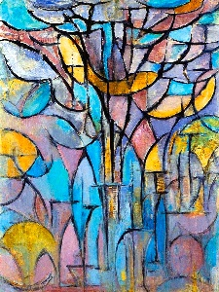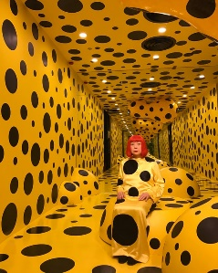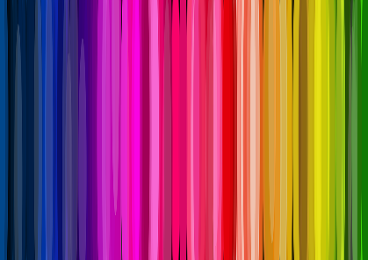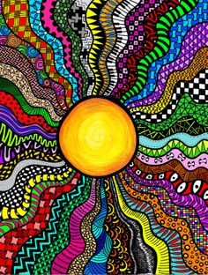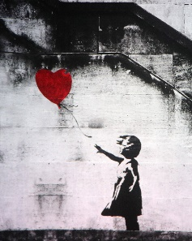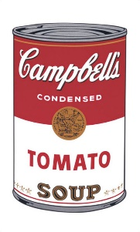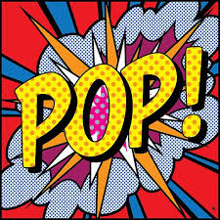
KS4 ART & DESIGN MEDIUM TERM PLAN – CURRENT YEAR (2022-2023)
Aspiration for Life |  | Differentiated, aspirational targets dependent on pupil needs. Aspiring to be outstanding artists |  |  | Language for Life |  | Explicit teaching/ exposure to new and know vocabulary. |  |  |  | Learning for Life |  | Opportunities to develop cross curricular skills e.g. Design and Technology and History
CYCLE 1 – 2022 - 2023 | Pupils & students will develop ideas & master a wide range of techniques in using colour, pattern, texture, line, shape, form and space to use a range of materials creatively to design & make products. They will self-assess own work & suggest improvements, including commenting on artworks using visual language. They will use a combination of materials that use a range of techniques e.g. cut, glued, scrunched (crumpled). Select & explore suitable materials for specific outcomes including creating & combing shape to create recognisable forms. Include texture that convey feelings expression or movements, & se clay and other mouldable materials. They will use a range of sources to collect imagines for inspiration. Composition- awareness of size and appreciating scale (fill the paper) and colour (own work) neatly filling the shape and within the boundaries and use I.T. to research art, and generate images. Begin to appreciate art e.g. do you like it? Why do you like it? How does it make you feel? Know about the work of a range of artists, craft makers and designers, describing the differences & similarities between different practices & disciplines, & making links to their own work. Participate in own exhibitions within school seeing the value in the effort involved | POP ART |  | GRAFFITI/SET DESIGN |  | CONTEMPORARY |  |  | EXPRESSIONISM |  |  | INSIDE SPACES |  | BUGS & INSECTS
 |  | Autumn 1 - 8 weeks |  | Autumn 2 - 7 weeks |  | Spring 1 - 6 weeks |  |  | Spring 2 - 6 weeks |  |  | Summer 1 - 5 weeks |  | Summer 2 - 7 weeks
 |  | Words in Art:  Onomatopoeia/Memes  Statement words/Repeated words around objects  Art Words: Expressive words/Stencil/Pop Art/  Artists:  Andy Warhol/Roy Lichtenstien/Damien Hirst/  Hamilton/David Hockney |  | Typography:  Stencils/Templates  Drawing – rulers/shapes  Art Words: Draw/vertical/draw around/contours/tone/bold  Artists:  BANSKY/Roy Lichtenstien  Modern Graffiti Artists  Old Record Sleeves |  | Colour Theory:  Primary Colours  Secondary Colours  Tertiary Colours  Art Words: Contemporary  Modern  Artists:  Houkaisai  Yakousai - Japanese Artist |  |  | Techniques:  Types of blending using paints and pastels  Art Words:  Expressionism/flicking/stippling  Artists:  Robert Delaunay  Cezanne  David Hockney – British Artist |  |  | Observational drawing/3D fruit:  Inside Objects/Inside jars/ Inside Vegetables and fruit  Art Words: Drawing objects and fruit and vegetables/2D and 3D shapes/form/tone/blending  Artists:  Van Goch – Dutch Impressionist  Cezanne – French Impressionist  Joseph Cornell – British Artist |  | Large Art Installations:  Giant bugs/insects/flowers  Art Words:  Enlargement/3D images/ Paper Mache/DIY skills  Artists:  William Morris  PIXAR Film images  Real bugs and Insects
 |  | SUGGESTED ART ACTIVITIES (Choose from or use suitable alternative)
 |  | Exclamations/words  Dot artwork with cotton buds/circle sponges  Andy Warhol every day object posters/collage  Roy Litchenstein portraits  Damien Hirst – draw a friend & add spots. Large posters depicting exclamations. Objects & sounds – onomatopoeia . Clay tile words |  | Abstract backgrounds, stencilled images  Drawings/paintings of objects. Banksy style Art Words  Graffiti art from around the world  Collages - old postcards & modern images |  | Patrick Caulfield paintings Primary/Secondary colours Drawing everyday objects & furniture/Exploring colours & how they make us feel – what colours look good together |  |  | Exploring Harmonious Colours. Drawing furniture and objects Large shapes in oil pastels/Adding colour and texture to pre-prepared images of objects. Painting with fine brushes using matt colours - gouache/acrylics Stencil images onto card/Still life sets/looking at spaces |  |  | Enlargement using light projector. Enlargement using the grid method Investigating ourselves – what are our favourite images/artefacts? Drawing half a fruit or vegetable. Making clay & insects using the pat/turn method, scooping out using a spoon and clay tools to mark make. Drawing bugs & insects from observation –primary resource–inside a pond /drawing insect from images on the internet |  | Drawing bugs & insects from observation –primary resource–inside a pond/drawing insect from images on the internet/ Exploring mark making on bugs/2-D/3-D bugs/clay bugs. Enlarging insects/charcoal & chalk
 |  | ART SKILLS & ART ELEMENTS
 |  | Stencils  Drawing  Follow lines | Stencils Enlargement  Decorating | Blending colours  Stencil and templates  Enlargement |  | Colours  Mixing  Painting |  | Mixing  Collage  Blending | Golden Section  Composition  Texture with paint  Templates | Expressionism  Flicking/Stippling  Following lines with  fine line pens |  | Drawing  2D and 3D shapes/form/tone/blending | Drawing from observation Clay skills - sculpture | Enlargement  Collage  Paper Mache  Manufacturing using power tools
 |  | ART VOCABULARY (In addition to ‘skills’ terms listed above)
 |  | Drawing  Templates/Stencils  Dots and printing |  | Fine line drawing/Drawing/  vertical/draw around/letters |  | Contemporary  Abstract  Out of this world |  |  | Expressionism  Flicking/Stippling  Expressive painting techniques |  |  | Drawing/2D and 3D shapes/form/tone/blending  What’s inside?/Detail and textures |  | Enlargement/3D images/ Paper Mache/DIY skills
 |  | IMPLEMENTATION
 |  | Week 1 Art Folder Covers Art Elements - reminder  Week 2 Andy Warhol stencil  Week 3 Pop art words  Week 4 Onomatopoeia Words  Week 5 Roy Litchenstein dots and speech bubbles  Week 6 Damien Hirst -spots  Week 7: Assessment |  | Week 1-2 Banksy and his use of words in art  Week 3-6 Set drawing inspired by theme. Set Design & using DIY skills, posters and imagery  Week 7 Christmas decorations |  | Week 1 - Art Elements reminder, then colours – harmonious colours from the colour wheel  Week 2 Still Life - Drawing everyday objects & furniture /Exploring over lapping artefacts – chair overlapping a table  Week 3-4 Patrick Caulfield paintings  Week 5 Abstract art collages  Week 6: Assessment |  |  | Week 1-2 Harmonious Colours revisited and colour mixing  Week 3-4 Collage and texture to objects  Week 5-6 Still Life sets with black lines – Looking at the Golden Section and Composition |  |  | Week 1 Enlargement Art Elements - reminder  Week 2 Drawing the inside of fruit/vegetables  Week 3 Drawing bugs and insects  Week 4 Bug Hotels with insect drawings  Week 5Clay bugs and insects  Week 5: Assessment |  | Week 1-2 Paper Mache  Week 3 Painting techniques/collage  Week 4-5 Giant Bugs  Week 6-7: Art Installations and SHINE Festival
 | INTENT

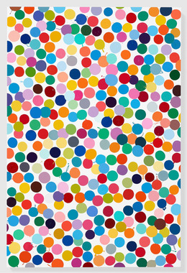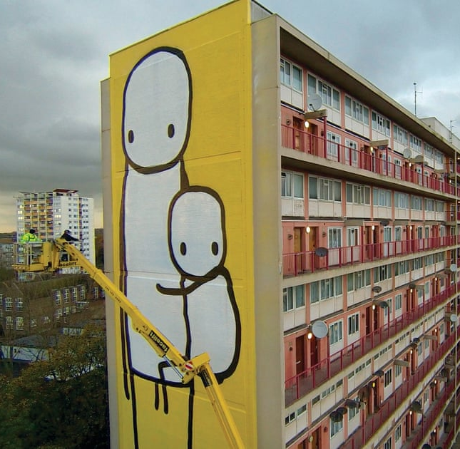

Stik – British Graffiti Artist – working today
He is best known for painting large stick figures, using bright, bold matt colours.
Some of his work has made £150,000.

He started painting graffiti art, then large scale murals in Hackney, London

He now paints all over the world – Europe, Asia and America

He paints the same style stickman figure but on a large scale.

Yayoi Kusama Japanese Artist – INFINITY
Yayoi took 45 years to become the artist she is today. Her exhibition in Los Angeles in the USA sold 90,000 tickets at $25 in an afternoon – making her $2.25 million. She still works today. She has a 5 story exhibition space in Tokyo.

Her obsessions with polka dots and dots derive from her early works involving adding spots and dots to everyday objects – cars/horses.

Her Pumpkins sell for up to $40,000
Her obsessions with pumpkins date back to her childhood in Japan, in her father’s garden.

Damien Hirst – British Artist – working today
Damien Hirst is famous for his ‘Cows in formaldehyde’. He also did a series of sheep using the same method.

Since 1986 he has produced over 1000 spot paintings. The dots might look machine made, but each one is painted by hand, celebrating precision and the joy of colours.
His spot designs feature on a pair of Vans shoes – for sale on one website for £1,306.

He created ‘For the Love of God’ – a skull encrusted with 8, 601 flawless diamonds.

KS4 ART & DESIGN MEDIUM TERM PLAN (2023-2024)
Aspiration for Life |  | Differentiated, aspirational targets dependent on pupil needs. Aspiring to be outstanding artists |  |  | Language for Life |  | Explicit teaching/ exposure to new and know vocabulary. |  |  | Learning for Life |  | Opportunities to develop cross curricular skills e.g. Design and Technology and History
CYCLE 2 – 2023 - 2024 | Pupils & students will develop ideas & master a wide range of techniques in using colour, pattern, texture, line, shape, form and space to use a range of materials creatively to design & make products. They will self-assess own work & suggest improvements, including commenting on artworks using visual language. They will use a combination of materials that use a range of techniques e.g. cut, glued, scrunched (crumpled). Select & explore suitable materials for specific outcomes including creating & combing shape to create recognisable forms. Include texture that convey feelings expression or movements, & se clay and other mouldable materials. They will use a range of sources to collect imagines for inspiration. Composition- awareness of size and appreciating scale (fill the paper) and colour (own work) neatly filling the shape and within the boundaries and use I.T. to research art, and generate images. Begin to appreciate art e.g. do you like it? Why do you like it? How does it make you feel? Know about the work of a range of artists, craft makers and designers, describing the differences & similarities between different practices & disciplines, & making links to their own work. Participate in own exhibitions within school seeing the value in the effort involved | OPTICAL ART |  | OP ART/ SET DESIGN |  | ABSTRACTION/ CONTEMPORARY |  | SURREALISM |  |  | SELF-IMAGE/ PORTRAITS |  | LIFE DRAWING/ SCULPTURES
 |  | Autumn 1 - 8 weeks |  | Autumn 2 - 7 weeks |  | Spring 1 - 6 weeks |  | Spring 2 - 6 weeks |  |  | Summer 1 - 5 weeks |  | Summer 2 - 7 weeks
 |  | Words in Art:  Optical Art/Repeated shapes/Colour combinations/Harmonious coulous/Contrasting Colours  Art Words: Optical Art/Optical Illusions/contours/shapes  Artists:  Artists =Carl Caskman/ Victor Vaseary/Walissy Kandinsky |  | Generating Optical Art:  Drawing – rulers/shapes/using tape to mask off areas  Art Words: Draw/vertical/draw around/contours/contrasts/spirals  Artists:  Artists = Edna Andrade/Bridget Riley/ |  | Colour Theory:  Primary/Secondary/Tertiary  Colour Mixing including adding white and black  Art Words: Abstract/Contemporary/Exhibitions/Artists/Installations/Repeated shapes and patterns/line/  Artists:  Artists = Yayoi Kusama Japanese Artist – INFINITY /Mondrian |  | Techniques:  Flat bold colours /cutting /collages /overlapping/golden section/placing objects where they shouldn’t be/Drawing objects in unusual places  Art Words:  Surrealism/Not real/out of place & context /imagination/exploring objects & art  Artists:  Artists = Rene Magitte /Paul Klee/Joan Miro/Kandinsky/Yves Tanguay /Dali |  |  | The Human Form:  Shape/body parts/head goes into the body x6/drawing stick men and adding detail/drawing the human form  Art Words: Portrait/Cartoon/enlarged images/simple line drawings/stick men/human form/key body parts  Artists: Stik/Keith Haring/Giacometti/ |  | Large Art Installations:  People and Celebration!  Flags/Banners and slogans  Art Words:  Enlargement/Human Form/3D/Paper Mache/DIY skills  Artists: Da Vinci /Henry Moore/Alison Lapper/ David Smith/Freud/ Antony Gormley
 |  | SUGGESTED ART ACTIVITIES (Choose from or use suitable alternative)
 |  | Carl Cashman and 3D  Finding shapes and colour  Optical Illusions  Computer Generated Designs  Vasary Spirals – giant spirals with contrasting colours and concentric lines  Patterns & Print Making  Spiral paintings on kick wheel |  | Bridget Riley patterns using acrylic paints  Use wooden rulers to print in black/white  Creating new patterns - textiles & wallpaper  Black and White Optical Illusions/Optical art pictures based on classic images – card & tissue. Set Design, |  | Recreating Kusama’s artwork – giant dots – amazing video of her 3D exhibition  What’s in this painting?/What can you see? – investigating surrealism and abstract art  Mondrian trees – take photos of trees & use to create Mondrian style painting of a tree |  | This is not a Pipe’ by Rene Magritte – produce own version – ‘this is not a ….’  Fantastic Landscapes’ – unusual/obscure colours – cutting and overlapping  Split a painting up with straight lines, photo and draw& paint – Paul Klee, style  Minimalism-art using curves, lines & space  Create a collage based on surrealism using images from magazines/newspapers |  |  | Keith Haring style people  STIK…watch the BBC video  3-D sculptures of figures  Basques – heads on shoulders  Expressive heads – three different heads  Digital photos/light box |  | Anthony Gormley  3-D faces in clay/wire/junk  Collage using fruit/vegetable print outs  Portraits, size, proportions, features– eyes/mouth/hair  Drawing people with clothes on  Making Giant installations, artwork and creativity for SHINE – our Arts Festival
 |  | ART SKILLS
 |  | Stencils  Drawing  Follow lines | Drawing lines  Painting within lines  Spirals | Painting fine lines  Painting spaces  Wallpapering  Cutiing/Measuring |  | Colours  Mixing  Painting  Drawing trees | Colour Mixing including adding white and black  Collage  Cutting/arranging | Imagination  Cutting with scissors and a craft knife  Composition | Cutting  Painting within straight lines  Golden Section  Following lines with  fine line pens |  | Stik – simple drawings of the same repeated image of a body  Giacometti – simple sculptures made from clay and wire | Making/ Modelling in various art media/ Form | Enlargement  Collage  Paper Mache  Manufacturing using power tools
 |  | ART VOCABULARY (In addition to ‘skills’ terms listed above)
 |  | Lines/Shapes/Spirals  Templates/Colour combinations/mix/contours |  | Fine line drawing/Drawing/  vertical/draw around /shapes/line/DIY and wallpapering skills |  | Abstract/Contemporary  Colour theory/primary colours/black/white  Black – absence of light  White – presence of light |  | Surrealism/Not real/out of place & context /imagination/exploring objects & art  Art that creates dreams and thoughts |  |  | Drawing/2D and 3D shapes/form/tone/blending |  | Enlargement/3D images/ Paper Mache/DIY skills/Painting/collage skills
 |  | IMPLEMENTATION
 |  | Week 1 Art Sketchbook front. Art Elements - reminder  Week 2 Optical Illusions  Week 3 Vasary Spirals  Week 4 Concentric lines  Week 5 Patterns & Prints  Week 6 Spiral paintings  Week 7: Assessment |  | Week 1-2 Suggested activities – see above.  Week 3-6 Set drawing inspired by theme. Set Design & using DIY skills  Week 7 Christmas decorations |  | Week 1 - Art Elements - reminder  Week 2-3 Recreating Kusama’s artwork – giant dots on objects and a background  Week 4 - Mondrian trees  Week 5 -Mondrian Broadway Boogy- Woogy  Week 6: Assessment |  | Week 1 -2 This is not a Pipe’  Week 3-4 Fantastic Landscapes’  Week 5 Split a painting up  Week 6 Surreal Collage based on a landscape and themselves – ‘A Dream’ |  |  | Week 1 - Art Elements - reminder  Week 2 Stik – simple drawings  Week 3 Basques – heads on shoulders with expressions – self-portraits in 3D  Week 4 Giacometti – simple sculptures  Week 5: Assessment |  | Week 1-2 Paper Mache  Week 3 Banners and Slogans  Week 4-5 Giant People  Week 6-7: Art Installations and SHINE Festival
 | INTENT
ANDY WARHOL – AMERICAN POP ARTIST /INFLUENCER/AVANT GUARD/ = Campbell’s Soup Can – Screen Print on Card. 1967.
Andy Warhol (August 6, 1928 – February 22, 1987) was an American visual artist, film director, & producer who was a leading figure in the visual art movement known as POP ART. His works explore the relationship between artistic expression, advertising, & celebrity culture that flourished by the 1960s, & span a variety of media, including painting, silkscreening, photography, film, & sculpture. Some of his best-known works include the silkscreen paintings Campbell's Soup Cans (1962) & Marilyn Diptych (1962), the experimental films Empire (1964), Chelsea Girls (1966), & the multimedia events known as the Exploding Plastic Inevitable (1966–67). Born & raised in Pittsburgh, Warhol initially pursued a successful career as a commercial illustrator. After exhibiting his work in several galleries in the late 1950s, he began to receive recognition as an influential & controversial artist. His New York studio, The Factory, became a well-known gathering place that brought together distinguished intellectuals, drag queens, playwrights, Bohemian street people, Hollywood celebrities, & wealthy patrons. widely used expression "everyone in the future will have …..15 minutes of fame".

BANKSY – BRITISH ARTIST/GRAFITTI ARTIST/POLITICAL INFLUENCER
= ‘The Girl with the Red Balloon’ 2007, and this original painting was shredded in front of an audience in Sotherby’s in 2018.
Banksy is a pseudonymous England-based street artist, political activist and film director whose real name and identity remain unconfirmed & the subject of speculation. Active since the 1990s, his satirical street art & subversive epigrams combine dark humour with graffiti executed in a distinctive stenciling technique. His works of political & social commentary have appeared on streets, walls & bridges throughout the world.^{[3]} Banksy's work grew out of the Bristol underground scene, which involved collaborations between artists & musicians. Banksy says that he was inspired by 3D, a graffiti artist and founding member of the musical group Massive Attack.

PIET MONDRIAN DUTCH ARTIST – ABSTRACT ART – AHEAD OF HIS TIME ‘Trees’ – 1912.
Piet Mondrian. (7 March 1872 – 1 February 1944), was a Dutch painter and art theoretician who is regarded as one of the greatest artists of the 20th century. He was known for being one of the pioneers of 20th-century abstract art, as he changed his artistic direction from figurative painting to an increasingly abstract style, until he reached a point where his artistic vocabulary was reduced to simple geometric elements. Mondrian's art was highly utopian & was concerned with a search for universal values & aesthetics. He proclaimed in 1914: "Art is higher than reality & has no direct relation to reality. To approach the spiritual in art, one will make as little use as possible of reality, because reality is opposed to the spiritual. We find ourselves in the presence of an abstract art. Art should be above reality, otherwise it would have no value for man." His art, however, always remained rooted in nature.

FUTURE CAREER AND ENTERPRISE OPPORTUNITIES
- Working as an artist/designer
- Working as a YouTuber – sharing artwork/design work on social media
- Becoming an influencer on social media – videos of drawing/painting/collaging/upcycling/hobbies/projects with art and design materials
- Working in the Museum/Art History Sector
- Working in the Trade industry – painting, decorating, renovating
- Working in the DIY industry – renovating, designing, upcycling, fixing and using art and design tools
- Working in the retail world – selling art and design tools and materials
- Working in any Art & Design industry that uses sustainable materials for the future of our planet
- Promoting events in the future.
- Working towards exhibitions
- Auction of artwork to raise money for school funds
- Selling artwork at Shine Festival and school fair
- Enhancing appearance of school with artwork

LINKS TO PROGRESSION DOCUMENT = BLUE
LINKS TO CULTURAL CAPITAL = GREEN

