Long Term Mapping
ENGLISH KS4

 |  | Cycle 1 | Cycle 2
 |  | (2023-2024) | (2022-2023)
Autumn | 1 | CHARLES DICKENS | LOVE AND LOSS
 | 2
Spring | 1 | HORROR | ADVENTURE
 | 2
Summer | 1 | DISABILITY | MYSTERY
 | 2

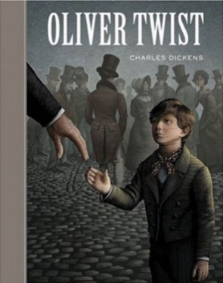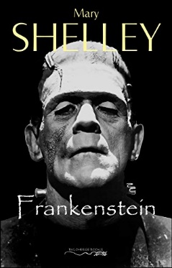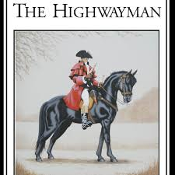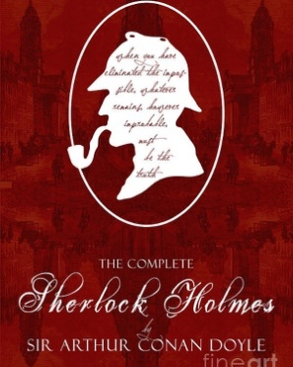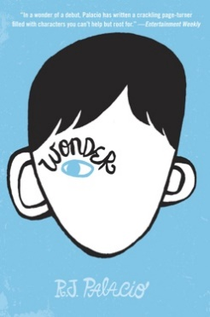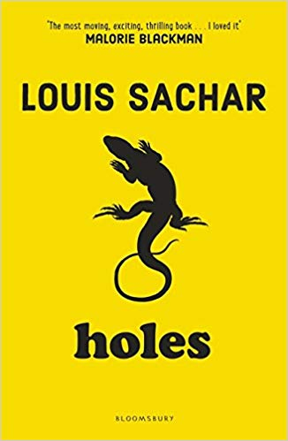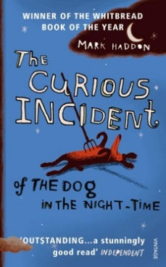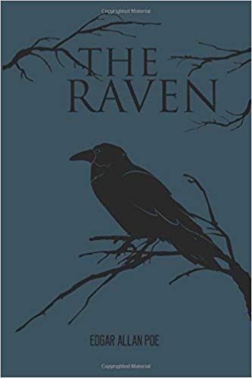

KS4 ENGLISH MEDIUM-TERM PLANNING
Aspiration for Life |  |  |  | Differentiated, aspirational targets dependent on pupil needs. |  | Language for Life |  | Explicit teaching/ exposure to new and know vocabulary. |  |  | Learning for Life |  |  | Opportunities to develop cross curricular skills e.g. drama
CYCLE 1 | To continuously build on skills and knowledge by providing, through a thematic approach, opportunities for reading, writing, speaking and listening. | Author | novelist | journalist | blogger | marketing & advertising | playwright | teacher | coach | reporter | customer services | broadcaster | CHARLES DICKENS |  |  |  | HORROR |  |  |  |  | DISABILITY
 |  |  | Autumn 1  7 weeks |  | Autumn 2  7 weeks |  | Spring 1  6 weeks |  |  | Spring 2  6 weeks |  | Summer 1  5 weeks |  |  | Summer 2  7 weeks
 |  |  | Fiction |  | Non - Fiction |  | Fiction |  |  | Non-Fiction |  | Fiction |  |  | Non-Fiction
 |  |  | Focus on Author:  Charles Dickens |  | Expository Writing: Biography linked to Dickens (4 weeks) |  | Creative Writing  Sensory imagery and suspense. |  |  | Diary Writing  (4 weeks) |  | Understanding others |  |  | Persuasive Writing:  Campaign (4 weeks)
 |  |  |  |  | Poetry |  |  |  |  | Poetry |  |  |  |  | Poetry
 |  |  |  |  | Injustice: Personification & Metaphor (3 weeks) |  |  |  |  | Repetition & Onomatopoeia  (2 weeks) |  |  |  |  | Simile (3 weeks)
 |  |  | SUGGESTED TEXTS
 |  |  | A Christmas Carol  Oliver  Great Expectation  (Charles Dickens) |  | The Ballad of the Landlord  (Langston Hughes)  Harriet Beecher Stowe  (Paul Dunbar)  Tableau  (Countee Cullen) |  | Frankenstein  (Mary Shelly)  Clay  (David Almond)  The Women in Black  (Susan Hill)  The Tell-Tale Heart  (Edgar Allen Poe) |  |  | The Raven  (Edgar Allen Poe)  Omens  (Cecelia Llompart)  All Hallows’ Eve  (Dorothea Tanning) |  | Wonder  (R.J. Palacio)  The Curious Incident of the Dog in the Night-Time  (Mark Haddon) |  |  | When You Pass Me On The Street  (R.Cantrell)
 |  |  | VOCABULARY | GRAMMAR
 |  |  | poor/poverty  industrial/industrialisation  consequence  Dickensian  Headline  article  caption  picture  author  Adjectives (WS)  Capital Letters/Full Stops  Pronouns (SS) |  | Past tense (TS)  3rd Person (SS)  biography  events  simile  timeline  Injustice  personification  metaphor  interference  + vocabulary that arises from the text covered |  | Simple sentences (SS)  Lists (TS)  Complex sentences (SS)  comma (P)  sense  mood  fear  suspense  tension  cliff-hanger  + vocabulary that arises from the text covered |  |  | Dear Diary (TS)  Past Tense (TS)  Repetition (TS)  Time Adverbials (SS)  1st Person (SS)  Onomatopoeia (SS)  scary  bleak  ghastly  omen |  | disability  extraordinary  Autism  lies  syndrome  slander  + vocabulary that arises from the text covered  Chronological Order (TS)  conjunctions (SS) |  |  | Present tense (TS)  comparative/superlative (WS)  exaggeration (TS)  summary (TS)  avoid  stare  merely  opt  disgust
 |  |  | SUGGESTED STIMULUS VISITS
 |  |  | Wigan pier  Helmshore textile museum  Manchester library  Whittaker park  Temperance Bar – Rawtenstall  Corn exchange  Travelling productions/Theatre visits  Victorian workshop |  |  |  | Lytham Windmills  Bolton Abbey  Astley Hall  Speke Hall |  | Bolton Abbey  Pendle Hill  Rawtenstall cemetery  Lancaster castle  Clitheroe Castle |  |  |  | Disability representation speakers – past pupils, charity, campaigners |  |  | Charity speaker visits  Council representatives
 |  |  | SUGGESTED IMPLEMENTATION
 |  |  | Week 1: Main characters + comparison (R)  Week 2: Main events + comparison (R + W)  Week 3: Newspaper of events (R + W)  Week 4: Recount  Week 6: Role Play characters.  Week 7: Assessment. |  | Week 1: Ebenezer Profile (R)  Week 2: Events & themes (R)  Week 3: Biography Features (R)  Week 4: Biography Writing: Ebenezer (R + W)  Week 5: Poem study.  Week 6: Poetry features.  Week 7: Poetry writing. |  | Week 1: Book cover analysis (R)  Week 2: Predictions (R) & sensory description (W)  Week 3: Setting analysis & suspense (R + W)  Week 4: Main events  Week 5: Recount with alternative events. (W) |  |  | Week 1: Recount text. (R)  Week 2: Diary Features & structure. (R)  Week 3: Diary writing informed from the text (W)  Week 4: Diary Writing (W)  Week 5: Poetry features (R)  Week 6: Poetry writing (repetition & onomatopoeia) |  | Week 1: About the author (R)  Week 2: Book cover analysis & predictions (R)  Week 3: Main events (R)  Week 4: Sequencing events (R + W)  Week 5: Recount.  Week 6: Assessment |  |  | Week 1: Campaign texts (R)  Week 2: Persuasive writing features (W)  Week 3: Debate Role Play (S+L)  Week 4: Campaign writing (W)  Week 5: Poem study (R)  Week 6: Simile.  Week 7: Poetry writing (W)
 | INTENT | CAREERS

KS4 ENGLISH MEDIUM-TERM PLANNING
Aspiration for Life |  |  |  | Differentiated, aspirational targets dependent on pupil needs. |  |  | Language for Life |  |  | Explicit teaching/ exposure to new and know vocabulary. |  |  | Learning for Life |  |  | Opportunities to develop cross curricular skills e.g. drama
CYCLE 1 | To continuously build on skills and knowledge by providing, through a thematic approach, opportunities for reading, writing, speaking and listening. | Author | novelist | journalist | blogger | marketing & advertising | playwright | teacher | coach | reporter | customer services | broadcaster | LOVE & LOSS |  |  |  |  |  | ADVENTURE |  |  |  |  |  | MYSTERY
 |  |  | Autumn 1  7 weeks |  |  | Autumn 2  7 weeks |  |  | Spring 1  6 weeks |  |  | Spring 2  6 weeks |  |  | Summer 1  5 weeks |  |  | Summer 2  7 weeks
 |  |  | Shakespeare |  |  | Non - Fiction |  |  | Fiction |  |  | Non-Fiction/Fiction |  |  | Fiction |  |  | Non-Fiction
 |  |  | Linear Narrative: Presenting the events of a story in the order which they happen.  Viewpoint Narrative: Express the points of view or subjective personal experience of a character. |  |  | Descriptive Writing: love letters/postcards  (4 weeks) |  |  | Creative Writing  Sensory imagery: Setting |  |  | Reports & Instructions  (4 weeks) |  |  | Focus on Author:  Sir Arthur Conan Doyle  Creative Writing  Sensory imagery: plot |  |  | Commentaries & News Reports (4 weeks)
 |  |  |  |  |  | Poetry |  |  |  |  |  | Cautionary Poetry |  |  |  |  |  | Poetry
 |  |  |  |  |  | Imagery & hyperbole (3 weeks) |  |  |  |  |  | Rhyme (2 weeks) |  |  |  |  |  | Repetition & Alliteration (3 weeks)
 |  |  | SUGGESTED TEXTS
 |  |  | Romeo & Juliet  (William Shakespeare) |  |  | Captain Corelli’s Mandolin  (Louis de Bernieres)  I Wanna Be Yours  (John Cooper Clarke)  Mid-Term Break  (Seamus Heaney) |  |  | Holes  (Louis Sacher)  Into Thin Air  (Jon Krakauer)  Lord of the Flies  (William Golding) |  |  | More Beasts (for Worse Children)  The Modern Traveller  Cautionary Tales for Children  (Hilaire Belloc) |  |  | Sherlock Holmes  (Sir Arthur Conan Doyle)  The Green Mile  (Stephen King) |  |  | The Highway Man  (Alfred Noyes)  Night Mail  (W.H. Auden)
 |  |  | VOCABULARY | GRAMMAR
 |  |  | Sequencing sentences (TS)  Verbs in present & past tense  Paragraphs (TS)  Pronouns for 1st Person (TS)  Linking paragraphs using adverbials (TS)  + vocabulary that arises from the text covered |  |  | Use of ‘and’ (SS)  Adjectives -suffixes (WS)  Nouns -prefixes (WS)  Time (Conjunctions, adverbs & prepositions) (SS)  Headings & Subheadings (TS)  address  + vocabulary that arises from the text covered |  |  | Word Families (WS)  Punctuation  setting  place  background  senses  environment  atmosphere  + vocabulary that arises from the text covered |  |  | Sentence Forms (SS)  Co-ordination (SS)  clauses (SS)  modal verbs (SS)  recipe  directions  Game instructions  rules  advice  expectations |  |  | Sequencing Sentences (TS)  verbs (suffixes)  Organisation of paragraphs  Fronted adverbials (SS)  beginning  middle  ending  conflict  resolution  + vocabulary that arises from the text covered |  |  | Tenses (TS)  Nouns & Adjectives (WS)  Verb inflections (WS)  3rd Person (SS)  cohesion (TS)  newspaper  journalism  article  media  tabloid
 |  |  | SUGGESTED STIMULUS VISITS
 |  |  | Theatre visit  Cinema Visit  Visiting theatre company |  |  |  |  | Southport beach  Chill factore  Rossendale Ski Slope |  |  |  |  |  | Stoneyhurst College |  |  | Local sorting office  Post Office  Lancashire east railway
 |  |  | SUGGESTED IMPLEMENTATION
 |  |  | Week 1: Main characters + plot summary (R)  Week 2: Main events sequencing (R + W)  Week 3: Main Events (R + W)  Week 4: Recount  Week 6: Recount from Character perspective.  Week 7: Independent write. |  |  | Week 1: Letter/postcards (R)  Week 2: Features (W)  Week 3: Text examples and comparison.  Week 4: Plan and write letter/post card.  Week 5: Poem study.  Week 6: Poetry features.  Week 7: Poetry writing. |  |  | Week 1: Book cover analysis (R)  Week 2: Predictions (R) & sensory description (W)  Week 3: Setting analysis (R + W)  Week 4: Main events.  Week 5: Recount with alternative setting. (W) |  |  | Week 1: Reports/instructions (R)  Week 2: Features (W)  Week 3: Text examples and comparison.  Week 4: Plan and write a report/ instruction.  Week 5: Poem study.  Week 6: Poetry features (Rhyme).  Week 7: Poetry writing. |  |  | Week 1: About the author (R)  Week 2: Book cover analysis & predictions (R)  Week 3: Main events (R)  Week 4: Sequencing events focussing on plot (R + W)  Week 5: Story plan  Week 6: Story draft  Week 7: Story write and edit. |  |  | Week 1: Newspapers (R)  Week 2: Features (W)  Week 3: Text examples and comparison. (R)  Week 4: Plan and write a newspaper article. (W)  Week 5: Edit article (W)  Week 5: Poem study. (R)  Week 6: Poetry features (Repetition & Alliteration).  Week 7: Poetry writing. (W)
 | INTENT | CAREERS

KS3 ENGLISH MEDIUM-TERM PLANNING
GRAMMAR & PUNCTUATION (PROGRESSION) | Grammar & Punctuation: The purpose of this supplement is to support the understanding of concepts and skills and the progression of this throughout the National Curriculum (2014). | Word Structure | Sentence Structure | Text Structure | Punctuation | Terminology
 |  | STEP 12 – 14 (Y1)
 |  | - Regular plural noun suffixes: -s | -es  - Suffixes added to verb: -ing | -ed |-er  - Prefix un-: added to verb & adjective. unkind | undoing | - Words combine to make sentences  - How and can join words and join sentences. | - Sequencing sentences to form short narratives | - Separation of words with space.  - Introduction of capital letters | full stops | question mark | exclamation mark to demarcate sentences.  - Capital letters for personal pronouns | word | sentence | letter | capital | letter | full stop | punctuation | singular | plural | question mark | exclamation
 |  | STEP 15 – 17 (Y2)
 |  | - Formation of nouns using suffixes -ness | -er.  - Formation of adjectives using suffixes -ful | -less  - Use of suffixes -er | -est to form comparisons of adjectives & adverbs. | - Subordination: when | if | that | because.  - Co-ordination: or | and | but  - Expanded noun phrase for description: blue butterfly | plain flour.  - Sentence forms: statement, question, exclamation & command. | - Consistent use of present tense.  - Continuous form of verbs in the present & past tense to mark actions: She is drumming | he was shouting. | - Capital letters | full stops | question mark | exclamation mark to demarcate sentences.  - Commas to separate a list.  - Apostrophe to mark contracted forms of spelling. | verb | tense | past | present | adjective | noun | suffix | apostrophe | comma
 |  | STEP 18 – 20 (Y3)
 |  | - Formation of nouns using a range of prefixes: super- | anti- | auto-  - Determiners a or an according to whether next word in vowel or consonant.  - Word Families | - Expressing time using:  Conjunctions: when | before | after | while | because.  Adverbs: then | next | soon | so  Prepositions: before | after | during | in | because of. | - Introduction to paragraphs as a way to group relative material.  - Headings & subheadings to aid presentation.  - Perfect form of verbs to mark time and cause: I have written it down so we can check what he said. | - Introduction of inverted commas (speech marks) to punctuate direct speech. | word family | conjunction | adverb | preposition | direct speech | inverted commas | prefix | consonant | vowel | clause | subordinate clause
 |  | STEP 21 – 23 (Y4)
 |  | - Difference between plural & possessive -s.  - Use of Standard English for verb inflections was | were | - Appropriate choice of pronoun or noun within sentences to avoid repetition.  - Fronted adverbials | - Use of paragraphs to organise ideas around a theme.  - Appropriate choice of pronouns or nouns across sentences. | - Use of inverted commas (speech marks) to punctuate direct speech.  - Apostrophe to mark singular and plural possession.  - Use of commas after fronted adverbials: Later that day, I heard bad news. | pronoun | possessive pronoun | adverbial
 |  | Year 5 (KLIP)
 |  | - Converting nouns or adjectives into verbs using suffixes.  - Verb prefixes: dis- | de- | mis- | over- | re- | - Relative clauses beginning who | which | where | whose  - Indicating possibility using:  Modal verbs might | should | will | must  Adverbs perhaps | surely | - Devices to build cohesion within a paragraph: then | after that | this | firstly.  - Linking ideas across paragraphs using adverbials of time (later) | place (nearby) | number (secondly) | - Brackets | dashes | commas to indicate parenthesis.  - Use of commas to clarify meaning or avoid ambiguity. | relative clause | model verb | relative pronoun | parenthesis | bracket | dash | determiner | cohesion | ambiguity
 |  | Year 6 (KLIP)
 |  | - The difference between vocabulary typical of informal speech and vocabulary appropriate for formal speech: reported | alleged | claimed versus said. | - Use of passive voice to affect the presentation of information in a sentence. ‘I broke the window’ versus ‘The window was broken’  - Expanded noun phrases to convey complicated information.  - Formal & informal speech structures. | - Linking ideas across paragraphs using a wider range of cohesive devices:  Semantic cohesion: repetition of a word or phrase.  Grammatical connections: use of adverbials (on the other hand | in contrast | as a consequence)  Elision  - Layout devices: heading, sub-heading, columns, bullets, tables. | - Use of semi-colon | colon | dash to indicate stronger subdivision of sentences than a comma.  - Punctuation of bullet points to list information.  - How hyphens can avoid ambiguity: man-eating shark | re-cover. | active voice | possessive voice | subject & object of a sentence | hyphen | synonym | colon | semi colon | bullet points
 | INTENT

