Long Term Mapping
Horticulture KS5

Autumn | 1 | Health and Safety /Harvesting/ Maintenance
 | 2 | Bulbs /Maintenance /Enterprise
Spring | 1 | Seeds/Ground Preparation/Maintenance
 | 2 | Seeds/ Potting/Enterprise
Summer | 1 | Repotting/Plant care
 | 2 | Plant care/ Harvesting/Enterprise

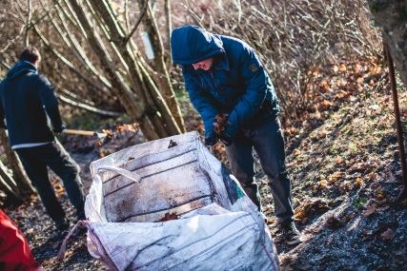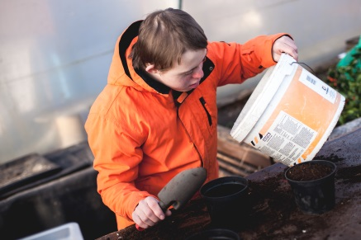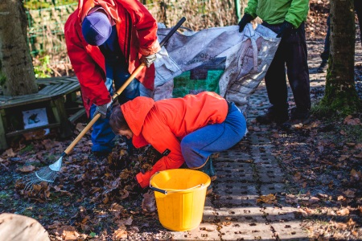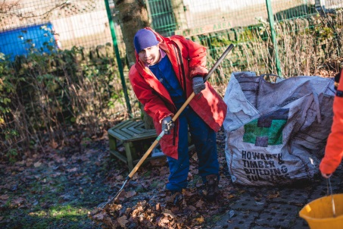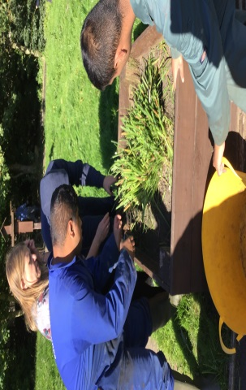

KS5 Horticulture MEDIUM TERM PLAN

Aspiration for Life |  | Differentiated, aspirational targets dependent on pupil needs. |  |  |  |  |  | Language for Life |  |  |  | Explicit teaching/ exposure to new and known vocabulary. |  |  |  |  |  |  | Learning for Life |  |  | Opportunities to develop cross curricular skills e.g.
CYCLE 1 | The intent of our lessons is to give a full and balanced view of horticulture offering our students the opportunity to care, create, support, achieve and grow. To teach them an excellent work ethic and encourage hard work and determination with visible results. To give students opportunity to explore their environment regardless of their physical ability by offering a broad and varied lesson differentiated to suit each individual. | Ground Preparation |  |  |  |  | Bulbs |  |  | Seeds |  |  |  |  | Planting/Repotting |  |  |  |  | Plant care |  |  | Harvesting
 |  | Autumn 1 - 7 weeks |  |  |  |  | Autumn 2 - 7 weeks |  |  | Spring 1 - 6 weeks |  |  |  |  | Spring 2 - 6 weeks |  |  |  |  | Summer 1 - 5 weeks |  |  | Summer 2 - 7 weeks
 |  | - Health and safety: Area knowledge tool and plant recognition, Weather and clothing  - Harvesting: Collect summer produce clearing raised beds.  - Maintenance: General up keep of all areas clearing footpaths, weeding etc |  |  |  |  | - Planting Bulbs: Choosing and planting from a selection  - Enterprise: Making a Christmas themed item to sell at Xmas fair.  - Maintenance: General up keep of all areas clearing footpaths, weeding etc |  |  | - Planting seeds: sieving soil, filling pots, sowing seeds.  - Environment: Spring changes, weather, being green ( growing your own food)  - Hanging baskets: looking at different plants, basket preparation, planting. |  |  |  |  | - Hanging baskets: Choosing plants creating baskets, selling baskets.  - Seeds: Repotting seedlings. Seed care. Seed planting  - Planting: re planting seedlings into raised beds |  |  |  |  | Plant care: weeding, watering ,feeding, pruning  Planting outside: Preparing beds choosing areas planting outside covering plants.  Area development: Updating re developing areas |  |  | Plant care: weeding, watering ,feeding, pruning  Area development: Updating  area developing areas  Harvesting:  Collecting and distributing food items grown.  Maintenance: General up keep of all areas clearing footpaths, weeding etc
 |  | SUGGESTED PRACTICALS (Choose from or use suitable alternative)
 |  | - Finding areas  - Harvesting  - Weeding  - Rotation/Fertilising beds  - Path clearing |  |  | - Plant recognition (flowers, garlic)  - Parts of a bulb  - Planting Bulbs  - Tool recognition  - Tool safety  - Pruning  - Enterprise |  |  |  | - Sieving soil  - Sowing seeds  - Composting/saving water  - Choosing food to grow  - Planting baskets |  |  |  |  | - Potting seedlings  - Re potting plants  - Filling pots and baskets  - Planting potatoes  - Watering  - Bed preparation |  |  |  | - Weeding  - Watering  - Pruning  - Re potting  - Planting outdoors  - Hanging baskets |  |  |  |  | - Weeding  - Watering  - Pruning  - Re potting  - Harvesting
 |  | SKILLS
 |  | Harvesting  Digging  Pruning  Rotating  Fertilising  Independence | Tool Safety  Plant safety |  | Planting  Team work  Working safely with power tools.  Tool names  Plant names  Independence |  |  |  | Planting  Plant recognition  Growing food  Tool recognition  Independence |  |  |  | Tool safety  Plant safety | Planting  Watering  Re potting  Plant care  Understanding plant needs.  Independence |  |  |  | Weeding  Watering  Pruning  Re potting  Planting  Filling baskets |  |  | Tool safety  Plant safety |  | Weeding  Watering  Pruning  Re potting  Harvesting |  |  | Tool safety  Plant Safety
 |  | VOCABULARY (In addition to ‘skills’ terms listed above)
 |  | Area names  (Nature, Pond, Sensory ,Poly tunnel)  Tool names  (Fork, spade, rotator, Wheelbarrow, gloves)  Plant/ Produce names  (Nettle, Weed ,strawberry rhubarb potato)  Environment  (Weather, Season ,Manmade Natural)  Annual perennial dormant sleeping |  |  |  | Area names  (Nature, Pond, Sensory ,Poly tunnel)  Tool names  (Sander screwdriver, hammer, nail, screw)  Plant/tree names  (daffodil, tulip, conifer, evergreen, )  Environment  (Weather, Season ,Manmade Natural)  Annual perennial dormant sleeping |  |  |  |  | Area names  (Nature, Pond, Sensory ,Poly tunnel)  Tool names  (Sieve, plant pot, trowel, fork, dibber)  Plant/tree names  (daffodil, tulip tomato, pepper, cucumber, radish, )  Environment  (Weather, Season ,Manmade Natural) |  |  |  |  | Area names  (Nature, Pond, Sensory ,Poly tunnel)  Tool names  (Sieve, plant pot, trowel, fork, dibber)  Plant/fruit/veg  (Petunia, fuchsia, )  Environment  (Weather, Season ,Manmade Natural) |  |  |  | Area names  (Nature, Pond, Sensory ,Poly tunnel)  Tool names  (Sieve, plant pot, trowel, fork, dibber)  Plant/fruit/veg  (Petunia, fuchsia, )  Environment  (Weather, Season ,Manmade Natural) |  |  |  | Area names  (Nature, Pond, Sensory ,Poly tunnel)  Tool names  (Fork, spade, rotator, Wheelbarrow, gloves)  Plant/ Produce names  (Nettle, Weed ,strawberry rhubarb potato)  Environment  (Weather, Season ,Manmade Natural)  Annual perennial dormant sleeping
 |  | IMPLEMENTATION
 |  | Week 1  1)Introduction to horticulture  2) Area knowledge (walk)  3)Skills assessment  4)Skills assessment  5)Skills assessment  6)Skills assessment  7)Skills assessment  8) Discussion, plan for next week what went well?  Week 2  1) Harvesting  2)Harvesting,  3)Clearing raised beds  4) Ground preparation  5) Harvesting  6)Harvesting,  7)Clearing raised beds  8) Discussion, plan for next week what went well?  Week 3  1) Harvesting  2)Harvesting,  3)Clearing raised beds  4) Ground preparation  5) Harvesting  6)Harvesting,  7)Clearing raised beds  8) Discussion, plan for next week what went well?  Week4)  1)Clearing Beds  2)Clearing Beds  3) Pruning/Horticulture skills  4)Pruning/Horticulture skills  5) Pruning/Horticulture skills  6)Pruning/Horticulture skills  7)Pruning/Horticulture skills  8) Discussion, plan for next week what went well?  Week5)  1)Pruning/Hort Skills  2)Pruning/Hort Skills  3)Pruning/Hort Skills  4)Pruning/Hort Skills  5)Clearing footpaths  6)Clearing Footpaths  7)General tidy all areas  8) Discussion, plan for next week what went well?  Week 6  1)Pruning/Horticulture skills  2)Pruning/Horticulture skills  3)Clearing footpaths  4)Clearing Footpaths  5)Pruning/Horticulture skills  6)Pruning/Horticulture skills  7)Clearing footpaths  8) Discussion, plan for next week what went well?  Week 7: Assessment week, general jobs done by students targets checked new targets set, files updated clearing and clearing of tools etc.  Each day students will be assessed on  Weather/ season/ area tool/plant recognition at the start and end of the day. |  | Week 1  1) Walk around areas assessment of jobs for coming term.  2)Look at enterprise ideas  3) Introduce bulbs.  4)General Maintenance  Week 2  1) Pruning /horticulture skills  2)Pruning/horticulture skills  3)Bulb planting/Enterprise  4) Bulb Planting/Enterprise  5)Footpaths/maintenance  6)Footpaths/maintenance  7)General tidy all areas  8) Discussion, plan for next week what went well?  Week 3  1) Pruning /horticulture skills  2)Pruning/horticulture skills  3)Bulb planting/Enterprise  4) Bulb Planting/Enterprise  5)Footpaths/maintenance  6)Footpaths/maintenance  7)General tidy all areas  8) ) Discussion, plan for next week what went well?  Week 4  1) Pruning /horticulture skills  2)Pruning/horticulture skills  3)Bulb planting/Enterprise  4) Bulb Planting/Enterprise  5)Footpaths/maintenance  6)Footpaths/maintenance  7)General tidy all areas  8) ) Discussion, plan for next week what went well?  Week 5  1) Pruning /horticulture skills  2)Pruning/horticulture skills  3)Bulb planting/Enterprise  4) Bulb Planting/Enterprise  5)Footpaths/maintenance  6)Footpaths/maintenance  7)General tidy all areas  8) ) Discussion, plan for next week what went well?  Week 6  1) Pruning /horticulture skills  2)Pruning/horticulture skills  3)Bulb planting/Enterprise  4) Bulb Planting/Enterprise  5)Footpaths/maintenance  6)Footpaths/maintenance  7)General tidy all areas  8) ) Discussion, plan for next week what went well?  Week 7: Assessment week, general jobs done by students targets checked new targets set, files updated clearing and clearing of tools etc.  Each day students will be assessed on  Weather/ season/ area tool/plant recognition at the start and end of the day. |  |  |  |  |  | Week1  1) Walk around areas assessment of jobs for coming term.  2) Look at seeds and decide what we will plant this year look over last years success.  3)Horticulture skills /planting  4)Horticulture skills /planting  5)Hanging Basket prep  6)Hanging Baskets prep  7) General tidy all areas  8) Discussion, plan for next week what went well?  Week 2  1)Seed plantings  2) Seed planting  3) Hanging Basket  4)Hanging Baskets  5)Horticulture skills/planting  6)Horticulture skills/planting  7)General tidy all areas  8) Discussion, plan for next week what went well?  Week 3  1)Horticulture skills/planting  2)Horticulture skills/planting  3)Seed plantings  4) Seed planting  5) Hanging Basket  6)Hanging Baskets  7)General tidy all areas  8) Discussion, plan for next week what went well?  Week 4  1)Seed plantings  2) Seed planting  3) Hanging Basket  4)Hanging Baskets  5)Horticulture skills/planting  6)Horticulture skills/planting  7)General tidy all areas  8) Discussion, plan for next week what went well?  Week 5  1)Horticulture skills/planting  2)Horticulture skills/planting  3)Seed plantings  4) Seed planting  5) Hanging Basket  6)Hanging Baskets  7)General tidy all areas  8) Discussion, plan for next week what went well?  Week 6: Assessment week, general jobs done by students targets checked new targets set, files updated clearing and clearing of tools etc.  Each day students will be assessed on  Weather/ season/ area tool/plant recognition at the start and end of the day. |  |  |  |  |  |  | Week 1  1)Assessment of jobs  2)Planting seeds  3)Planting seeds  3)Transplanting seedlings  4)Plant care horticulture skills  5)Repotting  6)Repotting  7)plant care horticulture skills  8) Discussion, plan for next week what went well  Week 2  1) Seedlings  2) Seedlings  3)Transplanting Seedlings  4) plant care Horticulture skills  5)repotting  6)repotting  7) Plant care horticulture skills  8) Discussion, plan for next week what went well  Week 3  1)Planting potatoes  2)Planting Potatoes  3)Planting potatoes  4) plant care Horticulture skills  5)Planting potatoes  6)Planting Potatoes  7) plant care Horticulture skills  8) Discussion, plan for next week what went well?  Week 4  1)Planting onions  2)Planting onions  3)Planting potatoes  4) plant care Horticulture skills  5)Planting onions  6)Planting onions  7) plant care Horticulture skills  8) Discussion, plan for next week what went well?  Week 5  1) Seedlings  2) Seedlings  3)Transplanting Seedlings  4) plant care Horticulture skills  5)repotting  6)repotting  7) Plant care horticulture skills  8) Discussion, plan for next week what went well  Week 6: Assessment week, general jobs done by students targets checked new targets set, files updated clearing and clearing of tools etc.  Each day students will be assessed on  Weather/ season/ area tool/plant recognition at the start and end of the day. |  |  | Week 1  1)Assessment of jobs  2)Planting seeds  3)Planting seeds  3)Transplanting seedlings  4)Plant care horticulture skills  5)Repotting  6)Repotting  7)plant care horticulture skills  8) Discussion, plan for next week what went well  Week 2  1&2)Plant care horticulture skills  3&4)Plant care horticulture skills  5&6)Plant care horticulture skills  7)General tidy all areas  8) Discussion, plan for next week what went well?  Week 3  1&2)Plant care horticulture skills  3&4)Plant care horticulture skills  5&6)Plant care horticulture skills  7)General tidy all areas  8) Discussion, plan for next week what went well?  Week 4  1&2)Plant care horticulture skills  3&4)Plant care horticulture skills  5&6)Plant care horticulture skills  7)General tidy all areas  8) Discussion, plan for next week what went well?  Week 5  1)Seed plantings  2) Seed planting  3) Hanging Basket  4)Hanging Baskets  5)Horticulture skills/planting  6)Horticulture skills/planting  7)General tidy all areas  8) Discussion, plan for next week what went well  Week 6  1)Seed plantings  2) Seed planting  3) Hanging Basket  4)Hanging Baskets  5)Horticulture skills/planting  6)Horticulture skills/planting  7)General tidy all areas  8) Discussion, plan for next week what went well  Week 7: Assessment week, general jobs done by students targets checked new targets set, files updated clearing and clearing of tools etc.  Each day students will be assessed on  Weather/ season/ area tool/plant recognition at the start and end of the day |  |  |  |  | Week 1  1)Assessment of jobs  2&3)Plant care horticulture skills  4&5)Plant care horticulture skills  6)General tidy all areas  7) Discussion, plan for next week what went well?  Week 2  1&2)Plant care horticulture skills  3&4)Plant care horticulture skills  5&6)Plant care horticulture skills  7)General tidy all areas  8) Discussion, plan for next week what went well?  Week 3  1&2)Plant care horticulture skills  3&4)Plant care horticulture skills  5&6)Plant care horticulture skills  7)General tidy all areas  8) Discussion, plan for next week what went well?  Week 4  1) Harvesting  2)Harvesting,  3)Clearing raised beds  4) Ground preparation  5) Harvesting  6)Harvesting,  7)Clearing raised beds  8) Discussion, plan for next week what went well?  Week 5  1) Harvesting  2)Harvesting,  3)Clearing raised beds  4) Ground preparation  5) Harvesting  6)Harvesting,  7)Clearing raised beds  8) Discussion, plan for next week what went well?  Week 6: Assessment week, general jobs done by students targets checked new targets set, files updated clearing and clearing of tools etc.  Each day students will be assessed on  Weather/ season/ area tool/plant recognition at the start and end of the day.
 | INTENT

