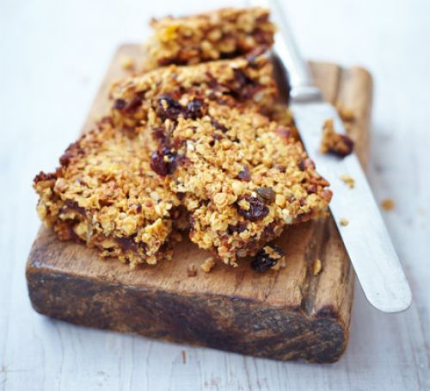

Healthier

Flapjacks

(Makes 12)

|  |  |
| --- | --- |
| **Ingredients**  • 150g ready-to-eat stoned date  • 100g low-fat spread  • 3 generous tbsp agave syrup - golden syrup will be fine too  • 50g ready-to-eat stoned dried apricot, finely chopped  • 50g chopped toasted hazelnut  • 3 tbsp mixed seed  • 50g raisin  • 150g porridge oat | Method |
| Heat the oven to 190C/170C fan/gas 5. Line an 18cm square tin with baking parchment. Put the dates into a food processor and process until they are finely chopped and sticking together in clumps. |
| **Nutrition: per serving**   * kcal190 * fat8.2g * saturates1.3g * carbs23.6g * sugars15.8g * fibre3.2g * protein4.4g * salt0.1g | Put the low-fat spread, agave syrup and dates into a saucepan and heat gently. Stir until the low-fat spread has melted and the dates are blended in. Add all the remaining ingredients to the pan and stir until well mixed. Spoon the mixture into the tin and spread level |
| **Cross curricular learning**   * Discuss textures, tastes and smells * Follow 1/2/3 key word instructions eg - “Can you get me the big, blue plate. * More and less * Big and small * Sharing * Signing, verbalising requests * Adjectives to describe the flapjacks * Measuring * Counting * Cleaning up after | Bake in the oven for 15-20 mins until golden brown. Remove and cut into 12 pieces. Leave in the tin until cold. Store in an airtight container. |