**Intensive Interaction at home.**

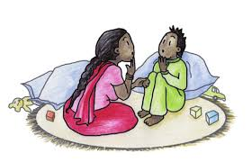

Many children have the opportunity to do ‘Jabadao’ at school. This is a fun and positive session for children and although it is done as a class in school it can easily work as a one to one session at home.

This 5 minute session will really benefit you and your child while schools are shut.

It is based on the principles of Intensive Interaction but is a great way to really focus on your child and reminds us to be mindful and present in the moment.

Choose a song / track and use the same song each time you do this so your child knows what to expect.

Before you start sit your child down (if appropriate) and explain that for the duration of the song you are going to copy their actions/dancing. (obviously you have still to keep them safe so you are not going to copy any actions that are potentially dangerous) But do try to refrain from telling them what to do.

For the duration of the song, you should focus only on your child...try not to think about what you are going to have for dinner etc. (this is a lot harder than you think...)

Make it clear when you start and when the activity is finished.

For the duration of the song copy all your child’s movement/actions whether they remain still or run around....

Once you are comfortable with doing this – you can then start to expand with some possible interventions, but always give ownership of the activity to your child. For example; you could exaggerate their movements, or you could follow their eye gaze if they keep shutting you out, you could try copying them being really close by or being further away.

There is no right way or wrong way to move/dance. If they want to flick their fingers for the entire song that is okay. This activity is an attempt to enter their world and see things from their perspective.

Have fun ☺