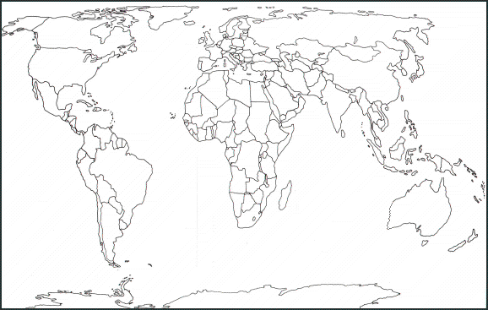Locate French speaking countries on a map using ICT, colour in/label the countries where French is spoken.