Curriculum Overview
2022-2023
“Music touches the very heart of our humanity and a sense of the wonder of music has touched human societies throughout history. Music education offers young people the chance to understand, perform and create in an aural dimension that often sits outside our capacity to describe in words. For many pupils, the music they love will be part of the narrative of their lives and bring colour to the experiences that shape them.”
Ofsted’s Research Review of Music, July 2021

Music Department Aim | To produce independent learners, musicians in any medium who have the confidence to engage with any musical discipline at any future stage in their lives. To make pupils life-long musical learners.
Statement of Curriculum Intent | At Tottington High School we musically engage pupils and establish their musical skills and understanding in year 7, then build on and develop this in year 8 and extend this in year 9.  For pupils who opt to study Music beyond key stage three, we further extend and consolidate pupils’ skills, understanding, and musicianship to make them the best musicians they can be.
Curriculum Implementation | At key stage 3 music is delivered through 2 hours of lesson time per fortnight and at GCSE this is expanded to 6 hours per fortnight. In addition to curriculum time, there are various extra-curricular opportunities available for all pupils who wish to be involved, which are adapted throughout the year to cater for pupils’ needs and interests.  Specific documentation outlines the exact content to be delivered, the specific programmes of study, as well as policies relating to pedagogy, assessment, and all aspects of teaching and learning.
Curriculum Impact | The measurement of Curriculum Impact is reviewed based on:  - KS3 Progress Tracker, which is linked to the three pillars of musical learning in the Model Music Curriculum  - GCSE Curriculum Skills and Knowledge (including a Progress Tracker)  - Formative, Peer, Self and Summative Assessment procedures  All assessments inform school Data Collections, and these are then reviewed to measure the impact of lessons taught. Amendments to Teaching and Learning, the curriculum and assessments are made in response to the impact the curriculum is having on pupils at every opportunity.

Curriculum Overview
2022-2023

 | Term 1 |  | Term 2 |  | Term 3
Y7 | BASELINE UNIT  (1: Singing; 2: Listening;  3: Composition) | INSTRUMENTAL SKILLS | KEYBOARD SKILLS | FINDING YOUR VOICE | KEYBOARD SKILLS 2 | UKULELE SKILLS
 | FINDING OUR VOICES  Singing unit which focuses on class ensemble skills | (Next to Me)  Learning to perform ‘Next to Me’ by Emeli Sande on keyboards, ukuleles and singing | Learning the notes of the keyboard, notation, and finger position, through a selection of melodies | MuFu approach to using voices creatively, through informal group learning | More advanced keyboard skills, introducing the bass clef, using two hands more independently | Singing and using the ukulele to accompany yourselves, in an informal group learning MuFu approach
 |  | 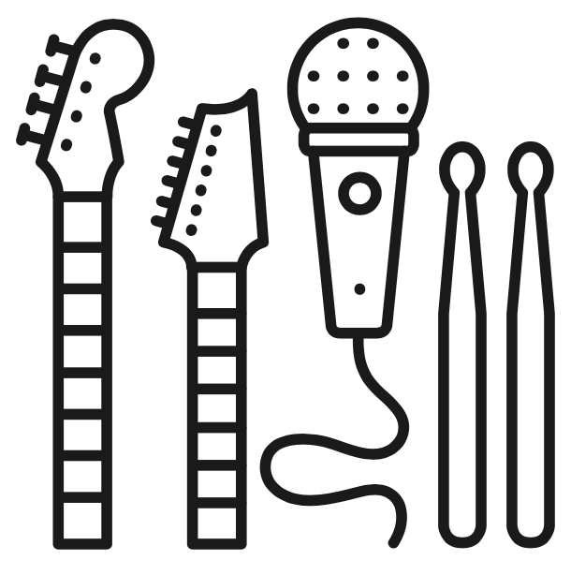 |  |  | 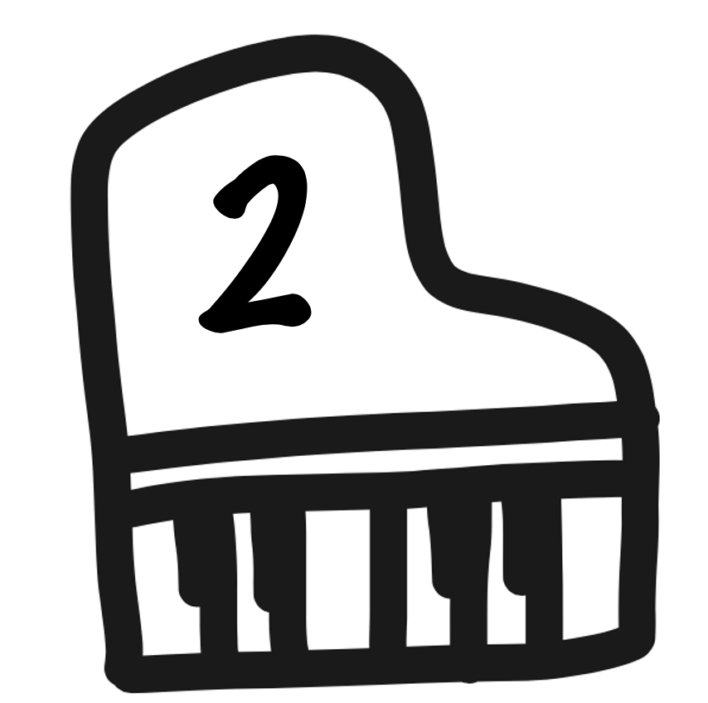
 | Independent Study  Research favourite song/artist and share in class. | Independent Study  Personal Practice, using online virtual instruments (or home instruments) | Independent Study  Music Theory quizzes (online) | Independent Study  Practise performing in front of family and discuss the experience in class. | Independent Study  Music Theory quizzes (online) | Independent Study  Personal Practice, using online virtual instruments (or home instruments)
 | Assessments  Baseline Unit:  Performing (singing)  Composing & Improvising  Listening & Appraising  Assessment in the first three lessons.  Find Your Voice:  Performing (singing)  Regular monitoring of pupil progress, recorded on a progress tracker. | Assessments  Performing  (keyboard, ukulele, singing)  Assessed group performances at the end of the unit. | Assessments  Performing  (keyboard - from notation)  Assessed solo performances at the end of the unit. | Assessments  Performing (singing)  Assessed group performances at the end of the unit. | Assessments  Performing  (keyboard - from notation)  Assessed solo performances at the end of the unit. | Assessments  Performing  (ukulele, singing)  Assessed group performances at the end of the unit.
By the End of Year 7, pupils will:
- play and perform confidently in a range of solo and ensemble contexts using their voice, playing keyboards and ukuleles
- use staff and other relevant notations appropriately
- identify and use the interrelated dimensions of music including use of different types of scales
- listen to a wide range of music from great composers and musicians
- develop an understanding of the music that they perform and to which they listen, and its history

 | Term 1 |  | Term 2 |  | Term 3
Y7 | FINDING OUR VOICES | INSTRUMENTAL SKILLS | KEYBOARD SKILLS | FINDING YOUR VOICE | KEYBOARD SKILLS 2 | UKULELE SKILLS
 | Composite Knowledge  Acquiring ensemble performance skills through whole class singing | Composite Knowledge  Acquiring ensemble and instrumental skills | Composite Knowledge  Acquiring performance skills through the keyboard | Composite Knowledge  Acquiring ensemble performance skills through group singing and vocal work | Composite Knowledge  Acquiring performance skills through the keyboard | Composite Knowledge  Acquiring performance and ensemble skills through the ukulele
 | Component Knowledge  - Knowledge of how to sing together, in time and in tune, accurately and fluently  - Knowledge of how to sing with expression in a breadth of musical styles  - Knowledge of how to enunciate and sing with diction  - Knowledge of how to rehearse successfully  - Knowledge of how to use notation to guide performance | Component Knowledge  - Knowledge of how to sing and play in time together accurately and fluently  - Knowledge of how to construct chords on the keyboard and the ukulele  - Knowledge of how to perform with expression  - Knowledge of how to rehearse successfully  - Knowledge of how to use notation to guide performance | Component Knowledge  - Knowledge of the finger system for piano and how to apply it to performance  - Knowledge of how to construct chords on the keyboard  - Knowledge of how to perform a breadth of increasingly ambitious keyboard pieces and perform them with accuracy, fluency, and expression  - Knowledge of how to rehearse successfully  - Knowledge of how to read treble clef notation to guide a performance | Component Knowledge  - Knowledge of how to sing with others, in time and in tune, accurately and fluently  - Knowledge of how to sing with expression and use the voice as an instrument in a breadth of ways  - Knowledge of how to enunciate and sing with diction  - Knowledge of how to rehearse successfully in groups  - Knowledge of how to use notation as well as aural skills to guide a performance | Component Knowledge  - Knowledge of the finger system for piano and how to apply it to performance  - Knowledge of how to perform a breadth of increasingly ambitious keyboard pieces and perform them with accuracy, fluency, and expression  - Knowledge of how to rehearse successfully  - Knowledge of how to read treble clef notation to guide a performance  - Knowledge of how to read bass clef notation to guide a performance | Component Knowledge  - Knowledge of how to sing and play in time together accurately and fluently  - Knowledge of how to construct chords on the ukulele  - Knowledge of how to perform with expression  - Knowledge of how to rehearse successfully  - Knowledge of how to use notation to guide performance

Curriculum Overview
2022-2023

 | Term 1 | Term 2 | Term 3
Y8 | MUSIC OF THE WORLD | THE BLUES | GROUND BASS | FOUR CHORDS
 | Exploring musical traditions from around the world, including performing with drums, composing using traditional scales, and performing Buffalo Soldier | Learning about chords, walking bass line and melody of Blues music, then adding improvisation skills | Learning to play Pachelbel’s Canon on the keyboard, writing a rap about school life to be accompanied by Pachelbel’s Canon | How a simple four chord sequence has been used in many pop songs, developing singing and keyboard and ukulele skills
 |  |  |  | 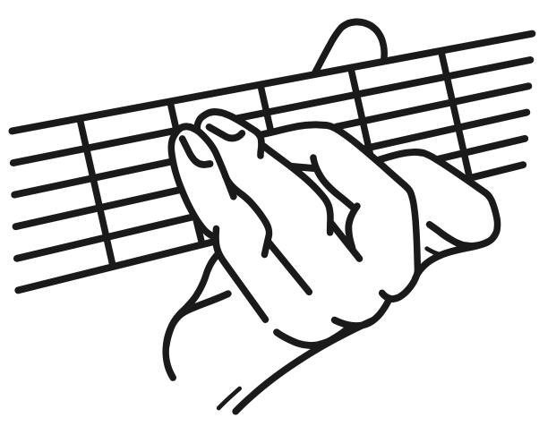
 | Independent Study  Music Theory quizzes (online) – rhythm, then pitch notation | Independent Study  Personal Practice, using online virtual instruments (or home instruments) AND Music Theory quizzes (online) | Independent Study  Personal Practice, using online virtual instruments (or home instruments) | Independent Study  Personal Practice, using online virtual instruments (or home instruments)
 | Assessments  Performing  (keyboard, drums, ukulele, singing - including from notation)  Composing  (including notating ideas, improvising)  Assessed group performances mid-way through and at the end of the unit. | Assessments  Performing  (keyboard, ukulele, singing - including from notation)  Improvising  Listening & Appraising  Assessed group performances mid-way through and group compositions at the end of the unit. | Assessments  Performing  (keyboard - from notation)  Composing  (lyrics)  Assessed group performances mid-way through and group compositions at the end of the unit. | Assessments  Performing  (keyboard, ukulele, singing)  Assessed group performances at the end of the unit.

By the End of Year 8, pupils will:
- play and perform confidently in a range of solo and ensemble contexts using their voice, playing instruments
- improvise and compose; and extend and develop musical ideas by drawing on a given range of musical structures, styles, genres and traditions
- use staff and other relevant notations appropriately and accurately in a range of musical styles, genres and traditions
- identify and use the interrelated dimensions of music expressively and with increasing sophistication using different types of scales and other musical devices
- listen with increasing accuracy to a wide range of music from great composers and musicians
- develop an understanding of the music that they perform and to which they listen, and its history

 | Term 1 | Term 2 | Term 3
Y8 | MUSIC OF THE WORLD | THE BLUES | GROUND BASS | FOUR CHORDS
 | Composite Knowledge  Developing knowledge of rhythms, scales, and melodies around the world | Composite Knowledge  Developing ensemble performance skills through Blues Music | Composite Knowledge  Developing performance skills through the keyboard | Composite Knowledge  Developing ensemble and instrumental skills
 | Component Knowledge  - Knowledge of a breadth of varied musical traditions from around the world  - Knowledge of how to perform together, in time and in tune, accurately and fluently in at least two differing world music styles  - Knowledge of how to perform with expression  - Knowledge of how to compose ambitious pieces using scales and traditions from around the world  - Knowledge of how to produce a high-quality performance of a composition  - Knowledge of how to rehearse successfully  - Knowledge of how to use treble clef notation to record a composition  - Knowledge of how to read treble clef notation to guide a performance  - Knowledge of how to read bass clef notation to guide a performance | Component Knowledge  - Knowledge of the history and culture of Blues Music including the slave trade  - Knowledge the conventions of Blues music including the blues scale, 12 bar blues, and improvisation  - Knowledge of how to perform together, in time and in tune, accurately and fluently on keyboard and ukulele  - Knowledge of how to compose and perform a high-quality piece of music as part of an ensemble  - Knowledge of how to rehearse successfully  - Knowledge of how to read treble clef notation to guide a performance  - Knowledge of how to read bass clef notation to guide a performance | Component Knowledge  - Knowledge of the finger system for piano and how to apply it to performance  - Knowledge of how to perform an increasingly ambitious keyboard piece with accuracy, fluency, and expression  - Knowledge of lyric creation  - Knowledge of how to rehearse successfully  - Knowledge of how to read treble clef notation to guide a performance  - Knowledge of how to read bass clef notation to guide a performance | Component Knowledge  - Knowledge of how to sing and play in time together accurately and fluently  - Knowledge of how to construct chords on the keyboard and the ukulele  - Knowledge of how to perform with expression  - Knowledge of how to rehearse successfully  - Knowledge of how to use notation to guide performance

Curriculum Overview
2022-2023

 | Term 1 |  | Term 2 |  | Term 3
Y9 | INSTRUMENTAL SKILLS | MINIMALISM | HISTORY OF POP | FILM MUSIC | SONGWRITING | IN AT THE DEEP END
 | (How to Save a Life)  Learning to perform ‘How to Save a Life’ by the Fray on keyboards, ukuleles and singing | Exploring various minimalist techniques to create own compositions that can be used to create soundscapes | Developing keyboard skills through a selection of pop songs from the 1960s to the present day, culminating in a solo performance | Leitmotifs (heroes and villains) and creating soundtracks. | Creating chord sequences, creating lyrics, and performing songs, firstly through class workshopping and then in small groups. | Pupils use resources and find their own methods to learn to play a song (or piece of music) of their choice – from a selection or with free-reign, learning informally
 |  |  |  |  |  | 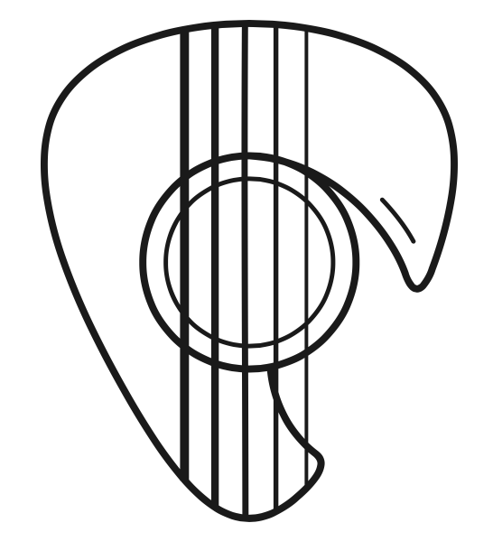
 | Independent Study  Personal Practice, using online virtual instruments (or home instruments) | Independent Study  Music Theory quizzes (online) | Independent Study  Personal Practice, using online virtual instruments (or home instruments) | Independent Study  Music Theory quizzes (online) | Independent Study  Research personally chosen topics for Protest Songs | Independent Study  Personal Practice, using online virtual instruments (or home instruments)
 | Assessments  Performing  (keyboard, ukulele, singing)  Assessed group performances at the end of the unit. | Assessments  Performing  (keyboard - including from notation)  Composing  Listening & Appraising  Assessed group performances mid-way through and group compositions at the end of the unit. | Assessments  Performing  (keyboard - including from notation)  Listening & Appraising  Assessed solo performances at the end of the unit. | Assessments  Composing (including notating ideas, improvising)  Listening & Appraising  Assessed paired compositions at the end of the unit. | Assessments  Composing (including notating ideas, improvising)  Listening & Appraising  Assessed paired compositions at the end of the unit. | Assessments  Performing  (various instruments - including from notation)  Assessed solo/paired performances at the end of the unit.

By the End of Year 9, pupils will:
- play and perform confidently in a range of solo and ensemble contexts using their voice, playing instruments musically, fluently and with accuracy and expression
- compose; and extend and develop musical ideas by drawing on a range of musical structures, styles, genres, and traditions
- use staff and other relevant notations appropriately and accurately in a range of musical styles, genres and traditions
- identify and use the interrelated dimensions of music expressively and with increasing sophistication, including use of tonalities, different types of scales and other musical devices
- listen with increasing discrimination to a wide range of music from great composers and musicians
- develop a deepening understanding of the music that they perform and to which they listen, and its history

 | Term 1 |  | Term 2 |  | Term 3
Y9 | INSTRUMENTAL SKILLS | MINIMALISM | HISTORY OF POP | FILM MUSIC | SONGWRITING | IN AT THE DEEP END
 | Composite Knowledge  Extending ensemble and instrumental skills | Composite Knowledge  Extending knowledge of performance and composition through 20th century music | Composite Knowledge  Extending performance skills through the keyboard | Composite Knowledge  Extending knowledge of composition through film music | Composite Knowledge  Extending knowledge of composition through songwriting | Composite Knowledge  Extending performance skills on an instrument suited to individuals
 | Component Knowledge  - Knowledge of how to sing and play in time together accurately and fluently  - Knowledge of how to construct chords on the keyboard and the ukulele  - Knowledge of how to perform with expression  - Knowledge of how to rehearse successfully  - Knowledge of how to use notation to guide performance | Component Knowledge  - Knowledge the conventions of minimalist music  - Knowledge of how to perform together, in time and in tune, accurately and fluently on keyboard  - Knowledge of how to compose and perform a high-quality piece of music as part of an ensemble  - Knowledge of how to rehearse successfully  - Knowledge of how to use notation to guide a performance  - Knowledge of how to use notation to record a composition | Component Knowledge  - Knowledge of the development of popular music and the various styles  - Knowledge of how to perform a breadth of increasingly ambitious keyboard pieces and perform them with accuracy, fluency, and expression  - Knowledge of how to rehearse successfully  - Knowledge of how to rehearse successfully  - Knowledge of how to use notation to guide a performance | Component Knowledge  - Knowledge of how composers use the elements of music to shape feelings  - Knowledge of how to compare film music from a breadth of genres  - Knowledge of how to produce a high-quality performance of a composition  - Knowledge of how to rehearse successfully  - Knowledge of how to use notation to guide a performance and to record a composition | Component Knowledge  - Knowledge of the development of a protest song  - Knowledge of the constructive components of a song, including chord sequences, melodies, and lyrics  - Knowledge of how to compose a song, including word setting of lyrics  - Knowledge of how to produce a high-quality performance of a composition  - Knowledge of how to rehearse successfully  - Knowledge of how to use notation to record a composition | Component Knowledge  - Knowledge of how to perform accurately and fluently  - Knowledge of how to perform with expression  - Knowledge of how to rehearse successfully  - Knowledge of how to use notation to guide a performance

Curriculum Overview
2022-2023
 | Autumn 1 | Autumn 2 | Spring 1 | Spring 2 | Summer 1 | Summer 2
Y10 | BASELINE UNIT  (1: Listening; 2-4: Composing; 5: Performing)  To determine ability in relation to target grades | THEORY: RHYTHM  (Exploring & consolidating understanding of metre, note values, and rhythmic devices [syncopation, cross-rhythm, polyrhythm, triplets, hemiola, diminution/augmentation, off-beats, anacrusis]) | THEORY: MELODY  (Exploring & consolidating understanding of pitch notation, melodic analysis [direction, type of movement, range]) | THEORY: HARMONY  (Exploring & consolidating understanding of tonality, chords, cadences, key signatures, circle of fifths) | MADTSHIRT: COLLABORATIVE ANALYSIS  (The elements of music, terminology, practice questions) | MADTSHIRT: INDEPENDENT ANALYSIS  (The elements of music, using scores, set works)
THEORY INTRODUCTION
(Music Literacy: reading notation, Italian terms, key signatures, intervals, rhythms; moving on to ABRSM grade material)
 |  | RHYTHMIC COMPOSITION  (Composing based on metre, notation, and rhythmic devices) | MELODIC COMPOSITION  (Creating melodic ideas, developing a melody, and establishing defining features) | HARMONIC COMPOSITION  (Harmonising melodies in a major key, deriving melody from a chord sequence, composing countermelody) | FREE COMPOSITION 1  (Starting free composition – creating a harmonised melody, responding to feedback) | FREE COMPOSITION 2  (Developing free compositions – texture, accompaniment, structure, development, responding to feedback)
AURAL SKILLS 1
(Listen, perform, and notate simple melodies)
 | CLASS PERFORMANCE  (Exploring riffs as a class, performing Clocks) | SOLO PERFORMANCE 1  (Exploring practise techniques) | AURAL SKILLS 2  (Listen, perform, and notate increasingly complex melodies) | ENSEMBLE PERFORMANCE 1  (Developing ensemble skills) | SOLO PERFORMANCE 2  (Consolidating practise techniques) | ENSEMBLE PERFORMANCE 2  (Consolidating ensemble skills)
 | Independent Study  Music Theory quizzes online & personal practice | Independent Study  Music Theory quizzes online & personal practice | Independent Study  Music Theory quizzes online & personal practice | Independent Study  Music Theory quizzes online & personal practice | Independent Study  Continue with composition, revision & personal practice | Independent Study  Continue with composition, revision & personal practice
 | Assessments  BASELINE: AO1-4  Listening test, composition, & solo performances  THEORY: AO3-4  Exam-style test paper  PERFORMANCE: AO1  Assessed performances  AURAL SKILLS: AO3  In-class assessment | Assessments  THEORY: AO3-4  Exam-style test paper  COMPOSITION: AO2-3  Assessment of composition  PERFORMANCE: AO1  Assessed performances | Assessments  THEORY: AO3-4  Exam-style test paper  COMPOSITION: AO2-3  Assessment of composition  AURAL SKILLS: AO3  In-class assessment | Assessments  THEORY: AO3-4  Exam-style test paper  COMPOSITION: AO2-3  Assessment of composition  PERFORMANCE: AO1  Assessed performances | Assessments  ANALYSIS: AO3-4  Exam-style test paper  COMPOSITION: AO2-3  Assessment of composition (on-going)  PERFORMANCE: AO1  Assessed performances | Assessments  ANALYSIS: AO3-4  Exam-style test paper  COMPOSITION: AO2-3  Assessment of composition (on-going)  PERFORMANCE: AO1  Assessed performances

Curriculum Overview
2022-2023
 | Autumn 1 | Autumn 2 | Spring 1 | Spring 2 | Summer 1 | Summer 2
Y11 | AREA OF STUDY 1  (MADTSHIRT Analysis: structure, forms, eras, history, orchestral music) | AREA OF STUDY 2  (MADTSHIRT Analysis: instrumentation, texture, chamber music, musicals, and jazz/blues) | AREA OF STUDY 3  (MADTSHIRT Analysis: instrumentation/timbre, dynamics, mood, and thematic development) | AREA OF STUDY 4  (MADTSHIRT Analysis: pop music, rock music, bhangra, and fusion music) | REVISION  (Mock Papers, reviewing MADTSHIRT and Areas of Study) | MOCK EXAM PAPERS  Revision and Preparation for the Listening Exam
 | FREE COMPOSITION 3  (Finalising and completing free compositions started in Y10, responding to feedback) | SET BRIEF COMPOSITION 1  (Starting set brief compositions - creating a harmonised melody, responding to feedback) | SET BRIEF COMPOSITION 2  (Developing set brief compositions - texture, accompaniment, structure, development, responding to feedback) | SET BRIEF COMPOSITION 3  (Finalising and completing set brief compositions, responding to feedback) | COMPOSITION COMPLETION  (Making final adjustments to free and/or set brief compositions as needed, responding to feedback)
 | PERFORMANCE PREPARATION 1  (Non-Examined Assessment) | PERFORMANCE PREPARATION 2  (Non-Examined Assessment) | PERFORMANCE RECORDING  (Non-Examined Assessment) | PERFORMANCE  RE-RECORDING  (Non-Examined Assessment) | PERFORMANCE  COMPLETION  (Non-Examined Assessment)
 | Independent Study  Continue with composition, revision & personal practice | Independent Study  Continue with composition, revision & personal practice | Independent Study  Continue with composition, revision & personal practice | Independent Study  Continue with composition, revision & personal practice | Independent Study  Continue with composition, revision & personal practice | Independent Study  Revision
 | Assessments  ANALYSIS: AO3-4  Exam-style test paper  COMPOSITION: AO2-3  Assessment of composition (on-going)  PERFORMANCE: AO1  Assessed performances | Assessments  ANALYSIS/MOCK: AO3-4  Exam-style test paper  COMPOSITION: AO2-3  Assessment of composition (on-going)  PERFORMANCE: AO1  Assessed performances | Assessments  ANALYSIS: AO3-4  Exam-style test paper  COMPOSITION: AO2-3  Assessment of composition (on-going)  PERFORMANCE: AO1  Assessed performances  (on-going) | Assessments  ANALYSIS: AO3-4  Exam-style test paper  COMPOSITION: AO2-3  Assessment of composition (on-going)  PERFORMANCE: AO1  Assessed performances  (on-going) | Assessments  ANALYSIS: AO3-4  Exam-style test paper  COMPOSITION: AO2-3  Assessment of composition (on-going)  PERFORMANCE: AO1  Assessed performances  (on-going) | Assessments  ANALYSIS: AO3-4  Exam-style test paper which will be externally marked by Eduqas

