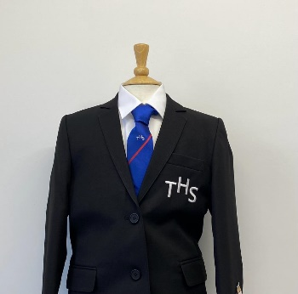
PTS School Wear Ltd
14 Market Parade 7 New Road
Bury Radcliffe
Lancashire Manchester
BL9 0QE M26 1LS
0161 761 1365 0161 723 0991
www.pts-schoolwear.co.uk
Spend & save in June & July Only
Tottington High School Uniform List 2024
Prices are correct at the time of printing.
School Year Tie’s Yr7 Blue Yr8 Green Yr9 White Yr10 Red Yr11 Yellow

Girls
From
Badge Blazer 40.99
Badged V-neck Jumper 21.99
Official School Skirt 25.99
Trousers Black 20.50
White Blouses Twin pack 17.99
School Tie Year colours 8.50
White Apron 9.50
Cream Apron 9.50
Name Tapes 3.50
Boys
From
Badge Blazer 40.99
Badged V-neck Jumper 21.99
Trousers Black 17.50
Shirts Twin pack 17.99
School Tie Year colours 8.50
White Apron 9.50
Cream Apron 9.50
Name Tapes 3.50

P.E Kit
Badged T-shirt 18.50
Badged Shorts 13.50
Royal Sports Socks 7.99
Training Trousers 23.99
Badged Leggings 20.99
Opt Badged Hoodie 25.99
SPEND & SAVE
£3.00 OFF
When you spend £30

£5.00 OFF
When you spend £50

£10 OFF
When you spend £100

