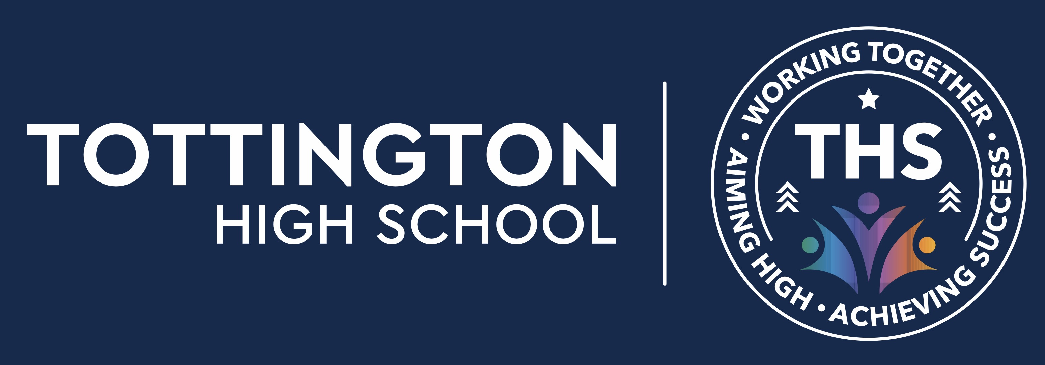
Assessment policy
Tottington High School

Approved by: | [ ] | Date: 24th September 2023
Last reviewed on: | 24th September 2023
Next review due by: | Sept 2024

Contents
1. Aims 2
2. Assessment approaches 2-4
3. Collecting and using data 4
4. Recording and reporting 4
5. Inclusion 5
6. Training 5
7. Roles and responsibilities 5-6
8. Monitoring 6

1. Aims
This policy aims to:
- Provide clear guidelines on our approach to formative and summative assessment
- Establish a consistent and coherent approach to recording summative assessment outcomes and reporting to parents
- Clearly set out how and when assessment practice will be monitored and evaluated

2. Assessment approaches
At Tottington High School we see assessment as an integral part of teaching and learning, and it is inextricably linked to our curriculum.
We use 3 broad overarching forms of assessment: day-to-day in-school formative assessment, in-school summative assessment and nationally standardised summative assessment.
2.1 In-school formative assessment
Effective in-school formative assessment enables:
- Teachers to identify how students are performing on a continuing basis and to use this information to provide appropriate support or extension, evaluate teaching and plan future lessons
- Students to measure their knowledge and understanding against learning objectives, and identify areas in which they need to improve
- Parents to gain a broad picture of where their child’s strengths and weaknesses lie, and what they need to do to improve

Formative Assessment involves the ongoing monitoring of student progress that shapes future lesson planning and intervention. This is not graded, with the focus instead on positive actionable feedback to help students “close the gap” between their current and potential attainment (or challenge their learning further). Examples include, but are not limited to; verbal feedback, retrieval practice, quizzing, questioning, self and peer-assessment, targeted skills/subject specific content, observations. Recommended formative assessment strategies are identified in each subject’s Schemes of Learning. Students in Key Stage 3 are able to track their individual progress with the use of their Progress Trackers. Every student will have a different Progress Tracker for each subject area and will use this to identify areas that they need to improve.
2.2 In-school summative assessment
Effective in-school summative assessment enables:
- School leaders to monitor the performance of student cohorts, identify where interventions may be required, and work with teachers to ensure students are supported to achieve sufficient progress and attainment
- Teachers to evaluate learning at the end of a unit or period and the impact of their own teaching
- Students to understand how well they have learned and understood a topic or course of work taught over a period of time. It should be used to provide feedback on how they can improve
- Parents to stay informed about the achievement, progress and wider outcomes of their child across a period

Summative Assessment involves designated graded assessment and often comes at the end of a topic or course including, but not limited to; end of topic/course tests, end of Year exams in Year 7, 8 & 9, Pre-Public Exams (PPE’s) in Year 10 & 11 and will form the basis of termly Teacher Assessment Data reports that follow the data assessment Calendar.

Summative assessments could include, but is not limited to any of the following:
• sample examination question(s)
• extended writing tasks
• speaking or listening tests
• activity or projects to demonstrate skills recently learnt

Each subject’s Scheme of Learning has specific detail on the nature of each Summative Assessment delivered. The outcomes of these assessments inform both in year progress and accumulative progress across the student’s career at Tottington. In Key Stage 3 this is fed back to both students and parents via marking and feedback linked to their Progress Trackers and through reports.
In-school KS4 Summative Assessments are designed by Subject Leads using their GCSE specification material as a basis to ensure that all students will have the knowledge/skills to access their GCSE courses. At Key Stage 3, summative assessments assess the taught curriculum, and reflect each subject’s scheme of learning. In-school Summative Assessments are standardised and moderated internally by departments and the Senior Leadership Team.
2.3 Nationally standardised summative assessment
Nationally standardised summative assessment enables:
- School leaders to monitor the performance of student cohorts, identify where interventions may be required, and work with teachers to ensure students are supported to achieve sufficient progress and attainment
- Teachers to understand national expectations and assess their own performance in the broader national context
- Students and parents to understand how students are performing in comparison to students nationally
Nationally standardised summative assessments take the form of GCSEs and vocational qualifications at the end of Key Stage 4.

3. Collecting and using data

All subjects collect data as part of Tottington High School’s data cycle. Data will be collected by departments for both formative and summative assessments. Teachers will use the formative data collection to identify how students are performing on a continuing basis and use this information to provide appropriate support or extension, evaluate teaching and plan future lessons. The summative data collections will be collected departmentally after each end of topic/course test. These will be used to monitor the performance of the students departmentally and used to identify any interventions that are required – this will be monitored by the senior leadership team and the department’s intervention plans. All subjects will be asked to collate their cumulative summative data for each student and input into the shared school system, three times a year, for each year group and this will then be quality assured by the senior leadership team. This will then be shared with Shaw Education Trust for further quality assurance.

4. Recording and Reporting

Recording and reporting ensures regular and relevant communication and progress to students, teachers, parents and other appropriate external audiences. It is linked to both formative and summative methods of assessment and the recording of individual student assessment outcomes, measured against agreed and shared assessment criteria, is the responsibility of each teacher, within the context of agreed departmental and whole school assessments policies.
Recording
Consistent record keeping by all teachers allows the effective monitoring of student progress and the regular evaluation of teaching content/styles/methods:
Good practice includes but is not limited to:
- Formative/summative assessment marks recorded in teacher mark books
- Formative assessment highlighted on student progress trackers
- Summative assessments recorded in departmental shared area.

Reporting
Formal Termly Reports – Years 7 to 11:
- Single page computer generated reports given to parents at the end each term. These reports will include:
  - Attendance
  - Number of late sessions
  - Positive and negative behaviour points
  - An attitude to learning grade for each subject studied
  - An area of the subject to develop
  - For Key Stage 3, it will identify if the student is ON/ABOVE/BELOW/CAUSE FOR CONCERN based on their knowledge of the curriculum at the age-appropriate standard
  - For Key Stage 4, it will identify their GCSE forecast and target grade.

5. Inclusion
The principles of this assessment policy apply to all students, including those with special educational needs or disabilities.
Assessment will be used diagnostically to contribute to the early and accurate identification of students’ special educational needs and any requirements for support and intervention.
We will use meaningful ways of measuring all aspects of progress, including communication, social skills, physical development, resilience and independence. We will have the same high expectations of all students. However, this should account for the amount of effort the student puts in as well as the outcomes achieved.
For students working below the national expected level of attainment, our assessment arrangements will consider progress relative to student starting points, and take this into account alongside the nature of students’ learning difficulties.

6. Training
Tottington staff receive a rigorous CPD program across the academic year. The CPD program includes keeping staff up to date with developments in assessment practice through internal sessions including, CPD Twilight Sessions, Teaching & Learning briefings, Middle Leader Meetings, Faculty Meetings, Faculty Data Meetings and whole school INSET days.
Activities include but are not limited to:

- moderation of assessment both within school and across local schools;
- sharing of best practice across departments;
- standardisation using progress trackers and exam board materials;
- reflecting on effective use of pedagogical assessment practices to boost student progress.

7. Roles and responsibilities
7.1 Governors
Governors are responsible for:
- Being familiar with statutory assessment systems as well as how the school’s own system of non-statutory assessment captures the attainment and progress of all students
- Holding school leaders to account for improving student and staff performance by rigorously analysing assessment data
7.2 Headteacher
The headteacher is responsible for:
- Ensuring that the policy is adhered to
- Monitoring standards in core and foundation subjects
- Analysing student progress and attainment, including individual students and specific groups
- Prioritising key actions to address underachievement
- Reporting to governors on all key aspects of student progress and attainment, including current standards and trends over previous years
7.3 Teachers
Teachers are responsible for following the assessment procedures outlined in this policy.

8. Monitoring
This policy will be reviewed yearly by Kristy Gardner. At every review, the policy will be shared with the governing board.
All teaching staff are expected to read and follow this policy. The senior leadership team are responsible for ensuring that the policy is followed.
The senior leadership team will monitor the effectiveness of assessment practices across the school, through:

- moderation of both formative and summative assessment;
- lesson observations;
- work scrutinies;
- data progress meetings;
- departmental health checks.

