Tottington High School
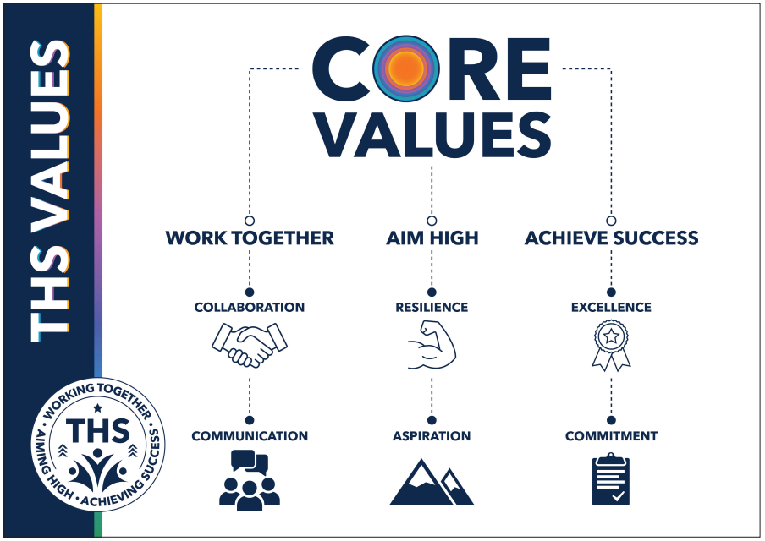
SEND Information Report 2023-2024

Our Vision
At THS we are relentless in our pursuit of excellence.
We want to inspire our school community to believe they can achieve their high aspirations and will be successful in the future.
We will accomplish this by:
- Working as a team and promoting inclusivity
- Striving for greatness everyday
- Being inspired to reach our goals

Introduction
A child or young person has SEND if they have a learning difficulty or disability which calls for special educational provision to be made for him or her.
A child of compulsory school age or a young person has a learning difficulty or disability if he or she:
- Has a significantly greater difficulty in learning in relation to other pupils of the same age.
- Has a disability which prevents or hinders him or her from making use of educational facilities of a kind generally provided for others of the same age in mainstream schools or mainstream post-16 institutions.
We endeavour to answer all the questions parents may have in relation to the provision we have for children and young people who have special educational needs.
If you would prefer to talk to one of our friendly, highly skilled and experienced staff, please do not hesitate to contact the school.
Our Special Educational Needs Policy can be accessed via the school’s website, or by contacting the school office who will be happy to provide you with a printed copy.

Our SENDCo is Mr Moreton.

- The kinds of special educational needs for which provision is made at the school
The graduated approach to SEND within the Children and Families Act 2014 and as detailed in the SEND 0-25 Code of Practice 2015, underpins Tottington High School’s approach when implementing an Assess, Plan, Do, Review cycle model (APDR).
There are 4 broad areas of need where learners may have difficulties:

- Cognition and Learning
- Communication and Interaction
- Social, Emotional and Mental Health
- Sensory and/or Physical

Where a learner is not progressing at a similar rate to that of their peers, or fails to match their previous rate of progress, despite quality first teaching, it may be that the learner has SEND.
There can be many issues which can impact on progress and attainment, such as:
- attendance and punctuality;
- disability, health and welfare;
- socio economic factors;
- safeguarding concerns and historic and ongoing ACES and trauma;
- attendance
- multiple school moves;
- difficulties where English is not the first language
( this is not an exhaustive list)

We understand that children who experience barriers to learning are vulnerable. However, this does not mean that all vulnerable learners have SEND. Only those identified as having a persistent learning difficulty or disability which requires special educational provision, in one or more of the areas of need described above, will be identified as having SEND.

- Information about the school’s policies for the identification and assessment of pupils with special educational needs (mainstream schools)
Information about students is gathered in a wide variety of different methods including:

- KS2 Results, Baseline and Ongoing Assessments such as Sparx Literacy, Sparx Numeracy, Literacy Gold and Star Reading;
- Data used to identify attainment and progress to show whether a child is falling behind their peers and/or whether the child is not progressing as expected.
- Primary School reports, visits, meetings and teacher input.
- Transition information
- Professional reports
- Parental voice
- Pupil voice
- Diagnostic testing
- Teacher/SENCo observation.
- Observations/Interaction with pupils - mentors/counsellors/teachers/non-teaching staff/outside agencies.
- Professional meetings with external providers

- Information about the school’s policies for making provision for pupils with special educational needs:

Tottington High School has a child centred inclusive approach to education. The school is committed to ensuring all students receive a high-quality education and realise their academic potential regardless of any challenges they may face.

Students with SEND are educated via quality first teaching and through an ambitious broad and balanced curriculum in the classroom, as part of this inclusive strategy, but may receive additional intervention and support on a personalised level if this is deemed necessary.
Education, Health and Care Plan (EHCP) students receive support as set out in their plan. They access an individualised programme of support which focuses on their specific needs.

Please refer to the schools’ Policy for Special Educational Needs.

- The name and contact details of the SEN Co-ordinator (mainstream schools)

Our Special Educational Needs Co-ordinator (SENDCo) is Mr Moreton who can be contacted via the main school office:
Tottington High School
Laurel Street
Tottington
Bury
BL8 3LY
01204 882327
peter.moreton@ths.set.org

- Information about the expertise and training of staff in relation to children and young people with special educational needs and how specialist expertise will be secured

Our SENDCo is currently undertaking the National Award for Special Educational Needs (NASENCo) and is a fully qualified teacher and experienced leader of SEN. The SEND Inclusion Team at Tottington High School has a complement of 7 Teaching Assistants with 3 Higher Level Teaching Assistants (HLTA) who provide both in class support and deliver personalised intervention programmes.

Tottington High School are part of the Bury SENDCo network and have regular access to specialist SEN training delivered by Bury Additional Needs Team. Additional training for staff is secured where necessary. This might be delivered in school by external training providers such as the Educational Psychology Service, specialist teachers and health care professionals or attendance at external training events. The school is further supported by a wider team as part of the Shaw Education Trust.

- Information about how equipment and facilities will be secured

The first £6,000 of additional funding for SEND learners (above and beyond the average educational funding per child) should be met by the school from the dedicated schools grant. Where the value of a learner’s additional needs is greater than £6,000, then the learner is classified as having ‘High Needs’ and an application for funding from the High Needs Block will be made to the Local Authority, following the procedure set out in the High Needs Funding Documents.

Where a learner has needs within the realm of Sensory Difficulties i.e. visual and/or hearing impairment, the Sensory Needs team, in consultation with the SENDCo, will provide an agreed level of support including the provision and monitoring of specialist equipment.

- Arrangements for consulting parents of children with special educational needs about, and involving such parents in, the education of their child.

Parents/ carers will be informed if their child requires SEND Support and meetings will be held to discuss and review provision and progress towards the set outcomes.

- Arrangements for consulting young people about, and involving them in, their education
Wherever possible, learners with SEND are involved in meetings arranged with parents/carers to agree desired outcomes and to review progress made towards these. During these meetings, they are invited to contribute, to give their views about provision and their own learning experiences. Learners are encouraged to play a full role in the development of their SEND Pupil Passport. Where a learner has an Education, Health and Care Plan, a Local Authority Annual Review/Person Centred Review will be carried out annually
.
- Arrangements made by the Governing Body in relation to complaints from parents of pupils with special educational needs concerning the provision made at the school

The school’s complaints procedure is published on the school’s website.

- Contact details of support services for parents of pupils with special educational needs, including those for arrangements made in accordance with Section 32 (mediation)
This information is set out in the local authority’s Local Offer: www.theburydirectory.co.uk

- The school’s arrangements for supporting pupils with special educational needs in a transfer between phases of education or in preparation for adulthood and independent living

Arrangements are made to collect all relevant information and records for new entrants through visits to primary schools for Year 6 learners. Where a learner enters Tottington High School after this point, reference to records from a previous school will be accessed.

The SEND Inclusion and pastoral team will visit primary schools to liaise with Y6 teachers in the first half of the summer term. The SENDCo will attend Y5/Y6 reviews for learners with EHC Plans. This process facilitates our first meetings with parents/carers and enables us to establish positive relationships. We aim to access as much relevant information as possible prior to transition, to inform our planning and provision.

Transition meetings are held between the Form Tutor’s, Teaching Assistants and the SENDCo in the latter half of the Summer Term to ensure a clear, consistent approach to learning and support can be sustained. All learners for whom it is deemed appropriate will be offered extended transition opportunities. Bury Secondary PRU Outreach Service and the Additional Needs team support the transition of vulnerable learners as agreed with the primary school and the SENDCo.

Liaison between the Headteacher, SENDCo, Pastoral Team and Bury Secondary Inclusion Support Team for learners entering school who are known to have high level SEMH needs is essential when ensuring that the correct provision is in place to facilitate a successful transition.

Records for learners who move to other schools are forwarded to their new school. Transition arrangements for Y11 learners are established as part of their annual reviews and person - centred plans in collaboration with Realistic Choices, the SEND team and specialist practitioners from the FE colleges. Supported visits to selected colleges are arranged for SEND learners as appropriate.

- Information on where the local authority’s local offer is published.

www.theburydirectory.co.uk

