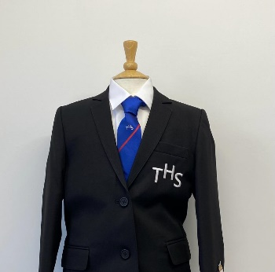
PTS School Wear Ltd
Savings Club
School Vouchers
Accepted
14 Market Parade 7 New Road
Bury Radcliffe
Lancashire Manchester
BL9 0QE M26 1LS
0161 761 1365 0161 723 0991
www.pts-schoolwear.co.uk
Sale on Selected Garments in June & July Only
Tottington High School Uniform List 2023
Prices are correct at the time of printing.
School Year Tie’s Yr7 Green Yr8 White Yr9 Red Yr10 Yellow Yr11 Blue
Girls
From Special Offer
Badge Blazer 40.99 36.89
Badged V-neck Jumper 21.99
Official School Skirt 23.99 21.59
Trousers Black 16.99
White Blouses Twin pack 16.99
School Tie Year colours 7.99
White Apron 8.99
Cream Apron 8.99
Name Tapes 3.50

P.E Kit
Badged T-shirt 14.99
Badged Shorts 11.99
Badged Leggings 20.99
Royal Sports Socks 7.99
Opt Badged Hoodie 20.99

Boys
From Special Offer
Badge Blazer 40.99 36.89
Badged V-neck Jumper 21.99
Trousers Black 16.99
Shirts Twin pack 16.99
School Tie Year colours 7.99
White Apron 8.99
Cream Apron 8.99
Name Tapes 3.50

P.E Kit
Badged T-shirt 14.99
Badged Shorts 11.99
Royal Sports Socks 7.99
Opt Badged Hoodie 20.99

