# E:\Users\simon.roche\AppData\Local\Microsoft\Windows\Temporary Internet Files\Content.Word\Evidencing the Impact of the Primary PE and Sport Premium Template 2019 7.3 Images_Page_1.jpg

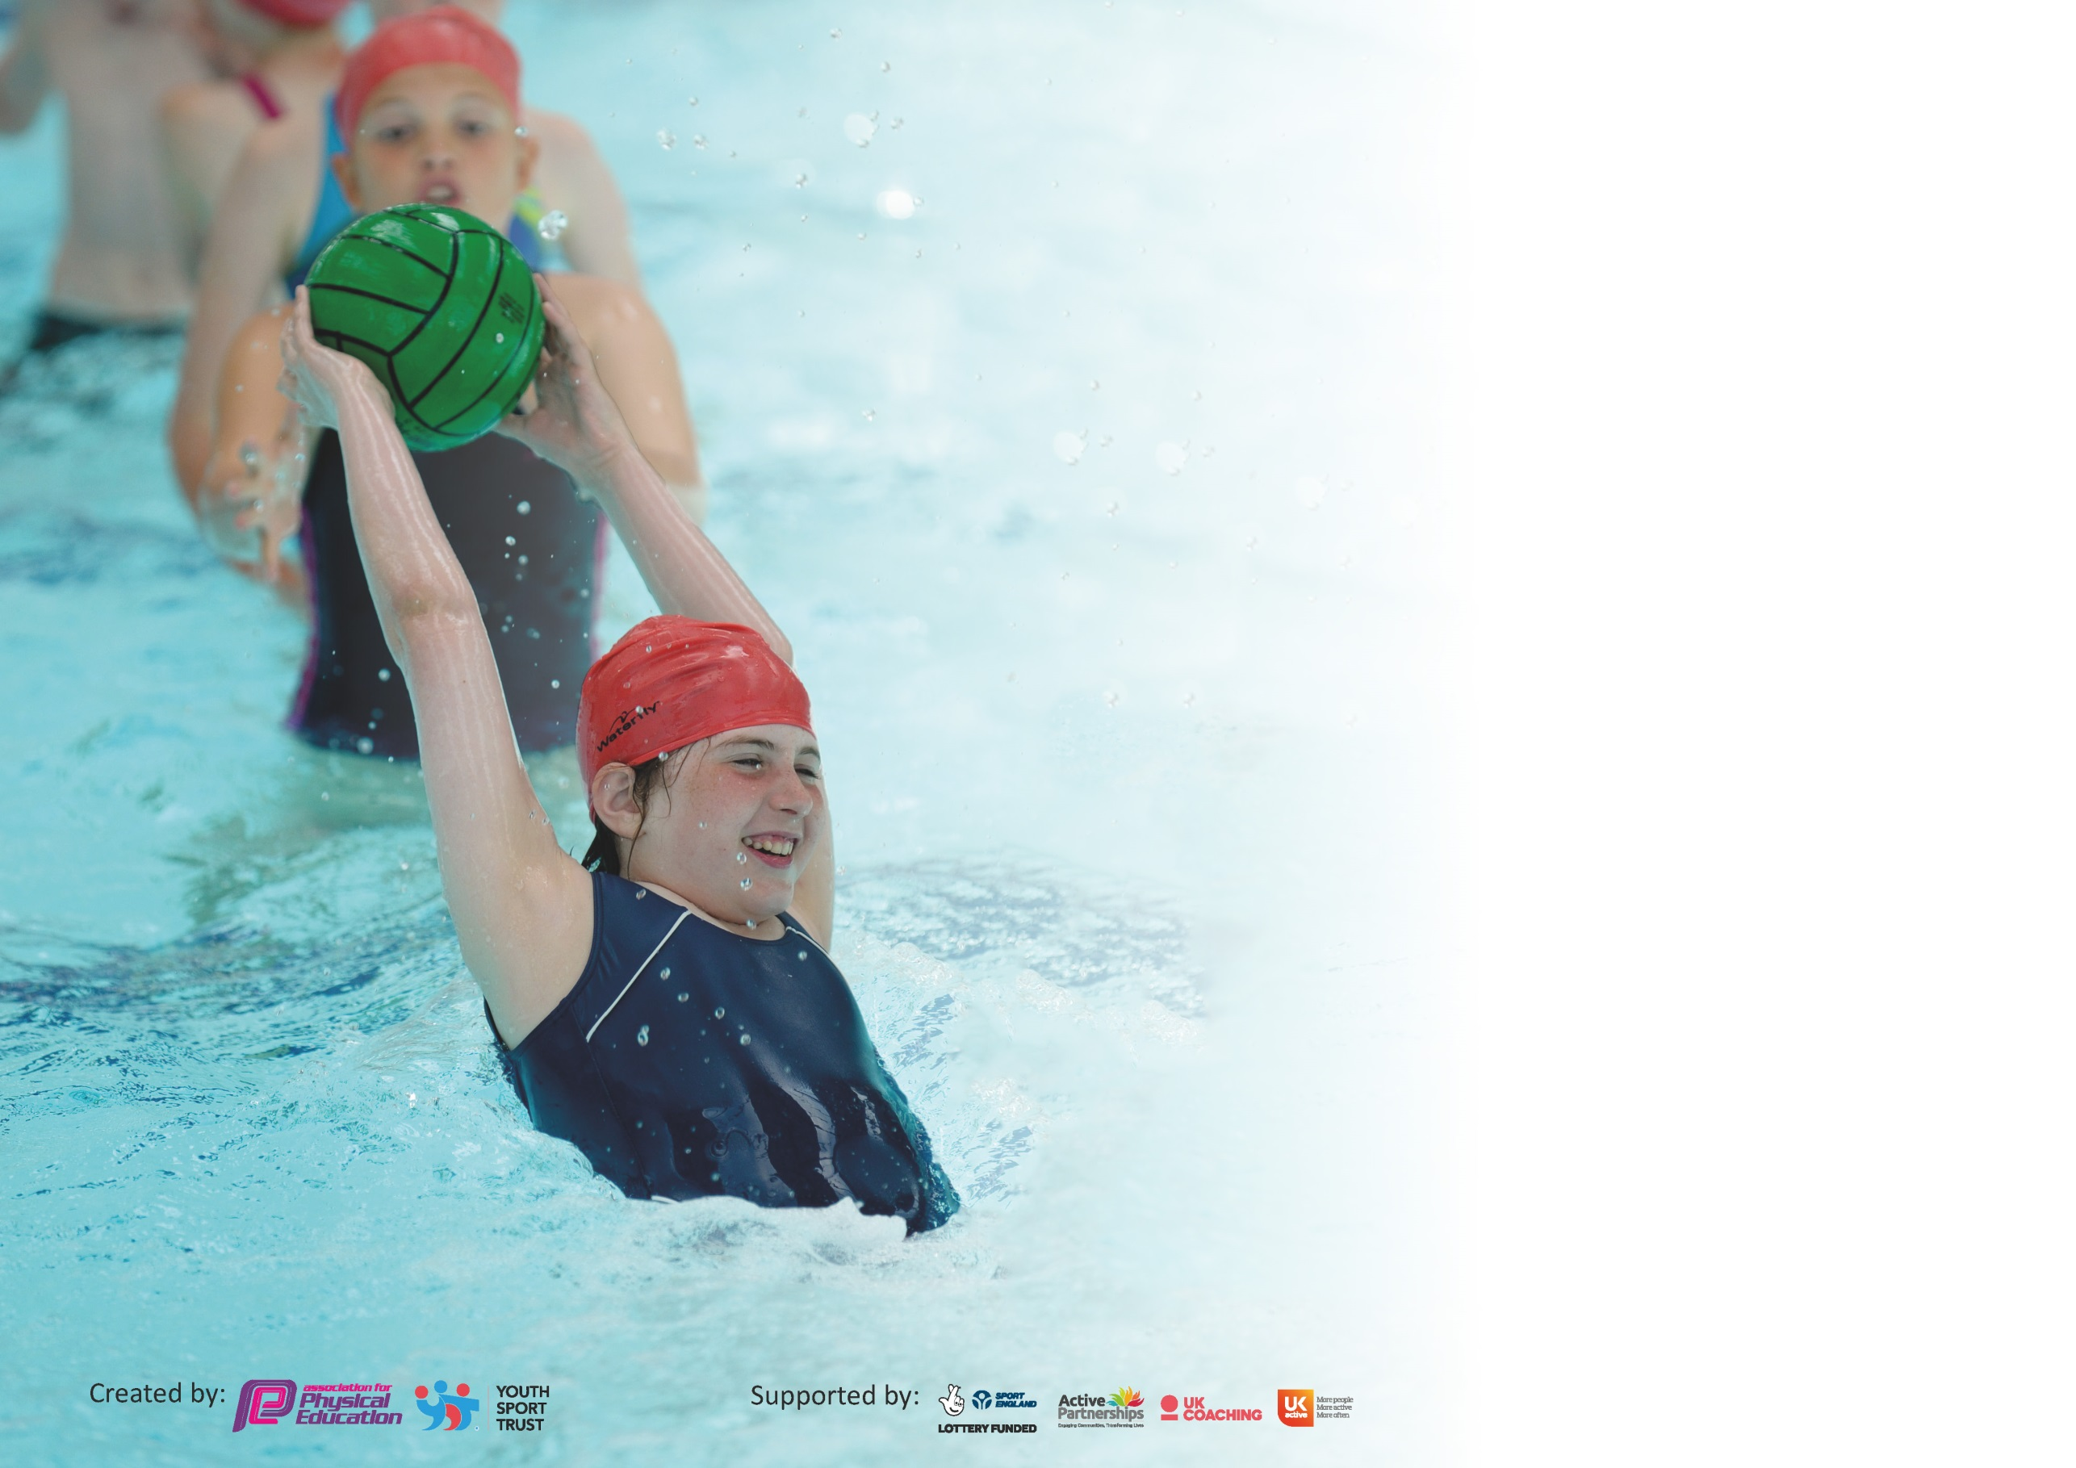

It is important that your grant is used effectively and based on school need. The [Education Inspection Framework](https://assets.publishing.service.gov.uk/government/uploads/system/uploads/attachment_data/file/843108/School_inspection_handbook_-_section_5.pdf) (Ofsted 2019 p64) makes clear there will be a focus on **‘whether leaders and those responsible for governors all understand their respective roles and perform these in a way that enhances the effectiveness of the school’**.

Under the [Quality of Education criteria](https://assets.publishing.service.gov.uk/government/uploads/system/uploads/attachment_data/file/843108/School_inspection_handbook_-_section_5.pdf) (p41) inspectors consider the extent to which schools can articulate their curriculum (INTENT), construct their curriculum (IMPLEMENTATION) and demonstrate the outcomes which result (IMPACT).

To assist schools with common transferable language this template has been developed to utilise the same three headings which should make your plans easily transferable between working documents.

Schools must use the funding to make **additional and sustainable** improvements to the quality of Physical Education, School Sport and Physical Activity (PESSPA) they offer. This means that you should

use the Primary PE and Sport Premium to:

* Develop or add to the PESSPA activities that your school already offer
* Build capacity and capability within the school to ensure that improvements made now will benefit pupils joining the school in future years

Please visit [gov.uk](https://www.gov.uk/guidance/pe-and-sport-premium-for-primary-schools) for the revised DfE guidance including the 5 key indicators across which schools should demonstrate an improvement. This document will help you to review your provision and to report your spend. DfE encourages schools to use this template as an effective way of meeting the reporting requirements of the Primary PE and Sport Premium.

We recommend you start by reflecting on the impact of current provision and reviewing the previous spend.

Schools are required to [publish details](https://www.gov.uk/guidance/what-maintained-schools-must-publish-online#pe-and-sport-premium-for-primary-schools) of how they spend this funding as well as on the impact it has on pupils’ PE and sport participation and attainment by the end of the summer term or by **31st July 2021** at the latest.

We recommend regularly updating the table and publishing it on your website throughout the year. This evidences your ongoing self-evaluation of how you are using the funding to secure maximum, sustainable impact. Final copy must be posted on your website by the end of the academic year and no later than the 31st July 2021. To see an example of how to complete the table please click [HERE](http://www.afpe.org.uk/physical-education/wp-content/uploads/afPE-Example-Template-Indicator-2018-Final.pdf).

Support for review and reflection - considering the 5 key indicators from DfE, what development needs are a priority for your setting and your pupils now and why? Use the space below to reflect on previous spend and key achievements and areas for development.

|  |  |
| --- | --- |
| Key achievements to date until July 2023: | Areas for further improvement and baseline evidence of need: |
| * At least 2 hours of taught PE across all year groups. * Great attendance of clubs – variety of clubs offered (highest numbers ever attending) * Staff commitment to improve and develop their own practise. * Opportunities for children to enjoy a range of sports competitions/activities during the school year. * Relationships developed with community groups * Peer mentor/ young leaders | * Continue to develop swimming provision – transition to Year 4 attending. |

|  |  |
| --- | --- |
| Meeting national curriculum requirements for swimming and water safety. |  |
| What percentage of your current Year 6 cohort swim competently, confidently and proficiently over a distance of at least 25 metres?  **N.B.** Even though your pupils may swim in another year please report on their attainment on leaving  primary school at the end of the summer term 2020. | 70% |
| What percentage of your current Year 6 cohort use a range of strokes effectively [for example, front crawl, backstroke and breaststroke]? | 70% |
| What percentage of your current Year 6 cohort perform safe self-rescue in different water-based situations? | 80% |
| Schools can choose to use the Primary PE and Sport Premium to provide additional provision for swimming but this must be for activity **over and above** the national curriculum requirements. Have you used it in this way? | Yes |

**Action Plan and Budget Tracking**

Capture your intended annual spend against the 5 key indicators. Clarify the success criteria and evidence of impact that you intend to measure to evaluate for pupils today and for the future.

|  |  |  |  |  |
| --- | --- | --- | --- | --- |
| **Academic Year:** 2023/24 | **Total fund allocated:** £17,800 | **Date Updated:** | |  |
| **Key indicator 1:** The engagement of all pupils in regular physical activity – Chief Medical Officer guidelines recommend that primary school pupils undertake at least 30 minutes of physical activity a day in school | | | | Percentage of total allocation: |
| 13% |
| **Intent** | **Implementation** | | **Impact** |  |
| To increase opportunities for daily fitness activity outside of PE sessions.  All children to be encouraged to develop stamina and resilience whilst working towards personal challenges.  To engage all children in quality active play and physical activity during playtimes. Exercise opportunities will be  timetabled every day for teachers to  ensure all pupils get at least 30  minutes of exercise per day. | Provide quality sports equipment to engage active playtimes and maintain high level of teaching and engagement in PE sessions. Subscription to Primary PE Planning to support teachers with planning sequences of high quality, progressive curriculum. | £2395 | Improved stamina and physical resilience in children. Children are challenged to beat personal bests and improve physical performance in PE lessons. | Continue to develop organised active play times through development of Play Leaders. |
| **Key indicator 2:** The profile of PESSPA being raised across the school as a tool for whole school improvement | | | | Percentage of total allocation: |
| 14% |
| **Intent** | **Implementation** | | **Impact** |  |
| To provide children with opportunities to develop personal, social and emotional skills through character building sessions and activities.  To improve physical and mental well-being in all children through project me. | To provide children with sporting experiences and activities that they may not get the opportunity to participate in. Groups will be able to take part in project me working on character building and resilience. | £2500 | Pupils will be able to use  character building sessions to develop a range of skills .Pupils will improve physical and mental well-being as a result of the short active bursts ad skipping throughout the day. | Teachers to continue to use active learning ideas and resources to improve well-being and child engagement in all lessons. To develop capacity to run character building sessions on site to benefit more children across the school. |

|  |  |  |  |  |
| --- | --- | --- | --- | --- |
| **Key indicator 3:** Increased confidence, knowledge and skills of all staff in teaching PE and sport | | | | Percentage of total allocation: |
| 42% |
| **Intent** | **Implementation** | | **Impact** |  |
| To improve the confidence of all staff to deliver high quality PE.  To provide opportunities for staff to access CPD in a range of activities tailored to their individual need or interest. | Team teaching with PE specialist one day per week to increase confidence, knowledge and skills of staff in Physical Education particularly in outdoor games and striking and fielding. Support from PE specialist to focus on teaching with delivering high quality Physical Education and ways of differentiating/challenging during lessons.  PE lead to attend PE conference and co-ordinator meetings to enable PE lead to keep up to date with developments. PE lead to support with delivery of PE and work with class teachers during the year and provide staff training. Twilight training to be organised for all staff to train together.  PE lead to audit where staff feel their weaknesses are and target CPD towards where teachers need it.  PE Lead to upskill his ability and knowledge from the various workshops and resources available from the PE conference attended.  Forest school training for staff to utilise our outdoor space.  Staff to upskill themselves working in partnership working with Delta Gymnastics. | £7,500 | All staff to feel confident in  delivering a wide variety of sports  and activities. An improved skill  set and ideas to use in PE  sessions. | Staff to report back during  staff meetings any activities  that have been very successful  to improve the quality of the  overall PE provision. |
| **Key indicator 4:** Broader experience of a range of sports and activities offered to all pupils | | | | Percentage of total allocation: |
| 20% |
| **Intent** | **Implementation** | | **Impact** |  |
| Provide opportunities to develop balance and coordination through balance bike skills coaching for EYFS.  To hold ‘New Sport Week’ as  showpieces for the school.  Broaden the offer of extra-curricular clubs to promote health and fitness across the schools. | Children to experience and develop their balance and coordination on balance bikes with weekly sessions with Balance Bike coach .  Children enjoy ‘New Sports Week’ being led by specialists in sports normally unavailable in school. Coaches of these sports will be  hired and sourced to come into  school and deliver special occasion days of sport. Delta gymnastics to run weekly gymnastics session providing children the opportunity to learn new skills. | £3645 | Excitement and renewed interest  in sport across the school. Pupils  will see a variety of activities and  become enthused and want to  join new clubs and seek-out new  sporting experiences.  Engagement and participation in Hockey club supports development of hockey skills and children are prepared for competitions.  Children are inspired to improve stamina and fitness. | Follow up the most popular  Sessions from ‘New Sports Week’ to see if longer-term  clubs are viable and can take  place in school.  Further develop partnership with Swindon Wildcats to inspire and engage all pupils in physical activity. |

|  |  |  |  |  |
| --- | --- | --- | --- | --- |
| **Key indicator 5:** Increased participation in competitive sport | | | | Percentage of total allocation: |
|  |
| **Intent** | **Implementation** | | **Impact** | 10% |
| To provide opportunities for children to compete in competitive and non-competitive competitions with other schools.  To be apart of the football leagues to provide opportunities for children to play competitive football. | Children to take part in competitive sporting festivals as part of Fortius to raise the profile of PE and sport across the school.  Children to be involved in sporting competitions to raise the profile of PE and sport across the school. | £1760 | Increased participation in  competitive sport and improved  confidence and pride in school  involvement. | Staff and experienced coaches to deliver specific clubs linked to the events and organise coach to accompany the pupils to events. |

|  |  |
| --- | --- |
| Signed off by | |
| Head Teacher: | Helen Tudor |
| Date: | 10th July 2023 |
| Subject Leader: | Shaun Preen |
| Date: | 10th July 2023 |
| Governor: | Emily Medland |
| Date: | 10th July 2022 |