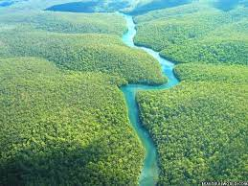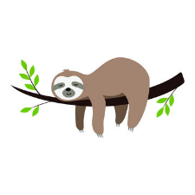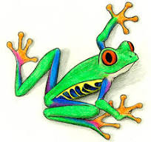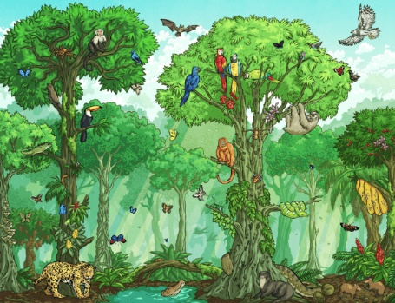

**French**

We will be learning and family and friends and food.

**Science**

Through observations, and scientific investigations we are going to develop our knowledge about plants, forces and magnets. By carrying our experiments, we will develop our scientific skills, particularly learning how to carry out fair tests and apply our knowledge to draw conclusions.

**Art and DT**

Over this term, in **art**, we are going to learn how to visualise the world around us like an artist would. We will develop our drawing and painting skills.

In **design technology** we will be developing our knowledge and skills in food technology, learning about seasonal foods and designing our own seasonal tart.

**Values and PSHE**

Our values for this term are Patience and Justice.

We will be looking at the different types of relationships we have and how we change as we grow up and move onto the next step.

**RE**

We will be investigating the questions;

What do different people believe about God?

Why do people pray?

**Computing**

We will be developing and practising our desk-top publishing skills as well as learning how to program events and information in programs.

**Internet safety** will see us learning about relationships on line and managing on line information.

Rainforests

**Geography**

**Physical geography** Locating where rainforests are in the world, learning about their structure and characteristics. We will study the Amazon rainforest in more detail.

**Human geography** We will be finding out more about what is like to live in the rainforest and compare what it is like to live in Swindon.

**PE**

This term we shall be developing our leadership skills, learning how to play cricket, develop our understanding of rounders and practising our athletic skills.

**Music**

We will be continuing with our weekly African drumming lessons.

We will also be looking at patterns in songs, learning songs and how to improvise. We shall also be creating our own song and performing it.

**English**

We are exploring the ‘Tin Forest’ and ‘The Wonder Garden’ as our texts plus using short films, ‘Catchit ‘ and ‘National Geographic’ as our inspiration for writing. We will be practising our writing in many different ways resulting in writing a story and a commentary for a documentary.

We will be developing our reading skills and practising our comprehension.

**Maths**

Over this term we will be developing our mathematical skills and knowledge by finding amounts in fractions, learning how to tell the time, develop our skills measuring length, mass and capacity and learn about collecting and presenting data. We will practise our times tables and mental and written calculation skills.